**win7下载地址：**[https://cdn.npm.taobao.org/dist/node/v12.16.0/node-v12.16.0-x64.msi](https://cdn.npm.taobao.org/dist/node/v12.16.0/node-v12.16.0-x64.msi" \t "https://www.cnblogs.com/nature161/p/_blank)

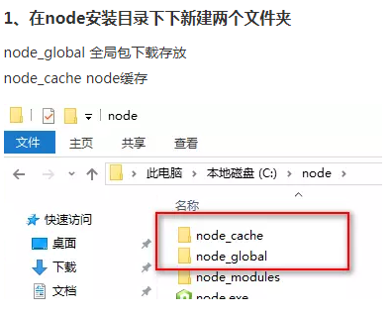

npm config set prefix "E:\java\nodejs\node_global"

npm config set cache "E:\java\nodejs\node_cache"

