Xtc 1.7.1

Linux Thin Client Project

vmfree.org

© Volker Matheis 2019

License
This program is free software: you can redistribute it and/or modify it under the terms of the GNU General Public License as published by the Free Software Foundation, either version 3 of the License, or (at your option) any later version.

This program is distributed in the hope that it will be useful, but WITHOUT ANY WARRANTY; without even the implied warranty of MERCHANTABILITY or FITNESS FOR A PARTICULAR PURPOSE. See the GNU General Public License for more details.

You should have received a copy of the GNU General Public License along with this program. If not, see <https://www.gnu.org/licenses/>.

System requirements for xtc
Raspberry Pi:
- Raspberry Pi 3 or Pi 4
- SD memory card at least 8 GB storage space
- File xtc.tar.gz or xtcdestkop.tar.gz
Ubuntu or manual installation:
- Ubuntu-Server 20.04
- File xtcbin.tar.gz
Optional:
- Raspberry Pi 3: Pi desktop case from element14:
https://www.element14.com/community/docs/DOC-83477?ICID=searchandfilter-result-designcenter
- Raspberry Pi 4: Case from One Nine Design:
https://www.raspberrypiplastics.com/power-hat-board

Release Notes
Release 1.0:
- initial release
Release 1.1:
- support for Ubuntu 17.10
- new network interface
Release 1.2:
- use Raspbian Stretch Lite
Release 1.3:
- Allow connection with VNC
- Allow connection with ssh
- Bug fixes
Release 1.3.1:
- Bug fixes
Release 1.4:
- New release Raspbian Stretch to support Raspberry Pi 3 Model B+
- configure videocard
- alternative connections
Release 1.4.1:
- own login X2GO
- New release Raspbian
Release 1.5:
- VPN connection
- New release Raspbian
Release 1.5.1:
- New release Raspbian
- Release for Raspberry Pi 4
Releas 1.6:
- Support for case from One Nine Design with power switch for Raspberry Pi 4
- Support for case Argon 1 with power switch for Raspberry Pi 4
Release 1.7:
- Supports sound via HDMI
- Automount USB memory stick
Release 1.7.1:
- Supports Ubuntu 20.04 Server
- Supports Raspberry Pi OS May 2020
- Raspberry Py: support for network services with dhcpcd.conf (Rasperry Pi)
- Tiger-VNC replaces RealVNC

Contact
Any questions or solutions? Contact: info@vmfree.org

Installation für Raspberry Pi 3 or Pi 4
The Raspberry Pi 3 contains the software for the case from element14. The Raspberry Pi 4 contains the software for the case of Argon 1 and openninedesign.

The file xtc.zip contains an image file which contains the operating system Raspberry Pi OS and xtc. After writing the image to a memory card, xtc is immediately available. Here's how:

With Linux:
- Download the file.
- Unpack the file xtc.zip
- Copy the unpacked file xtc.img to the memory card.
With Linux:
In a console: sudo dd if=xtc.img of=<device name memory card)
Find the device name of the memory card with the command: fdisk -l
With Windows:
Use a tool like Win32Diskimager.exe to write the image file xtc.img to the memory card.
- After this action insert the memory card into the Raspberry Pi and start the Raspberry.

Installation on Ubuntu
For the next steps you need a existing internet connection.

- Install Ubuntu Server 20.04
- Unpack the file xtcbin.tar.gz.
- Install xtc: sudo sh xtc/install.sh
- Reboot your PC.

xtc handling
After Reboot your system you see a dialog with different tabs:

Connect
System
Configure
Network
System

Do you have set a password (in the second tab „System“), you can‘t use the tabs Configure und Network. Because you are now in the user mode. When you start xtc at the first time you are in admin mode.

Admin mode
After the installation, or when you don‘t need a passwort, or when you start your system as admin (checkbox „Start as Administator“) all tabs are available.

User mode
The system starts in user mode, when you set a password. In the user mode only the connect and the system tab are available.

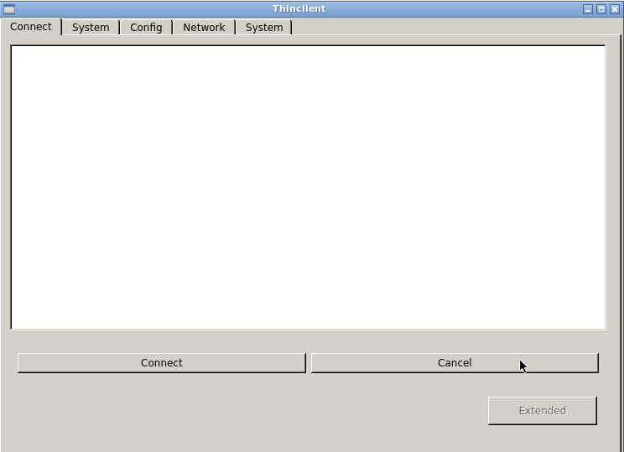
Connection
In the connection tab you can see the created connections. After a double click the connection will be established. You can establish a connection also when you click on a connection name in the list and then click the „Connect“ button. To disconnect click the button „Cancel“.
Button „Extended“: The button is available when you are in user mode. After clicking the button, you see a password dialog. Enter the password and you are now in admin mode.
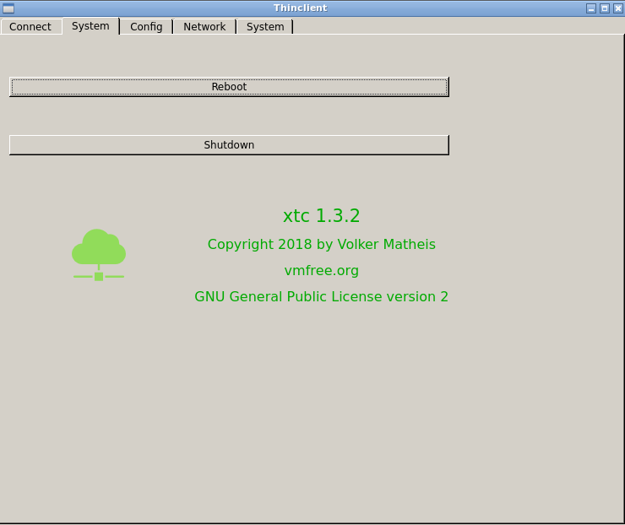

(1. tab) System
Button „Reboot“: Click the button to reboot the system.
Button „Shutdown“: Click the button to shutdown your system.

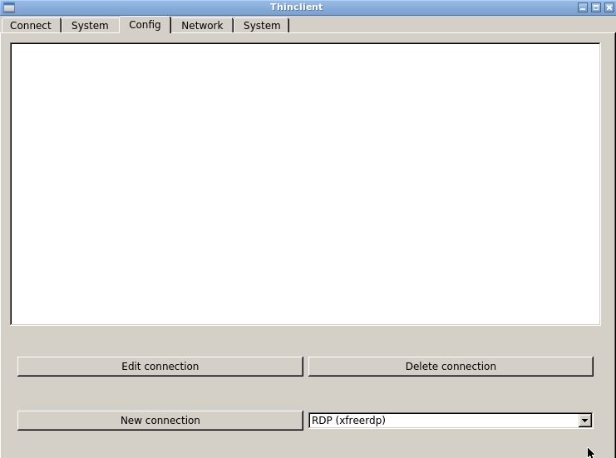
Configure
Configure a connection.

Button „New Connection“:
Select a connection type in the selection field right from this button.
Then click the button „New Connection“. You see a configuration dialog for the selected connection type.
Button „Edit connection“:
Select a connection and click this button. You see a dialog with the parameters from the selected connection. Edit the connection.
Button „Delete connection“:
Select a connection and click this button. You see a dialog „Delete connection?“ Press the button „yes“ to delete the selected connection.

Depending of the connection type you have different input possibilities:

Name: Connection name. This name is shown in the list.
Address: IP-address or name from the server to connect with.
Port: Port on the server.
Resolution: Choose a display resolution for this connection.
Color: Choose a color depth.
System Login (only RDP): Use the user and password dialog from xtc before you connect with the server.
Keyboard layout (only X2GO): Choose a keyboard layout.l.
Desktop (only X2GO): Choose the desktop from the server.
Login Name (only SSH): User name from the connection.
Password (only SSH): Password from the connection.
Application (only SSH): Application name on the server.
Autostart: Establish this connection after reboot your system.
Connect new: After disconnection connect again automatically.
Further Parameter: Choose supplementary parameters for this connection. Read the manual of the connection command to find other parameters you need.
Alternative: Choose a alternative connection. This connection starts, when the conigured connection is not available.

Connection software
In the table you find the connection software, which is used by xtc.

Connection Type | Client software
RDP | xfreerpd, rdesktop
VNC | tiger-vncviewer
X2GO | pyhoca-cli
SSH | ssh
XDMCP | xephyr

Read the manual pages from the software for further parameters.

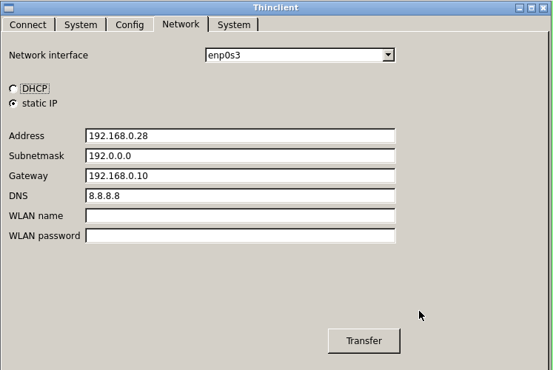
Network
Configure the thin client network.
Network interface: Choose a network connection.
DHCP, static IP: Choose the type of network connection.
With static IP fill the following fields:
Address: The IP address from your system.
Subnetmask: The subnetmask from your system.
Gateway: Gateway, if needed.
DNS: Nameserver, if needed.
WLAN name: When you configure a WLAN network, write here the name (SSID) from your WLAN network.
WLAN passsword: The password from your WLAN network.
After this click the button Transfer. You see a dialog question „Reboot?“. Click yes to restart the system to activate the changes.

(2. tab) System
Button „Terminal“: Click the button to start a console terminal on the thin client.
Start as administrator: Select the check box to start xtc in the admin mode.
Password: Choose the password. Now you can change from user mode to admin mode only with this password.
Repeat Password: repeat the password for admin mode.
Language: Select the application language for xtc.
Keyboard layout: Select the keyboard layout for xtc.
Allow connection VNC: activate this function to admin the xtc GUI from a remote PC. On this PC you need a VNC-Client (i.e. RealVNC) to connect to xtc. For example: connect to xtc from a linux shell: vncviewer <ip-adress>:0
Password VNC connection, Repeat password: To connect with VNC you need a password. Enter here the password.
Allow connection ssh: Activate this field to start an ssh-Server. The default login and password to use ssh is: Login „thinclient“, password „thinclient“.
Monitor standby: Choose this option, to disconnect the monitor after 10 minutes inactivty.
Screensaver: Choose this option, to activate the scrrensaver after 10 minutes inactivty.
Resolution: screen resolution. With Ubuntu the input is in the format <width>x<heigt>. For example: 1024x768. For Raspberry Pi, the input is the hdmi_mode, see:
https://www.raspberrypi.org/documentation/configuration/config-txt/video.md
For Example: the input 16 set the resolution to 1024x768, 60 Hz.
Connect USB automatically: Check this box if you want a USB stick to be connected automatically. The data is then available under the folder /media/usb0. The USB memory stick must have the VFAT (= Windows) file system.
Activate Oneninedesign on/off switch: If you use a Raspberry Pi 4 with the case from oneninedesign with a built-in on/off switch, you can activate the on/off switch using this checkbox.
Activate Argon 1 on/off switch: If you use a Raspberry Pi 4 with the case Argon 1 with a built-in on/off switch, you can activate the on/off switch using this checkbox.
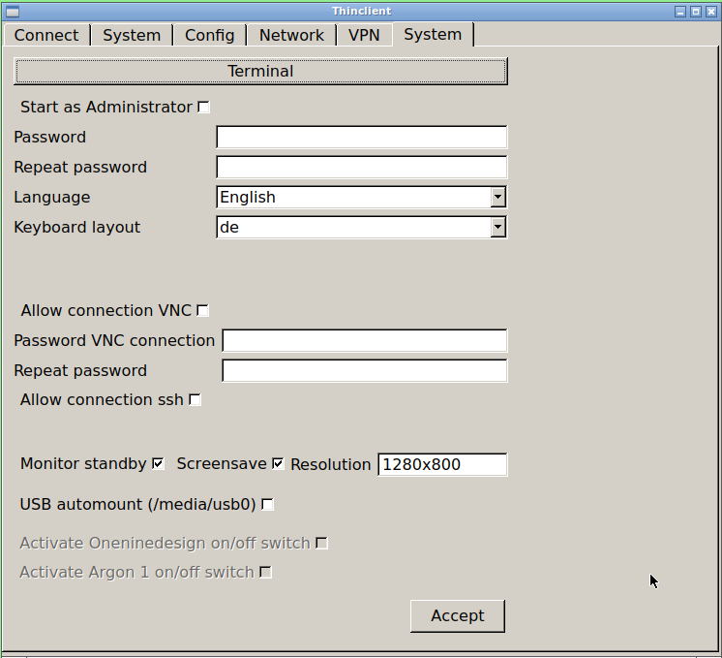
Click the button „Accept“ to use the changes. Press „yes“ in the „Reboot?“ dialog. After restarting the system the changes are active.

VPN
A VPN connection can be set up via the "VPN" tab. As a VPN server openvpn is used.
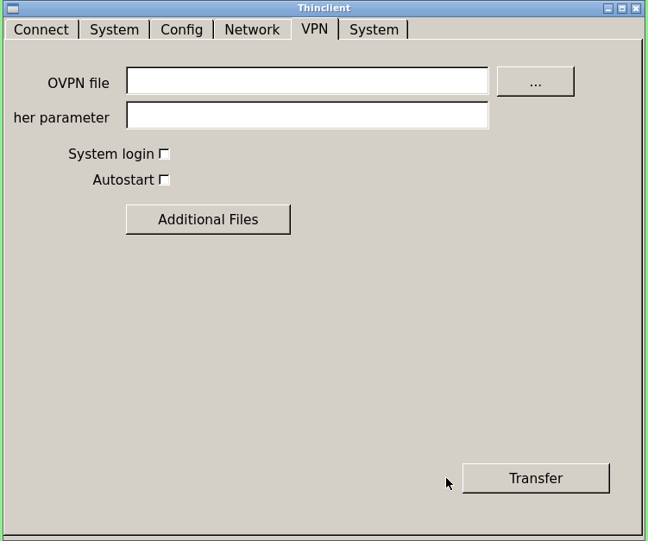

Requirements
For a VPN connection, several files are needed:
- An OVPN file containing the connection parameters
- CA certificate
- User certificate
- Private key
- maybe, a password file

Installation with USB stick
Insert the USB stick with the OVPN file and the certificate data files into an available USB port.

Copy OVPN file
- Click the "..." button
- In File Manager, select the folder / data / usb.
- In File Manager, select the OVPN file.
- Click the "Open" button.
- The OVPN file is now copied to xtc.

Copy certificates and other files
- Click the "More Files" button.
- In File Manager, select the folder / data / usb.
- In File Manager, select the desired file.
- Click the "Open" button.
- The selected file will now be copied to xtc.
Repeat the process for all other files.

Note for Ubuntu: Possibly. have a different drive name for the USB drive. The default is /dev/sda1. If that does not work, change the /opt/thinclient/script/mountusb.sh and /opt/thinclient/script/umountusb.sh files to the desired drive.

Installation with scp
You can also copy the needed files to xtc with scp. For this, the ssh access must be activated. See section "(2.Register) System".

Copy files to xtc with scp on Linux
Open a shell on your Linux PC and enter this command:
scp <file to copy> thinclient @ <IP address xtc>: / data / vpn
Example:
scp test.ovpn thinclient@192.168.0.42: / data / vpn
You must enter the password of the user thinclient. By default, this is thinclient
The files must always be copied to the folder / data / vpn.

Other parameters
Further parameters: Here you can enter further parameters which should be executed when openvpn starts. The syntax of the parameters can be found in the documentation of openvpn.

Own Login: Select "Own Login", if the username and password should be entered when starting the VPN connection.

Start automatically: Select "Start automatically" if you want the VPN connection to run automatically when you start xtc.

After entering all files and parameters, click the "Apply" button to save the values.

To create or exit a VPN connection, use the appropriate buttons. See chapter "(1st register) System".

Installation for experts
The following section is for a manual installation with linux.

Configure sd memoy card
Use the commands in a console terminal.

Find sd memory card
- Insert sd card in the pc.
- Input: sudo fdisk -l
- You see a list of all availables devcices. Find your sd memory card. A typicall name is /dev/sdb.
- execute fdisk: sudo fdisk /dev/sdb
The following commands are for the application „fdisk“.

Delete sd card
Press „d“ and press <return>. Repeat this command for all partitions.

Create a new partitin
- Press „n“ and <return>. Confirm all questions with „y“.
- Change partition type to VFAT: press „t“ and <return>, then „b“ and <return>.
- Type „w“ and <return> to write the changes to the sd card.
Format sd card
Input: sudo mkfs.vfat /dev/sdb1

Copy operation system to sd card
Input: sudo dd bs=4M if=<Image-Datei Raspbian Lite> of=/dev/sdb

Create a further partition
- Input: fdisk /dev/sdb
- Type „n“ and <return>. Confirm all questions with „y“.
- Write changes: press „w“ and <return>.
- Format new partition. Input: sudo mkfs.ext4 /dev/sdb3
This partition is called /data. Only this partition is writeable on a Rasperry Pi 3 system.

Configure Raspbian
Start the Raspberry Pi with the sd memory card.
Login as user „pi“:
Login: pi
Password: raspberry

Optional: Change the password for user „root“
Input: sudo passwd

Optional: Configure network
Use a static IP address:
Datei /etc/network/interfaces ändern:
allow-hotplug eth0
iface eth0 inet static
address <IP-Adresse>
netmask 255.255.255.0
gateway <IP-Adresse Router>
dns-nameservers <(IP-Adresse DNS-Server>

Reboot the Raspberry Pi: sudo reboot

Update Raspbian
Login as user „pi“. Input:
sudo apt-get update
sudo apt-get upgrade

Install xtc on Raspberry
You need the file xtcbin.tar.gz
- Copy the file to the Raspberry Pi.
- Unpack the file. For example: tar xvfzp xtcbin.tar.gz
- Start the insallation as root: sudo sh xtc/install.sh

Note: You need a internet connection for the installation.

After the installation restart the Raspberry Pi: sudo reboot

Details
- Used packages:
ssh-Server: ssh, sshpass
NFS-Client: nfs-client
X: xorg
Desktop: openbox
Taskleiste: tint2
Desktopwechsler: wmctrl
Python: qt5-default, python3-pyqt4
VNC-Viewer: tight-vncserver, tiger-vncviewer
RDP-Viewer: freerdp-x11 and rdesktop
XDMCP: xserver-xephyr
X2Go-Viewer: pyhoca-cli
- GUI ist openbox.
- New user: thinclient.
- Deleted user: pi
- ssh-Server is installed.
- /etc/sudoers advanced for user thi nclient.
- Autologin user thinclient.
- Start script: /etc/init.d/thinclient_start
- Shutdown script: /etc/init.d/thinclient_shutdown
- /home/thinclient/.bashrc starts the GUI.
- Directories / and /boot only readable.
- Directotries /tmp and /home are temp. file systems.
- Only Directory /data is writeable.
- The directories for the applications:
/opt/thinclient/bin: the xtc application.
/opt/thinclient/scripts: used scripts for xtc.
/opt/thinclient/config: system parameters
/var/thinclient/home: home directory for the user thinclient
/data/thinclient: config files

Writeable file system (only Raspberry)
To make the file system changeable: sudo mount -o remount,rw /

Edit the file /etc/fstab:
from:
tmpfs /tmp tmpfs nodev,nosuid 0 0
tmpfs /home/thinclient tmpfs nodev,nosuid 0 0
to:
#tmpfs /tmp tmpfs nodev,nosuid 0 0
#tmpfs /home/thinclient tmpfs nodev,nosuid 0 0

Reboot the system: sudo reboot

Edit /home/thinclient
At first yout must change to file system to writeable.
To edit the directory /home/thinclient, make your changes in the directory /var/thinclient/home/thinclient.

On system start xtc copies the content from /var/thinclient/home/thinclient to /home/thinclient. Because /home ist a temp. File system.

Examples for xfreerdp
Here some examples to make a connection to an RDP server with addtional parameter.

Redirect sound
additional parameter: /sound:sys:alsa

Redirect USB memory stick
Make sure, that the option „USB automount“ is set.
additional parameter: /drive:USB0,/media/usb0

