# POSD2018f_Midterm

Clone the project on .

(https://ssl-gitlab.csie.ntut.edu.tw/root/POSD_Midterm_2018f.git).

You will find that circle, rectangle, and shape are given to you already. We want to add two different shapes: **Ellipse** and **ComplexShapes** shape using **Composite pattern**. We then want to create an operation that works on Shape objects using the Visitor pattern.

1. Create the Ellipse class in ellipse.h. And Ellipse class is represented as a leaf in Composite Pattern. Ellipse constructor have parameter a, b, where **a** is the length of the semi-major axis and **b** is the length of the semi-minor axis.

**Notation:**

**(π -> You must use M_PI from math.h/cmath to implement below operation)**

The area of an ellipse is:

**π× a × b**

The perimeter of an ellipse is:

perimeter formula

**Tips:you can use sqrt() from <math.h>/<cmath>**

1. Create the ComplexShapes class (the Composite in the pattern) in complex_shapes.h. A ComplexShapes object can be made of multiple Shapes, including both leaf and composite in the Composite Pattern.
   1. Member functions In **ComplexShapes** class:
      1. **Constructor**:

**ComplexShapes(std::vector<Shape*> *shapes)**

* + 1. **add()**: add the shape to composition

**void add(Shape *s)**

* + 1. **area()**:sum of the child area

**double area () const**

* + 1. **perimeter()**:sum of the child perimeter

**double perimeter() const**

* + 1. **getChild()**: get child by index

**Shape * getChild(int index)**

* + 1. **numberOfChild()**: return child amount

**int numberOfChild()**

1. 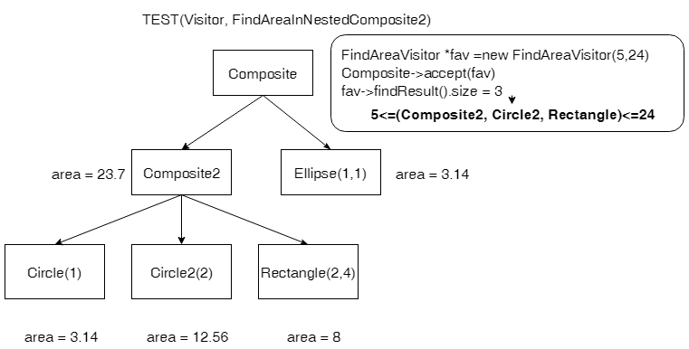Use the Visitor Pattern to implement an operation to find shapes – *leaf or composite* nodes - with an area inside [min, max].
   1. Create FindAreaVisitor class in find_area_visitor.h .
   2. Add an **accept()** method to the "Shape" hierarchy.

**void accept(FindAreaVisitor * fav)**

* 1. Member functions In FindAreaVisitor class:
     1. **Constructor**:

**FindAreaVisitor(double min, double max)**

* + 1. **visit():** the **visit()** operation must find the **child** object which area is between min and max(min<=area<=max)

**“ child include leaf and composite “**

* + 1. **findResult():**return result which area() are between min and max(min<=area<=max).

**std::vector<Shape*> findResult()**

**Submit your code**

Submit your code by committing to your repository (https://ssl-gitlab.csie.ntut.edu.tw/users/sign_in) before the deadline (2018-10-28 17:30 pm). Submit frequently! Don’t wait till the last minute!

**Midterm Project Structure**

**Example:**

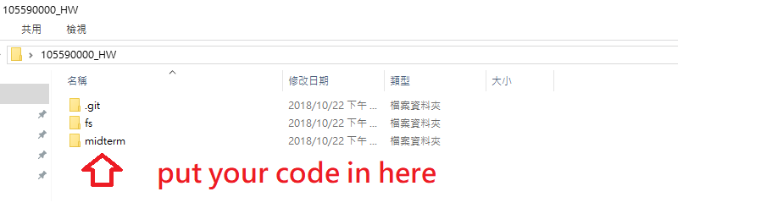

**midterm/**

**src/**

**bin/**

**test/**

**makefile**

**Note**

* Make sure your code are writen in the correct file.
* The score of this exam will be divided into three parts: code(40%), unit tests given to you byTA (20%), unit tests on Jenkins but not given to you (40%).

**Resources allowed to use**

* Design Patterns (GoF) textbook
* projects in class (https://ssl-gitlab.csie.ntut.edu.tw/yccheng/posd2018f)
* Your own homework repository on Gitlab
* cplusplus.com (<http://www.cplusplus.com>)
* Prescribed Dictionary(<https://dictionary.cambridge.org/zht>)

**Attention!! You cannot visit any other website and you must turn off your mobile phone during the midterm exam, or you will be considered as cheating.**