- Gambarkan ε-NFA (Boleh di-simplify) :
  - a* (baa)* (a | b)
Jawab :
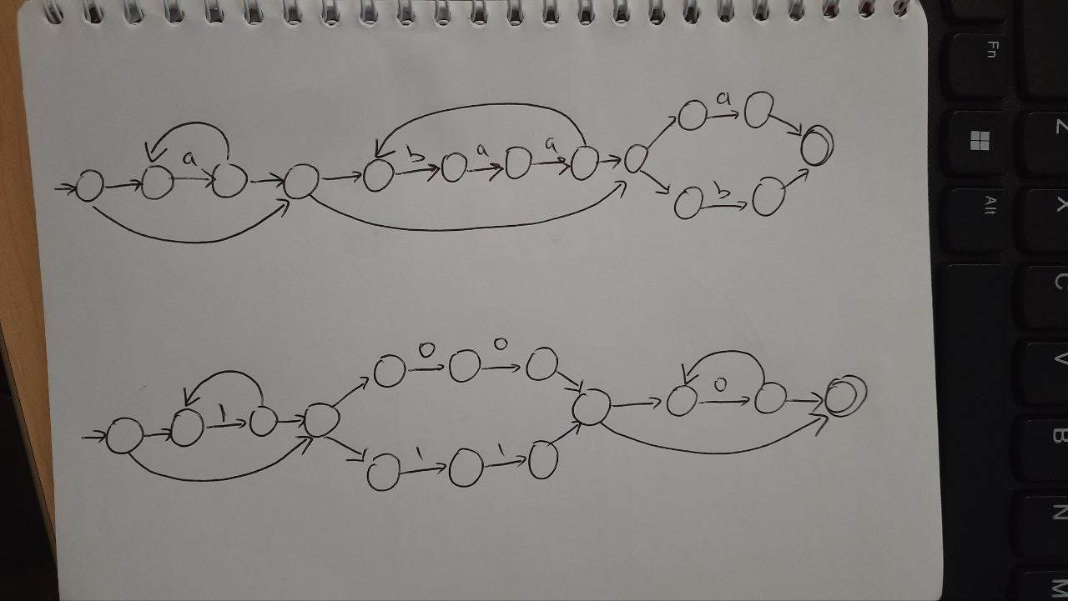

  - 1* (00 | 11) 0*
Jawab :

Diketahui -NFA sbb :
 | ε | 0 | 1
→P | Q | {Q, R} | P
Q | P | {R, S} | R
R | - | P | Q
S* | {P, Q} | R | P

Ditanyakan :

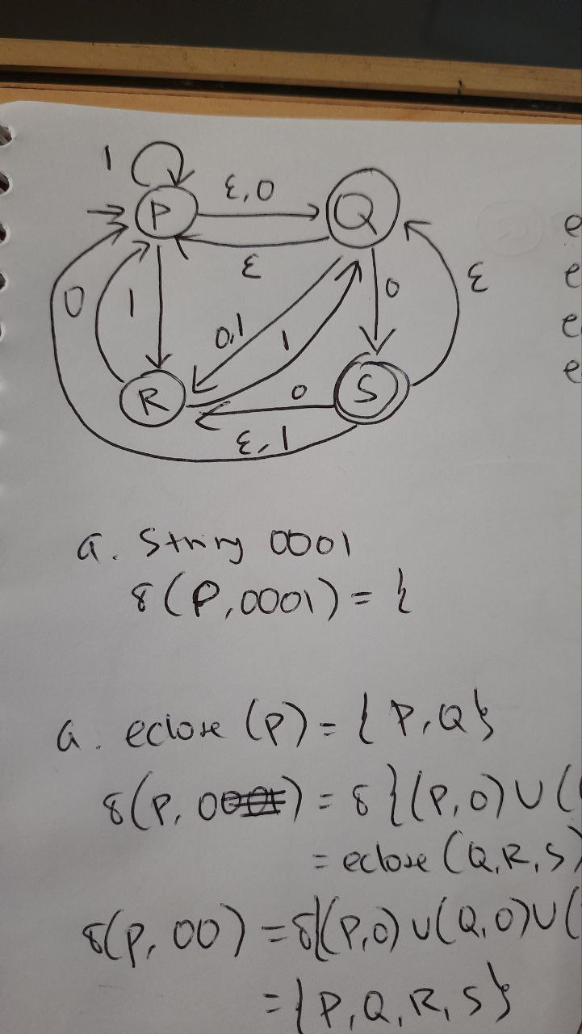
Eclose (P) = {P, Q}
Eclose (Q) = {P, Q}
Eclose (R) = {R}
Eclose (S) = {P, Q, S}

Lakukan penelusuran string 0001 (Accepted/Rejected)
Eclose (P) = {P, Q}
δ {P, 0} = δ {(P, 0) U (Q, 0)} = {Q, R, S}
Eclose (Q,R,S) = {P, Q, R, S}
δ {P, 00} = δ {(P, 0) U (Q, 0) U (R, 0) U (S, 0)} = {P, Q, R, S}
Eclose (P, Q,R,S) = {P, Q, R, S}
δ {P, 000} = δ {(P, 0) U (Q, 0) U (R, 0) U (S, 0)} = {P, Q, R, S}
Eclose (P, Q,R,S) = {P, Q, R, S}
δ {P, 0001} = δ {(P, 1) U (Q, 1) U (R, 1) U (S, 1)} = {P, Q, R }
Eclose (P, Q,R) = {P, Q, R} → Rejected

Konversikan ke DFA dan gambarkan hasilnya
- Start State = Eclose (P) = {P, Q}
- δ ({P,Q}, 0) = (P, 0) U (Q, 0) = {Q, R, S}
Eclose (Q,R,S) = {P, Q, R, S}
→δ ({P,Q}, 0) = {P, Q, R, S}
- δ ({P,Q}, 1) = (P, 1) U (Q, 1) = {P, R }
Eclose (Q,R,S) = {P, R }
→δ ({P,Q}, 0) = {P, Q, R }
- δ ({P,Q,R,S}, 0) = (P, 0) U (Q, 0) U (R, 0) U (S, 0)= {P,Q, R, S}
Eclose (P,Q,R,S) = {P, Q, R, S}
→δ ({P,Q,R,S}, 0) = {P, Q, R, S}
- δ ({P,Q,R,S}, 1) = (P, 1) U (Q, 1) U (R, 1) U (S, 1)= {P,Q, R}
Eclose (P,Q,R) = {P, Q, R}
→δ ({P,Q,R,S}, 1) = {P, Q, R}
- δ ({P,Q,R}, 0) = (P, 0) U (Q, 0) U (R, 0) = {P,Q, R, S}
Eclose (P,Q,R,S) = {P, Q, R, S}
→δ ({P,Q,R}, 0) = {P, Q, R, S}
- δ ({P,Q,R}, 1) = (P, 1) U (Q, 1) U (R, 1) = {P,Q, R}
Eclose (P,Q,R) = {P, Q, R}
→δ ({P,Q,R}, 1) = {P, Q, R}

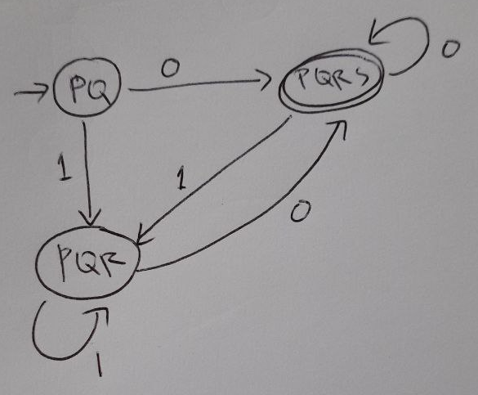

- Diketahui Regular Expression sebagai berikut : (0 | 01)* (01 | 0)* 1
  - Buatlah Syntax tree, lengkap dengan FIRSTPOS, LASTPOS dan FOLLOWPOS
Jawab :
0
0
•
|
1
*
•
|
0
•
1
0
•
#
1
{1}{1}
2
{2}{2}
3
{3}{3}
4
{4}{4}
5
{5}{5}
6
{6}{6}
8
{1,2}{1,3}
{1,2} {1,3}
{2}{3}
{4}{5}
{4,6}{5,6}
{1,2,4,6} {1,3,5,6}
{1,2,4,6,7} {7}
{1,2,4,6,7} {8}
•

{8} {8}

1
{7} {7}
7

*
{4,6} {5,6}

(0 | 01)* (01 | 0)* 1 #
1 2 3 4 5 6 7 8

Firstpos Root : {1, 2, 4, 6, 7}
 | Followpos
1 | 1,2,4,6
2 | 3
3 | 1,2,4,6
4 | 5
5 | 4,6,7
6 | 4,6,7
7 | 8
8 | -

  - Buatlah DFA dan gambarkan hasilnya

 | 0 | 1
→ {1, 2, 4, 6, 7} | Follow (1,2,4,6)  = {1,2,3,4,5,6,7} | Follow(7) = {8}
{1,2,3,4,5,6,7} | Follow (1,2, 4, 6)  = {1,2,3,4,5,6,7} | Follow (3,5,7)  = {1,2,4,6,7,8}
*{8} | - | -
*{1,2,4,6,7,8} | Follow (1,2,4,6)  = {1,2,3,4,5,6,7} | Follow (7) = {8}

{1,2,4,6,7}
{1,2,3,4,5,6,7}
0
0

1
1
0

{8}
{1,2,4,6,7,8}
1

Buatlah CFG dari RE berikut
  - (b | a)* (aa | b )* a
Jawab :
S → Aba
A → bA | aA | ε
B → aaB | bB | ε

  - 1* 00 (00 | 11)
Jawab :
S → A00B
A → 1A | ε
B → 00 | 11

Lakukan DFA Minimize dan gambarkan hasilnya

 | 0 | 1
→A | B | C
B | A | C
C | D | E
D | B | F
E | G | C
*F | G | E
G | A | F

Jawab :
G1 = {F}
G2 = {A, B, C, D, E, G}

 | A | B | C | D | E | G
0 | B 2 | A 2 | D 2 | B 2 | G 2 | A 2
1 | C 2 | C 2 | E 2 | F 1 | C 2 | F 1

G3 = {D, G}
G2 = {A, B, C, E }

 | A | B | C | E
0 | B 2 | A 2 | D 3 | G 3
1 | C 2 | C 2 | E 2 | C 2

G4 = {C, E}
G2 = {A, B }

Hasilnya :
A, B
C, E
0
1
D, G
0
1
F
1
0

Buatlah CFG ekuivalen dengan melakukan Left Recursion elimination ataupun Left Factoring
S → aAB | SaB | aSB | b
A → baA |a
B → bS | b

Jawab :

Left Recursion Elimination
S → aABS’[ |aSBS’ | bS’
S’ → aBS’
A → baA |a
B → bS | b

Left Factoring
S → aX| bS’
X → ABS’ |SBS’
S’ → aBS’
A → baA |a
B → bY
Y → S | ε

