**Assignment 3**

Develop an application to manage human resources with 2 types of users: the administrators and employees. The user must be login to process the employee management functions, the application can recognize login user is admin or employee roles and redirect to corresponding menu. The application using the following files to save data of admin and employees:

* administrators.dat : store username and password for administrator account type
* employees.dat : store username and password for employee account type.
* [username].dat : store user information(user profile) that including name, address, phone number and email address (you can store each information per line).

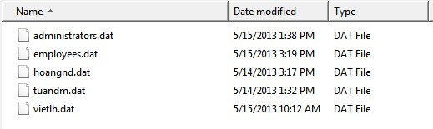

The administrators have right to run the following functions:

1. Login with admin account and password. (2 mark)
2. Register a new employee with his/her username, password, name, address, phone number and email address. (3 mark)
3. Find an employee by account. (1 mark)
4. Edit the information of employee. (1 mark)
5. View information of all employees. (1 mark)

The employee have right to run the following functions:

1. Login with employee account and view his/her profile. (1 mark)
2. Chang the password for the next login session. (1 mark)

Requirements:

* The program using Oriented Object Programming with **inheritance, polymorphism and stl map to manage** the list of employees.
* Using map<string, User*>. User is a class with necessary information, there are 2 classes named Admin and Employee that extend User class.
* Using class named FileUtil, which processes reading and writing text files.
* Using class named AccountControl, which processes functions relates the accounts of employees.
* The main class using the above classes and input data.