**Assignment 5**

Develop an application Win32 SDI Project in Visual Studio to manage human resources with 2 types of users: the administrators and employees. The user must be login to process the employee management functions with admin or employee account.

The application using the following files to save data of admin and employees:

* administrators.dat : store username and password for administrator account type
* employees.dat : store username and password for employee account type.
* [username].dat : store user information(user profile) that including name, address, phone number and email address (you can store each information per line).

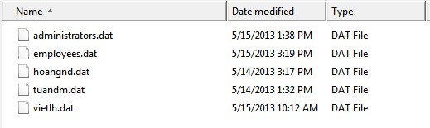

* 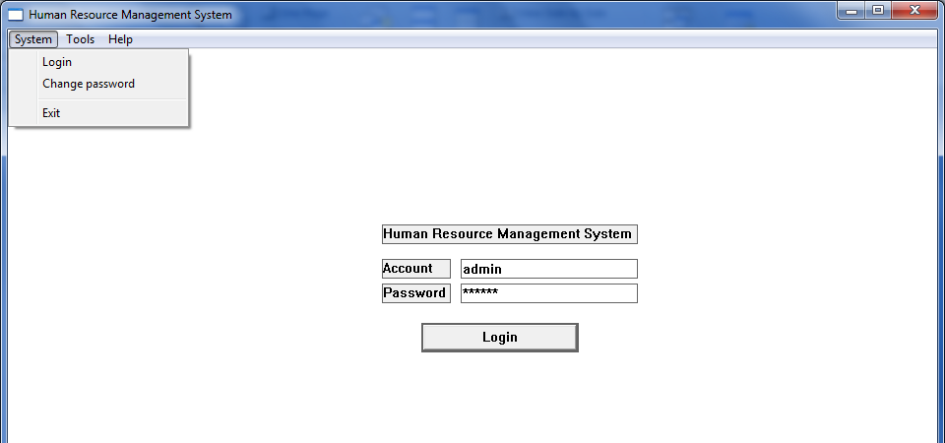

When the administrator account login, he/she has right to run the following functions, preview Menu available appropriate (1 mark)

1. Login with admin account and password. (2 mark)
2. Register a new employee with his/her username, password, name, address, phone number and email address. (3 mark)
3. Edit the information of employee. (1 mark)
4. View information of all employees. (1 mark)

When the employee account login, he/she has right to run the following functions, preview Menu available appropriate.

1. Login with employee account and view his/her profile. (1 mark)
2. Chang the password for the next login session. (1 mark)

You should design application interface (GUI) as follows:

* Menu of application

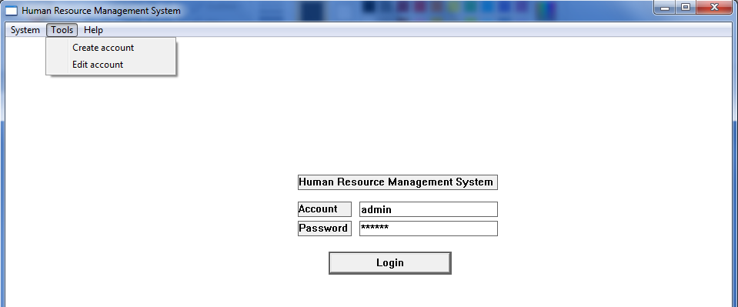

* After login the application will display below information.

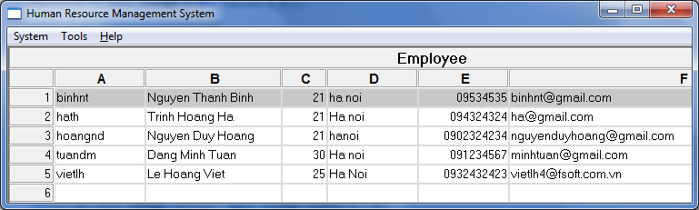

* The change password form as below.

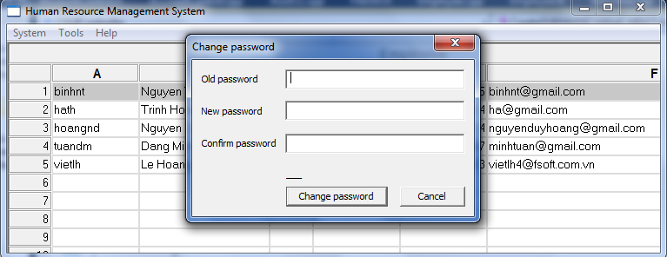

* Edit account of employee

