**Assignment 6**

Develop an application Win32 **MDI** Project in Visual Studio to manage human resources with 2 types of users: the administrators and employees. The user must be login to process the employee management functions. All windows such as Login window, Change password window, Employee list windows, Create employee window and Edit employee window are MDI child windows.

The application using the following files to save data of admin and employees:

* administrators.dat : store username and password for administrator account type
* employees.dat : store username and password for employee account type.
* [username].dat : store user information(user profile) that including name, address, phone number and email address (you can store each information per line).

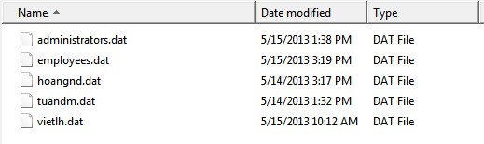

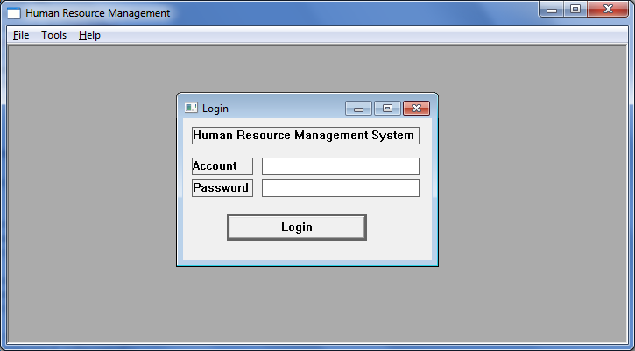

The administrators have right to run the following functions, preview available Menu appropriate (1 mark)

1. Login with admin account and password (2 mark)
2. Register a new employee with his/her username, password, name, address, phone number and email address. (3 mark)
3. Edit the information of employee. (1 mark)
4. View information of all employees. (1 mark)

The employee have right to run the following functions, preview available Menu appropriate.

1. Login with employee account and view his/her profile. (1 mark)
2. Chang the password for the next login session. (1 mark)