**Project 02**

**CS2803 –WDB**

**Fall 2014**

For this project, you are to create a web site that is your personal version of the layouts primer that we have been doing in class this week.

The requirements are:

* Your site must consist of five pages that are styles as indicated by the images below. (Figs 2-6)
* The site will be viewed on a Chrome browser that is at least 800px wide.
* The page must be entirely in gray scale (also errantly referred to as black and white).
* Each page must have the same logo displayed in the upper left corner. (Fig 1)
* Each page must have the same horizontal navigation menu displayed to the right of the logo. (Fig 1) (Note: ignore the sixth menu item on the navigation bar displayed in the figures below.)
* Each page must have the same tag line displayed centered across the entire page just below the logo and navigation menu. (Fig 1)
* Each page must have a footer that indicates the author and is centered and located at the bottom of the page. (Fig 1)
* The navigation menu must have the default styling of list items and anchor links removed. (Fig 1)
  + No list item bullets
  + No blue and purple underlined text to indicate active or visited links
* The navigation menu items must indicate the present page via a change of the background color of the tab associated with the current page. (Fig 1)
* The navigation menu items must react to the user’s mouse over a menu item by changing the font of the menu item.
* Page 1 must display a two column layout with each column containing an image and text. (Fig 2) The columns do not have to be the same width.
* Page 2 must display a three column layout with each column containing an image and text. (Fig 3) The columns do not have to be the same width.
* Page 3 must display a 3 box layout. The big box must extend across the majority of the page. The other two boxes must be on a row separate from the big box and on the same row as each other. (Fig 4) The big box row does not have to be the top row. Each box must display an image. Text is optional. There must be margins between all boxes.
* Page 4 must display a 5 box layout. The big box must extend across the majority of the page. The other four coxes must be on a separate row from the big box and on the same row as each other. (Fig 5) The big box row does not have to be the top row. Each box must display an image. Text is optional. There must be margins between all boxes.
* Page 5 must display a featured graphic layout. (Fig 6) This is essentially a two column layout with one column containing text and the other containing an image or graphic. A single image must serve as the background for both columns. Horizontal centering is applied and vertical centering is approximated to give a bold yet minimal and clean look.



Figure

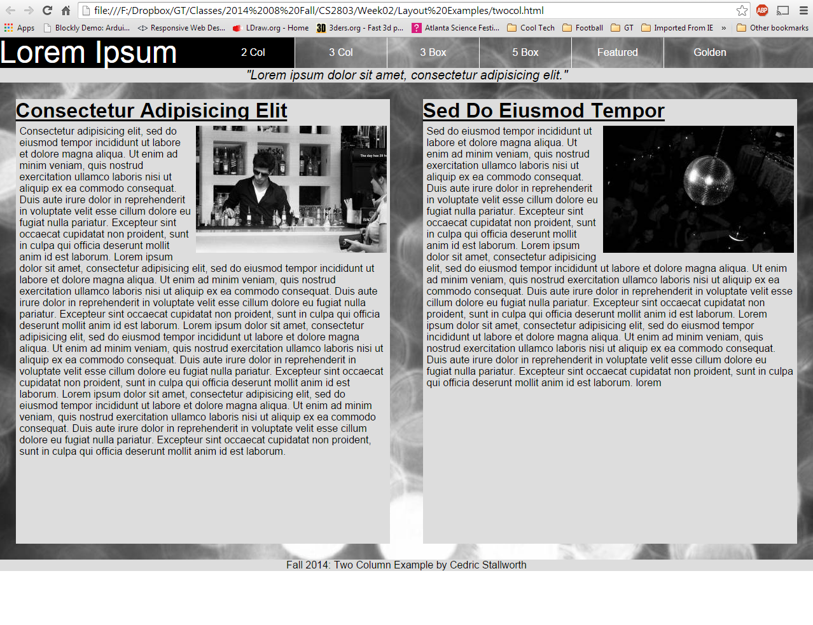

Figure

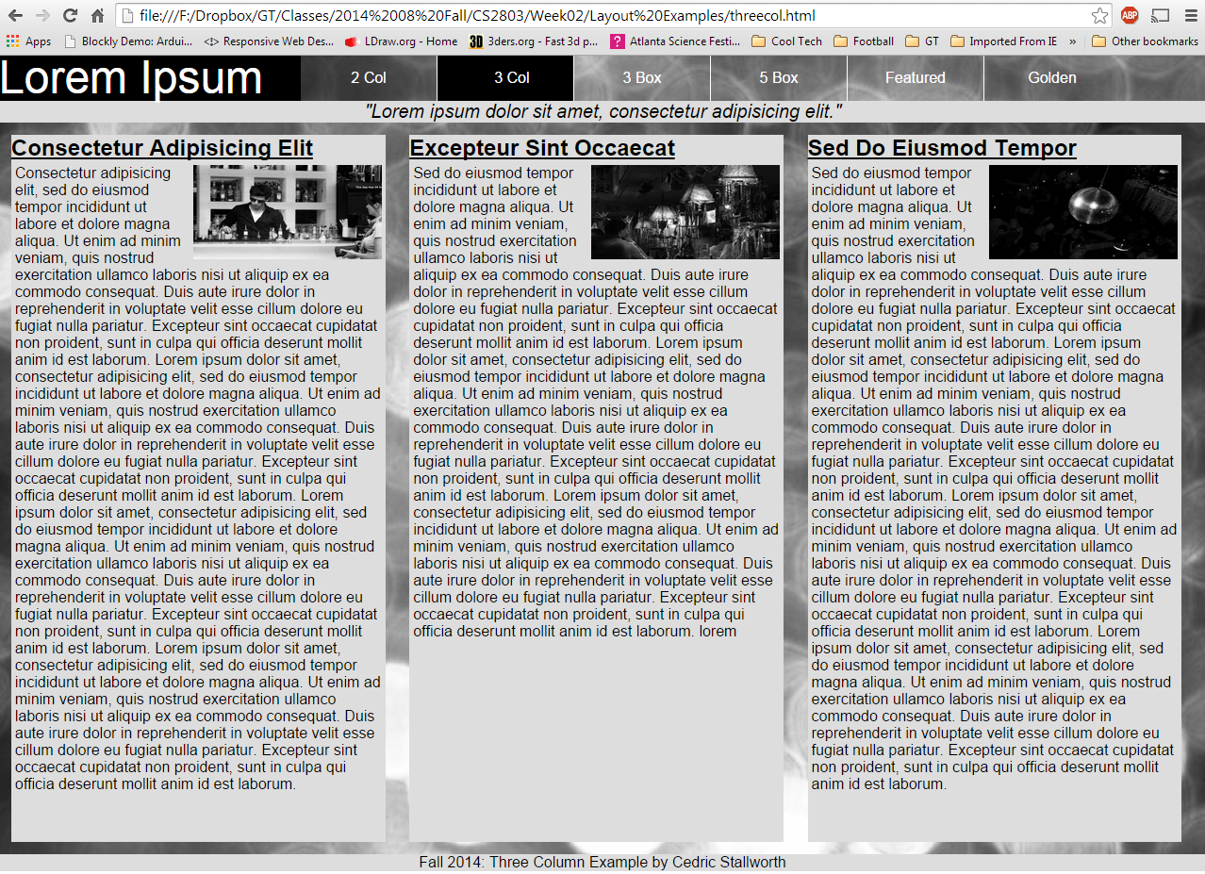

Figure

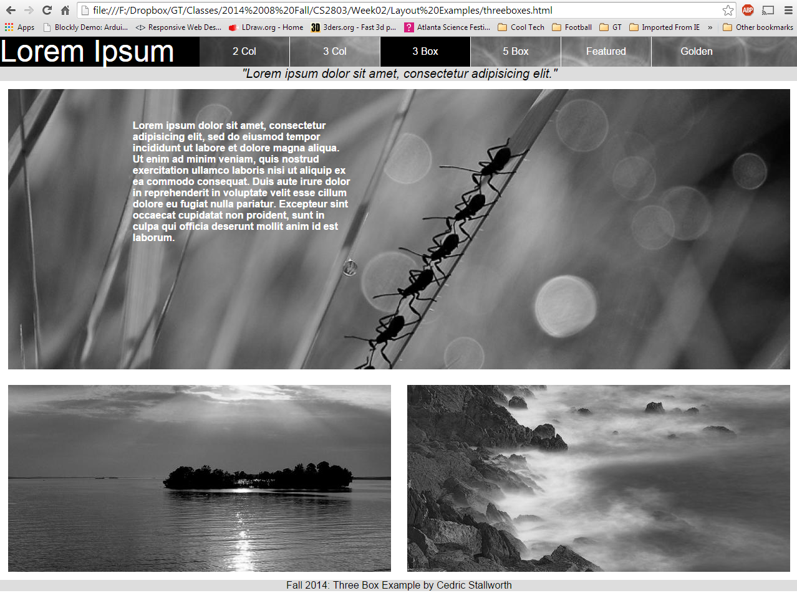

Figure

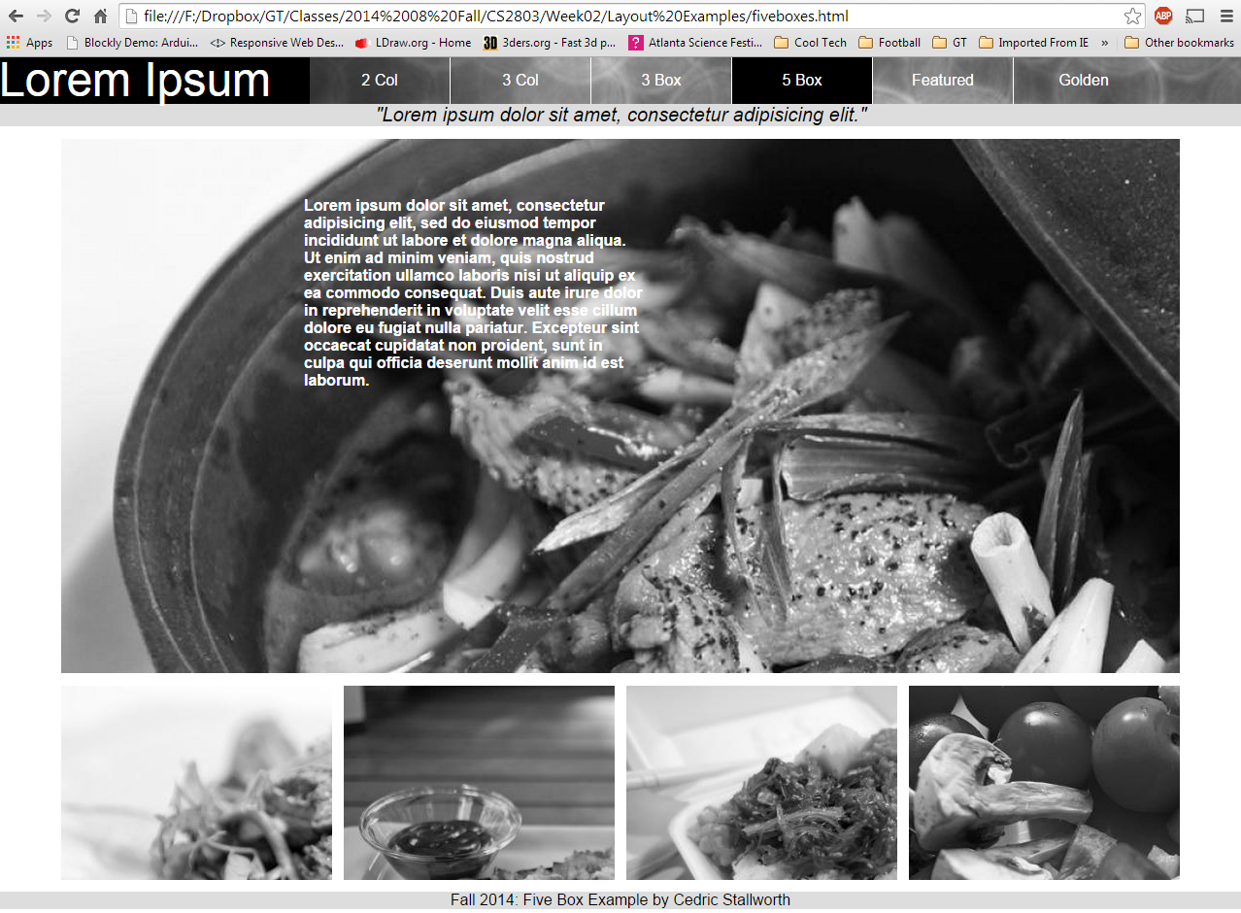

Figure

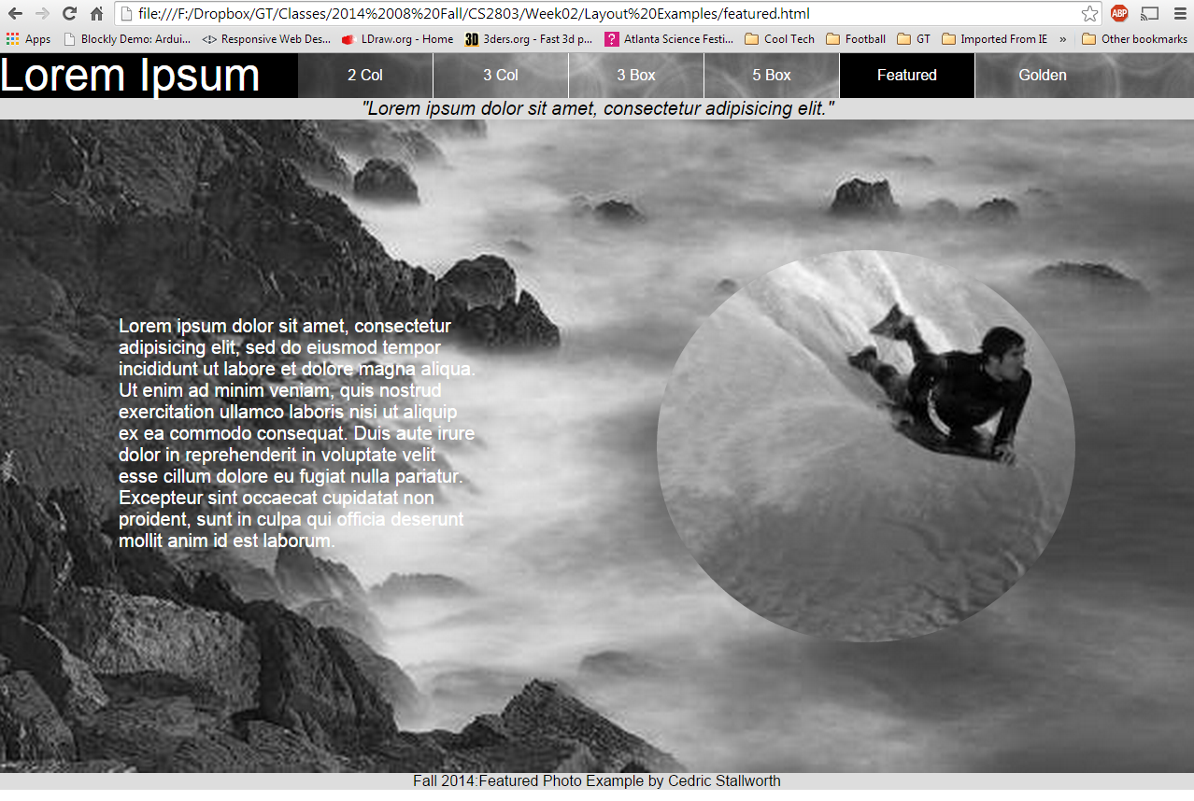

Figure