Table of Contents

Design Proposal
Mechatronic Design 2026 – Hexapod (Dancing Robot)
Team 6
Dillon Ma
Leena Aljurashi
Mithun Roy
Thomas Wang
February 12, 2026

Project Description
Our main design is a rectangular shaped hexapod, featuring 6 legs with 3 degrees of freedom (DOF) each, allowing for the most optimized movement. The hexapod will be able to allow two people to sit and perform on both sides, with the emergency stop dead center of the robot, allowing for easiest access for both people, while also in case the robot flips, it auto shuts itself off.
The robot will be controlled via a custom wireless controller with joysticks and a speed dial, communicating over Bluetooth to an onboard Raspberry Pi. The design prioritizes safety in a dance performance environment, modularity for transport, and robust construction capable of supporting a 170 lb rider at 2–3 ft off the ground.
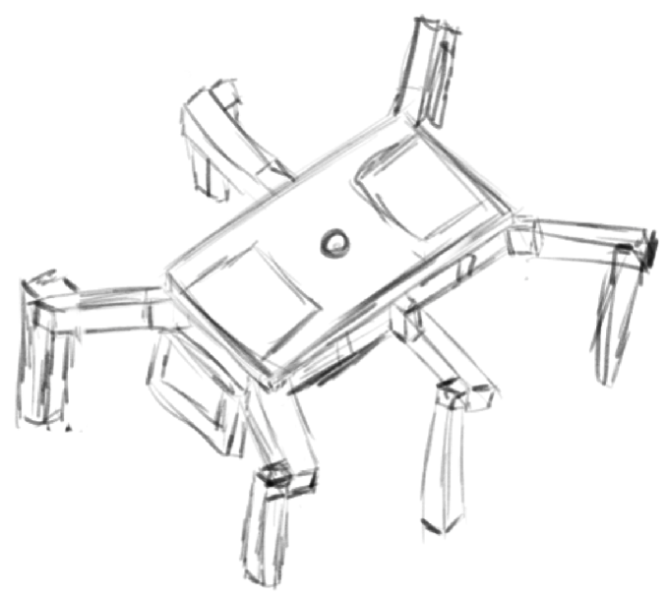 | 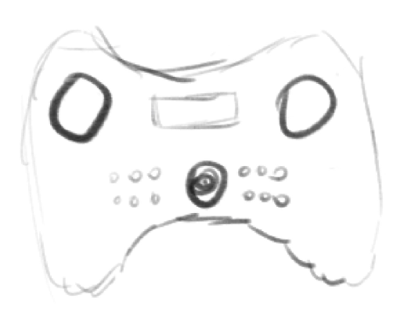
Concept sketches of the hexapod dancing robot (left) and custom wireless controller (right).

Design Requirements

Locomotion and Maneuvering
- Must be controlled/initiated through legs.
- Must travel in at least 2 directions (forward and backward).
- Must have zero-degree turning radius (turning in place).
- Must navigate to a designated point within 1 minute.

Size, Weight, Payload, and Rider Geometry
- Footprint must be less than or equal to 5 ft $×$ 5 ft.
- User rides 2–3 ft off the ground.
- The device must be less than 150 lbs.
- Must carry a person up to 170 lbs.
- Seat must allow users to sit cross-legged or standard chair seated.

Packaging and Transport
- Must ship in a 3 ft $×$ 3 ft case.
- Must disassemble into no more than 7 parts.

Power
- Battery life must be at least 30 minutes.

Safety
- Must be safe in a dance performance environment, no rough edges/burrs/exposed screw tips.
- Ride must be smooth enough that the user can ride safely without being strapped in.
- Emergency stop button accessible to both riders, positioned dead center.
- Auto shut-off if the robot flips (IMU-based detection).

Weight Budget
Table 1 provides the estimated weight breakdown of the hexapod. [PLACEHOLDER: Fill in estimated weights for each subsystem.]
Weight Budget
Component | Estimated Weight (lbs)
Body frame / chassis | [PLACEHOLDER: XX]
Legs (6 total) | [PLACEHOLDER: XX]
Servo motors (18 total) | [PLACEHOLDER: XX]
Battery | [PLACEHOLDER: XX]
Electronics (RPi, wiring) | [PLACEHOLDER: XX]
Fasteners & misc. | [PLACEHOLDER: XX]
Total | [PLACEHOLDER: XX / 150 max]

Functional Architecture
The functional architecture of the hexapod dancing robot is organized into five major subsystems: Power, Compute, Mechanical System, Control, and Locomotion. Figure 2 depicts the block diagram showing the flow of energy, information, and mechanical forces between these subsystems.
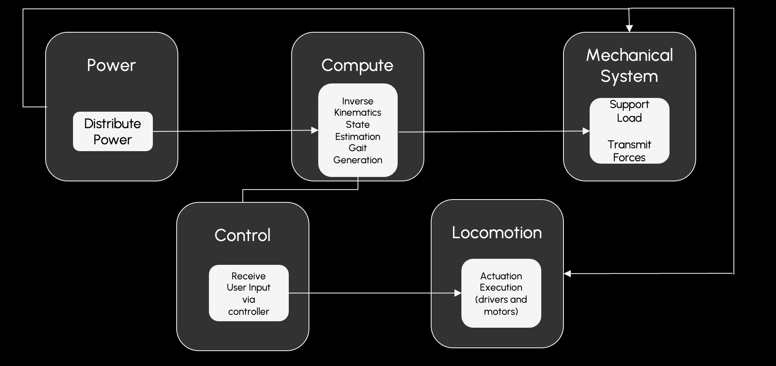
Functional Architecture Diagram of the Hexapod Dancing Robot.
Power distributes electrical energy from the onboard battery to all electronic and mechanical subsystems.
Compute performs inverse kinematics calculations to determine joint angles for each leg, estimates the robot’s state (orientation, balance) using IMU data, and generates gait patterns for walking and dancing movements.
Control receives user input from the wireless controller (joystick directions, speed via potentiometer, and button commands) and translates these into high-level movement commands passed to the Compute subsystem.
Locomotion executes the computed joint angles by driving the 18 servo motors (3 per leg $×$ 6 legs) through motor drivers, converting electrical signals into physical leg motion via actuation execution (drivers and motors).
Mechanical System provides structural support for the payload (riders), supports the load, and transmits the forces generated by the servo motors through the leg linkages to the ground.

Design Trade Studies
We have debated between multiple different designs for each part of the robot and the tradeoffs within. For each subsystem, we use a weighted decision matrix to evaluate and choose between design alternatives.

Leg Configuration: 2 DOF vs. 3 DOF
The number of degrees of freedom per leg is a critical design choice affecting mobility, complexity, and cost. A 2 DOF leg provides only pitch-based motion (up/down and forward/backward), while a 3 DOF leg adds a yaw joint (coxa) enabling lateral movement and in-place turning.
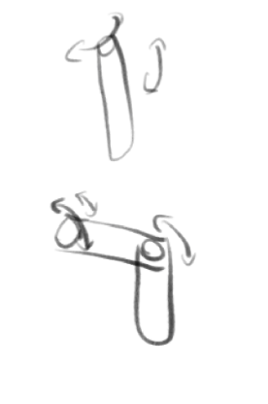
Design alternatives for leg DOF: 2 DOF (top) vs. 3 DOF (bottom).
Decision Matrix: Leg DOF Configuration
Criteria | Weight | 2 DOF | 3 DOF
Range of Motion | [PLACEHOLDER: W] | [PLACEHOLDER: S] | [PLACEHOLDER: S]
Stability | [PLACEHOLDER: W] | [PLACEHOLDER: S] | [PLACEHOLDER: S]
Ease of Control | [PLACEHOLDER: W] | [PLACEHOLDER: S] | [PLACEHOLDER: S]
Cost | [PLACEHOLDER: W] | [PLACEHOLDER: S] | [PLACEHOLDER: S]
Mechanical Complexity | [PLACEHOLDER: W] | [PLACEHOLDER: S] | [PLACEHOLDER: S]
Weighted Total |  | [PLACEHOLDER: T] | [PLACEHOLDER: T]
[PLACEHOLDER: Explain why 3 DOF was selected. Key reasons: lateral leg motion is essential for zero-degree turning radius (a hard requirement) and enables more expressive dance movements. The added mechanical and control complexity is justified by functional requirements.]

Body Shape: Hexagonal vs. Rectangular Base
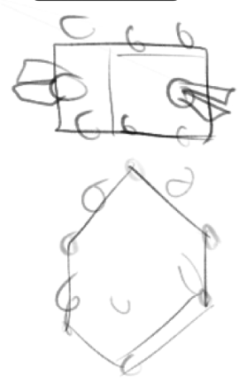
Design alternatives for body shape: rectangular (top) vs. hexagonal (bottom).
Decision Matrix: Body Shape
Criteria | Weight | Hexagonal | Rectangular
Rider Seating (2 people) | [PLACEHOLDER: W] | [PLACEHOLDER: S] | [PLACEHOLDER: S]
Leg Mounting Symmetry | [PLACEHOLDER: W] | [PLACEHOLDER: S] | [PLACEHOLDER: S]
Manufacturing Ease | [PLACEHOLDER: W] | [PLACEHOLDER: S] | [PLACEHOLDER: S]
Transportability | [PLACEHOLDER: W] | [PLACEHOLDER: S] | [PLACEHOLDER: S]
Weighted Total |  | [PLACEHOLDER: T] | [PLACEHOLDER: T]
[PLACEHOLDER: Explain why rectangular was selected. Key reasons: flat surfaces on both ends for two riders, easier manufacturing, fits 3 ft $×$ 3 ft shipping constraint.]

Microcontroller: Arduino vs. ESP32 vs. STM32
For the low-level motor control and communication, we evaluated three microcontroller platforms.
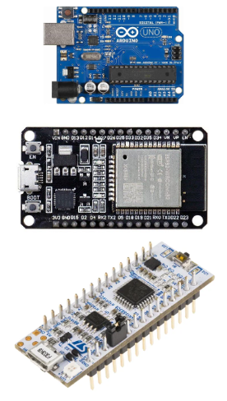
Microcontroller options considered: Arduino Uno (top), ESP32 (middle), STM32 (bottom).
Decision Matrix: Microcontroller Selection
Criteria | Weight | Arduino | ESP32 | STM32
PWM Channels | [PLACEHOLDER: W] | [PLACEHOLDER: S] | [PLACEHOLDER: S] | [PLACEHOLDER: S]
Wireless (BT) | [PLACEHOLDER: W] | [PLACEHOLDER: S] | [PLACEHOLDER: S] | [PLACEHOLDER: S]
Processing Speed | [PLACEHOLDER: W] | [PLACEHOLDER: S] | [PLACEHOLDER: S] | [PLACEHOLDER: S]
Cost | [PLACEHOLDER: W] | [PLACEHOLDER: S] | [PLACEHOLDER: S] | [PLACEHOLDER: S]
Community Support | [PLACEHOLDER: W] | [PLACEHOLDER: S] | [PLACEHOLDER: S] | [PLACEHOLDER: S]
Weighted Total |  | [PLACEHOLDER: T] | [PLACEHOLDER: T] | [PLACEHOLDER: T]
[PLACEHOLDER: Explain microcontroller selection and reasoning. Note: The ESP32 is paired with a Raspberry Pi which serves as the main compute unit for higher-level processing.]

Controller: Custom vs. Premade (Xbox/PS)
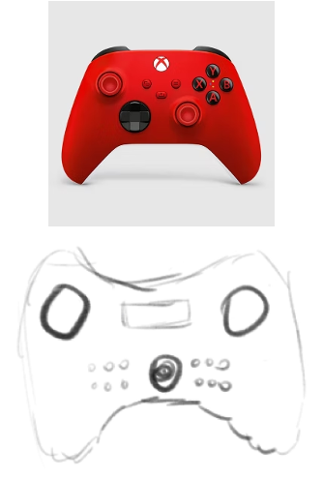
Controller options: premade Xbox controller (top) vs. custom controller concept (bottom).
Decision Matrix: Controller Design
Criteria | Weight | Custom | Premade (Xbox)
Customizability | [PLACEHOLDER: W] | [PLACEHOLDER: S] | [PLACEHOLDER: S]
Ergonomics | [PLACEHOLDER: W] | [PLACEHOLDER: S] | [PLACEHOLDER: S]
Cost | [PLACEHOLDER: W] | [PLACEHOLDER: S] | [PLACEHOLDER: S]
Reliability | [PLACEHOLDER: W] | [PLACEHOLDER: S] | [PLACEHOLDER: S]
Weighted Total |  | [PLACEHOLDER: T] | [PLACEHOLDER: T]
[PLACEHOLDER: Explain controller selection and reasoning. Key considerations: custom allows dedicated hexapod-specific controls (gait selection, speed dial via potentiometer) that premade controllers cannot provide.]

Cyberphysical Architecture
The cyberphysical architecture, shown in Figure 7, maps the functional subsystems to specific hardware and software components, detailing the flow of power, information, and control signals throughout the system.
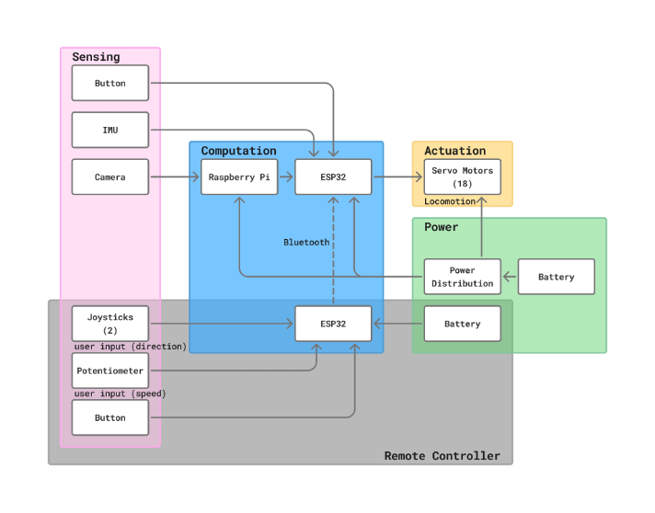
Cyberphysical Architecture Diagram. The system consists of Sensing (Button, IMU, Camera), Computation (Raspberry Pi + ESP32), Actuation (18 servo motors), Power (Battery + Power Distribution), and a Remote Controller (ESP32 + Joysticks + Potentiometer + Button) communicating via Bluetooth.
Sensing: The onboard sensing suite includes an IMU for orientation and flip detection, a camera module connected to the Raspberry Pi for possible computer vision, and a physical emergency stop button mounted at the center of the body.
Computation: A Raspberry Pi serves as the main compute platform, handling inverse kinematics, gait generation, state estimation, and camera processing. It communicates with an ESP32 microcontroller which handles real-time servo control and Bluetooth communication with the remote controller.
Actuation: Eighteen servo motors (3 per leg $×$ 6 legs) are driven via PWM signals. The servos produce the joint rotations for the coxa (hip yaw), femur (hip pitch), and tibia (knee pitch) of each leg.
Power: A battery feeds a power distribution board that regulates voltage for the Raspberry Pi, ESP32, and provides direct power to the servo motors. A separate smaller battery powers the remote controller.
Remote Controller: A second ESP32 on the controller reads two analog joysticks (direction control), a potentiometer (speed control), and buttons (mode selection, emergency stop). Data is transmitted to the onboard system via Bluetooth.
[PLACEHOLDER: Add additional text highlighting how the cyberphysical architecture parallels the functional architecture, and any software architecture details if needed.]

System Description/Depiction
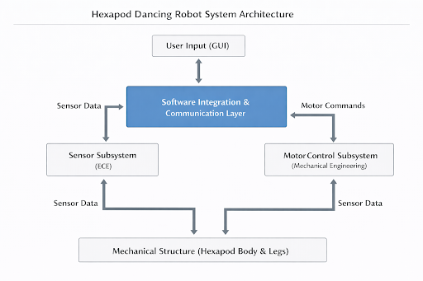
Hexapod Dancing Robot System Architecture. The Software Integration & Communication Layer serves as the central hub, coordinating between the Sensor Subsystem (ECE), Motor Control Subsystem (Mechanical Engineering), and the Mechanical Structure, with User Input (GUI) providing high-level commands.
Figure 8 provides an overview of the system architecture. The software integration and communication layer acts as the central coordinator, receiving sensor data from below (IMU, camera) and user commands from above (controller GUI), then dispatching motor commands to the actuation subsystem. The three major subsystems—Sensor, Motor Control, and Mechanical Structure—each interface bidirectionally with the software layer, enabling closed-loop control.

Motor Control Subsystem (Mechanical Engineering)
The motor control subsystem is responsible for generating the physical motion of the robot through servo motors. The hexapod uses 18 high-torque digital servo motors—specifically the Hitec D845WP—organized as three per leg:
- Coxa joint (hip yaw): Rotates the leg horizontally, enabling turning and lateral movement. One per leg (6 total).
- Femur joint (hip pitch): Lifts the leg up and down, critical for stepping over obstacles and generating the walking gait. One per leg (6 total).
- Tibia joint (knee pitch): Extends and retracts the lower leg segment, controlling ground contact and stride length. One per leg (6 total).
The D845WP servo was selected for its high torque output (694 oz-in / 50 kg$⋅$cm at 7.4V), coreless motor construction for smooth motion, IP67 water and dust resistance for durability, and steel gears with dual ball bearing support for long-term reliability under the high loads expected from a human-rideable platform. Each servo weighs 8 oz (227g) and provides 0.17 sec/60$​^{∘}$ speed at 7.4V, enabling responsive leg movements.
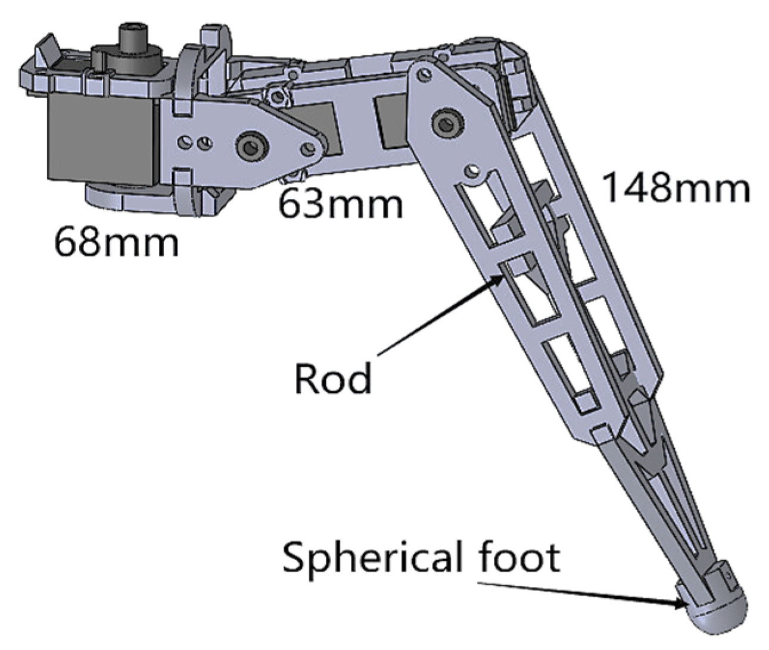 | 
Overall leg design showing the complete 3 DOF leg assembly with dimensioned segments: coxa (68mm), femur (63mm), tibia (148mm), rod linkage, and spherical foot.
As shown in Figures [fig:single_leg] and 9, each leg consists of three segments:
- Coxa segment (68mm): Mounted to the body frame, houses the coxa servo that provides yaw rotation.
- Femur segment (63mm): Connects the coxa to the tibia, driven by the femur servo for pitch rotation.
- Tibia segment (148mm): The longest segment, extending from the femur to the ground. A rod linkage connects the tibia servo to the lower leg, and a spherical foot at the tip provides stable, multi-directional ground contact.
The leg segments are fabricated from aluminum and 3D-printed high-strength polymer to balance structural integrity with weight. The total leg reach (coxa + femur + tibia) of approximately 279mm provides adequate stride length and step height for smooth locomotion while supporting the required payload.

Sensor Subsystem (ECE)
The sensor subsystem provides information about the robot’s operational state to monitor system behavior, support motion stability, and provide automation feedback:
- IMU (Inertial Measurement Unit): Mounted at the body center, provides 6-axis accelerometer and gyroscope data for orientation estimation and balance monitoring. Critically, the IMU enables flip detection—if the robot exceeds a dangerous tilt angle, the emergency shutdown is triggered automatically.
- Camera: A forward-facing camera connected to the Raspberry Pi provides a video feed for possible small-size computer vision model integration, such as waypoint navigation or obstacle detection.
- Joysticks (on controller): Two analog joysticks provide X/Y directional input for translation and rotation commands.
- Potentiometer (on controller): Provides continuous analog speed control, allowing the operator to smoothly adjust the robot’s walking/dancing speed.

Software Integration & Communication Subsystem
The software subsystem integrates all hardware components and implements the robot’s intelligence. Running primarily on the Raspberry Pi, it consists of several key modules:
- Inverse Kinematics Engine: Given a desired foot position $(x,y,z)$ for each leg, the IK solver computes the required coxa, femur, and tibia joint angles using a geometric approach. This is the core algorithm that translates high-level movement commands into specific servo positions.
- State Estimation: Fuses IMU data (accelerometer and gyroscope) to estimate the robot’s current orientation and detect unsafe conditions such as excessive tilt or flipping.
- Gait Generation: Implements multiple gait patterns:
  - Tripod gait: 3 legs move simultaneously for fast, stable walking.
  - Wave gait: one leg at a time for maximum stability at lower speed.
  - Custom dance gaits: choreographed leg sequences for performance.
- Bluetooth Communication: Bidirectional communication between the controller ESP32 and the onboard system, transmitting joystick/potentiometer values and mode commands at low latency.
- Small-size CV Model (optional): A lightweight Python-based computer vision pipeline on the Raspberry Pi that can process camera frames for target detection or navigation assistance.
- Movement Design: Predefined movement sequences and transitions that can be triggered via the controller, enabling smooth choreographed performances.
The software architecture follows a layered design: the Communication Layer handles Bluetooth I/O, the Control Layer processes user commands and sensor data, and the Execution Layer drives the servos through the IK engine and gait generator. This separation allows independent development and testing of each layer.

Project Management

Schedule
Figure 10 presents the project Gantt chart for the semester. Pre-spring break, team members work on their respective subsystems independently (CAD, firmware, sensors). Post-spring break, all subsystems are integrated and the full hexapod is assembled and tested.
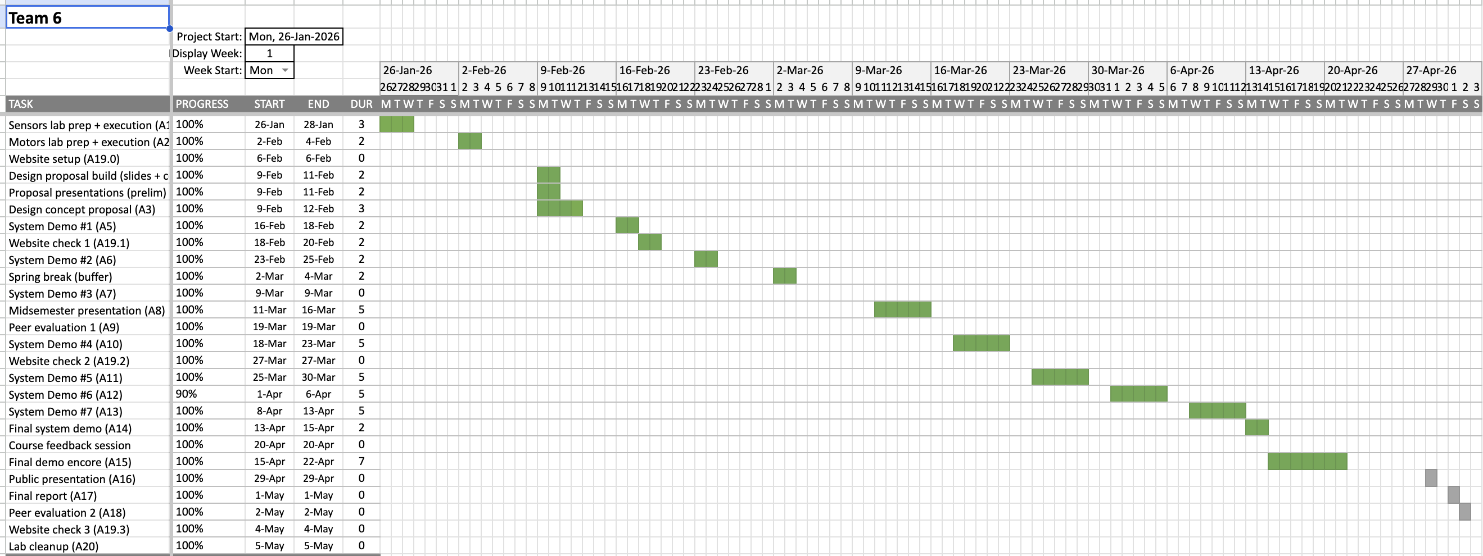
Project Gantt Chart showing the semester schedule from January to May 2026 with biweekly task granularity.

Team Member Responsibilities
Team Member Responsibilities
Team Member | Primary Responsibility | Secondary Responsibilities
Thomas Wang | Software, System Integration | UI, possible CV/ML
Dillon Ma | CAD, Mechanical Design | Manufacturing
Leena Aljurashi | Software, Embedded Systems | Controller, Bluetooth
Mithun Roy | Mechanical, Electrical | Power, Wiring

Budget
Table 7 provides a provisional parts list and budget. The servo motors represent the largest single expense. Items marked as placeholders require further research and pricing.
Provisional Budget
Subsystem | Item | Unit Cost | Qty | Total
Actuation | D845WP Servo (Hitec) | $134.99 | 18 | $2,429.82
 | Servo gearbox (if needed) | $139.99 | [PLACEHOLDER: Q] | [PLACEHOLDER: T]
 | PCA9685 PWM driver board | $8.00 | 3 | $24.00
Compute | Raspberry Pi 4 (4GB) | $55.00 | 1 | $55.00
 | ESP32 DevKit | $10.00 | 2 | $20.00
 | Pi Camera Module v2 | $25.00 | 1 | $25.00
Sensing | IMU (MPU6050) | $5.00 | 1 | $5.00
Power | Battery | [PLACEHOLDER: P] | [PLACEHOLDER: Q] | [PLACEHOLDER: T]
 | Power distribution board | [PLACEHOLDER: P] | 1 | [PLACEHOLDER: T]
 | Voltage regulators | [PLACEHOLDER: P] | [PLACEHOLDER: Q] | [PLACEHOLDER: T]
 | Controller battery | [PLACEHOLDER: P] | 1 | [PLACEHOLDER: T]
Mechanical | [PLACEHOLDER: Frame materials] | [PLACEHOLDER: P] | [PLACEHOLDER: Q] | [PLACEHOLDER: T]
 | [PLACEHOLDER: 3D printing filament] | [PLACEHOLDER: P] | [PLACEHOLDER: Q] | [PLACEHOLDER: T]
 | [PLACEHOLDER: Bearings, fasteners] | [PLACEHOLDER: P] | [PLACEHOLDER: Q] | [PLACEHOLDER: T]
Controller | Joysticks, potentiometer, buttons | [PLACEHOLDER: P] | 1 | [PLACEHOLDER: T]
 | Controller enclosure | [PLACEHOLDER: P] | 1 | [PLACEHOLDER: T]
Misc. | [PLACEHOLDER: Wiring, connectors] | [PLACEHOLDER: P] | 1 | [PLACEHOLDER: T]
 | Contingency | [PLACEHOLDER: P] | 1 | [PLACEHOLDER: T]
Total Estimated Cost: |  |  |  | [PLACEHOLDER: Total]

Risk Management

Design Risks
- [PLACEHOLDER: Describe design risks and mitigation strategies. Consider: servo torque sufficiency, structural failure under 170 lb load, tipping during motion, leg linkage durability.]

Schedule Risks
- [PLACEHOLDER: Describe schedule risks and mitigation strategies. Consider: parts delivery delays (especially servos), integration challenges, spring break timeline.]

Resource Risks
- [PLACEHOLDER: Describe resource/budget risks and mitigation strategies. Consider: servo motors consuming majority of budget, 4-person team availability, manufacturing access.]

References
- Hitec D845WP Servo Specifications, ServoCity. Available: https://www.servocity.com/d845wp-servo/
- ServoCity Servo Gearboxes. Available: https://www.servocity.com/servo-gearboxes/
- [PLACEHOLDER: Add additional references: hexapod design papers, IK references, gait generation references, etc.]

