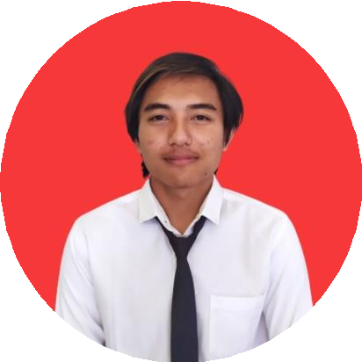

|  |  |
| --- | --- |
| YN  OBJECTIVE  Hope to be a part of bangkit academy. With that I can improve myself even better and learn new things with the experience I have now.  SKILLS  I'm very good at programming, especially web programming. Besides that, there are several programming languages that I can use such as Java, C++, and SQL. I'm also very fast in learning new things which are sometimes difficult for others  to understand. | KADEK INDRA PRAYUDYA  JUNIOR WEB DEVELOPER  PROGRAMMER • LECTURE RESEARCH • 2021   * Designing website system * Developing website * System testing   PROGRAMMER • LECTURE RESEARCH • 2021   * Designing UI * System testing   INTERNSHIP • STUDIO KAMI MANDIRI • 2018   * Make website using PHP framework   EDUCATION  2020 - NOW • POLITEKNIK NEGERI BALI  2017 - 2020 • SMK TI BALI GLOBAL DENPASAR  2014 - 2017 • SMPN 2 KUTA SELATAN |



[INDRADEK@GMAIL.COM](mailto:INDRADEK@GMAIL.COM) +62 823 2018 0734