**Instruction** (set up necessary extensions):

* 1. Set up the "**Web Server for Chrome**" extension in the Google Chrome (it allows a local web server directly from the browser).
  + Click the link: <https://simplewebserver.org/download.html>.
  + Click “Portable (.zip): 64 bit” and download it.
  + Unzip the compressed folder and click “Simple Web Server.exe” within the folder.
  + If it says this app is not trusted, click “run anyway”. This message won’t pop out next time.
* 2. Choose "**Folder path**": Choose the folder that contains the "**home.html**", "**README.docx**", "**js**".
* 3. Copy the **Web Server URL**(s) below the “CHOOSE FOLDER” button, and then open it in **Google Chrome**.
  + The URL looks like: <http://127.0.0.1:8887> (8887 is the port number). Note that the port number may differ in your computer.
* 4. Set up the "**Super Simple Highlighter**"extension in the Google Chrome (optional). The purpose of this extension is to allow you to highlight the sentences in the webpage that may help you evaluate these cases.
  + Click the link: <https://chrome.google.com/webstore/detail/super-simple-highlighter/hhlhjgianpocpoppaiihmlpgcoehlhio>.
  + Click "Add to Chrome” if you have not installed it.
  + Recommended step (optional):

(1) Activate the extension shortcuts: **chrome://extensions/shortcuts**. (Copy and open it in the Google Chrome)

(2) Go to "Super Simple Highlighter", select the hot keys for "Highlight #1", "Highlight #2" …

**Instruction** (tips for reviewing the cases):

* 1. After opening the **Web Server URL** in the Google Chrome**,** click "**home.html**". Then you will see the home page for the case review:

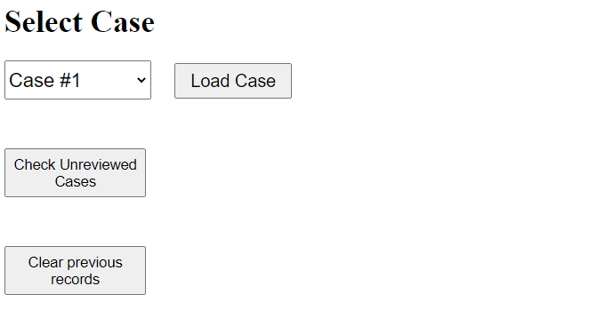

* 2. The home page allows you to select the case number from a dropdown menu. After you choose the case number, click the “**Load Case**”. The purpose of the other two buttons is summarized as follows:
  + “**Check Unreviewed Cases**”: it allows you to find what cases you have not reviewed. This is useful if you miss a case and do not realize it.
  + “**Clear previous records**”: it allows you to clear the browser cache. If it is your first time to review, it is fine to click “OK”. Otherwise, it is not recommended to touch this button.
* 3. Each case contains “**Indications**”, “**Findings**”, “**Clinical Impression**”, “**AI Impression**”, and two “**scoring**” sections for the impression evaluation. You will need to give the scores to **7** categories, including “**Addition**”, “**Omission**”, “**Factual Correctness**”, “**Clarity/organization**”, “**Interpretive / technical jargon**”, “**Appropriate recommendations**” and “**Overall quality**”. The definition of each category can be found by moving the mouse to the red “**?**”. In addition, feel free to drop any **comments** on the given impression. It will be valuable for us to further improve our AI models to better align with the physicians’ preference.
* 4. After giving all scores, please click the “**Submit Score**” button. A txt file named “**scores_case_{case number}.txt**” will be downloaded automatically. It contains the scores for this case. The purpose of this is to back up the scores in case you lose it if you switch to other computers or browsers (like Microsoft Edge) or clear the cache.
* 5. If you are done with this case, click “**Next Case**”. It will ask you whether you are certain to move to the next one, click “OK”. Then a message box will appear showing how many cases you have not scored yet.
* 6. After reviewing all cases, click “**Download All Score**”, a txt file named “**scores.txt**” will be downloaded automatically. It contains all scores for the evaluated cases (e.g., 24 or 72).
* 7. Please place “**scores.txt**” along with “**scores_case_1.txt**”, “**scores_case_2.txt**”, “**scores_case_3.txt**”, … in the folder “**scores**”. Then compress it and send it to us via email.

* Note that if you **refresh** the page, you will go back to the home page.