DOCUMENTATION

ASSIGNMENT 1

STUDENT NAME: Antonescu Maria-Cristina
GROUP: 30431

CONTENTS

1. Assignment Objective 3
2. Problem Analysis, Modeling, Scenarios, Use Cases 3
3. Design 3
4. Implementation 3
5. Results 3
6. Conclusions 3
7. Bibliography 3

Assignment Objective
  - Main objective

The main objective of this assignment is to develop a desktop application with a graphical user interface, which is able to perform operations on polynomials given as input.

  - Sub-objectives

- Design and implement a Graphical User Interface (GUI) that allows the user to input two polynomials.
- Create functions to add, subtract, multiply, divide, integrate, and differentiate polynomials.
- Integrate the polynomial functions into the GUI so that the user can select which operation to perform on the input polynomials.
- Implement error handling for cases such as division by zero and invalid input.
- Test the calculator with different input polynomials to ensure accuracy and correctness of the calculations.

Problem Analysis, Modeling, Scenarios, Use Cases
The functional requirements for this assignment are the following:
- The polynomial calculator should subtract two polynomials.
- The polynomial calculator should multiply two polynomials.
- The polynomial calculator should divide one polynomial by another and return the quotient and remainder.
- The polynomial calculator should integrate a polynomial with respect to the variable x and return the result.
- The polynomial calculator should differentiate a polynomial with respect to the variable x and return the result.
- The polynomial calculator should handle errors, such as division by zero and invalid input.
- The polynomial calculator should display the input polynomials and the results of the mathematical operations to the user.
- The polynomial calculator should allow users to clear the input fields and start over.

The above functional requirements result in the following use case diagram:
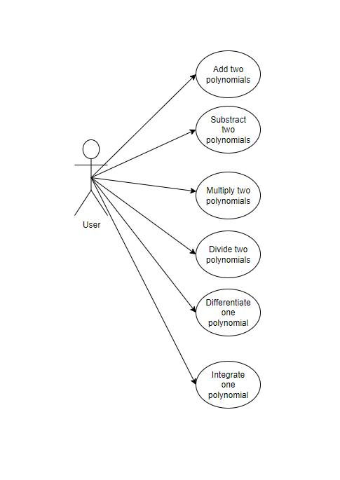

Use Case: Add Polynomials
Primary Actor: User
Main Success Scenario:
1. The user inserts the 2 polynomials in the graphical user
interface.
2. The user selects the “addition” button
3. The polynomial calculator performs the addition of the
two polynomials and displays the result

Alternative Sequence: Incorrect polynomials
The user inserts incorrect polynomials (e.g. with 2 or more variables)
The scenario returns to step 1

Use Case: Subtract Polynomials
Primary Actor: User
Main Success Scenario:
- The user inserts the 2 polynomials in the graphical user interface.
- The user selects the “subtraction” button.
- The polynomial calculator performs the subtraction of the two polynomials and displays the result.

Alternative Sequence: Incorrect polynomials
The user inserts incorrect polynomials (e.g. with 2 or more variables).
The scenario returns to step 1.

Use Case: Multiply Polynomials
Primary Actor: User
Main Success Scenario:
- The user inserts the 2 polynomials in the graphical user interface.
- The user selects the “multiplication” button.
- The polynomial calculator performs the multiplication of the two polynomials and displays the result.
Alternative Sequence: Incorrect polynomials
The user inserts incorrect polynomials (e.g. with 2 or more variables).
The scenario returns to step 1.

Use Case: Divide Polynomials
Primary Actor: User
Main Success Scenario:
- The user inserts the 2 polynomials in the graphical user interface.
- The user selects the “division” operation.
- The polynomial calculator performs the division of the two polynomials and displays the quotient and remainder.
Alternative Sequence: Incorrect polynomials
The user inserts incorrect polynomials (e.g. with 2 or more variables).
The scenario returns to step 1.

Alternative Sequence: Division by zero
The user attempts to divide by zero.
The calculator displays an error message and the scenario returns to step 1.

Use Case: Integrate Polynomial
Primary Actor: User
Main Success Scenario:
- The user inserts the polynomial in the graphical user interface.
- The user selects the “integration” button.
- The polynomial calculator performs the integration of the polynomial with respect to x and displays the result.

Alternative Sequence: Incorrect polynomial
The user inserts an incorrect polynomial (e.g. with 2 or more variables).
The scenario returns to step 1.

Use Case: Differentiate Polynomial
Primary Actor: User
Main Success Scenario:
- The user inserts the polynomial in the graphical user interface.
- The user selects the “differentiation” button.
- The polynomial calculator performs the differentiation of the polynomial with respect to x and displays the result.

Alternative Sequence: Incorrect polynomial
The user inserts an incorrect polynomial (e.g. with 2 or more variables).
The scenario returns to step 1.

Design
For this assignment I used the MVC design pattern, so I have the following 3 packages:
- Model – where I defined the Polynomial entity and the PolynomialOperations
- View – where I defined the GUI
- Controller – where I linked the Model and the View through the PolynomialController, which takes the data from the input and provides an ouput.
Package diagram:
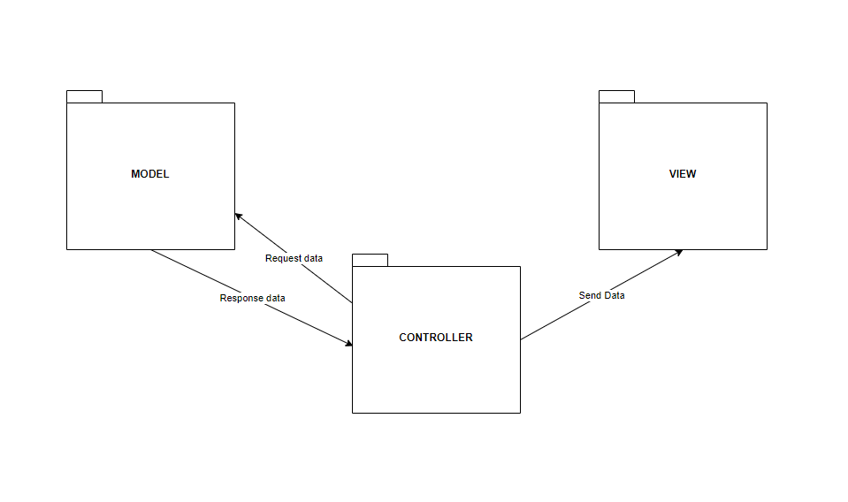
Class diagram:
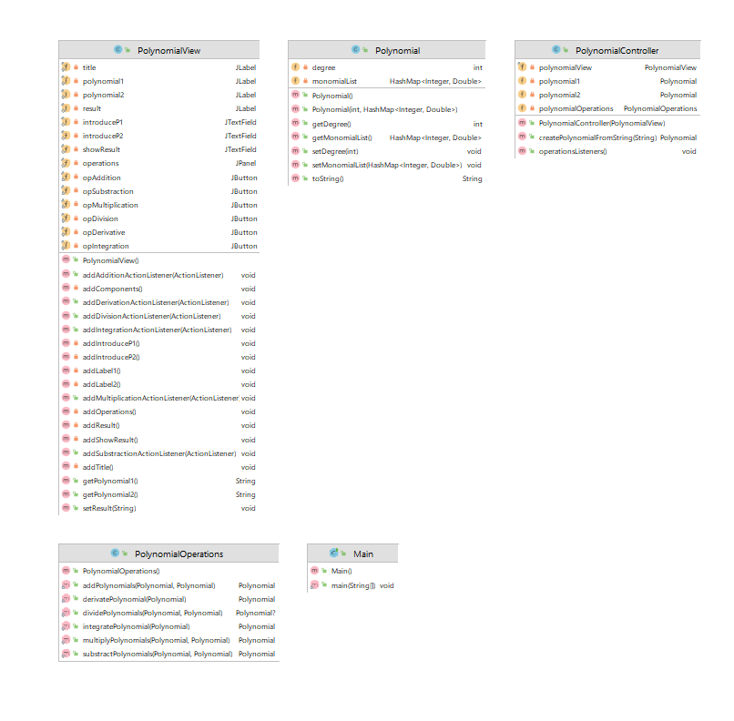
As it can be observed from the above class diagram, I have decided to use a HashMap to store the polynomial, where the key is given as an Integer and it represents the degree of the monomial and the value a Double which stores the coefficient of a monomial of a certain degree.

Polynomial Operations Ideas:

- Addition
The 2 polynomials will be traversed and the coefficients which have the same key will be added and stored in the new polynomial.

- Substraction
The 2 polynomials will be traversed and the coefficients which have the same key will be substracted and stored in the new polynomial. The coefficients of the second polynomial will be substracted from the coefficients of the first polynomial.

- Multiplication
Each monomial from the first polynomial will be multiplied with each monomial from the second polynomial.The coefficients will be multiplied and added to the position with the degree the sum of degrees of the two monomials.

- Division
For the division I implemented the following algorithm for long division:
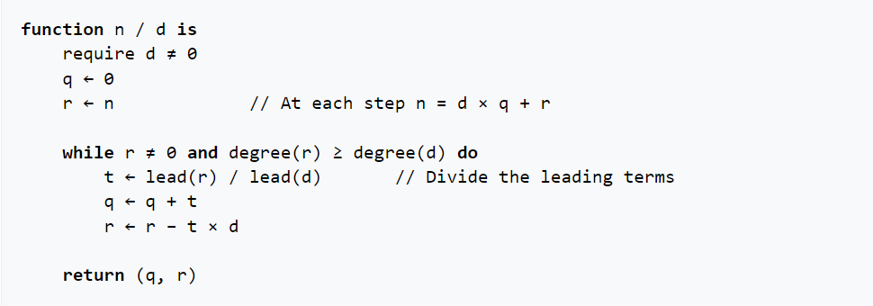

- Integration
Each monomial from the first polynomial will be integrated according to the following rule, then added to the result:
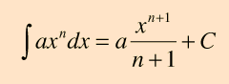

- Derivation
Each monomial from the first polynomial will the derivated according to the following rule, then added to the result:
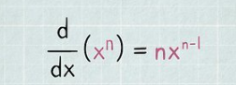

Implementation
Each class will be described (fields, important methods). Also, the implementation of the graphical user interface will be described.
In this section, I will describe the classes I used and the important methods and the fields.
- Polynomial – defines the entity polynomial
- Degree – the degree of the polynomial
- monomialList – the list of monomials which make up the polynomial, stored in HashMap with integer keys (degrees) and double values (coefficients).
- toString() – it overrides the default method used to display the polynomial on the GUI
- PolynomialOperations – class which defines static methods for polynomial arithmetics
- addPolynomials(Polynomial polynomial1, Polynomial polynomial2) – performs the addition of 2 polynomials
- substractPolynomials(Polynomial polynomial1, Polynomial polynomial2) – substracts polynom2 from polynom1
- multiplyPolynomials(Polynomial polynomial1, Polynomial polynomial2) – multiplies the 2 polynomials
- dividePolynomials(Polynomial polynomial1, Polynomial polynomial2) – divides polynom1 to polynom2
- derivatePolynomial(Polynomial polynomial) – derivates the first polynomial
- integratePolynomial(Polynomial polynomial) – integrates the first polynomial

- PolynomialView

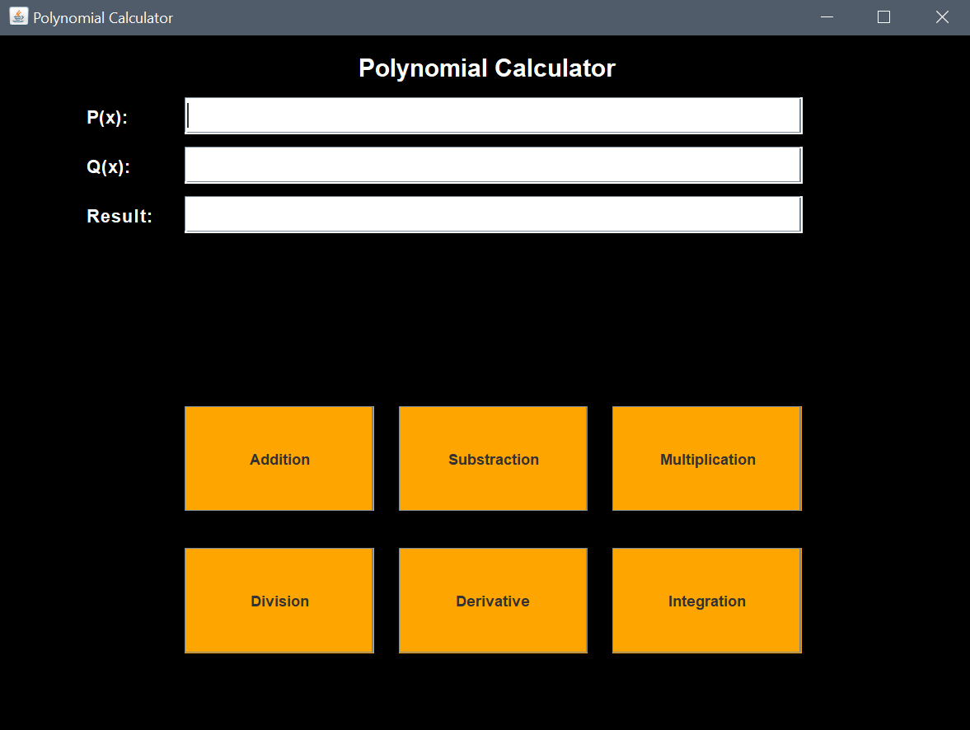

This class builds the user interface. As it can be seen above, it has labels which denote which polynomial will be introduced/displayed, TextFields in which the user can introduce the first 2 polynomials/ the result can be displayed and 6 buttons to select the operation the user want to perform. Each button has an ActionListener added to them.

- PolynomialController – it links the Model (Polynomial, PolynomialOperations) and the View (PolynomialView)
- createPolynomialFromString(String polynomial() – it takes a String and input and uses a regular expression to match a monomial format against the string and extract the degrees and coefficients.
- operationsListeners() – it calls the methods from the PolynomialView for each button and explicitly describes the operations performed when each button is pressed.

Results
I have manually tested all the operations in the Main class and printed in the console the output. I have already computed by hand the results beforehand and compared them with the output.
One testing case: firstPolynomial is “+1.0*x^2+2.0*x^1+1.0*x^0”, secondPolynomial is “1.0*x^3+5.0*x^2+2.0*x^1+1.0*x^0”. I declared a polynomialOperations instance with which I performed the operations on the two polynomials.

Conclusions
In conclusion, the polynomial calculator has been successfully developed to perform mathematical operations on two input polynomials. The calculator allows the user to input the polynomials through a GUI and select the desired operation. The implemented functions include addition, subtraction, multiplication, division, integration, and differentiation. The calculator also handles errors and displays the input polynomials and results to the user.

Through this assignment, I have learned the importance of designing and implementing error-free code, especially when dealing with mathematical calculations. I have also improved my understanding of GUI design and integration, as well as the implementation of polynomial functions. Additionally, I have gained valuable experience in testing and debugging code to ensure its accuracy and correctness.

Future developments for the polynomial calculator could include the addition of more mathematical functions, such as finding the roots of a polynomial or solving a system of polynomial equations. The calculator could also be enhanced to handle more complex polynomial expressions, such as those involving trigonometric or logarithmic functions. Another potential development could be the creation of a mobile or web-based version of the calculator to make it more accessible to a wider range of users.

Bibliography
- https://dsrl.eu/courses/pt/
- https://www.programiz.com/java-programming/library/hashmap
- What are Java classes? - www.tutorialspoint.com
- https://en.m.wikipedia.org/wiki/Polynomial_long_division?fbclid=IwAR24Ge1BkpHeemeAPEfbLWQU9hMA1EUaOWH6E_yxNcPm32ixVxJQLQkZ7ds

