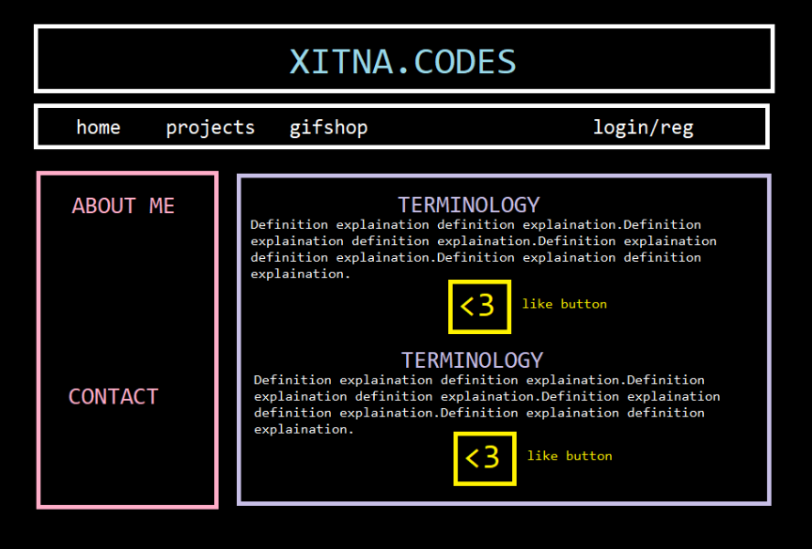
- HOME PAGE
  - About me and contact information
  - Term: definition, can like
  - Like button
    - adds user id or generic guest id
    - to like data table
    - uses under object id
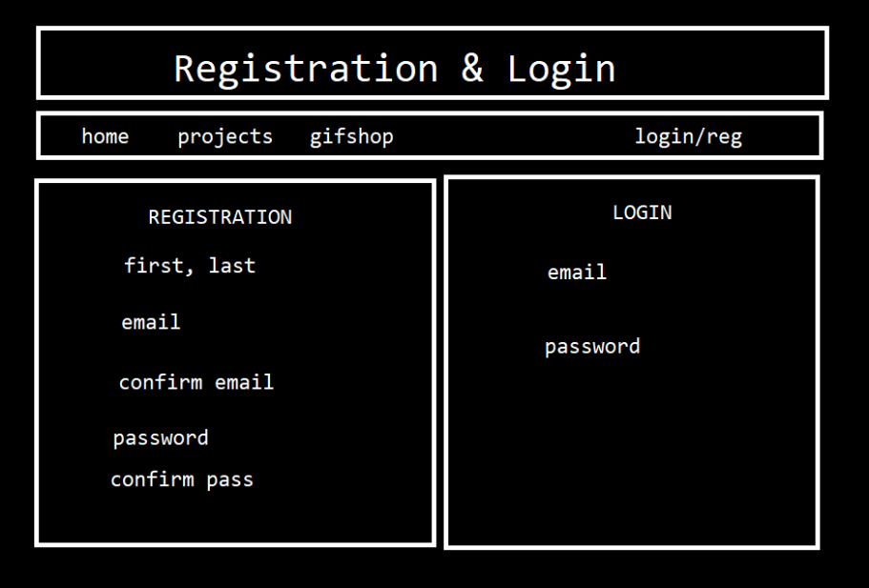

- LOGIN AND REGISTRATION
  - Registration validation:
    - Email not in system,
    - confirm email
    - confirm password
    - password regex.
  - Login validation
  - Navigate to dashboard

- USER DASHBOARD
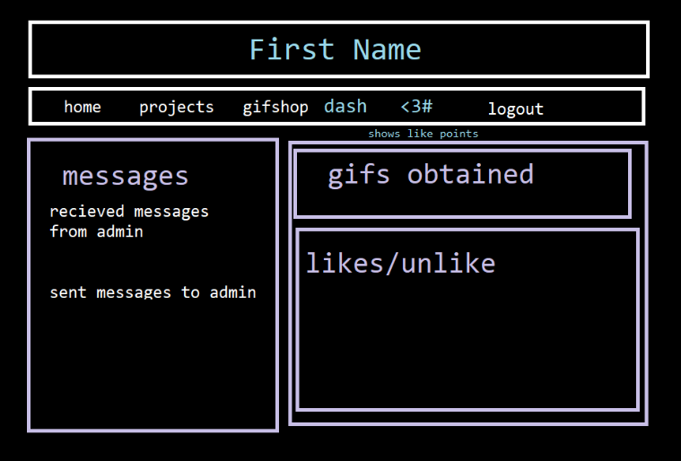
  - Navbar:
    - Dashboard
    - Like count funds: add one for each item liked, subtract when buying something from the giftshop.
  - Messages:
    - Received messages: from admin
    - Sent messages: to admin, EDIT FUNCTION
  - Gifs
    - Shows gifs purchased from giftshop
  - Likes/unlike
    - Shows likes to object and link from url given back to object
    - Unlike button, keep your like funds
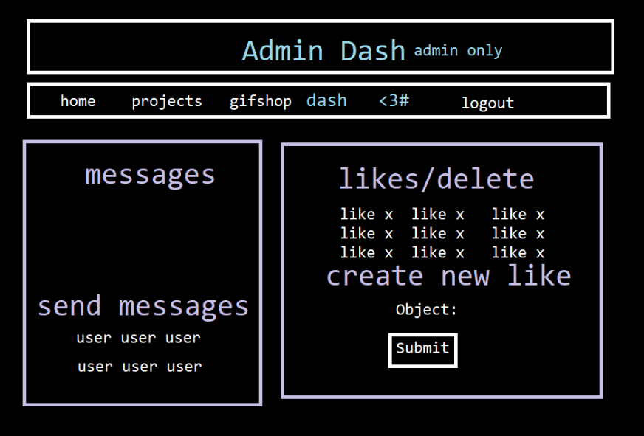
- ADMIN DASH:
  - Read messages sent
  - Send messages:
    - Create new message
    - Form
    - To each user
  - Likes / delete
    - Shows each like in db
    - Can delete
  - Create new like
    - Form
    - Object id
    - url
    - name
    - description

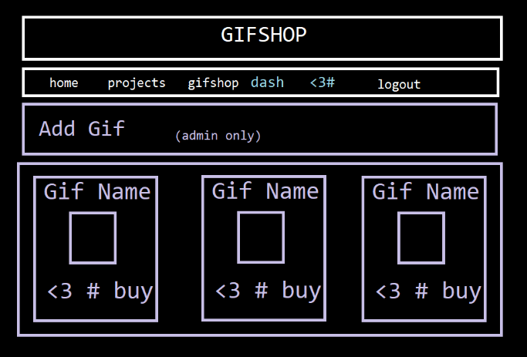

- GIFSHOP
  - Add gif:
    - Nme
    - Image
    - Description
    - Like id
  - Gifs(each in db):
    - Name
    - Image
    - Description
    - Like price $
    - Buy button

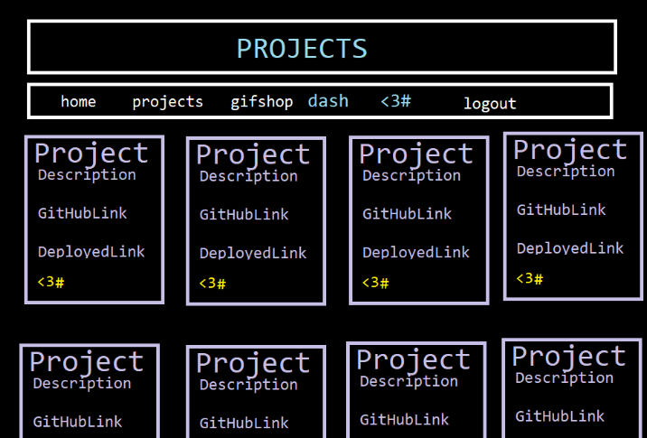
- PROJECTS
  - Gets projects from github api
  - Checks if in projects db
  - Shows to add using
    - description,
    - git id,
    - url,
    - deploy url,
    - name

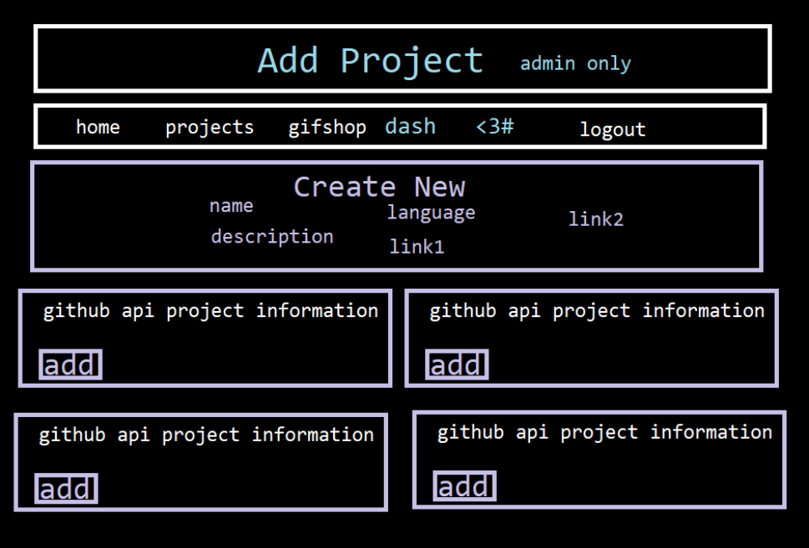

- ADD PROJECT
  - Create new
    - Form
    - Name
    - Description
    - Language
    - Link to git
    - Like to deploy

