APPENDIX N

Group Logo.

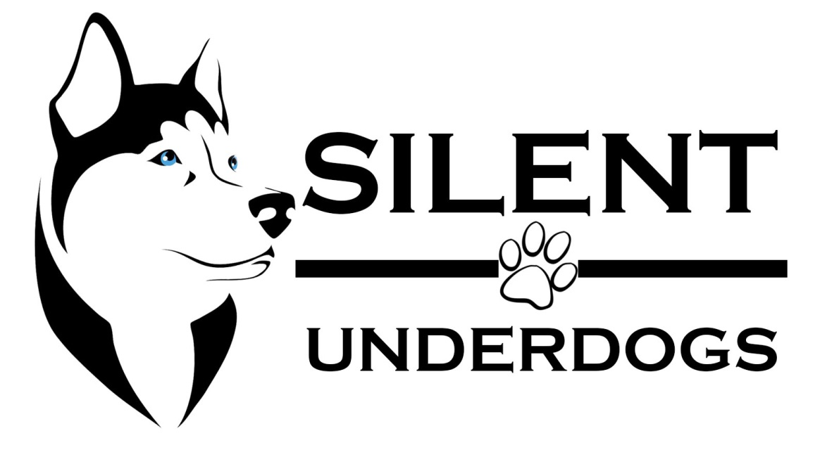

The team logo is consists of a clipart of a calm looking Husky facing at the right which means that the team is on track. The team decided to use a Husky because it is a kind of dog which is intelligent yet humble and dependable in all its ways. The developers’ logo also includes the name of the team, Silent Underdogs, which means humble beginning. At the center of the name is a paw, which means that the team is remarkable.