# 

# ENEL503 Computer Vision

# Lab 4

**Object Edge/Contour Detection and Image Feature Extraction**

# Instructor: Prof. Yingxu Wang

# TA: Abbas Mahbod, abbas.mahbod1@ucalgary.ca

# Due: 5:00pm, Wednesday, March 29, 2023

Name: _________________________________________

UCID: _________________________________________

**Purpose**

The purposes of this lab assignment are as follows:

1. Practice MATLAB image processing by object edge/contour detection and image feature extraction;
2. Apply typical principles and algorithms for image processing and analyses;
3. Improve programming skills for computer vision in MATLAB;
4. Become familiar with MATLAB toll boxes for real-world problem solving.

**Marks**

|  |  |  |
| --- | --- | --- |
| **Question** | **Mark allocation** | **Mark received** |
| 1 | 20 |  |
| 2 | 30 |  |
| 3 | 20 |  |
| 4 | 30 |  |
| **Total** | **100** |  |

**General Instructions**

To ensure consistent and efficient marking, a Word template will be provided for each ENEL 503 lab. Complete this Word template with your answers, MATLAB code, and plots as required. Submit an electronic copy of your lab report by email attachment to TA Abbas Mahbod at [abbas.mahbod1@ucalgary.ca](mailto:abbas.mahbod1@ucalgary.ca) .

Some questions ask for MATLAB code to be inserted. Make sure that the code is commented sufficiently but avoid being too verbose, in order to make the marking job for the TA as efficient as possible. Obscure code that is insufficiently or incorrectly commented will also result in lost marks.

Equations in the report need to be represented in proper mathematical form using the equation editor in Word (under Insert > Object > Microsoft equation). The MathType equation editor is highly recommended. Hand written math expressions are not expected.

MATLAB plots can be copied directly from the figure window of MATLAB by ‘Edit > Copy Figure’. Then, you can paste the figure into the Word template. Color reports are encouraged due to the nature of this course.

**1.** (20) How many stars are there in the sky as given in the photo of a region of the universe? This is a challenging problem that humans may not be able to handle by naked eyes. However, computer vision technologies may do it sufficiently and efficiently.

Using the morphological and labeling (bwlabel) technologies as given in L8-40 to detect the number of stars in *Universe.jpg*. Test you code for different brightness threshold (Th), which transfers a gray image to a binary one, where Th1 = 0.3 for counting all stars; Th2 = 0.6 for counting all mid-level and first-level stars; and Th3 = 0.8 for counting only first-level stars of brightness in the image.

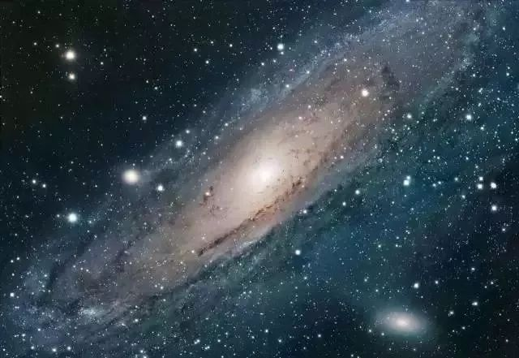

----------------------------------- MATLAB code (15) -----------------------------------

---------------------------------------------------------------------------------------------

----------- Plots of ImC, ImG, and star counts in 3 sets against each threshold (5) ----------

-----------------------------------------------------------------------------------------------------

**2.** (30) *Watershed regions* for *object contour detection* have been widely applied in computer vision. Given a sample image, *Flowers.jpg* as shown below, try to test and practice the algorithm as provided in L8-35 to L8-38 in order to determine the optimized watershed lines for object contour segmentations. A few comparative case studies may be reported by using different convolutional filters fspecial() and structure elements se = strel(). Plot three sets of testing results of watershed lines and composed B/W and color images based on your case studies.

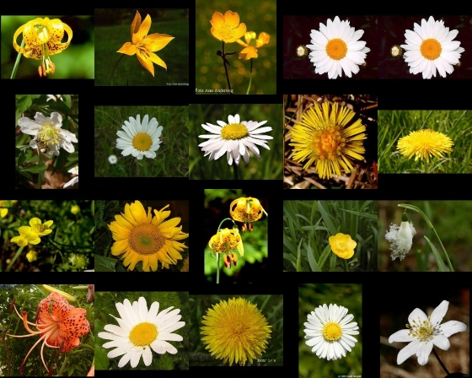

-------------------------------------- MATLAB code (20) --------------------------------------

---------------------------------------------------------------------------------------------------

-------- Plots of 3 sets of watershed lines and composed B/W and color images (10) --------

Case 1: fx = fy = fspecial(…), and se = strel(…).

Case 2: fx = fy = fspecial(…), and se = strel(…).

Case 3: fx = fy = fspecial(…), and se = strel(…).

---------------------------------------------------------------------------------------------------------

**3.** (20) Adapting the solutions for Question 2 to a gray scale image, *CoinsG.png*, as shown below. Test if the algorithm that you developed in Question 2 may be minorly updated and reused for determining the watershed and object contour segmentations in gray objects. Plot the results of watershed lines and composed B/W and color images.

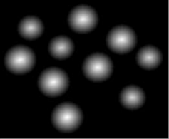

----------------------------------- MATLAB code (15) -----------------------------------

---------------------------------------------------------------------------------------------

------------- Plots of watershed lines and composed B/W and color images (5) -------------

------------------------------------------------------------------------------------------------------

**4.** (30) *Image feature extraction* by object boundary detection and labeling are important technologies in computer vision. Given a sample binary image, *TestShapes.png,* as shown below, try to determine the *boundaries* and *labels* of each objects by bwboundaries and bwlabel, respectively, as described in L9-20 to 22.

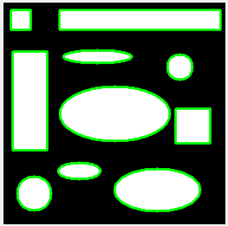

Then, collect the following 7 features by your program for each object and register them in a structure model, Features = uint16(zeros(N,8)),according to the given schema as follows.

Object# | Area | Centroid(1) | Centroid(2) | Perimeter | EulerNumber | ThinnessRatio | AspectRatio

-------------------------------------- MATLAB code (20) --------------------------------------

---------------------------------------------------------------------------------------------------

------------------ Plots of 10 labeled objects and collected features (10) ---------------

a) Plot the 10 labeled objects in the image

b) Plot the features for each object generated in a 10 x 8 structure of Features.

------------------------------------------------------------------------------------------------