**DEVELOPMENT OF MICROCONTROLLER BASED WEARABLE DEVICE WITH MONITORING SYSTEM FOR BODY-FOCUSED REPETITIVE BEHAVIOR**

A Capsule Proposal Presented to the Faculty of  
Department of Computer and Electronics Engineering  
College of Engineering and Information Technology  
Cavite State University, Indang, Cavite

In Partial Fulfillment  
of the Requirements of the course  
CPEN 200 CpE Design Project 1

Bachelor of Science in Computer Engineering  
A.Y. 2021 – 2022

**BAHILLO, RYAN CHRISTOPHER D.  
DALANON, IRIKS MARIA B.**

February 2022

**Rationale**

Body-focused repetitive behavior (BFRB) is a term that refers to a group of compulsive habits that unintentionally harm one's body and alter one's appearance (Abrahams & Trotzky, 2017). The main distinction between BFRBs and other compulsive behaviors that hurt the body is that BFRBs involve direct body-to-body contact. BFRBs are one of the most misunderstood, under diagnosed, and mistreated conditions around nowadays (Houghton et al., 2018). Pulling, picking, biting, or scraping one's hair, skin, or nails are examples of these behaviors. Trichotillomania (hair pulling), dermatillomania (skin plucking, also known as excoriation disorder), and onychophagia are among the disorders (compulsive nail biting). As many as 1 in 20 people have a BFRB, affecting both children and adults (Smitha Bhandari, 2020).

In a related study published in npj Digital Medicine, a team lead by Child Mind Institute researchers found that utilizing heat sensors in addition to inertial measurement and proximity sensors, a wearable tracking system they designed achieves greater accuracy in position tracking. Tingle, a wrist-worn gadget, could also tell the difference between actions aimed at six distinct parts of the head. The paper, titled "Thermal Sensors Improve Wrist-worn Position Tracking," provides preliminary evidence of the device's potential use in the diagnosis and treatment of excoriation disorder, nail-biting, trichotillomania, and other body-focused repetitive behaviors (Jake J. Son, Jon C. Clucas, Curt White, Anirudh Krishnakumar, Joshua T. Vogelstein, Michael P. Milham, 2019).

This proposed project aims to develop a microcontroller based wearable technology that conveys a signal to the user and is integrated with mobile application for motion sensors in real time. This project will assist in the treatment of the Body-Focused Repetitive Behavior (BFRB patient). The device will be able to send a signal to the patient by using the vibration motor; it has a trained model implemented to the microcontroller by using its accelerometer and gyroscope in addition with distance sensor to improve the accuracy. By this, the user will control the repetitive behavior. This current proposal is not a medication, but it will assist BFRB patients in self-control.

**Objectives of the Study**

The project will conduct in the proposal of a microcontroller-based wearable device that will be used to help the patient control its repetitive behavior. To accomplish this, the following objectives will be met:

1. **To develop a microcontroller based wearable technology that conveys a signal to the patient.** The main components include Arduino Nano microcontroller board, a proximity sensor, a vibration motor, and various optional components such as batteries and a chassis.
2. **To embed mobile application for motion sensors in real time.** The software design will be implemented using Python programming language to build a user interface for the patient.
3. **To assist in the treatment of the Body-Focused Repetitive Behavior (BFRB patient) with the proposed project.** Giving alert using haptic feedback to the patient to stop the urge of repetitive behavior.

**Methodology**

This project will come up with a solution to help the patient with BFRB by using a wearable device that will warn or send signals. By doing this, the study needs a Microcontroller Unit that can provide all the parameters it needs. The Arduino Nano family is designed to fit any electronic project in an affordable way. Its dimensions are why it can make this project small-scale and compact. It also has motion sensors to measure the tri-axial acceleration and angular rate, these two are the main factors of the proposed project.

The MCU will know if the patient is going to commit its repeating behavior by simply using a machine learning technique. The accelerometer and gyroscope, as shown in figure 1 and 2, will detect the acceleration force and angular velocity of the wrist. This study can improve the tracking accuracy by using the distance sensor. The Time-of-Flight (ToF) distance sensor can fit our proposal project. Compared to the HC-SR04 also known as ultrasonic sensor, the ToF is twice smaller, and the speculation is not excessive to what is only needed. In this way, acceleration, gyroscope, and distance can store the raw data and use it for training the model using a machine learning algorithm. The Figure below shows the components and orientation of measurements.

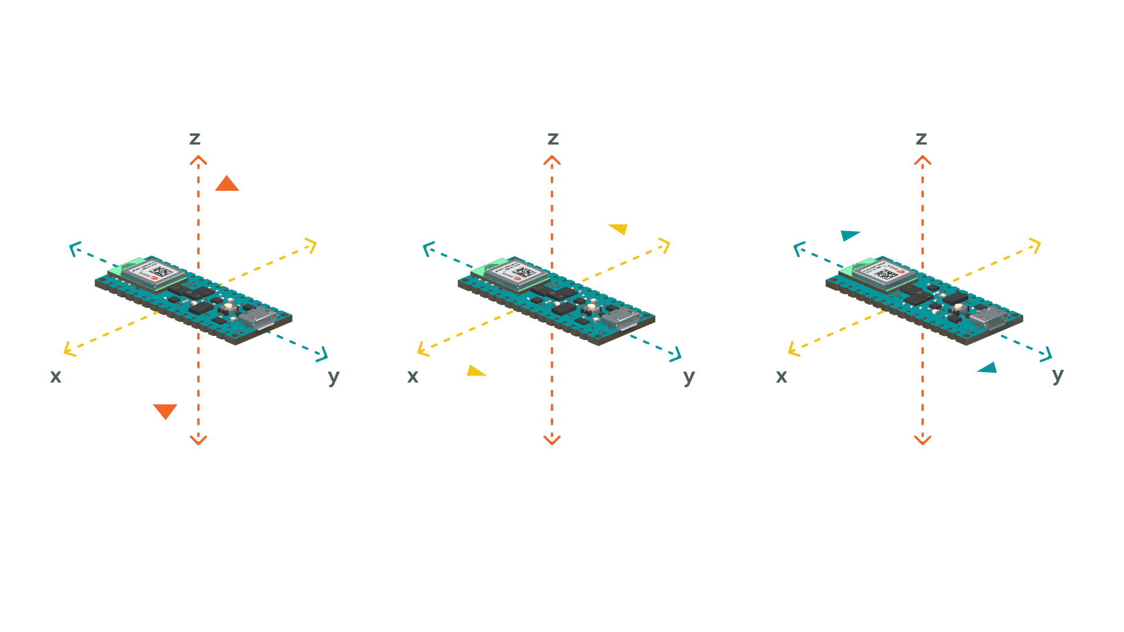

**Figure 1.** Accelerometer

(www.https://docs.arduino.cc/tutorials/nano-33-ble-sense/imu_accelerometer)

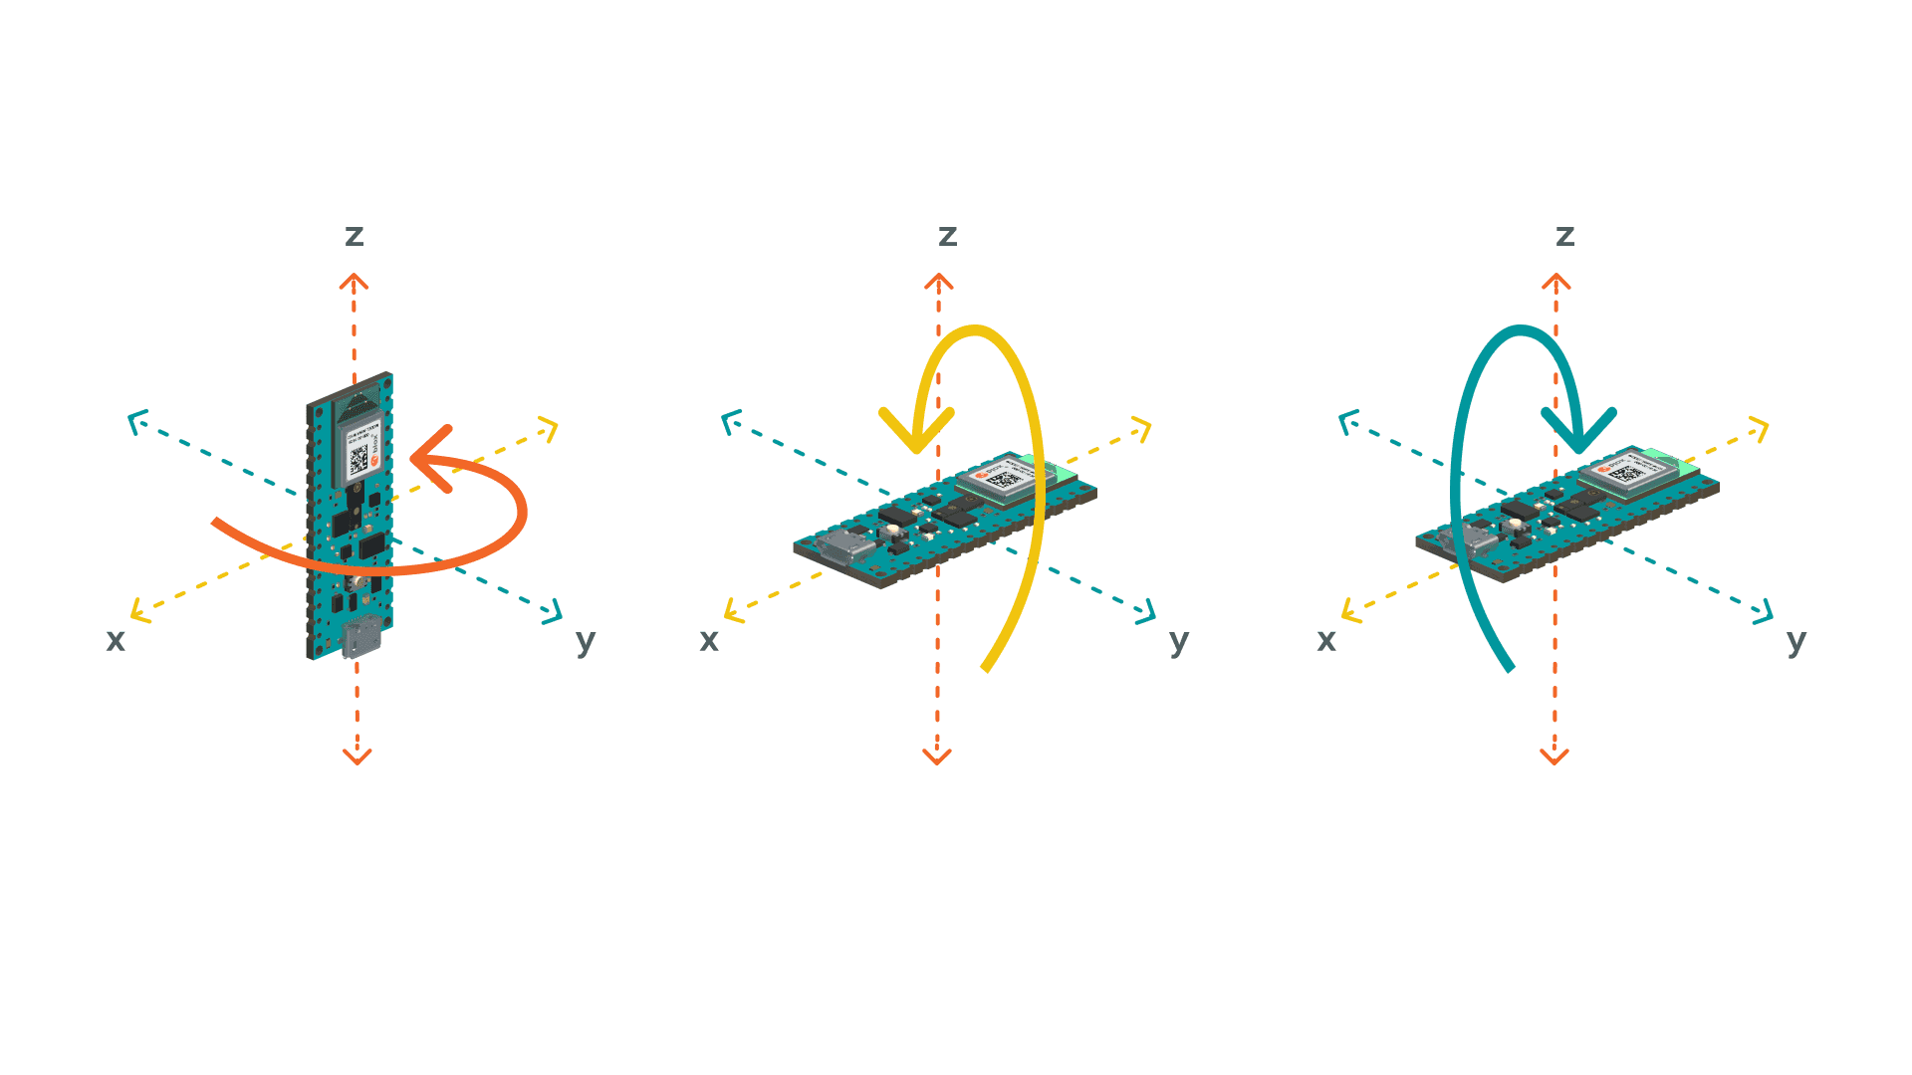

**Figure 2.** Gyroscope

(www.https://docs.arduino.cc/tutorials/nano-33-ble-sense/imu_gyroscope)

**Figure 3.** Time-of-Flight Sensor

(www.https://osoyoo.com/2019/04/21/arduino-lesson-vl53l0x-time-of-flight-distance-sensor/)

This study will use the cross-platform deep learning framework TensorFlow Lite. It is open source and product ready that converts pre-trained models to a special format that can be optimized for speed storage. The Arduino Nano 33 BLE (Bluetooth Low Energy) Sense is the only microcontroller in the Arduino family that is supported by TensorFlow Lite. The model is first trained using the TensorFlow library in Python, this trained model cannot be imported from the MCU unless converted to the Lite version that produces a smaller memory size that the MCU can handle.

As shown in Figure 4, the researchers will create a mobile application so that the patient can have a better experience using the device. It will monitor the changes of the motion sensors in real time and this application can train the software to detect the range when the device will send a signal to the patient or not. The researchers can freely choose their machine learning algorithm in either Support Vector Machine (SVM) or Convolutional Neural Network (CNN). The SVM has a great edge computing algorithm. However, machine learning models are being replaced with the recent novelty of neural network research. There is a study about using the CNN for speed detection based for walking and running using a wrist-worn device. They proved that CNN regression has a high accuracy result against train-test evaluation split and for cross-validation strategies (Seethi & Bharti, 2020).

For the wearable and the mobile phone to communicate, this project will use the Bluetooth communication protocol. In this way, it can send the raw data produced by the wearable to the mobile phone to begin the training. The trained model is saved and sent back to the wearable, then it will be able to load the model. This is a great help for the new patient that is willing to use the device.

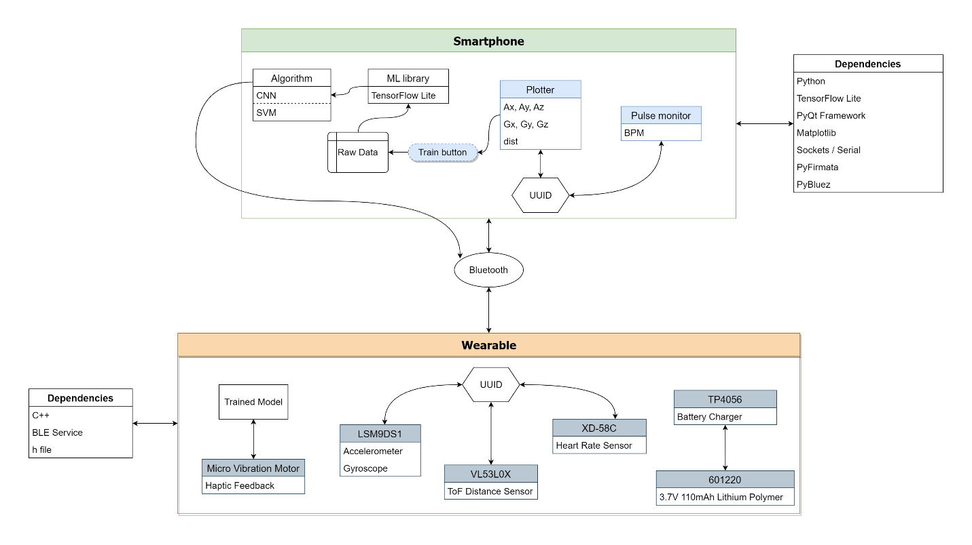

**Figure 4.** UML Diagram of design project (available in appendix section)

The wearable device will be able to send a warning to the patient by using the vibration motor. The researchers can tweak the frequency for his/her preferences so that the patient will sense the vibration. For the power supply, the project will use the Lithium Polymer battery for 3.7 supply voltage for the MCU. This battery is safe as it has no leakage problem because the inside of the battery does not contain a liquid electrolyte. It is also a rechargeable battery to avoid the replacement each time the battery has run out. The conceptual image of this proposal is also available in the appendix section.

**Materials**

**Table 1.** List of components and corresponding costs

| **Purpose** | **Component** | **Quantity** | **Unit Cost (Php)** |
| --- | --- | --- | --- |
| **Microcontroller** | Arduino Nano 33 BLE Sense | 1 | 3,770 |
| **Proximity** | VL53L0X ToF Sensor | 1 | 120 |
| **Tracker** | MLX90614 Temperature Sensor | 1 | 800 |
| Pulse Sensor | 1 | 145 |
| **Haptic Feedback** | Micro Vibration Motor | 1 | 150 |
| **Power** | 601220 Lithium Polymer Battery | 1 | 110 |
| TP4056 Charger Module | 1 | 40 |
| **Connections** | SPDT Slide Switch | 1 | 15 |
| Stranded Wire | 2 | 10 |
| Jumper Wire | 20 | 60 |

**Budgetary Estimate**

Included in Table 1 is a summary list of all the materials used in the creation of the wearable device, the total cost is Php 5,220. The listed prices are based on existing product pages in online commerce platforms as of the time of this writing. Summing it up with the allocated Php 1,000 for the miscellaneous, the budgetary estimate of this study is **Php 6,220**. The website can also cost money by deploying and maintaining the server running. However, there are free web hosting available online that can handle a limited amount of storage and memory usage.

**References**

Abrahams, T., & Trotzky, A. (2017). *BFRBs: Compulsive Behaviors That Unintentionally Cause Physical Damage*. Anxiety.org. https://www.anxiety.org/what-is-body-focused-repetitive-behavior-bfrb

Houghton, D. C., Alexander, J. R., Bauer, C. C., & Woods, D. W. (2018). *Body-focused repetitive behaviors: More prevalent than once thought?* (Issue 2000, pp. 389–393). Psychiatry Research. https://doi.org/https://doi.org/10.1016/j.psychres.2018.10.002.

Jake J. Son, Jon C. Clucas, Curt White, Anirudh Krishnakumar, Joshua T. Vogelstein, Michael P. Milham, A. K. (2019). *Thermal sensors improve wrist-worn position tracking*. npj Digital Medicine. https://doi.org/10.1038/s41746-019-0092-2

Seethi, V. D. R., & Bharti, P. (2020). CNN-based Speed Detection Algorithm for Walking and Running using Wrist-worn Wearable Sensors. *Proceedings - 2020 IEEE International Conference on Smart Computing, SMARTCOMP 2020*, 278–283. https://doi.org/10.1109/SMARTCOMP50058.2020.00064

Smitha Bhandari, M. (2020). *Understanding Body-Focused Repetitive Behaviors*. WebMD. https://www.webmd.com/mental-health/ss/slideshow-understanding-body-focused-repetitive-behavior

**Appendix**

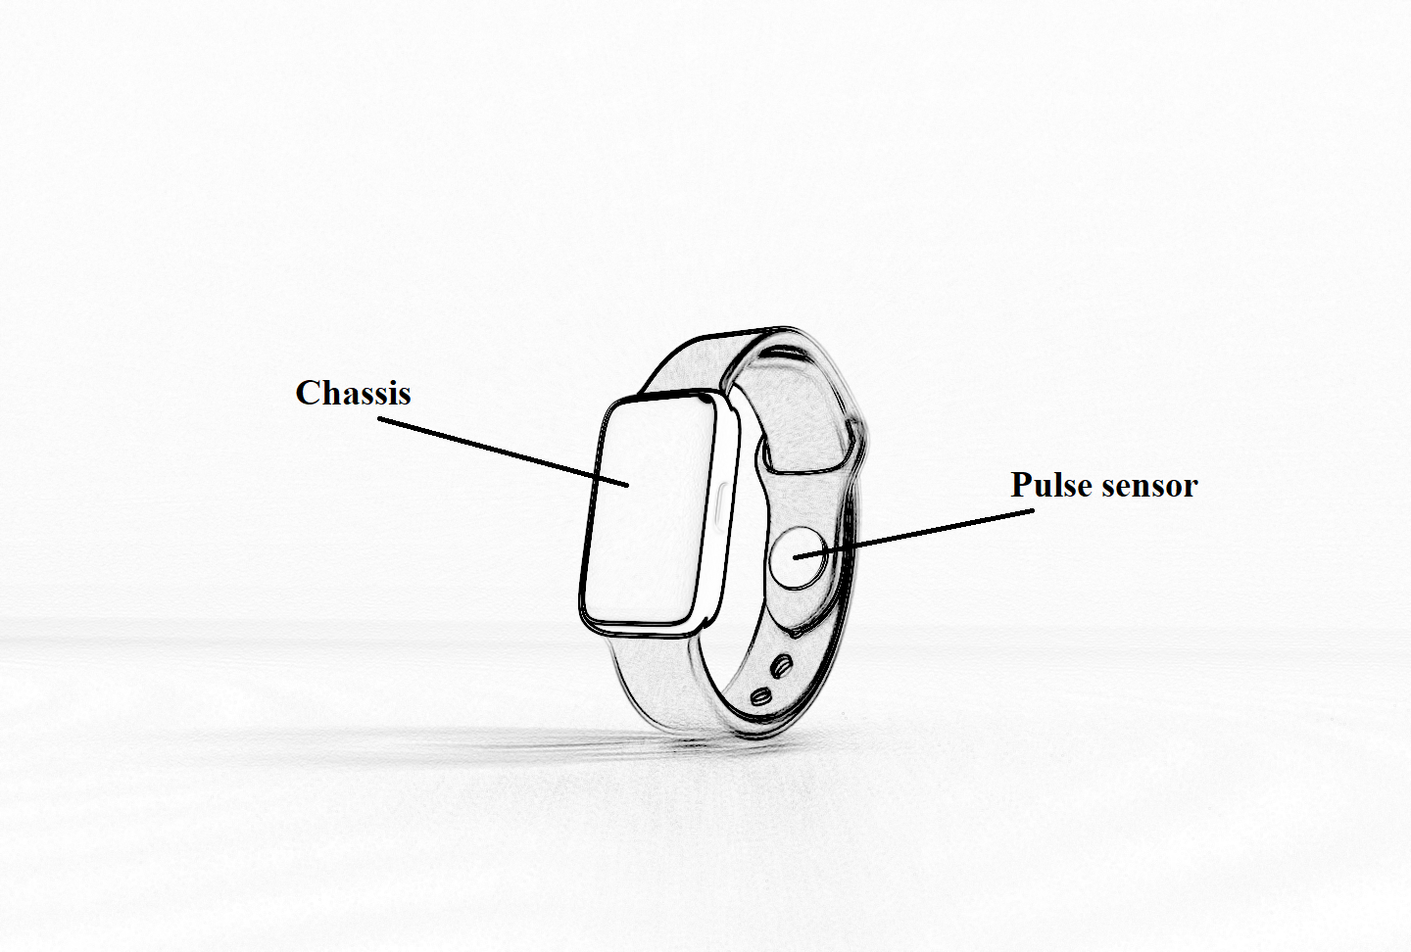

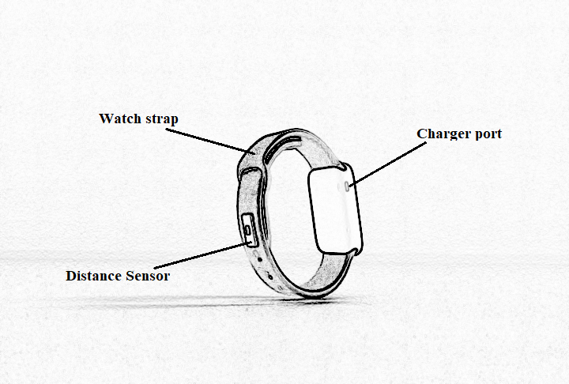

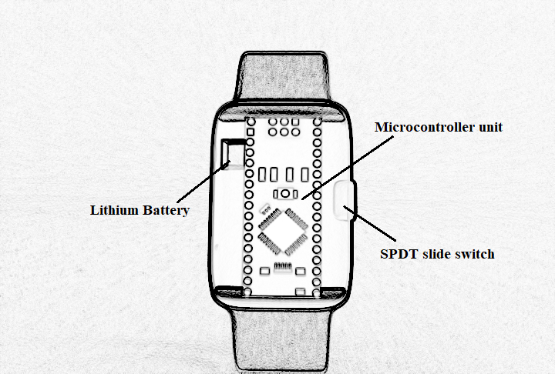

**GANTT CHART OF ACTIVITIES**

| **Activity** | **Month 1** | **Month 2** | **Month 3** | **Month 4** | **Month 5** |
| --- | --- | --- | --- | --- | --- |
| Background Reading |  |  |  |  |  |
| Conduct Literature Review |  |  |  |  |  |
| System Analysis and Design |  |  |  |  |  |
| Data Analysis |  |  |  |  |  |
| Testing and Evaluation |  |  |  |  |  |
| Deployment |  |  |  |  |  |
| Conduct Conclusion |  |  |  |  |  |
| Final Draft |  |  |  |  |  |