**Development of Microcontroller Based Wearable Device with Monitoring System for Body-Focused Repetitive Behavior**

*Bahillo, Ryan Christopher D.*

*Dalanon, Iriks Maria B.*

An undergraduate design project prepared and submitted to the faculty of the Department of Computer and Electronics Engineering (DCEE), College of Engineering and Information Technology (CEIT), Cavite State University (CvSU), Indang, Cavite in partial fulfilment of the requirements for the degree of Bachelor of Science in Computer Engineering with Contribution No. _______. Prepared under the supervision of Prof. Marivic G. Dizon.

**CHAPTER I**

***INTRODUCTION***

This chapter presents the context and background by which the study will be introduced. It also outlines the goals of the researchers were trying to achieve, the study's limitations, and its scope. Additionally, the intended audience are stated and the detailed explanation of the technical terms in which the key or important terms in this study are clearly defined.

***Background of the Study***

Body-focused repetitive behavior (BFRB) is a term that refers to a group of compulsive habits that unintentionally harm one's body and alter one's appearance (Abrahams & Trotzky, 2017) but the factors that predispose individuals to these behaviors are poorly understood. The main distinction between BFRBs and other compulsive behaviors that hurt the body is that BFRBs involve direct body-to-body contact. BFRBs are one of the most misunderstood, under diagnosed, and mistreated conditions around nowadays (David C. Houghton et al., 2018). Pulling, picking, biting, or scraping one's hair, skin, or nails are examples of these behaviors. Trichotillomania such as hair pulling, dermatillomania such as skin plucking, also known as excoriation disorder, and onychophagia are among the disorders such as compulsive nail biting. As many as 1 in 20 people have a BFRB, affecting both children and adults (Smitha Bhandari, 2020).

In approach to BFRB monitoring, a study shows the data collected in different locations on the head can be calculated by measuring the distance between each pair of the target locations on the head using the data from the proximity and the Inertial Measurement Unit (IMU) sensors (Son et al., 2019). They disassembled and used N68 Fitness Tracker as their main component for their PCB along with the MCU and IMU. However besides of the appearance, the price is on the expensive side and is not affordable for the public use. The Keen created by HabitAware is a wearable-based tracking device to detect BFRB activity. It uses a gesture recognition for the initial use that makes the device recognize such habit. It then transmits a vibration signal to the patient wearing the device (HabitAware, 2020). Despite that, no published peer-reviewed study has shown the effectiveness of this device. There are testimonies that are presented in their website, but these are not great evidence to say that the device is well-suited for BFRB monitoring or treatment.

This study aims to develop a microcontroller based wearable technology that conveys a signal to the user and is integrated with mobile application for motion sensors in real time. This study will assist in the treatment of the Body-Focused Repetitive Behavior patient. The device will be able to send a signal to the patient by using the vibration motor; it has a trained model implemented to the microcontroller by using its IMU in addition of proximity and thermal sensor to improve the accuracy. By this, the user will control the repetitive behavior. It should be noted that this study is not a medication but will assist only BFRB patients in self-control.

***Objectives of the Study***

The study will conduct in the creation of microcontroller-based wearable device that will be used to help the patient control its repetitive behavior. To accomplish this, the following objectives will be met:

1. To develop a microcontroller based wearable technology that conveys a signal to the patient.
2. To embed mobile application for motion sensors in real time.
3. To assist in the treatment of the Body-Focused Repetitive Behavior (BFRB patient) with the study.
4. To evaluate the effectiveness and performance of the wearable device such as hardware and software stability when predicting with a neural network.

***Scope and Limitations of the Study***

This study covers the development of microcontroller based wearable device that can detect BFRB compulsive activities such as trichotillomania, excoriation, and onychophagia. It documents how the researchers construct the wearable device. The device has two components, the main system where the microcontroller is present, it will generate data from the user; and the mobile application that collects the data from the wearable device. Researchers will also test how the device will accurately predict the hotspot location for the compulsive behavior of the patient.

The study does not document as an alternative treatment to the patient with BFRB disorder as it requires professional treatment of psychological disorders and problems. It can be described as effective or well-suited for patients with compulsive behavior through in-person/face to face survey to capture the verbal and non-verbal cues of the patients such as discomfort or enthusiasm with the questions, that might not be able to pick up with any other interview approach. The study shall have male and female respondents that are residents in Cavite, Philippines with the age of 18 and above. Minors with the age of 10-17 can also be a subject but they must have a parental consent.

***Significance of the Study***

The findings of the study could be a great help in providing crucial information and knowledge about the development of device. It can also help the scope of the study in treating their behavioral disorders. Specifically, the results of this study could benefit the following:

**Patient with BFRB.** The study could help treating the behavioral disorders of the patients. The patients will benefit from the constructed device by the researchers. The device will understand the external triggers that lead a person to engage in their BFRB, as well as the external events that reinforce them that make this behavior more likely to happen again in the future.

**Society.** The study could give basic understanding of what is BFRB and why a person urges to occur this kind of behavior. This can also help the society to give insights on how the device will help to anxiety management of a person with a compulsive behavior.

**Medical Professionals.** The findings of this study can give medical professionals a conclusion on how a haptic feedback help a patient not to urge their compulsive behavior. They can also evaluate the effectiveness of this device towards their target and future audiences.

**Future Researchers.** This study can be beneficial to the new researchers that is conducting related research that may be used as their reference data. This will also serve as their cross-reference that will give them a background or an overview for the construction of the wearable device.

***Definition of Terms***

To a have a full understanding of this paper, the following are the prominent terms used as presented in this study. This is intended to assist in understanding commonly used terms and concepts when reading, interpreting, and evaluating scholarly research in this study.

**Accelerometer.** It is a device that measure acceleration, which is the rate of change of the velocity of an object. They measure in meters per second squared (m/s2) or in G-forces (g).

**Bluetooth Low Energy.** It is a power-conserving variant of Bluetooth personal area network technology, designed for use by Internet-connected machines and appliances.

**Checksum.** It is a small-sized block of data derived from another block of digital data for the purpose of detecting errors that may have been introduced during its transmission or storage.

**Cloud Storage.** It allows to save data and files in an off-site location that user can access either through the public internet or a dedicated private network connection.

**Deep Learning.** It is a type of machine learning based on artificial neural networks in which multiple layers of processing are used to extract progressively higher-level features from data.

**Dermatillomania**. It is also known as skin picking disorder or excoriation disorder, it is a mental health condition where a person compulsively pick at their skin.

**Gyroscope.** It is a device that can measure and maintain the orientation and angular velocity. These can measure the tilt and lateral orientation of the object.

**Microcontroller.** It is a computer contained within a single integrated circuit that is dedicated to doing a single task and executing a single program.

**Motor.** It is a device that changes a form of energy into mechanical energy to produce motion.

**Onychophagia**. It is the practice of biting one's nails, especially when done habitually and as a symptom of emotional disturbance.

**Oximeter.** It is a noninvasive medical device for measuring continuously or intermittently the degree of oxygen saturation of circulating blood or a localized region of tissue.

**Random-Access Memory.** It is a computer's short-term memory, where the data that the processor is currently using is stored.

**Sensor.** It is a device that measures physical input from its surroundings and turns it into data that either a human or a machine can comprehend.

**Trichotillomania**. It is a compulsive habit that causes people to pull out their own hair. They may pull hair from their scalp, brows, eyelashes, or pubic area.

**Wearable.** It is any technology that is designed to be used while worn. Common types of wearable technology include smartwatches and smart glasses.

**CHAPTER II**

***REVIEW OF RELATED LITERATURE***

This chapter contains literatures and studies in both local and foreign to support the study. To ensure its relevance, the researchers used studies from the year 2016–present. This weighs information and conclusions from existing literature of the topic. This section can also identify gaps or contradictions in current literature, which can then be discussed further after reviewing the study. Through the study, the researchers address these gaps and resolve these conflicts.

***Foreign Literatures***

According to research titled "Sensory Processing in Body-Focused Repetitive Behaviors" in section 1.6 ways of treating BFRBs, behavioral interventions have been utilized to block symptom performance and induce extinction of the BFRB habit to permit fewer instances of symptom performance. It is hypothesized that by continuing to abstain from the BFRB symptoms, reinforcement is no longer supplied, and the behavior should become less common over time (David Christian Houghton, 2019).

A study about using N-Acetylcysteine (NAC) for the treatment of Trichotillomania, Excoriation Disorder, Onychophagia, and Onychotillomania found that it was effective in lowering compulsive behaviors in BFRB disorders. Although NAC has been shown to be effective in the treatment of BFRB problems, evidence is taken from a small number of clinical studies and case reports involving a small number of individuals. Larger, longer-term trials are required to properly demonstrate NAC's effectiveness in these illnesses (Lee & Lipner, 2022).

***Local Literatures***

A signal comparison was carried out based on the occurrence of emotion change caused by cinematic fright presumed to identify distress compared to that of a normal and workout condition. A low-cost prototype was created by embedding a pulse rate sensor, Global Positioning System (GPS), and Global System for Mobile communication (GSM) modules in a wearable wrist band. Additionally, an SMS message is sent to an emergency contact, and a locating map may be seen on a smart phone or computer. The results indicate the features of a distressed person's heartbeat, with a rise of an average of 37 bpm in 10 seconds, or a 41 ±3% increase from the usual heart rate. The gadget is calibrated in a 1-minute startup to report normal heart rate. The reaction rate of the wearable locating device has been shown to be faster than the reaction time when a person takes up a phone, dials, and makes a distress call (Navarro et al., 2019).

***Foreign Studies***

The researchers from University of Cambridge proposed a multi-sensory approach combining motion, orientation, and heart rate sensors to detect BFRBs. They conducted a feasibility study in which participants (N=10) were exposed to BFRBs-inducing tasks and analyzed 380 mins of signals under an extensive evaluation of sensing modalities, cross-validation methods, and observation windows. The models achieved an AUC > 0.90 in distinguishing BFRBs, which were more evident in observation windows 5 mins prior to the behavior as opposed to 1-min ones. In a follow-up qualitative survey, it found that not only the timing of detection matters but also models need to be context-aware, when designing just-in-time interventions to prevent BFRBs (Searle et al., 2021).

A previous conducted narrative review of the use of wearable devices in health care settings by searching papers in PubMed, EMBASE, Scopus, and the Cochrane Library published since October 2015 to 2019 showed a total of 82 relevant papers drawn from 960 papers about wearable devices in health care settings were qualitatively analyzed, and the information was synthesized. Our review shows that the wearable medical devices developed so far have been designed for use on all parts of the human body, including the head, limbs, and torso. These devices can be classified into 4 application areas: (1) health and safety monitoring, (2) chronic disease management, (3) disease diagnosis and treatment, and (4) rehabilitation. However, the wearable medical device industry currently faces several important limitations that prevent further use of wearable technology in medical practice, such as difficulties in achieving user-friendly solutions, security and privacy concerns, the lack of industry standards, and various technical bottlenecks (Lu et al., 2020).

In a related study published in npj Digital Medicine, a team lead by Child Mind Institute researchers found that utilizing heat sensors in addition to inertial measurement and proximity sensors, a wearable tracking system they designed achieves greater accuracy in position tracking. Tingle, a wrist-worn gadget, could also tell the difference between actions aimed at six distinct parts of the head. The paper, titled "Thermal Sensors Improve Wrist-worn Position Tracking," provides preliminary evidence of the device's potential use in the diagnosis and treatment of excoriation disorder, nail-biting, trichotillomania, and other body-focused repetitive behaviors (Son et al., 2019).

The researchers compare the capacity and characteristics of their study to a proposed project from Sydney, Australia that makes use of sensors and a microcontroller linked to a mobile app. To identify swimmers in difficulty at various depths and in many kinds of aquatic conditions, this research suggests an effective and waterproof sensor-based device. Four primary parts make up the proposed device: sensors for heart rate, blood oxygen level, movement, and depth. Although each of these sensors could function alone, they were intended to cooperate to increase the system's anti-drowning effectiveness. The sensors could measure the depth up to 12.8m, the acceleration with selectable sensitivities of 2g, 4g, 8g, and 16g, and the heart rate with an accuracy of 1% SpO2 (Jalalifar et al., 2022).

***Local Studies***

The related study from Cavite State University – Main Campus titled Development of a Remotely-Monitored Health Status Wristband uses a microcontroller, digital thermometer, oximeter, Organic Light Emitting Diode (OLED) display that is capable of sensing body temperature, heart rate, and oxygen saturation. It then displays the information in real-time through an OLED screen. After the information is gathered, data is stored in their database using a Hypertext Markup Language (HTML) website. They test and evaluate their device according to the accuracy of the analysis and the functionality of the system and consider the low-cost computation (Closa & Tambaoan, 2018).

A study from Mapua University in Manila, the Philippines, titled "Body Position Detection Using Accelerometer Integration Human Belt with GPS Localization Interconnected over GSM" is utilized to examine the accelerometer's capacity for body detection and will serve as the reference for this research. This study created a human belt tracking belt gadget that enables users to text a selected contact with their current position using short message service (SMS). The gadget determined the user's activities of daily living (ADL), which were restricted to walking, sitting, standing, and lying for the purposes of this study (Cruz et al., 2016).

In a related study, researchers examined the capability of wireless sensors on detection of body positions that will be a great help in identifying the body position of patients with BFRB using the study done by Mapua University students titled "Real-Time Human Sitting Position Recognition using Wireless Sensors." Application of psychological and physiological norms and theories that influence the design of goods, procedures, and systems is known as "human factors". Flex sensors were used in this investigation, which were positioned in the upper body. These flex sensors will record each point's resistance when the licensed physical therapist gives the all-clear, and they will send that information to the server. The distance between the table and chair, customizable table heights for each body type, and upper body points like the left trapezius muscle, left and right deltoids, and stylomastoids were used in the study to design ergonomic principles using machine learning techniques. This opens the door for the creation of more sophisticated computational systems that will shield people against musculoskeletal illnesses (Estrada & Vea, 2020).

***Theoretical Framework***

To integrate inertial measurements with other sensors and models for position and orientation estimation, it is necessary to precisely define the quantities obtained by the inertial sensors as well as characterize the usual sensor errors. These physical properties are monitored along three sensitive axes in 3D accelerometers and 3D gyroscope sensors. They are measured in terms of an output voltage, which is translated to a physical measurement using factory calibration values. Even if the sensors are normally calibrated at the factory, inaccuracies, which are time-varying, might still exist (Kok et al., 2017). The criteria in sensor technology listed below are critical for proper functioning:

1. **Coordinate frames** – a set of vectors having unit length and that make a right angle with one another.
2. **Angular velocity** – the rate at which an item rotates or revolves around an axis, or the rate at which the angular displacement of two bodies varies.
3. **Specific force** – a non-gravitational force per unit mass. It is also called g-force and mass-specific force and is measured in meters per second squared (m/s2)
4. **Sensor errors** – the deviation of the measured value from the actual value of the property being measured.

***Comparative Analysis***

This table shows the matrix of related studies based on the similarity of their research including this paper. The matrix only shows the study with relation to a wearable/wristband device.

1. Development of Microcontroller Based Wearable Device with Monitoring System for Body-Focused Repetitive Behavior.
2. Development of a Remotely-Monitored Health Status Wristband.
3. Thermal sensors improve wrist-worn position tracking.
4. A Smart Multi-Sensor Device to Detect Distress in Swimmers.

|  |  |  |  |  |  |  |  |  |  |
| --- | --- | --- | --- | --- | --- | --- | --- | --- | --- |
| Study | Sensor | | | | | Neural Network | Screen Display | Mobile App | Web Server |
| Accelerometer | Gyroscope | Distance | Temperature | Pulse |
| 1 | Yes | Yes | Yes | Yes | Yes | Yes | No | Yes | Yes |
| 2 | No | No | No | Yes | Yes | No | Yes | No | No |
| 3 | Yes | No | Yes | Yes | No | Yes | No | Yes | No |
| 4 | Yes | No | No | No | Yes | No | Yes | No | No |

***Conceptual Framework***

**Figure 2.1.** Design and development plan for wearable and monitoring device.

Figure 2.1 shows on how the researchers will come up with the construction of the device. The researchers use an Input-Process-Output model for planning the development. Generally, it enumerates the hardware and software requirements to have an effective outcome. While conducting the study, researchers also needed to evaluate each process to test the performance and effectiveness of each feature completion until certain requirements are satisfied.

**CHAPTER III**

***METHODOLOGY***

In this chapter, the researchers present the approach in making the wearable device. It includes the research design and pattern to achieve the objectives of this study. The materials and estimated cost are also shown in this chapter to give understanding on the features and emphasize its functions. The evaluation of performance is discussed at the end of this chapter whereas the crucial part of making the device effective.

***Research Design***

The study is focused in an early-stage design prototype where the literature is critically reviewed, important prototype goals are examined, key techniques are reviewed critically, and links between techniques are analyzed. These insights are then combined. Prototype design, development, and testing should all be carefully planned according to the breadth of the research questions and the available resources. Therefore, the researchers will facilitate prototyping by reducing cost and time and directly enhance prototype results.

The researchers use this design pattern because it translates an idea that is just on paper or in theory into a real object that, at the very least, approximates the desired functionality. On a small scale of each feature, it could appear that developing prototypes for the components is a waste of time and money that might be used to develop the wearable device straight immediately. The researchers will have development time that is significantly shortened by creating test samples. By doing this, the most important issues are exposed and helped to be resolved quickly.

***Materials***

**Arduino Nano 33 BLE Sense** is a lot more powerful processor than the ordinary Arduino Nano. It uses the nRF52840 from Nordic Semiconductors with a 32-bit ARM Cortex-M4 CPU running at 64 MHz. The size of its program memory is 1MB and 256KB of SRAM for more variables. The main feature of this board is its capability of transmitting and receiving data using the BLE (Bluetooth Low Energy) communication chipset (Kurniawan, 2021).

**VL53L0X Time-of-Flight Sensor** works optically by emitting short infrared pulses and measuring the time it takes the light to be reflected. The sensor can measure distances up to 2 meters, though that figure depends significantly on several conditions like surface reflectance, field of view, temperature etc. In general, developers can expect surfaces up to 60cm to work, after that they need to make sure the surface is reflecting well enough (Komarizadehasl et al., 2022).

**MAX30100 Pulse Oximeter and Heart-Rate Sensor** is a modern, integrated pulse oximeter and heart rate sensor IC, from Analog Devices. It combines two LEDs, a photodetector, optimized optics, and low-noise analog signal processing to detect pulse oximetry (SpO2) and heart rate (HR) signals (Maxim Integrated, 2022).

**Micro Vibration Motor** acts as haptic feedback to any wearable devices, it provides power from a battery or microcontroller pin, and it will buzz away. The rated voltage is 2.5 to 3.8V, it vibrates from 2V up to 5V, higher voltages result in more current draw but also a stronger vibration (Jiang et al., 2020).

**601220 Lithium Polymer Battery** has a 3.7V 100mAh capacity and can be easily incorporated into a variety of electrical products. The battery has one prismatic cell in a one-series, one-parallel arrangement. Over-charge, over-discharge, over-current, and short-circuit protection are all provided by integrated battery PCBs or protection circuit boards (Crazell, 2022).

**TP4056 Charger Module** is a lithium battery charger for a single cell battery, protecting the cell from over and under charging. It has two status outputs indicating charging in progress and charging complete. It also has a programmable charge current of up to 1A. It can be used to charge batteries directly from a USB port since the working input voltage range is 4V ~ 6V (Addicore, 2019).

**SRAM 23LC1024** is a 1Mbit (125 KB) Serial Static Random-Access Memory chip enables limitless reads and writes to the memory array and is designed to connect directly with the Serial Peripheral Interface (SPI) port of many of today's most popular microcontroller families. With a zero write time speed, this is a wonderful alternative for data recording and is perfect for adding extra SRAM memory to the microcontroller (Microchip, 2022).

**Single Pole, Double Throw (SPDT) switch** has a single input and two dissimilar outputs which is used to control two dissimilar circuits through a similar single input (Elprocus, 2022).

**Micro SD Card Module** enables to read or write to the memory card and connect with it. The SPI protocol is used for the module interfaces. High-capacity memory cards cannot be used with these modules. Typically, these modules have a maximum capacity of 2GB for SD cards and 16GB for micro-SD cards (Bradley & Wright, 2020).

**LSM9DS1 Inertial Measurement Unit (IMU)** is a system-in-package featuring a 3D digital linear acceleration sensor, a 3D digital angular rate sensor, and a 3D digital magnetic sensor. It measures and reports raw or filtered angular rate and specific force/acceleration experience by the object it is attached to. Data outputs for an IMU are typically body-frame accelerations, angular rates, and magnetic field measurements (STMicroelectronics, 2018).

**MLX90614 Temperature Sensor** is an infrared thermometer for non-contact temperature measurements. This component has a pulse width modulation digital output setting (PWM). The 10-bit PWM is typically set up with an output precision of 0.14°C and designed to send temperature readings constantly in the range of -20 to 120°C (Costanzo & Flores, 2020).

***Budgetary Estimate***

List of materials and its corresponding prices are shown in Table 1. The materials will be used in the creation of the wearable device must be minimized yet functional. It should stand the test of time and the balance between high quality materials should keep the costs at an appropriate level. Components prices are based on existing product pages in online commerce platforms as of the time of this writing. The shipping fee will also be added to material cost, therefore summing up to Php 5,220.

**Table 1.** List of components and corresponding costs

|  |  |  |  |
| --- | --- | --- | --- |
| **Purpose** | **Component** | **Quantity** | **Unit Cost (Php)** |
| **Microcontroller** | Arduino Nano 33 BLE Sense | 1 | 3,770 |
| **Proximity** | VL53L0X ToF Sensor | 1 | 120 |
| **Tracker** | MLX90614 Temperature Sensor | 1 | 800 |
| Pulse Sensor | 1 | 145 |
| **Haptic Feedback** | Micro Vibration Motor | 1 | 150 |
| **Power** | 601220 Lithium Polymer Battery | 1 | 110 |
| TP4056 Charger Module | 1 | 40 |
| **Connections** | SPDT Slide Switch | 1 | 15 |
| Stranded Wire | 2 | 10 |
| Jumper Wire | 20 | 60 |
| Total |  |  | 5,220 |

This also does not include miscellaneous items which are the device chassis or case and other minor hardware requirements of the device. Summing it up with the allocated Php 1,000 for the miscellaneous, the budgetary estimate of this study is **Php 6,220**. The website can also cost money by deploying and maintaining the server running. However, there are free web hosting available online that can handle a limited amount of storage and memory usage.

***System Overview***

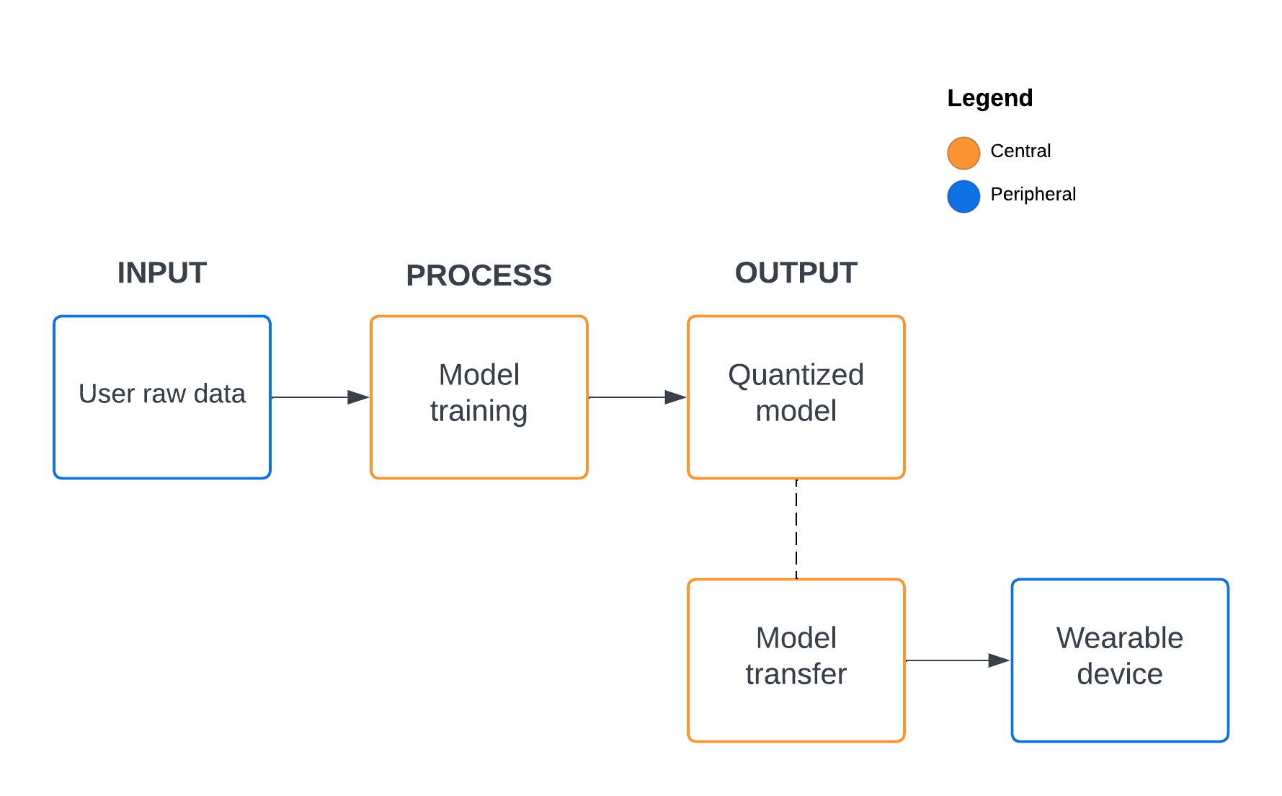

**Figure 3.1.** Wearable device and monitoring system relationship.

The wearable device system diagram is shown in Figure 3.1 wherein the user will generate his/her raw data to classify two hotspots, the on-target, and the off-target. It will automatically record the position by using the IMU component as well as the temperature and distance sensor. The raw data that is generated by the device is recorded and saved directly on the mobile application, this will save time and memory compared when saving from the device then sending via Bluetooth. After the recording, it will upload the data on the server then train the model using the Long short-term memory (LSTM) neural network. The data is shuffled and normalized accordingly then splits to 80% for training and 20% for validation. The training time is expected to be less than two (2) minutes while giving it small amount of data and using quantization to limit the model contents for transferring the file. The researchers also considered a lot of regularization to avoid overfitting since this is a big factor of this research outcome. Model is then ready for transfer using the Bluetooth characteristic of the device and mobile application. The device is given to receive the file contents of the model by using the Universal Unique Identifier (UUID) pair of connection. Finally, after the model contents are transferred, the device will initialize the model then starts calculating the prediction output of position tracking.

***BLE Characteristic***

Understanding the distinction between a central and a peripheral device is crucial for understanding BLE connection. In this section, the central and peripheral devices of the study is discussed. It is crucial to comprehend how a BLE connection operates, the functions of the various devices involved, and how data is exchanged from one device to another over the air to have a successful custom implementation.

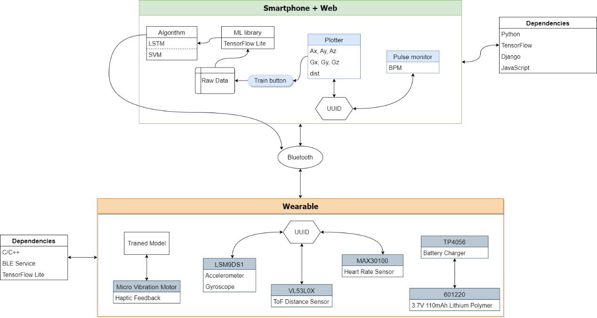

**Figure 3.2.** Design pattern of the study.

Figure 3.2 shows the simplified design pattern of this study. Basically, the smartphone works in conjunction with the web server while the wearable is a standalone device that will take the responsibility for position tracking. The dependencies showed are the main tools and libraries that the researchers will be using.

**Central**

The researchers consider having a website that acts as a central device for pairing the wearable device (peripheral) through Bluetooth connection. The main purpose of the website is to act like a server, this will handle the training for deep neural networks and monitor the system for live plotting. It includes the summary (training and validation) of the trained model that will be helpful for data analysis. The data collected sent by the peripheral device are stored in an array before the model is trained then the C-header file containing the hex array will be sent back to the device through Bluetooth file transfer by a block of 128 bytes of data iteratively.

**Peripheral**

The Arduino Nano 33 BLE Sense is the motherboard of the wearable device. The purpose of this peripheral device is to send data to the mobile application and retrieve the hex array content of the C-header file that will be used in position tracking. The mobile application and the wearable device have its compatibility when sending or receiving data using the cyclic redundancy check of 32-bit binary sequence or CRC32 file checksum. It will check if the two are similar after the file transfer is complete, if it is not, the model import will be cancelled. This happens because of the noise interference such as network errors and disk write errors.

***Design and Construction of the Wearable Device***

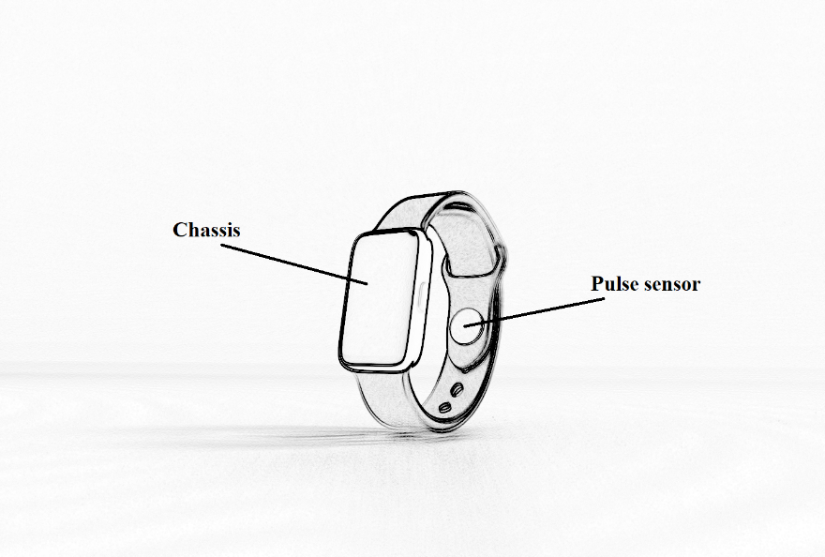

**Figure 3.3.** Expected output of the wearable device.

Figure 3.3 shows the expected output of the microcontroller based wearable device. The main components are protected with a chassis to prevent it from any dirt/debris and water particles that may cause from destroying the entire circuit. The chassis are also expected to be 3D printed made with a strong filament of plastic to add durability. It can also prevent some form of electric shock commonly known as Electrostatic Discharge (ESD) to the user, but this has a very small chance of occurrence because microcontrollers are designed to be low powered. The pulse sensor is located at the wrist strap that is directly pointing or close to the pulse of the user. The researchers plan to create a compact device like any other smartwatches that will fit to any people using it. Due to its size limitation, the design of the device and its subsystem is still subject to change and can be added more features for the monitoring system.

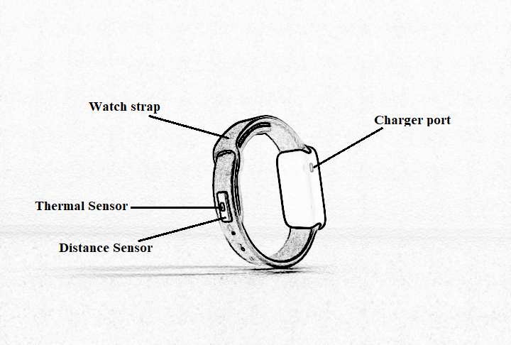

**Figure 3.4.** Expected output of the wearable device.

Beside the pulse sensor, the external components are shown in Figure 3.4. The thermal sensor measures the body temperature without contact in conjunction with another sensor to measure the distance between the device and the target. The purpose of placing these components externally is to make it the same pointing side of the user’s palm. Thus, contributes to the measurements of data for position tracking. The charger port is exposed on the outside of the chassis. It can connect with a Micro Type B connector that is commonly used in the Android charger. The researchers plan to have a customized watch strap to place the external components and attach the chassis into it. It can adjust the size of the strap to fasten to the small or wide wrist of the user. As seen in this Figure, there is an available space at the back of the chassis. This is where the researchers plan to place the pulse sensor if the previous one is uncomfortable.

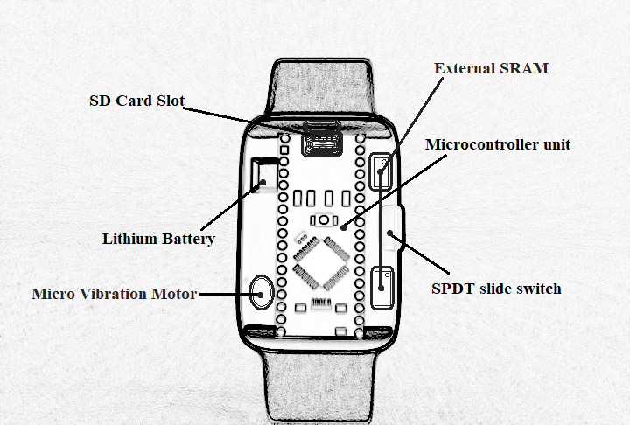

**Figure 3.5.** Chipset of the wearable device.

Figure 3.5 shows the components inside the chassis. The subcomponents (resistors, capacitors, wires, etc.) are also set to fit inside the device. The researchers plan to use a lithium polymer battery for 3.7 supply voltage for the MCU, this battery is safe as it has no leakage problem because the inside of the battery does not contain a liquid electrolyte. It is also a rechargeable battery to avoid the replacement each time the battery has run out. The SD card slot will serve as the storage for the trained model. In this way, if the user has already trained the model and planned to change the position tracking, they will not need to re-train the model again. Because the MCU has only 256KB of SRAM, the researchers plan to use an external SRAM. This external SRAM works in correlation with the SD card. This will also serve as the storage for the global variables for the incoming data from the mobile application.

Placement of the MCU in the chassis must be sturdy otherwise, the IMU recording will generate random and unstable numbers. Thus, position tracking will fail. The SPDT switch are placed on the side of the chassis with a placement of LED lights to indicate on and off status. Finally, the wearable device will be able to send a haptic feedback/warning to the patient by using the vibration motor. The researchers can tweak the frequency for user preferences so that they will sense the vibration.

***Design and Construction of the Mobile Application***

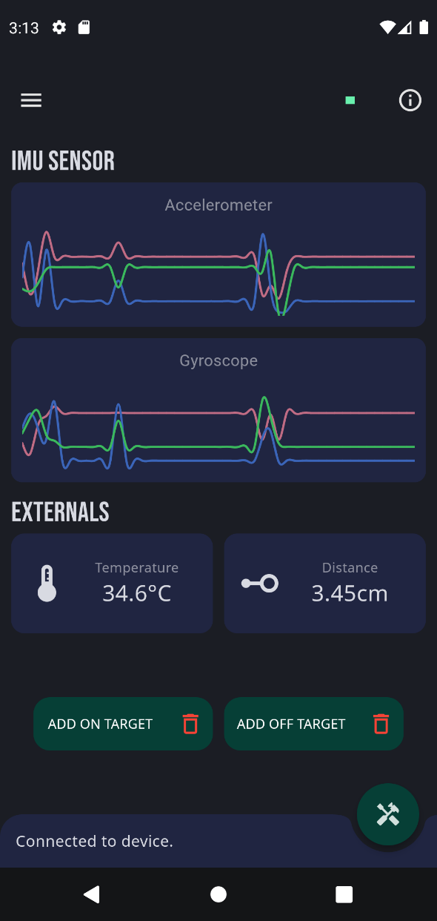

**Figure 3.6.** Mobile application design.

The design of the mobile application is shown in Figure 3.6 where the application is divided into three (3) section, the real-time monitoring system, the training application, and the status section where the success, progress, notification, and errors are displayed. The device must be in the on-state and the user must turn-on the Bluetooth before the connection. This implementation of the Bluetooth connection can be made using Flutter, it is a mobile application framework and uses Dart programming language provided by Google for building natively compiled and cross-platform applications from a single codebase.

The researchers decide to use the Python programming language as the backend of mobile application for training the model. Researchers uses Django, this is a web framework built on Python that uses the model-template-views (MTV) architectural design. The development of the backend encourages the researchers for rapid development, clean, and pragmatic design (Idris et al., 2020). The main purpose of this website is to receive input data then sends back the output model data. The neural network model is trained using the TensorFlow. It is a machine learning platform that helps to implement best practices for data automation, model tracking, performance monitoring, and model retraining (Fridriksdottir & Bonomi, 2020).

With being the Flutter as the frontend, it will handle the user input for training to use specify the on-target and off-target data for classification while displaying its data in the real-time graph. It then allows the user to begin training after the required parameters are met. User can also monitor the data being sent to the device in the form of displaying the total number of bytes left in progress.

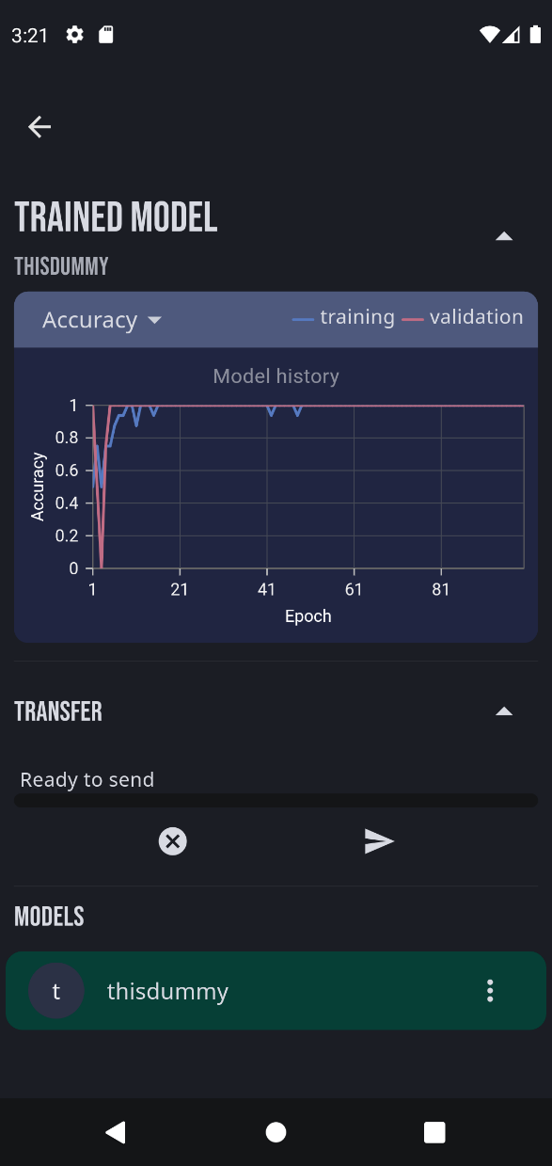

**Figure 3.7.** Design of the model-result viewer.

Figure 3.7 shows the results of model after the training process. The user can optionally analyze the validation accuracy and validation loss per epoch, in this way the user can have an option to retrain their model. The researchers will also make the application user friendly thus the user can have ease of using the interface. Retraining the model does not add up to the previous data of the model because it can expand the result of the hexadecimal data representation of the model causing the wearable device to go out of memory.

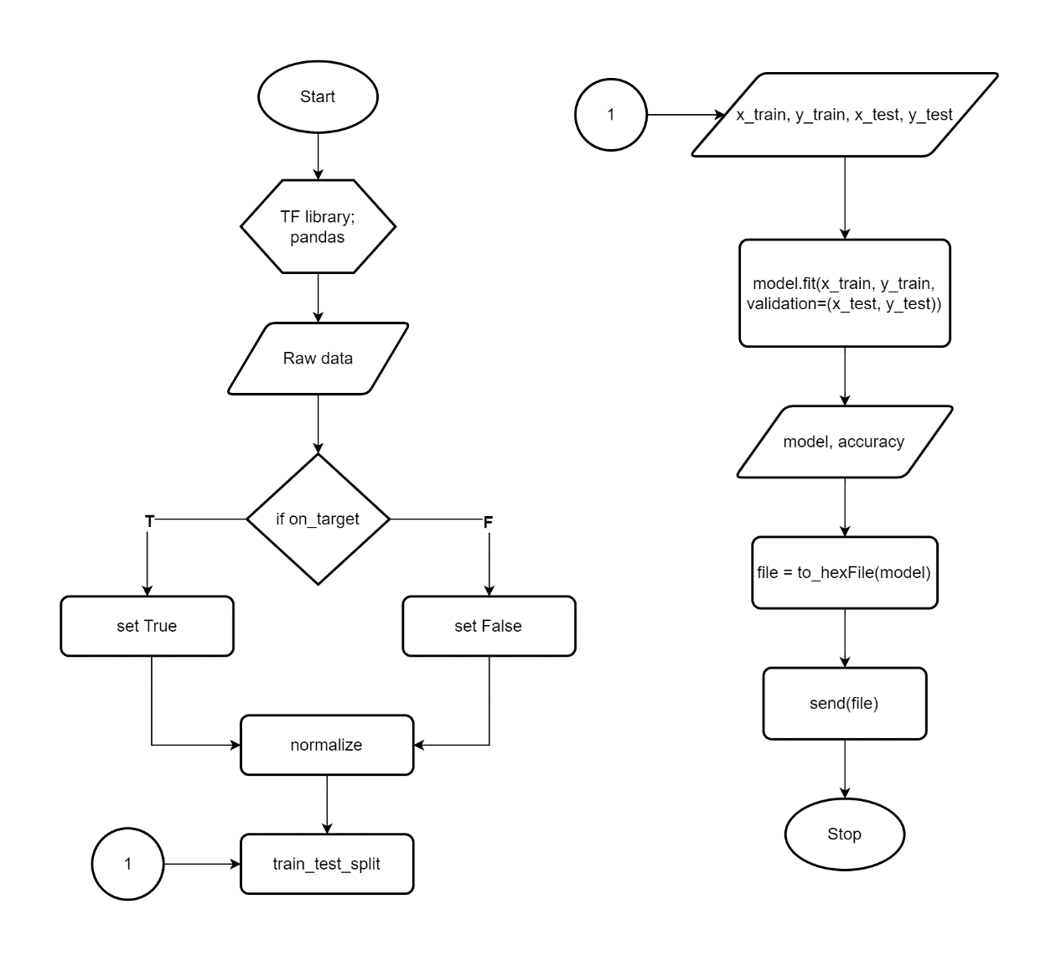

**Figure 3.8.** Server-side flowchart training behavior.

The behavior of the server-side or the central device is shown in Figure 3.8. This explains the detail of process when the data is handled by this service. After the data is prepared, the server will filter and classify each data by marking it as true for on-target and false for off-target this is done using data manipulation and analysis. Each data is then normalized and standardized to speed up the learning process and make each feature on a similar scale. For example, the Arduino LSM9DS1 library accelerometer range is set at ±4 g and ±2000 degrees per second for gyroscope (Arduino, 2022). Therefore, this range set values can be calculated as:

where ***x*** is the negative to positive readings and ***y*** is the min to max range value.

It is now safe and easy for the deep learning library to calculate the value of each feature. The sequential model will be used for building and training the model. In this way, the divided values can be easily maintained for manual changes. The cloud storage will handle the saved model and saving its path to the database. This allows the user to choose their desired model for sending the model to the device via Bluetooth.

***Testing and Evaluation of the System***

To ensure that the device and mobile application are functional, this study will be evaluated through a unit and integration test. This is where the researchers will run a test on each feature completion. The interface between modules may be problematic even while the modules themselves functions properly in isolation. Researchers may also provide a survey of how effective and comfortable the device is based on their experience. Intended audience such as technical critique, professors, and other respondents (a person with BFRB), will be also evaluated through a survey form.

Stability is also a key factor to make the study successful. The device's electronic components will be subject to inspection by the researchers since they will be compatible with the output specified by the software. Therefore, early error detection reduces the need for costly and time-consuming correction and a higher number of defects will be found when a software and hardware is tested more extensively.

***REFERENCES***

Abrahams, T., & Trotzky, A. (2017). *BFRBs: Compulsive Behaviors That Unintentionally Cause Physical Damage*. Anxiety.org. https://www.anxiety.org/what-is-body-focused-repetitive-behavior-bfrb

Addicore. (2019). *TP4056 / TC4056A Lithium Battery Charger and Protection Module*. Addicore. https://www.addicore.com/TP4056-Charger-and-Protection-Module-p/ad310.htm

Arduino. (2022). *Arduino_LSM9DS1*. Arduino CC. https://www.arduino.cc/reference/en/libraries/arduino_lsm9ds1/

Bradley, L. J., & Wright, N. G. (2020). Optimising SD Saving Events to Maximise Battery Lifetime for ArduinoTM/Atmega328P Data Loggers. *IEEE Access*, *8*, 214832–214841. https://doi.org/10.1109/ACCESS.2020.3041373

Closa, C. C., & Tambaoan, C. A. (2018). *Development of a Remotely Monitored Health Status Wristband*. Retrieved from Cavite State University - Main Campus Library.

Costanzo, S., & Flores, A. (2020). A non-contact integrated body-ambient temperature sensors platform to contrast COVID-19. *Electronics (Switzerland)*, *9*(10). https://doi.org/10.3390/electronics9101658

Crazell. (2022). *601220*. Crazell Technology Limited. https://www.crazell.com/product/601220/

Cruz, F. R., Torres, J., Baltazar, J. M., Naungayan, K. P., Villaverde, J. F., & Linsangan, N. (2016). Body Position Detection Using Accelerometer Integration Human Belt with GPS Localization Interconnected through GSM. *ASEAN Journal of Engineering Research*, *5*, 1 to 12. https://ejournals.ph/article.php?id=13386

Elprocus. (2022). *What is SPDT Switch : Working & Its Applications*. 2022. https://www.elprocus.com/spdt-switch/

Estrada, J. E., & Vea, L. A. (2020). Real-Time Human Sitting Position Recognition using Wireless Sensors. *Proceedings of the 2020 2nd International Conference on Image, Video and Signal Processing*, 133–137. https://doi.org/10.1145/3388818.3393714

Fridriksdottir, E., & Bonomi, A. G. (2020). Accelerometer-based human activity recognition for patient monitoring using a deep neural network. *Sensors (Switzerland)*, *20*(22), 1–13. https://doi.org/10.3390/s20226424

HabitAware. (2020). *Keen*. Habitaware. https://habitaware.com/

Houghton, David C., Alexander, J. R., Bauer, C. C., & Woods, D. W. (2018). *Body-focused repetitive behaviors: More prevalent than once thought?* (Issue 2000, pp. 389–393). Psychiatry Research. https://doi.org/https://doi.org/10.1016/j.psychres.2018.10.002.

Houghton, David Christian. (2019). Sensory Processing in Body-Focused Repetitive Behaviors. *Doctoral Dissertation. Texas A&M University*, *August*. https://hdl.handle.net/1969.1/174003

Idris, N., Feresa, C., Foozy, M., & Shamala, P. (2020). A Generic Review of Web Technology: DJango and Flask. *International Journal of Advanced Science Computing and Engineering*, *2*(1), 34–40. https://ijasce.org/index.php/IJASCE/article/view/29

Jalalifar, S., Kashizadeh, A., Mahmood, I., Belford, A., Drake, N., Razmjou, A., & Asadnia, M. (2022). A Smart Multi-Sensor Device to Detect Distress in Swimmers. *Sensors*, *22*(3), 1–15. https://doi.org/10.3390/s22031059

Jiang, Z. X., Park, K. H., Kim, J. H., Jiang, Y. W., Xu, D. P., & Hwang, S. M. (2020). Analysis and design of a new linear vibration motor used to reduce magnetic flux leakage in in-vehicle infotainment. *Applied Sciences (Switzerland)*, *10*(10). https://doi.org/10.3390/APP10103370

Kok, M., Hol, J. D., & Schön, T. B. (2017). Using inertial sensors for position and orientation estimation. *Foundations and Trends in Signal Processing*, *11*(1–2), 1–153. https://doi.org/10.1561/2000000094

Komarizadehasl, S., Mobaraki, B., Ma, H., Lozano-Galant, J. A., & Turmo, J. (2022). Low-Cost Sensors Accuracy Study and Enhancement Strategy. *Applied Sciences (Switzerland)*, *12*(6). https://doi.org/10.3390/app12063186

Kurniawan, A. (2021). *Arduino Nano 33 BLE Sense Board Development*. IoT Projects with Arduino Nano 33 BLE Sense. https://doi.org/10.1007/978-1-4842-6458-4_2

Lee, D. K., & Lipner, S. R. (2022). The Potential of N-Acetylcysteine for Treatment of Trichotillomania, Excoriation Disorder, Onychophagia, and Onychotillomania: An Updated Literature Review. *International Journal of Environmental Research and Public Health*, *19*(11). https://doi.org/10.3390/ijerph19116370

Lu, L., Zhang, J., Xie, Y., Gao, F., Xu, S., Wu, X., & Ye, Z. (2020). Wearable health devices in health care: Narrative systematic review. *JMIR MHealth and UHealth*, *8*(11). https://doi.org/10.2196/18907

Maxim Integrated. (2022). *MAX30100*. Maxim Integrated. https://www.maximintegrated.com/en/products/sensors/MAX30100.html

Microchip. (2022). *23LC1024 2.5-5.5V 1Mb SPI Serial SRAM*. Microchip Technology Inc. https://www.microchip.com/en-us/product/23LC1024

Navarro, M. R., Valdez, N., & Enojas, M. J. (2019). Real Time Wearable Locator Device for Distress. *Innovatus*, *2*. https://ejournals.ph/article.php?id=14065

Searle, B. L., Spathis, Di., Constantinides, M., Quercia, D., & Mascolo, C. (2021). Anticipatory Detection of Compulsive Body-focused Repetitive Behaviors with Wearables. *Proceedings of MobileHCI 2021 - ACM International Conference on Mobile Human-Computer Interaction: Mobile Apart, MobileTogether*. https://doi.org/10.1145/3447526.3472061

Smitha Bhandari, M. (2020). *Understanding Body-Focused Repetitive Behaviors*. WebMD. https://www.webmd.com/mental-health/ss/slideshow-understanding-body-focused-repetitive-behavior

Son, J. J., Clucas, J. C., White, C., Krishnakumar, A., Vogelstein, J. T., Milham, M. P., & Klein, A. (2019). Thermal sensors improve wrist-worn position tracking. In *npj Digital Medicine* (Vol. 2, Issue 1). npj Digital Medicine. https://doi.org/10.1038/s41746-019-0092-2

STMicroelectronics. (2018). *LSM9DS1 iNEMO inertial module, 3D magnetometer, 3D accelerometer, 3D gyroscope, I2C, SPI*. STMicroelectronics N.V. https://www.st.com/resource/en/datasheet/lsm9ds1.pdf%0Ahttp://www.st.com/en/mems-and-sensors/lsm9ds1.html