**Development of Microcontroller Based Wearable Device with Monitoring System for Body-Focused Repetitive Behavior**

*Bahillo, Ryan Christopher D.*

An undergraduate design project prepared and submitted to the faculty of the Department of Computer and Electronics Engineering (DCEE), College of Engineering and Information Technology (CEIT), Cavite State University (CvSU), Indang, Cavite in partial fulfilment of the requirements for the degree of Bachelor of Science in Computer Engineering with Contribution No. _______. Prepared under the supervision of Prof. Marivic G. Dizon.

**CHAPTER I**

***INTRODUCTION***

Body-focused repetitive behavior (BFRB) is a term that refers to a group of compulsive habits that unintentionally harm one's body and alter one's appearance but the factors that predispose individuals to these behaviors are poorly understood. The main distinction between BFRBs and other compulsive behaviors that hurt the body is that BFRBs are characterized by repetitive, self-grooming behaviors that result in damage to the body. Pulling, picking, biting, or scraping one's hair, skin, or nails are examples of these behaviors. Trichotillomania such as hair pulling, Dermatillomania such as skin plucking, also known as Excoriation disorder, and Onychophagia are among the disorders such as compulsive nail biting. According to Smitha Bhandari (2020), ***“As many as 1 in 20 people have a BFRB, but they can be dismissed as bad habits.”*** It is also stated that obsessive-compulsive disorder (OCD) is not the same as BFRB. OCD is a mental health disorder characterized by intrusive, distressing thoughts (obsessions) and repetitive behaviors or mental acts (compulsions) performed to alleviate anxiety. Compulsions in OCD are often elaborate and may not be directly related to body-focused grooming behaviors. Someone with OCD may engage in rituals such as checking, counting, or arranging items to reduce anxiety triggered by obsessions. Though they share some similarities with OCD, BFRBs typically involve a different underlying mechanism and response to treatment. BFRBs are often managed with habit-reversal therapy, cognitive-behavioral therapy, or medication, while OCD is typically treated with cognitive-behavioral therapy and exposure and response prevention therapy.

In approach of Son et al., (2019) to BFRB monitoring, a study shows the data collected in different locations on the head can be calculated by measuring the distance between each pair of the target locations on the head using the data from the proximity and the Inertial Measurement Unit (IMU) sensors. They disassembled the N68 Fitness Tracker to utilize its main component as their Micro Controller Unit (MCU) – Nordic nrf52832 and sensors. The Keen created by HabitAware (2020) is a wearable-based tracking device to detect BFRB activity. It uses gesture recognition for the initial use that makes the device recognize such habit. It then transmits a vibration signal to the patient wearing the device. Despite that, it is unclear how well-suited they are for BFRB monitoring or treatment because there has been no published peer-reviewed study showing the effectiveness of the device.

This study aims to develop a microcontroller based wearable technology that conveys a signal to the user and is integrated with a mobile application for monitoring of repetitive behavior relative to its position and motion sensors in real time. According to (https://www.frontiersin.org/journals/psychology/articles/10.3389/fpsyg.2023.1071532/full), Habit-reversal therapy (HRT) is a type of behavioral therapy that aims to help individuals become more aware of their BFRB behaviors, learn to recognize triggers, and develop alternative responses to replace the habit. The development of the wearable device can assist in the treatment of the individual’s repetitive behavior. Wearable devices can be designed to provide sensory feedback (such as vibration or buzzing) when they detect the individual engaging in the BFRB behavior. This feedback serves as a reminder to the individual to stop the behavior and can help increase awareness of when it occurs. By interrupting the cycle of the behavior and providing a cue for the individual to engage in a competing response (such as a relaxation technique or a specific behavior incompatible with the BFRB), wearable devices can support the principles of habit-reversal therapy. The development of the researcher’s device can send a signal to the patient by using the vibration motor as haptic feedback along with a passive buzzer to increase the awareness in engaging the repetitive behavior of an individual. It has a function to implement a trained model to the microcontroller by using its IMU in addition to proximity and thermal sensor to use as its parameters. By this, the user can control the repetitive behavior. It should be noted that this study is not a medication but only assists BFRB patients in self-awareness.

***Objectives of the Study***

The study was conducted in the creation of a microcontroller-based wearable device that was used to help the patient control its repetitive behavior. To accomplish this, the following objectives were met:

1. To develop a microcontroller based wearable technology that conveys a signal to the user.
2. To embed mobile application for monitoring and motion sensors in real time.
3. To assist in the treatment of Body-Focused Repetitive Behavior using the wearable device.
   1. Trend analysis of percentage change over time.
   2. Calculate the overall improvement experienced by the user over several days of use.
4. To evaluate the effectiveness and performance of the wearable device such as hardware and software stability when predicting with a neural network.

***Scope and Limitations of the Study***

This study covers the development of a microcontroller based wearable device that can detect body-focused repetitive activities such as trichotillomania, excoriation, and onychophagia. It documents how the researcher constructs the wearable device, development of the mobile application, and web server for accessing neural network training. This study also tests how the device accurately predicts the hotspot location for the repetitive behavior of the user. The numerical results of the usage taken by the user in several days are then calculated for trend analysis to find the percentage of change. It is done using device evaluation through test and trials, a survey to evaluate the acceptability of the developed software application, and qualitative field test of the wearable device for a period of selected days.

***Significance of the Study***

The findings of the study could be a great help in providing crucial information and knowledge about the development of the device. It can also help the scope of the study in treating their behavioral disorders. Specifically, the results of this study could benefit the following:

**Individuals with BFRB.** The study could help treating the behavioral disorders of individuals. It can benefit from the constructed device by the researchers. The device can understand the external triggers that lead a person to engage in their BFRB, as well as the external events that reinforce them that make this behavior more likely to happen again in the future.

**Society.** The study could give basic understanding of what is BFRB, the difference of other compulsive behaviors, and why a person urges to occur this kind of behavior. This could also help society to give insights on how the device can help to manage its anxiety for their repetitive behavior.

**Medical Professionals.** The findings of this study can give medical professionals a finding on how haptic feedback helps a patient prevent to engage their repetitive behavior. They can also evaluate the effectiveness of this device towards their target and future audiences.

**Future Researchers.** This study can be beneficial to the new researchers that are conducting related research that may be used as their reference data. This can also serve as their cross-reference that can give them a background or an overview for the construction of the wearable device.

***Time and Place of the Study***

The wearable device underwent its initial conceptualization and construction phase in August 2023, within Alfonso Cavite, Philippines. Following a series of iterative adjustments and refinements to its design and construction methodology, the device reached its final stage of development in February 2024. A comprehensive study was undertaken to evaluate the efficacy and functionality of the device during a period from March 3rd, 2024, to April 15th, 2024. The Testing and evaluation spanned from various locations of Alfonso to perform data gathering of each participant.

***Definition of Terms***

To have a full understanding of this paper, the following are the prominent terms used as presented in this study. This is intended to assist in understanding commonly used terms and concepts when reading, interpreting, and evaluating scholarly research in this study.

**Accelerometer** is a device that measures acceleration, which is the rate of change of the velocity of an object. They measure in meters per second squared (m/s2) or in G-forces (g).

**Anticipatory Detection**

**Bluetooth Low Energy (BLE)** is a power-conserving variant of Bluetooth personal area network technology, designed for use by Internet-connected machines and appliances.

**Body-Focused Repetitive Behavior (BFRB)** refers to a group of psychological disorders characterized by repetitive self-grooming behaviors that result in damage to the body. These behaviors are often compulsive in nature and can lead to physical and emotional distress.

**Checksum** is a small-sized block of data derived from another block of digital data for the purpose of detecting errors that may have been introduced during its transmission or storage.

**C-plus-plus (C++)**

**Deep Learning** is a type of machine learning based on artificial neural networks in which multiple layers of processing are used to extract progressively higher-level features from data.

**Dart** is a programming language developed by Google, popular for its simplicity and speed. It is used for building various types of applications, especially mobile apps with Flutter.

**Gyroscope.** It is a device that can measure and maintain the orientation and angular velocity. These can measure the tilt and lateral orientation of the object.

**Python**

**CHAPTER II**

***REVIEW OF RELATED LITERATURE***

This chapter contains literature and studies in both local and foreign to support the study. To ensure its relevance, the researchers used studies from the year 2016–present. This weighs information and conclusions from existing literature of the topic. This section can also identify gaps or contradictions in current literature, which can then be discussed further after reviewing the study. Through the study, the researchers addressed these gaps and resolved these conflicts.

***Foreign Literatures***

**Body-focused repetitive behavior interventions**

As Houghton, D. (2018) behavioral interventions have been utilized to block symptom performance and induce extinction of the BFRB habit to permit fewer instances of symptom performance. It is hypothesized that by continuing to abstain from the BFRB symptoms, reinforcement is no longer supplied, and the behavior should become less common over time.

A study about using N-Acetylcysteine (NAC) as solution for the treatment of Trichotillomania, Excoriation Disorder, and Onychophagia found that it was effective in lowering compulsive behaviors in BFRB disorders. According to Lee & Lipner, (2022), although NAC has been shown to be effective in the treatment of BFRB problems, evidence is taken from a small number of clinical studies and case reports involving a small number of individuals. Larger, longer-term trials are required to properly demonstrate NAC's effectiveness in these illnesses.

**Wearable device integration**

In a related study of Son et al., (2019) published in npj Digital Medicine, a team lead by Child Mind Institute researchers found that utilizing thermal sensors in addition to inertial measurement and proximity sensors, a wearable tracking system they designed achieves greater accuracy in position tracking. Tingle, a wrist-worn gadget, could also tell the difference between actions aimed at six distinct parts of the head. The paper, titled "Thermal Sensors Improve Wrist-worn Position Tracking," provides preliminary evidence of the device's potential use in the diagnosis and treatment of excoriation disorder, nail-biting, trichotillomania, and other body-focused repetitive behaviors.

As Closa & Tambaoan (2018), microcontrollers such as Arduino Nano is effective to make a low-cost wearable device. They also added a digital thermometer, oximeter, Organic Light Emitting Diode (OLED) display that is capable of sensing body temperature, heart rate, and oxygen saturation. It then displays the information in real-time through an OLED screen. Data is stored in their database using a Hypertext Markup Language (HTML) website. Thus, Arduino can make HTML requests and responses through the internet.

According to Kok M. et al., (2017), to integrate inertial measurements with other sensors and models for position and orientation estimation, it is necessary to precisely define the quantities obtained by the inertial sensors as well as characterize the usual sensor errors. These physical properties are monitored along three sensitive axes in 3D accelerometers and 3D gyroscope sensors. They are measured in terms of an output voltage, which is translated to a physical measurement using factory calibration values. Even if the sensors are normally calibrated at the factory, inaccuracies, which are time-varying, might still exist. (https://arxiv.org/pdf/1704.06053.pdf)

**Machine learning for wearable devices**

According to the study of Wang H. et al., (2023), traditional machine learning (ML) algorithms like support vector machine (SVM), backpropagation neural network (BP), decision tree (DT), and random forest (RF) can perform gesture recognition classification. They used an inertial sensor-based gesture data acquisition system with the goal of constructing a gesture-recognition model based on the collected static and dynamic gesture datasets. (<https://www.mdpi.com/2072-666X/14/5/947>)

In a study conducted by Liu S. et al. (2020), a method for monitoring the dynamic movement of human limbs using wearable technology was introduced. This method integrates motion capture with velocity detection, eliminating the need for additional equipment. They developed a wearable device by combining micro tri-axis flow sensors with micro tri-axis inertial sensors. This device enables precise measurement of three-dimensional motion velocity, acceleration, and attitude angle during various daily activities, as well as strenuous and prolonged exercises. Additionally, they employed a back propagation (BP) neural network to discern the coordination within limbs during walking and running activities. (file:///C:/Users/Bahillo/Desktop/s41467-020-19424-2.pdf)

***Local Literatures***

**Monitoring applications**

As Navarro M. et al., (2019). A low-cost prototype was created by embedding a pulse rate sensor, Global Positioning System (GPS), and Global System for Mobile communication (GSM) modules in a wearable wrist band. Additionally, an SMS message is sent to an emergency contact, and a locating map may be seen on a smart phone or computer. The response time for sending a distress notification varies depending on the strength of the mobile network signals. (https://innovatus-pub.github.io/papers/2019/paper9.pdf)

A study of Cruz F. et al., (2016) from Mapua University in Manila, accelerometer integration human belt is utilized to examine the accelerometer's capacity for body detection. The prototype sends messages if the predetermined values are reached by the accelerometer reading. This study created a human belt tracking belt gadget that enables users to text a selected contact with their current position using short message service (SMS). The gadget determined the user's activities of daily living, which were limited to walking, sitting, standing, and lying. (https://ejournals.ph/function/reader1/read2/web/reader.php?id=uploads%2Farchive%2FAJER%2FVol.+5+No.+1+%282016%29%2FArticles%2FA1_Cruz.pdf&di=13386)

***Comparative Analysis***

Bla bla bla bla bla bla bla bla bla bla bla bla bla bla bla bla bla bla bla bla bla bla bla bla bla bla bla bla bla bla bla bla bla bla bla bla bla bla bla bla.

1. Development of Microcontroller Based Wearable Device with Monitoring System for Body-Focused Repetitive Behavior.
2. Development of a Remotely-Monitored Health Status Wristband.
3. Thermal sensors improve wrist-worn position tracking.
4. A Smart Multi-Sensor Device to Detect Distress in Swimmers.

|  |  |  |  |  |  |  |  |  |  |
| --- | --- | --- | --- | --- | --- | --- | --- | --- | --- |
| Study | Sensor | | | | | Neural Network | Screen Display | Mobile App | Web Server |
| Accelerometer | Gyroscope | Distance | Temperature | Pulse |
| 1 | Yes | Yes | Yes | Yes | Yes | Yes | No | Yes | Yes |
| 2 | No | No | No | Yes | Yes | No | Yes | No | No |
| 3 | Yes | No | Yes | Yes | No | Yes | No | Yes | No |
| 4 | Yes | No | No | No | Yes | No | Yes | No | No |

***Conceptual Framework***

**Figure 2.1.** Design and development plan for wearable and monitoring device.

Figure 2.1 shows on how the researchers will come up with the construction of the device. The researchers use an Input-Process-Output model for planning the development. Generally, it enumerates the hardware and software requirements to have an effective outcome. While conducting the study, researchers also needed to evaluate each process to test the performance and effectiveness of each feature completion until certain requirements are satisfied.

**CHAPTER III**

***METHODOLOGY***

In this chapter, the researcher presents the approach in making the wearable device. It includes the research design and pattern to achieve the objectives of this study. The materials and estimated cost are also shown in this chapter to give understanding on the features and emphasize its functions. The evaluation of performance is discussed at the end of this chapter whereas the crucial part of making the device effective.

***Materials***

**Arduino Nano 33 BLE Sense** is a lot more powerful processor than the ordinary Arduino Nano. It uses the nRF52840 from Nordic Semiconductors with a 32-bit ARM Cortex-M4 CPU running at 64 MHz. The size of its program memory is 1MB and 256KB of SRAM for more variables. It has an integrated LSM9DS1 Inertial Measurement Unit sensor, which typically includes an accelerometer, gyroscope, and magnetometer. These sensors allow the board to measure acceleration, rotation, and magnetic fields in three-dimensional space, enabling precise motion tracking and orientation detection. The main feature of this board is its capability of transmitting and receiving data using the Bluetooth Low Energy (BLE) communication chipset.

**VL53L0X Time-of-Flight Sensor** works optically by emitting short infrared pulses and measuring the time it takes for the light to be reflected. The sensor can measure distances up to 2 meters, though it depends significantly on several conditions like surface reflectance, field of view, temperature etc. In general, developers can expect surfaces up to 60cm to work, after that they need to make sure the surface is reflecting well enough.

**Micro Vibration Motor** is typically used to describe a small electric motor designed to generate vibrations on a miniature scale. These motors are commonly found in various electronic devices such as smartphones, wearables, and gaming controllers. They are used to provide haptic feedback, notify users of incoming calls or messages, and for vibration alerts in various applications. The rated voltage is 2.5 to 3.8V, it vibrates from 2V up to 5V, higher voltages result in more current draw but also a stronger vibration.

**LP503035 Lithium Polymer Battery** is a rechargeable battery, it has an output range of 4.2V when completely charged to 3.7V. This battery has a capacity of 500mAh and can be easily incorporated into a variety of electrical products. The battery has one prismatic cell in a one-series, one-parallel arrangement. Over-charge, over-discharge, over-current, and short-circuit protection are all provided by integrated battery PCBs or protection circuit boards.

**TP4056 Charger Module** is a lithium battery charger for a single cell battery, protecting the cell from over and under charging. It has two status outputs indicating charging in progress and charging complete. It also has a programmable charge current of up to 1A. It can be used to charge batteries directly from a USB port since the working input voltage range is 4V to 6V.

**Single Pole, Double Throw (SPDT) switch** has a single input and two dissimilar outputs which is used to control two dissimilar circuits through a similar single input.

**Micro SD Card Module** enables to read or write to the memory card and connect with it. The SPI protocol is used for the module interfaces. High-capacity memory cards cannot be used with these modules. Typically, these modules have a maximum capacity of 2GB for SD cards and 16GB for micro-SD cards.

**MLX90614 Temperature Sensor** is an infrared thermometer for non-contact temperature measurements. This component has a pulse width modulation digital output setting (PWM). The 10-bit PWM is typically set up with an output precision of 0.14°C and designed to send temperature readings constantly in the range of -20 to 120°C.

**BC547** **Transistor** is a general-purpose NPN bipolar junction transistor (BJT) commonly used in electronic circuits for amplification or switching purposes. The maximum current gain of BC547 is 110 up to 800.

**Carbon Film Resistor (220 ohms)** is a cylindrical in shape, resembling a small capsule, and their resistance value is indicated by a series of colored bands painted around their body. The color code is used to determine the resistance value, tolerance, and sometimes even the temperature coefficient of the resistor. Carbon film resistors are widely used in electronic circuits due to their reliability, accuracy, and low cost.

**Pololu U3V12F9 9V Step-Up Voltage Regulator** is a compact and efficient electronic module used for boosting input voltages to a fixed 9V output voltage. It can convert input voltages as low as 2.5V up to 9V, making it suitable for a wide range of applications where a stable 9V power source is required. This regulator utilizes a step-up switching regulator topology, which enables it to achieve high efficiency while minimizing power loss and heat generation. It features a synchronous rectification mechanism, which further enhances efficiency by reducing voltage drop across the device.

***Budgetary Estimate***

List of materials and its corresponding prices are shown in Table 1. The materials will be used in the creation of the wearable device must be minimized yet functional. It should stand the test of time and the balance between high quality materials should keep the costs at an appropriate level. Components prices are based on existing product pages in online commerce platforms as of the time of this writing. The shipping fee will also be added to material cost, therefore summing up to Php 5,220.

**Methods**

The research methodology provides a comprehensive prototyping process where the literature is critically reviewed, important prototype goals are examined, key techniques are reviewed critically, and links between techniques are analyzed. These insights are then combined. The construction of the wearable device for body-focused repetitive behavior enables the device for anticipatory detection, it detects engaging behavior for a specific part of the body in real-time.

To make the device operational, a combination of programming languages is utilized. C++ is used for Arduino programming, ensuring seamless integration and control of hardware components. Dart is utilized for developing a mobile application for monitoring system, providing a user-friendly interface and real-time communication capabilities. Additionally, Python is used for the web server, enabling efficient data processing and remote access to device functionalities. These programming languages complement each other, working together to achieve the objectives of the study by facilitating robust functionality, accessibility, and user interaction across various platforms.

The process of testing and evaluating the device takes weeks due to the utilization of qualitative field-testing methods. It was carried out in multiple locations within the barangay of Alfonso, Cavite to ensure diverse feedback and perspectives. Various functionalities of the device undergo a thorough evaluation to ensure optimal performance and user experience. Despite the testing procedures, the device maintains a wearable design with a compact form factor, suitable for users of varying wrist sizes. Thus, provides a simple and flexible user experience, making manual testing easy to perform.

**Table 1.** List of components and corresponding costs

|  |  |  |  |
| --- | --- | --- | --- |
| **Purpose** | **Component** | **Quantity** | **Unit Cost (Php)** |
| **Microcontroller** | Arduino Nano 33 BLE Sense | 1 | 3,770 |
| **Proximity** | VL53L0X ToF Sensor | 1 | 120 |
| **Tracker** | MLX90614 Temperature Sensor | 1 | 800 |
| Pulse Sensor | 1 | 145 |
| **Haptic Feedback** | Micro Vibration Motor | 1 | 150 |
| **Power** | 601220 Lithium Polymer Battery | 1 | 110 |
| TP4056 Charger Module | 1 | 40 |
| **Connections** | SPDT Slide Switch | 1 | 15 |
| Stranded Wire | 2 | 10 |
| Jumper Wire | 20 | 60 |
| Total |  |  | 5,220 |

This also does not include miscellaneous items which are the device chassis or case and other minor hardware requirements of the device. Summing it up with the allocated Php 1,000 for the miscellaneous, the budgetary estimate of this study is **Php 6,220**. The website can also cost money by deploying and maintaining the server running. However, there are free web hosting available online that can handle a limited amount of storage and memory usage.

**Schematic Diagram of the Wearable**

In Figure 1, careful consideration was given to the components used and their connections to ensure effectiveness in achieving the objectives. The Arduino Nano 33 BLE Sense serves as the main board or the central component of the device. Its primary tasks include enabling the functionality of other components, establishing connections via BLE, and performing calculations based on sensor readings. The sensors used include the accelerometer and gyroscope of the LSM9DS1 inertial measurement unit (IMU) sensor, the VL53L0X time-of-flight (ToF) distance sensor, and the MLX90614 infrared (IR) temperature sensor, which are crucial parameters for anticipating user's repetitive behavior. The data are then used to classify anticipating behavior and use this as a signal to operate the vibration and passive buzzer.

Figure 1. Schematic Diagram of Connected Components of the Wearable Device.

The SD Card Module serves as the physical storage for machine learning components and behavioral activities. To power the circuit, two 3.7V 500mAh LiPo batteries are connected in parallel and linked to the TP4056 charging module, ensuring the wearable device remains rechargeable for extended use. However, the charging module alone cannot power the MCU, as the MCU requires an input voltage of 4.5 – 21V, while the charging module outputs only 3.7 – 4.2V, consistent with the LiPo batteries. To address this issue, the researcher used the U3V12F9 Step-up voltage regulator in conjunction with the charging module. This voltage regulator accepts a minimum input voltage of 2.5V and provides a constant output voltage of approximately 9V, effectively meeting the power requirements of the MCU.

**Design and Development of the Microcontroller Based Wearable Device**

Figures 2 and 3 show the dimensions (length, width, and height in millimeters) of the microcontroller based wearable device. The researcher used this dimension to fit all the components inside. The components are protected with a chassis to protect it from any dirt/debris and water particles that may cause from destroying the entire circuit. The chassis is 3D printed with strong filament of plastic for durability. It can also prevent some form of electric shock commonly known as Electrostatic Discharge (ESD) to the user, but this has a very small chance of occurrence because microcontrollers are designed to be low powered. The researcher used to create a compact wearable design like any other smartwatches that can fit any person using it.

Figure 2. Three-dimensional design of the main board chassis

Figure 3. Three-dimensional design of the external sensors’ chassis

The components are shown in Figures 4 and 5. The researcher placed the MCU at the top of the circuit to consider the reliability of the BLE connection. The passive buzzer and the micro vibration motor are placed at the edge of the circuit. Therefore, the user makes it easier to recognize the haptic feedback. Two LiPo batteries with a total of 1000mAh are used to double the capacity for extended use. These power supplies are stacked to each other while charging port and switch are placed at the bottom to match the design of the 3D printed chassis. The charger port is exposed on the outside of the chassis. It can connect with a Micro USB Type B connector that is commonly used in the Android charger.

The temperature sensor measures the body temperature without contact in conjunction with another sensor to measure the distance between the device and the target. The purpose of placing these components externally, rather than alongside the MCU which faces outward, is to orient them toward the side of the user's palm. Thus, effectively contributes to the measurements of data for position tracking. Figure 6 shows the completely assembled wearable device. The researcher customized a watch strap to connect the main chassis and the external chassis. It can adjust the strap size to accommodate all sizes of wrists.

Figure 4. Components inside the main chassis.

Figure 5. External components connecting to the main chassis.

[IMAGE]

Figure 6. Completely assembled wearable device.

**Software Development**

**Wearable Device**

The programming language used to create the software for the wearable is C++ using the Arduino IDE. The researchers used the library TensorFlowLite for microcontroller machine learning or TinyML. The researchers have allocated 120KB reserved for machine learning component/model for classification, average model size is 50-80KB. The SDFat library works in conjunction with ArduinoJSON library to save the machine learning component and collects data of the occurred detection in json format. The ArduinoBLE library is important in sending sensor data and receiving commands through the mobile application. This also makes the mobile application able to send the machine learning component through BLE. The library used for reading sensor values are LSM9DS1, VL53L0X, and MLX90614 which are for accelerometer and gyroscope, distance, and temperature sensor. The sensor values are normalized ranging from zero to one to increase the classification performance.

The researchers used to buzz and vibrate the wearable for an interval of 5 seconds per classification of anticipating behavior. While researchers are working to test the components, they noticed that the output voltage of each digital pin of the microcontroller is 3.3V and the components require more voltage to make the vibration and buzzer effective on noticed. The passive buzzer requires to have an alternating of high and low signal to make it work but researchers noticed a decrease by half of the peak voltage which is 1.65V. Therefore, the researchers used the BC547 BJT transistor to make a common-collector transistor configuration to increase the current gain. This is also applied for the vibration motor to increase the strength of haptic feedback.

The researchers used a Generic Attribute Profile (GATT) for Bluetooth connection. It consists of service, this can have one or multiple characteristics, and each service differentiates itself from others through a distinct numerical identifier known as a Universally Unique Identifier (UUID). The researcher used a notify property to write the sensor values to the mobile application in real-time. Before the wearable continues to receive the model via BLE, the mobile application sends calculation of 32-bit cyclic redundancy check (CRC32) to detect errors in digital data transmission or storage. It achieves this by generating a checksum, a short sequence of bits based on the data being checked, which is appended to the data. When the data is received or retrieved, CRC32 is recalculated from the wearable device, and if the checksum doesn't match the one initially generated, it indicates that the data has been corrupted or altered in some way during transmission or storage. The error notifies the mobile application that the data does not match, the model cannot initialize, and the user can resend the contents of model again. The error happens when there is a noise interference. This interference can be caused by electromagnetic interference, signal attenuation, or other external factors, but this is rare to happen. The researchers used this operation to detect errors for efficiency and memory management of the wearable because instead of comparing the two large data together, they can instead compare an eight-byte character plus the two-byte prefix which significantly reduce the memory consumption of the wearable device.

**Mobile Application**

The researchers used the Flutter framework in the Dart programming language for building a mobile application. Although the framework is a multi-platform, the mobile application only supports Android operating system because some packages do not support iOS specially for Bluetooth operations. In Figure **x,** the accounts page is shown. The researchers have integrated the HTTP Service in the client-side of the system to send requests to the server. The user must create their account on the register page on first use. Once they have created their account, they can use their credentials to login to the mobile application. The user does not need to login again their credentials to use the mobile application because once the user has logged in, their credentials including the token are saved and encrypted in the application to authenticate each time the user has opened the application.

Figure ... Accounts Page of the Mobile Application.

In Figure **x**, the researchers have divided the page for Dashboard, this is the monitoring system of the application. The user can analyze its improvements over the week or month. The UI will indicate if the data is improving if the trend is decreasing otherwise, not improving. The researchers have integrated calculations to analyze the trend for user experience. The improvements section in the monitoring system is calculated using the mean of the percentage change:

Where are data points of anticipated behavior occurred per day.

Figure … Monitoring System of the Mobile Application.

In Figure **x**, only the button for Bluetooth connectivity is shown, this is important when the user decides to train a new model or update the dashboard to get data from the wearable device. Therefore, connecting the wearable device to the mobile application through BLE is not necessary, the user can still use the wearable device normally. It will also indicate a callback message if the device is successfully connected, or if some error has occurred during the connection.

Figure … Bluetooth Connect Button of the Mobile Application.

The sensors page is shown in Figure **x**. In this page, the user can train their new model by collecting data from the on-target and off-target. Once the collection of data is complete the user can tap the build button to train the model. The user is also notified by the message when the model is still training or completed. The purpose of adding the sensor readings in real-time is to indicate that the sensor is working properly and there are no problems of data transmission from the wearable device.

Figure … Sensors Data Collection Page of the Mobile Application for Training.

In Figure **x**, the results page is shown. The user can monitor the model accuracy in the progress of training. This also includes the user’s model saved in the web server and they can use this to update the anticipatory detection of the wearable device by sending through the BLE in the transfer section. They can also view the progress of the sent bytes and remaining bytes to the wearable.

Figure … Results Page of the Mobile Application.

**Web Server**

The web server is created using the Django web framework in Python programming language. It is a Model-View-Template (MVT) architecture. The model in the architecture represents the data structure and logic while view handles user interaction and presentation logic. The template in the architecture is not widely used because the researchers have used Restful (REST) API to interact with the mobile application. Researchers also have an account management system integrated in their webserver. As said earlier, users can login, logout, and register their account. The accounts management system is also protected using the token authentication to add layer of security to the middleware.

The primary use of the web server is to produce a machine learning model. This is accomplished using the TensorFlow library. When the input data is uploaded to the server, it is then normalized from zero to one value to increase the performance and accuracy of the model. The researchers used One Hot Encoding to label the output during the preprocessing because researchers used a categorical cross entropy as their loss function. The data are augmented by adding noise to each sensor input and split in 60% for training and 40% for validation. This is due to the small size of the dataset and the simplicity of the model. The dataset comprises only 1200 samples across both classes, making it relatively small. Additionally, the model complexity is straightforward as it deals with one-dimensional time-series data.

As shown in Figure **x**, the researchers used a Feedforward Neural Network (FNN) as their ML algorithm. It consists of five fully connected layers with addition of dropout layer and kernel regularization to avoid overfitting. Training the model can consume time especially when the user is waiting for their model to be complete. To address this, the researchers have implemented an early stopping to monitor the validation accuracy. This stops the unnecessary training if the model is not learning. When the model is complete, trained models are saved in the web server media storage to manage the file for every user. In the file management system, the files of a single user are bundled and downloaded using the mobile application. This way, the researchers have avoided file collision when a new user has logged in using shared devices.

Figure … Process for creating a machine learning component in the web server.

The flowchart of the system is shown in Figure 7 to sum up the process of using the system. The user must turn on the wearable device to begin advertising BLE connectivity. Additionally, the user needs to turn on Bluetooth on their device to use the mobile application; this prompts the user to allow the use of Bluetooth upon first use. After BLE is connected, the user can read the sensors in real-time and begin collecting data of on-target and off-target. Data collection for each class takes 60 seconds to complete. This duration is because the researchers used a set of 300 samples for each class at a speed of 200 milliseconds per sample. The collected data is then uploaded to the web server to initiate training and export the TFLite model. The user must wait for a short period to finish training the model. Subsequently, the model is optimized to reduce the size of the TFLite model using quantization, and the content is converted into byte sized characters to send via BLE. Finally, when the model is sent to the wearable, it initializes the new model for use and begins classification. Additionally, the user can view analytics of their improvements on the dashboard page of the mobile application.

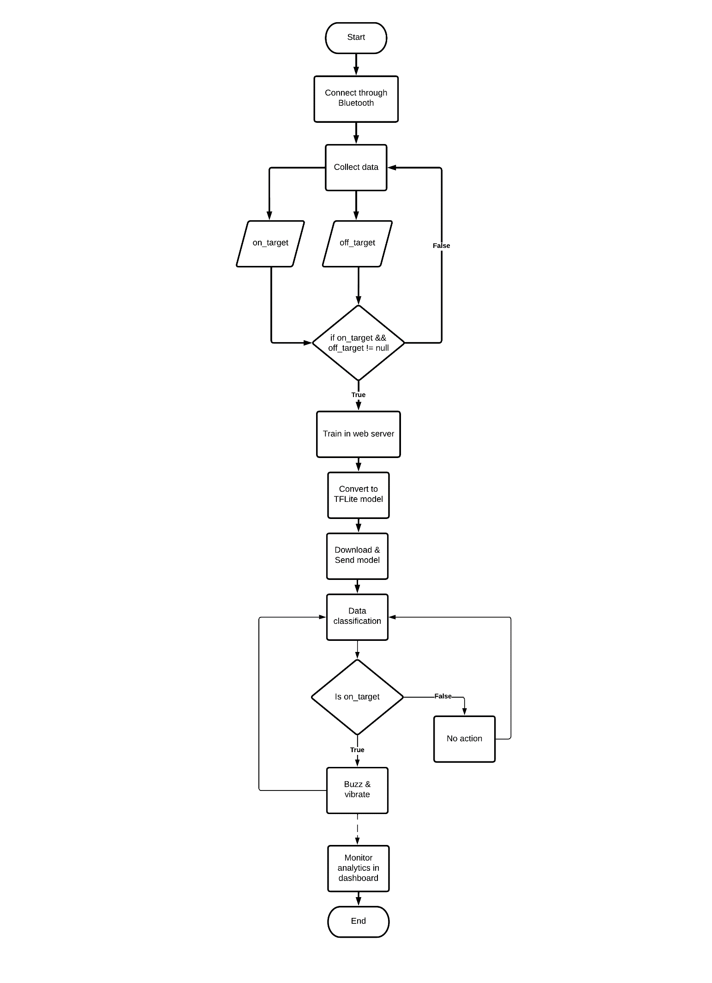

Figure … Flowchart of the System.

**Test and Evaluation of the System**

Statistical Treatment

Cost Computation

**RESULTS AND DISCUSSION**

***System Overview***

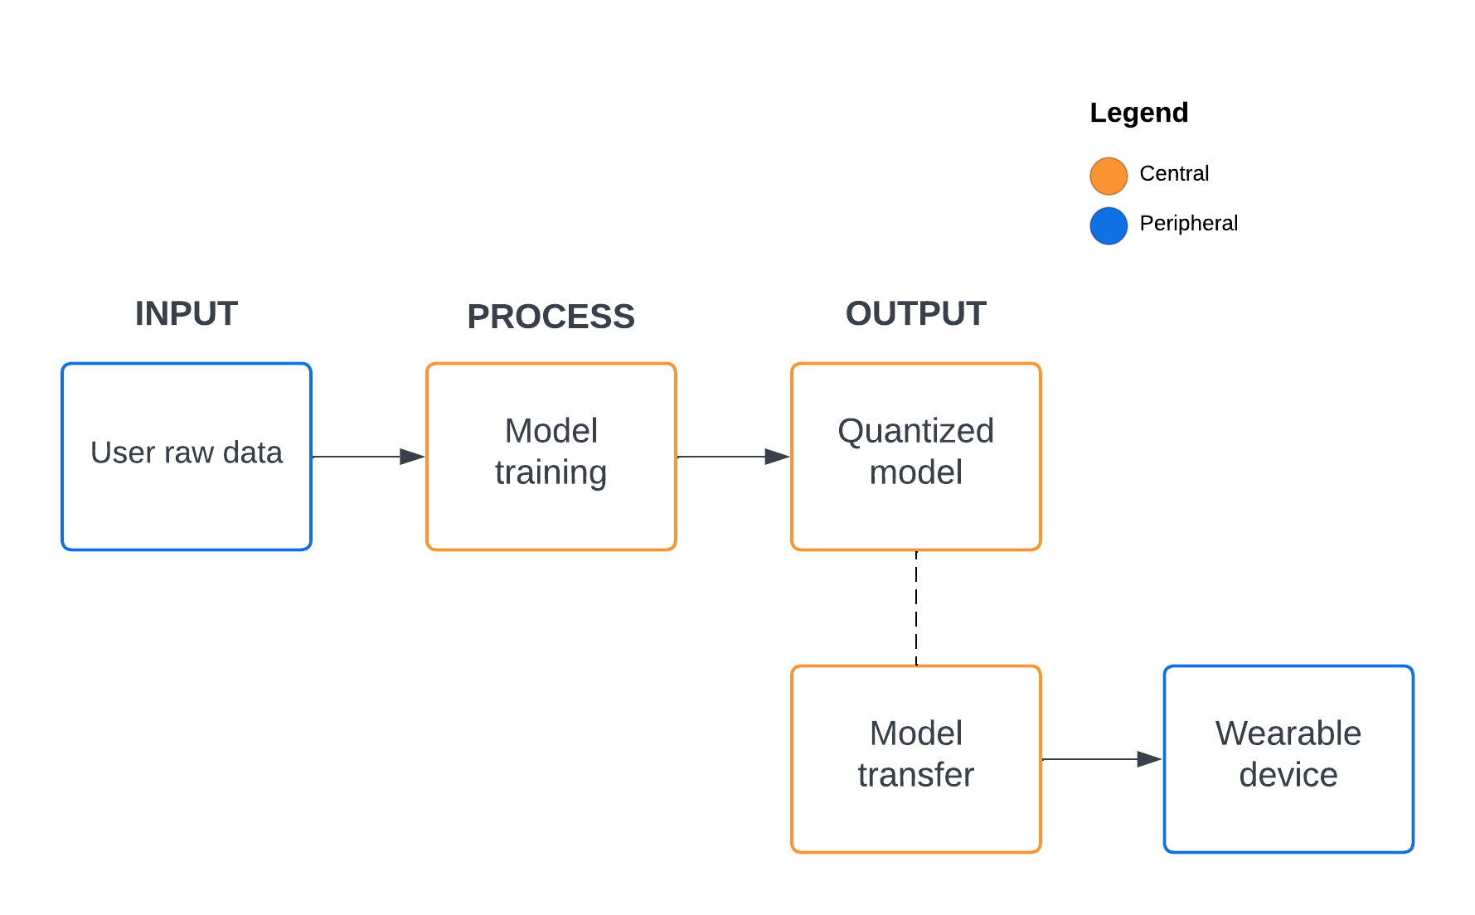

**Figure 3.1.** Wearable device and monitoring system relationship.

The wearable device system diagram is shown in Figure 3.1 wherein the user will generate his/her raw data to classify two hotspots, the on-target, and the off-target. It will automatically record the position by using the IMU component as well as the temperature and distance sensor. The raw data that is generated by the device is recorded and saved directly on the mobile application, this will save time and memory compared when saving from the device then sending via Bluetooth. After the recording, it will upload the data on the server then train the model using the Long short-term memory (LSTM) neural network. The data is shuffled and normalized accordingly then splits to 60% for training and 40% for validation. The training time is expected to be less than two (2) minutes while giving it small amount of data and using quantization to limit the model contents for transferring the file. The researchers also considered a lot of regularization to avoid overfitting since this is a big factor of this research outcome. Model is then ready for transfer using the Bluetooth characteristic of the device and mobile application. The device is given to receive the file contents of the model by using the Universal Unique Identifier (UUID) pair of connection. Finally, after the model contents are transferred, the device will initialize the model then starts calculating the prediction output of position tracking.

***BLE Characteristic***

Understanding the distinction between a central and a peripheral device is crucial for understanding BLE connection. In this section, the central and peripheral devices of the study is discussed. It is crucial to comprehend how a BLE connection operates, the functions of the various devices involved, and how data is exchanged from one device to another over the air to have a successful custom implementation.

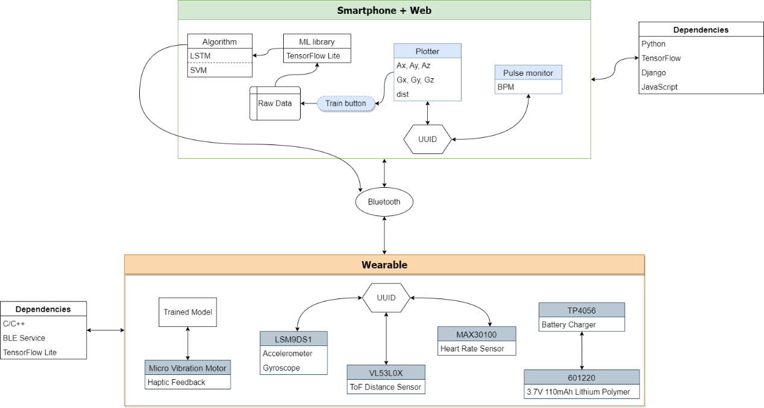

**Figure 3.2.** Design pattern of the study.

Figure 3.2 shows the simplified design pattern of this study. Basically, the smartphone works in conjunction with the web server while the wearable is a standalone device that will take the responsibility for position tracking. The dependencies showed are the main tools and libraries that the researchers will be using.

**Central**

The researchers consider having a website that acts as a central device for pairing the wearable device (peripheral) through Bluetooth connection. The main purpose of the website is to act like a server, this will handle the training for deep neural networks and monitor the system for live plotting. It includes the summary (training and validation) of the trained model that will be helpful for data analysis. The data collected sent by the peripheral device are stored in an array before the model is trained then the C-header file containing the hex array will be sent back to the device through Bluetooth file transfer by a block of 128 bytes of data iteratively.

**Peripheral**

The Arduino Nano 33 BLE Sense is the motherboard of the wearable device. The purpose of this peripheral device is to send data to the mobile application and retrieve the hex array content of the C-header file that will be used in position tracking. The mobile application and the wearable device have compatibility when sending or receiving data using the cyclic redundancy check of 32-bit binary sequence or CRC32 file checksum. It will check if the two are similar after the file transfer is complete, if it is not, the model import will be cancelled. This happens because of the noise interference such as network errors and disk write errors.

***Design and Construction of the Wearable Device***

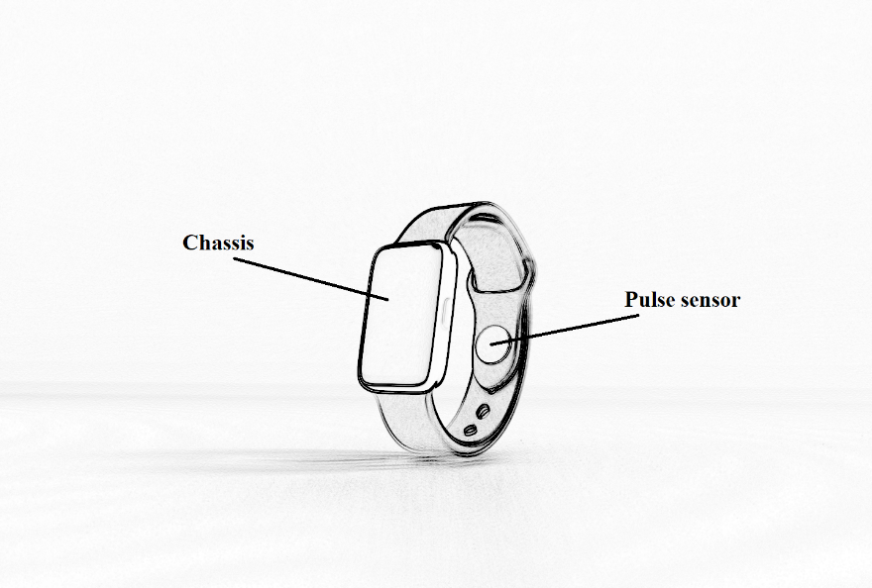

**Figure 3.3.** Expected output of the wearable device.

Figure 3.3 shows the expected output of the microcontroller based wearable device. The main components are protected with a chassis to prevent it from any dirt/debris and water particles that may cause from destroying the entire circuit. The chassis are also expected to be 3D printed made with a strong filament of plastic to add durability. It can also prevent some form of electric shock commonly known as Electrostatic Discharge (ESD) to the user, but this has a very small chance of occurrence because microcontrollers are designed to be low powered. The pulse sensor is located at the wrist strap that is directly pointing or close to the pulse of the user. The researchers plan to create a compact device like any other smartwatches that will fit any person using it. Due to its size limitation, the design of the device and its subsystem is still subject to change and can be added more features for the monitoring system.

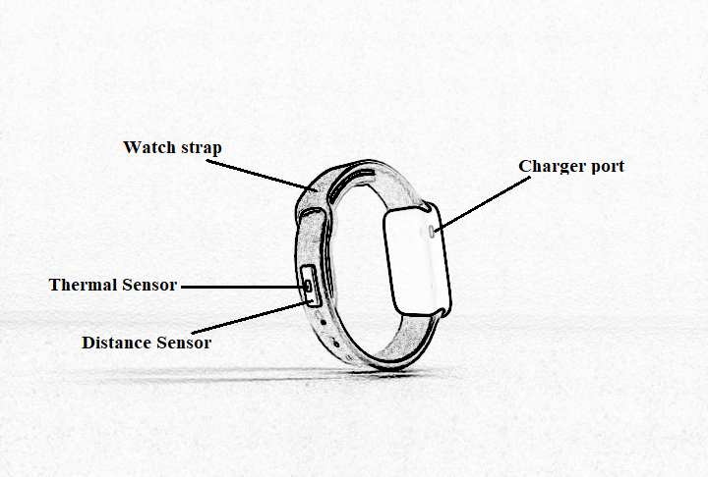

**Figure 3.4.** Expected output of the wearable device.

The external components are shown in Figure 3.4. The thermal sensor measures the body temperature without contact in conjunction with another sensor to measure the distance between the device and the target. The purpose of placing these components externally is to make it the same pointing side of the user’s palm. Thus, contributes to the measurements of data for position tracking. The charger port is exposed on the outside of the chassis. It can connect with a Micro Type B connector that is commonly used in the Android charger. The researchers plan to have a customized watch strap to place the external components and attach the chassis into it. It can adjust the size of the strap to fasten to the small or wide wrist of the user.

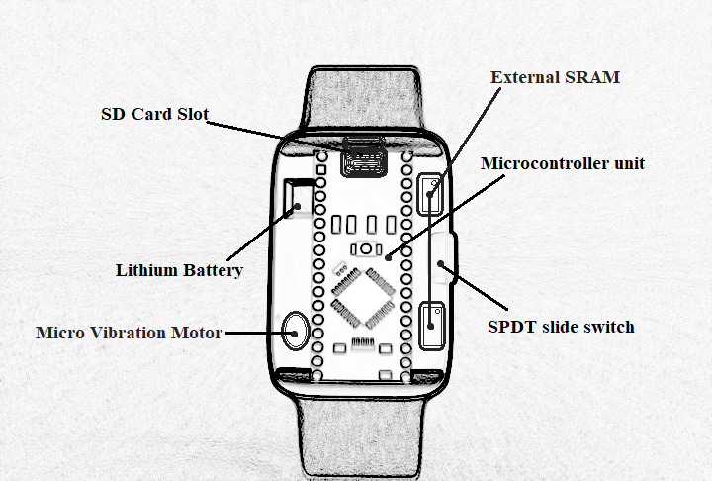

**Figure 3.5.** Chipset of the wearable device.

Figure 3.5 shows the components inside the chassis. The subcomponents (resistors, capacitors, wires, etc.) are also set to fit inside the device. The researchers plan to use a lithium polymer battery for 3.7 supply voltage for the MCU, this battery is safe as it has no leakage problem because the inside of the battery does not contain a liquid electrolyte. It is also a rechargeable battery to avoid the replacement each time the battery has run out. The SD card slot will serve as the storage for the trained model. In this way, if the user has already trained the model and planned to change the position tracking, they will not need to re-train the model again. Because the MCU has only 256KB of SRAM, the researchers plan to use an external SRAM. This external SRAM works in correlation with the SD card. This will also serve as the storage for the global variables for the incoming data from the mobile application.

Placement of the MCU in the chassis must be sturdy otherwise, the IMU recording will generate random and unstable numbers. Thus, position tracking will fail. The SPDT switch are placed on the side of the chassis with a placement of LED lights to indicate on and off status. Finally, the wearable device will be able to send a haptic feedback/warning to the patient by using the vibration motor. The researchers can tweak the frequency for user preferences so that they will sense the vibration.

***Design and Construction of the Mobile Application***

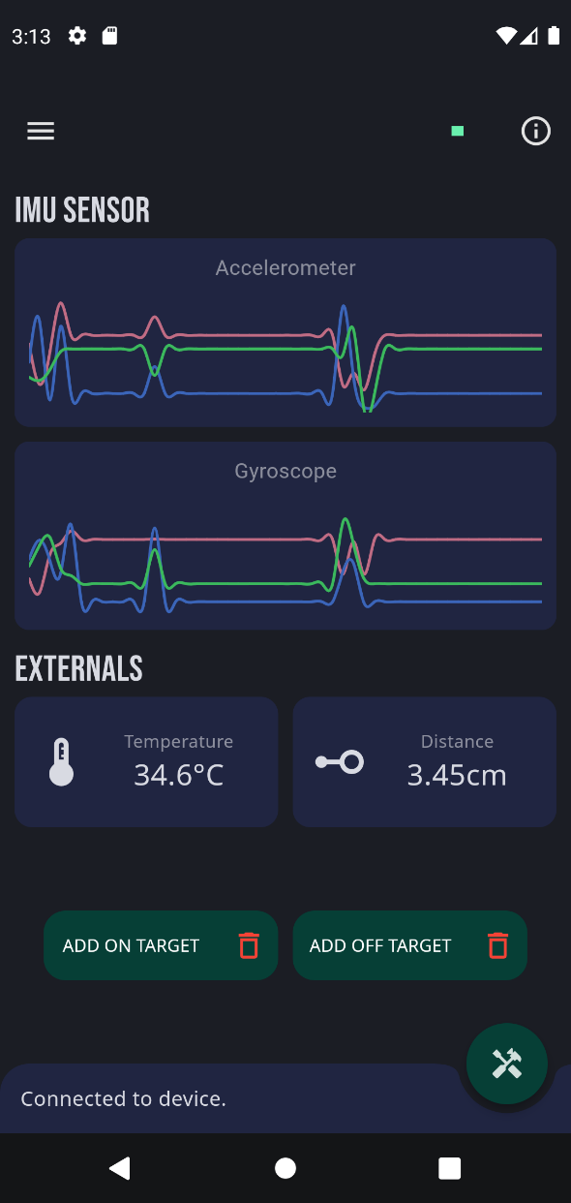

**Figure 3.6.** Mobile application design.

The design of the mobile application is shown in Figure 3.6 where the application is divided into three (3) section, the real-time monitoring system, the training application, and the status section where the success, progress, notification, and errors are displayed. The device must be in the on-state and the user must turn-on the Bluetooth before the connection. This implementation of the Bluetooth connection can be made using Flutter, it is a mobile application framework and uses Dart programming language provided by Google for building natively compiled and cross-platform applications from a single codebase.

The researchers decide to use the Python programming language as the backend of mobile application for training the model. Researchers uses Django, this is a web framework built on Python that uses the model-template-views (MTV) architectural design. The development of the backend encourages the researchers for rapid development, clean, and pragmatic design (Idris et al., 2020). The main purpose of this website is to receive input data then sends back the output model data. The neural network model is trained using the TensorFlow. It is a machine learning platform that helps to implement best practices for data automation, model tracking, performance monitoring, and model retraining (Fridriksdottir & Bonomi, 2020).

With being the Flutter as the frontend, it will handle the user input for training to use specify the on-target and off-target data for classification while displaying its data in the real-time graph. It then allows the user to begin training after the required parameters are met. User can also monitor the data being sent to the device in the form of displaying the total number of bytes left in progress.

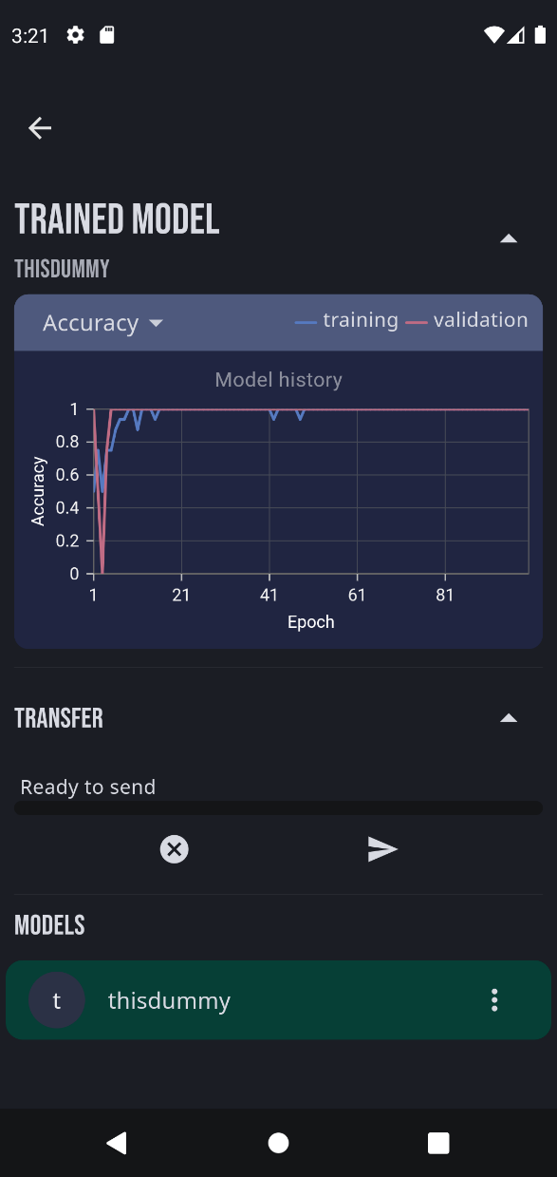

**Figure 3.7.** Design of the model-result viewer.

Figure 3.7 shows the results of model after the training process. The user can optionally analyze the validation accuracy and validation loss per epoch, in this way the user can have an option to retrain their model. The researchers will also make the application user friendly thus the user can have ease of using the interface. Retraining the model does not add up to the previous data of the model because it can expand the result of the hexadecimal data representation of the model causing the wearable device to go out of memory.

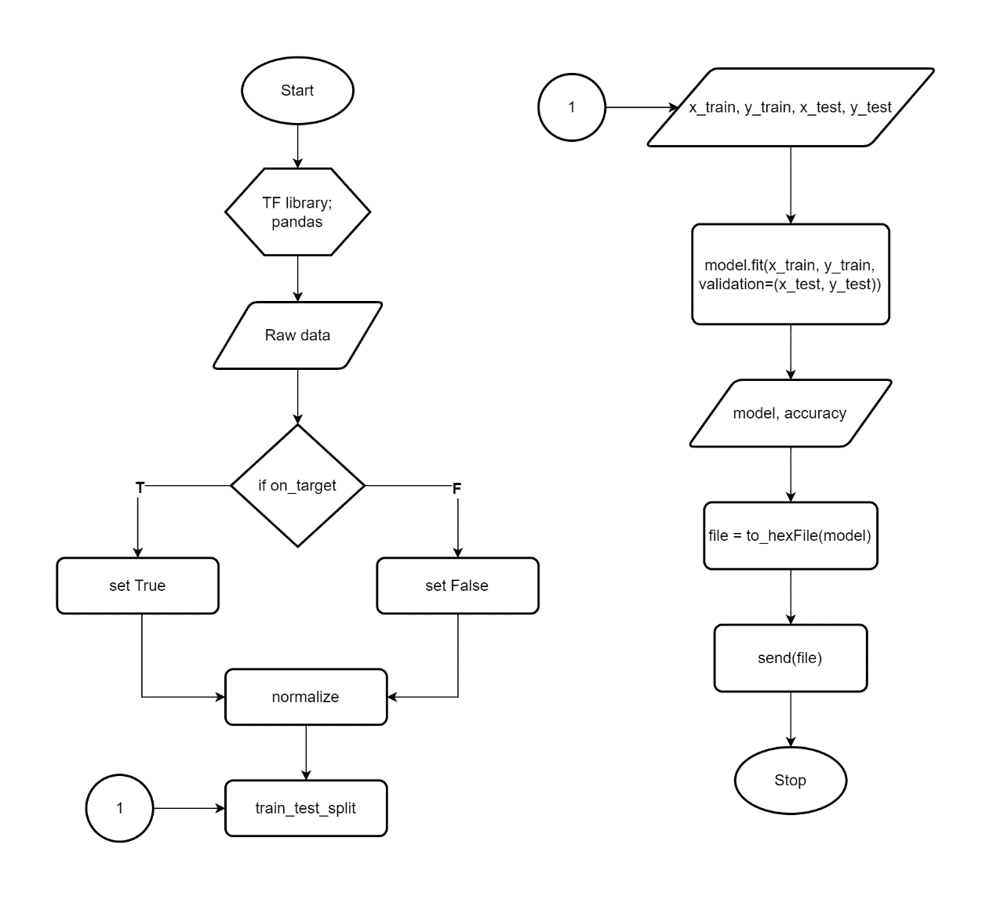

**Figure 3.8.** Server-side flowchart training behavior.

The behavior of the server-side or the central device is shown in Figure 3.8. This explains the detail of process when the data is handled by this service. After the data is prepared, the server will filter and classify each data by marking it as true for on-target and false for off-target this is done using data manipulation and analysis. Each data is then normalized and standardized to speed up the learning process and make each feature on a similar scale. For example, the Arduino LSM9DS1 library accelerometer range is set at ±4 g and ±2000 degrees per second for gyroscope (Arduino, 2022). Therefore, this range set values can be calculated as:

where ***x*** is the negative to positive readings and ***y*** is the min to max range value.

It is now safe and easy for the deep learning library to calculate the value of each feature. The sequential model will be used for building and training the model. In this way, the divided values can be easily maintained for manual changes. The cloud storage will handle the saved model and saving its path to the database. This allows the user to choose their desired model for sending the model to the device via Bluetooth.

***Testing and Evaluation of the System***

To ensure that the device and mobile application are functional, this study will be evaluated through a unit and integration test. This is where the researchers will run a test on each feature completion. The interface between modules may be problematic even while the modules themselves functions properly in isolation.

Stability is also a key factor to make the study successful. The device's electronic components will be subject to inspection by the researchers since they will be compatible with the output specified by the software. Therefore, early error detection reduces the need for costly and time-consuming correction and a higher number of defects will be found when a software and hardware is tested more extensively.

***REFERENCES***

Abrahams, T., & Trotzky, A. (2017). *BFRBs: Compulsive Behaviors That Unintentionally Cause Physical Damage*. Anxiety.org. https://www.anxiety.org/what-is-body-focused-repetitive-behavior-bfrb

Addicore. (2019). *TP4056 / TC4056A Lithium Battery Charger and Protection Module*. Addicore. https://www.addicore.com/TP4056-Charger-and-Protection-Module-p/ad310.htm

Arduino. (2022). *Arduino_LSM9DS1*. Arduino CC. https://www.arduino.cc/reference/en/libraries/arduino_lsm9ds1/

Bradley, L. J., & Wright, N. G. (2020). Optimising SD Saving Events to Maximise Battery Lifetime for ArduinoTM/Atmega328P Data Loggers. *IEEE Access*, *8*, 214832–214841. https://doi.org/10.1109/ACCESS.2020.3041373

Closa, C. C., & Tambaoan, C. A. (2018). *Development of a Remotely Monitored Health Status Wristband*. Retrieved from Cavite State University - Main Campus Library.

Costanzo, S., & Flores, A. (2020). A non-contact integrated body-ambient temperature sensors platform to contrast COVID-19. *Electronics (Switzerland)*, *9*(10). https://doi.org/10.3390/electronics9101658

Crazell. (2022). *601220*. Crazell Technology Limited. https://www.crazell.com/product/601220/

Cruz, F. R., Torres, J., Baltazar, J. M., Naungayan, K. P., Villaverde, J. F., & Linsangan, N. (2016). Body Position Detection Using Accelerometer Integration Human Belt with GPS Localization Interconnected through GSM. *ASEAN Journal of Engineering Research*, *5*, 1 to 12. https://ejournals.ph/article.php?id=13386

Elprocus. (2022). *What is SPDT Switch : Working & Its Applications*. 2022. https://www.elprocus.com/spdt-switch/

Estrada, J. E., & Vea, L. A. (2020). Real-Time Human Sitting Position Recognition using Wireless Sensors. *Proceedings of the 2020 2nd International Conference on Image, Video and Signal Processing*, 133–137. https://doi.org/10.1145/3388818.3393714

Fridriksdottir, E., & Bonomi, A. G. (2020). Accelerometer-based human activity recognition for patient monitoring using a deep neural network. *Sensors (Switzerland)*, *20*(22), 1–13. https://doi.org/10.3390/s20226424

HabitAware. (2020). *Keen*. Habitaware. https://habitaware.com/

Houghton, David C., Alexander, J. R., Bauer, C. C., & Woods, D. W. (2018). *Body-focused repetitive behaviors: More prevalent than once thought?* (Issue 2000, pp. 389–393). Psychiatry Research. https://doi.org/https://doi.org/10.1016/j.psychres.2018.10.002.

Houghton, David Christian. (2019). Sensory Processing in Body-Focused Repetitive Behaviors. *Doctoral Dissertation. Texas A&M University*, *August*. https://hdl.handle.net/1969.1/174003

Idris, N., Feresa, C., Foozy, M., & Shamala, P. (2020). A Generic Review of Web Technology: DJango and Flask. *International Journal of Advanced Science Computing and Engineering*, *2*(1), 34–40. https://ijasce.org/index.php/IJASCE/article/view/29

Jalalifar, S., Kashizadeh, A., Mahmood, I., Belford, A., Drake, N., Razmjou, A., & Asadnia, M. (2022). A Smart Multi-Sensor Device to Detect Distress in Swimmers. *Sensors*, *22*(3), 1–15. https://doi.org/10.3390/s22031059

Jiang, Z. X., Park, K. H., Kim, J. H., Jiang, Y. W., Xu, D. P., & Hwang, S. M. (2020). Analysis and design of a new linear vibration motor used to reduce magnetic flux leakage in in-vehicle infotainment. *Applied Sciences (Switzerland)*, *10*(10). https://doi.org/10.3390/APP10103370

Kok, M., Hol, J. D., & Schön, T. B. (2017). Using inertial sensors for position and orientation estimation. *Foundations and Trends in Signal Processing*, *11*(1–2), 1–153. https://doi.org/10.1561/2000000094

Komarizadehasl, S., Mobaraki, B., Ma, H., Lozano-Galant, J. A., & Turmo, J. (2022). Low-Cost Sensors Accuracy Study and Enhancement Strategy. *Applied Sciences (Switzerland)*, *12*(6). https://doi.org/10.3390/app12063186

Kurniawan, A. (2021). *Arduino Nano 33 BLE Sense Board Development*. IoT Projects with Arduino Nano 33 BLE Sense. https://doi.org/10.1007/978-1-4842-6458-4_2

Lee, D. K., & Lipner, S. R. (2022). The Potential of N-Acetylcysteine for Treatment of Trichotillomania, Excoriation Disorder, Onychophagia, and Onychotillomania: An Updated Literature Review. *International Journal of Environmental Research and Public Health*, *19*(11). https://doi.org/10.3390/ijerph19116370

Lu, L., Zhang, J., Xie, Y., Gao, F., Xu, S., Wu, X., & Ye, Z. (2020). Wearable health devices in health care: Narrative systematic review. *JMIR MHealth and UHealth*, *8*(11). https://doi.org/10.2196/18907

Maxim Integrated. (2022). *MAX30100*. Maxim Integrated. https://www.maximintegrated.com/en/products/sensors/MAX30100.html

Microchip. (2022). *23LC1024 2.5-5.5V 1Mb SPI Serial SRAM*. Microchip Technology Inc. https://www.microchip.com/en-us/product/23LC1024

Navarro, M. R., Valdez, N., & Enojas, M. J. (2019). Real Time Wearable Locator Device for Distress. *Innovatus*, *2*. https://ejournals.ph/article.php?id=14065

Searle, B. L., Spathis, Di., Constantinides, M., Quercia, D., & Mascolo, C. (2021). Anticipatory Detection of Compulsive Body-focused Repetitive Behaviors with Wearables. *Proceedings of MobileHCI 2021 - ACM International Conference on Mobile Human-Computer Interaction: Mobile Apart, MobileTogether*. https://doi.org/10.1145/3447526.3472061

Smitha Bhandari, M. (2020). *Understanding Body-Focused Repetitive Behaviors*. WebMD. https://www.webmd.com/mental-health/ss/slideshow-understanding-body-focused-repetitive-behavior

Son, J. J., Clucas, J. C., White, C., Krishnakumar, A., Vogelstein, J. T., Milham, M. P., & Klein, A. (2019). Thermal sensors improve wrist-worn position tracking. In *npj Digital Medicine* (Vol. 2, Issue 1). npj Digital Medicine. https://doi.org/10.1038/s41746-019-0092-2

STMicroelectronics. (2018). *LSM9DS1 iNEMO inertial module, 3D magnetometer, 3D accelerometer, 3D gyroscope, I2C, SPI*. STMicroelectronics N.V. https://www.st.com/resource/en/datasheet/lsm9ds1.pdf%0Ahttp://www.st.com/en/mems-and-sensors/lsm9ds1.html