**Name of Proponents:** Bahillo, Ryan Christopher D**.**

Dalanon, Iriks Maria B.

**Course:** Bachelor of Science in Computer Engineering

**School Year/Term:** AY 2021-2022, 2nd Semester

**Proposed Thesis Title:** Microcontroller Based Wearable Device: Therapy and Monitoring System for Body-Focused Repetitive Behavior

III. Rationale

Body-focused repetitive behavior (BFRB) is a term that refers to a group of compulsive habits that unintentionally harm one's body and alter one's appearance [1]. The main distinction between BFRBs and other compulsive behaviors that hurt the body (such as cutting or burning yourself) is that BFRBs involve direct body-to-body contact. BFRBs are one of the most misunderstood, under diagnosed, and mistreated conditions around nowadays [2]. Pulling, picking, biting, or scraping one's hair, skin, or nails are examples of these behaviors. Trichotillomania (hair pulling), dermatillomania (skin plucking, also known as excoriation disorder), and onychophagia are among the disorders (compulsive nail biting). BFRBs are thought to impact at least 3% of the population, affecting both children and adults [3].

This proposed project aims to develop a microcontroller based wearable technology that conveys a signal to the user and is integrated with mobile application for motion sensors in real time. This project will assist in the treatment of the Body-Focused Repetitive Behavior (BFRB patient). The device will be able to send a signal to the patient by using the vibration motor. By this, the user will control the repetitive behavior. This current proposal is not a medication, but it will assist BFRB patients in self-control.

IV. Objectives of the Study

Following are the objectives of the study:

* To develop a microcontroller based wearable technology that conveys a signal to the user.
* To embed mobile application for motion sensors in real time.
* To assist in the treatment of the Body-Focused Repetitive Behavior (BFRB patient) with the proposed project.

V. Methodology

This project will come up for the solution to help treat the patient with BFRB by using a wearable device that will warn or send signal. By doing this, we need a Microcontroller Unit that can provide all the parameters we need. The Arduino Nano family is designed to fit any electronic project in affordable way. Its dimensions are why we can make this project small-scale and compact. It also has motion sensors to measure the tri-axial acceleration and angular rate, these two are the main factor of our project.

The MCU will know if the patient is going to commit its repeating behavior by simply using a machine learning technique. The accelerometer and gyroscope will detect the acceleration force and angular velocity of the wrist. We can improve the tracking accuracy by using the distance sensor. The Time-of-Flight (ToF) distance sensor can fit our proposal project. Compared to the HC-SR04 also known as Ultrasonic sensor, the ToF is twice smaller, and the speculation is not excessive to what we only need. In this way, we can store the raw data and use it for training the model using a machine learning algorithm. The Figure below shows the components and orientation of measurements.

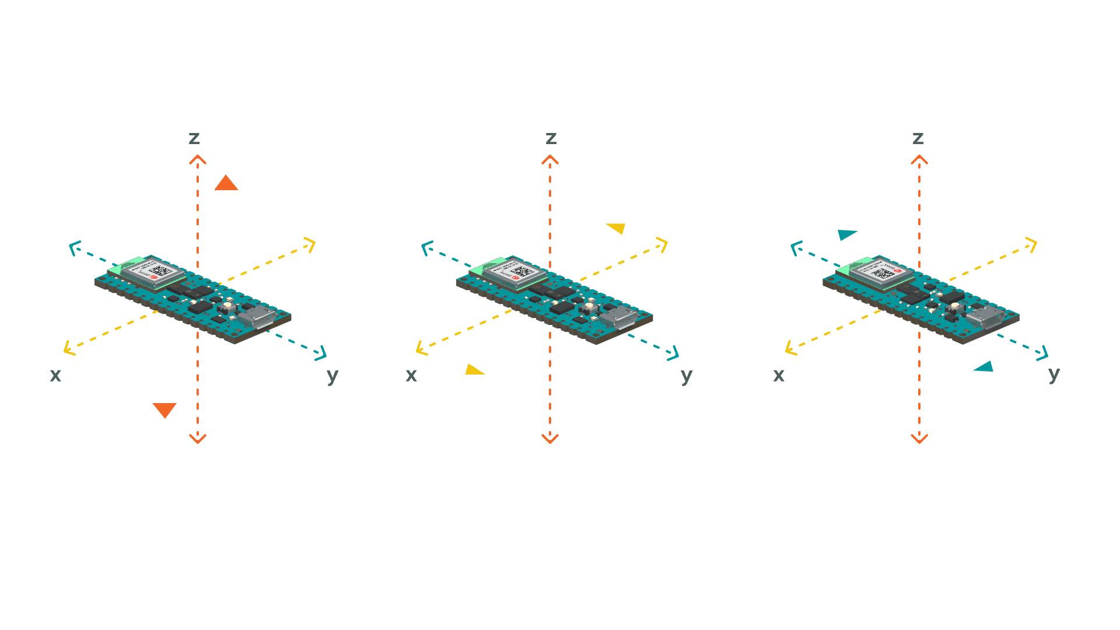

Accelerometer

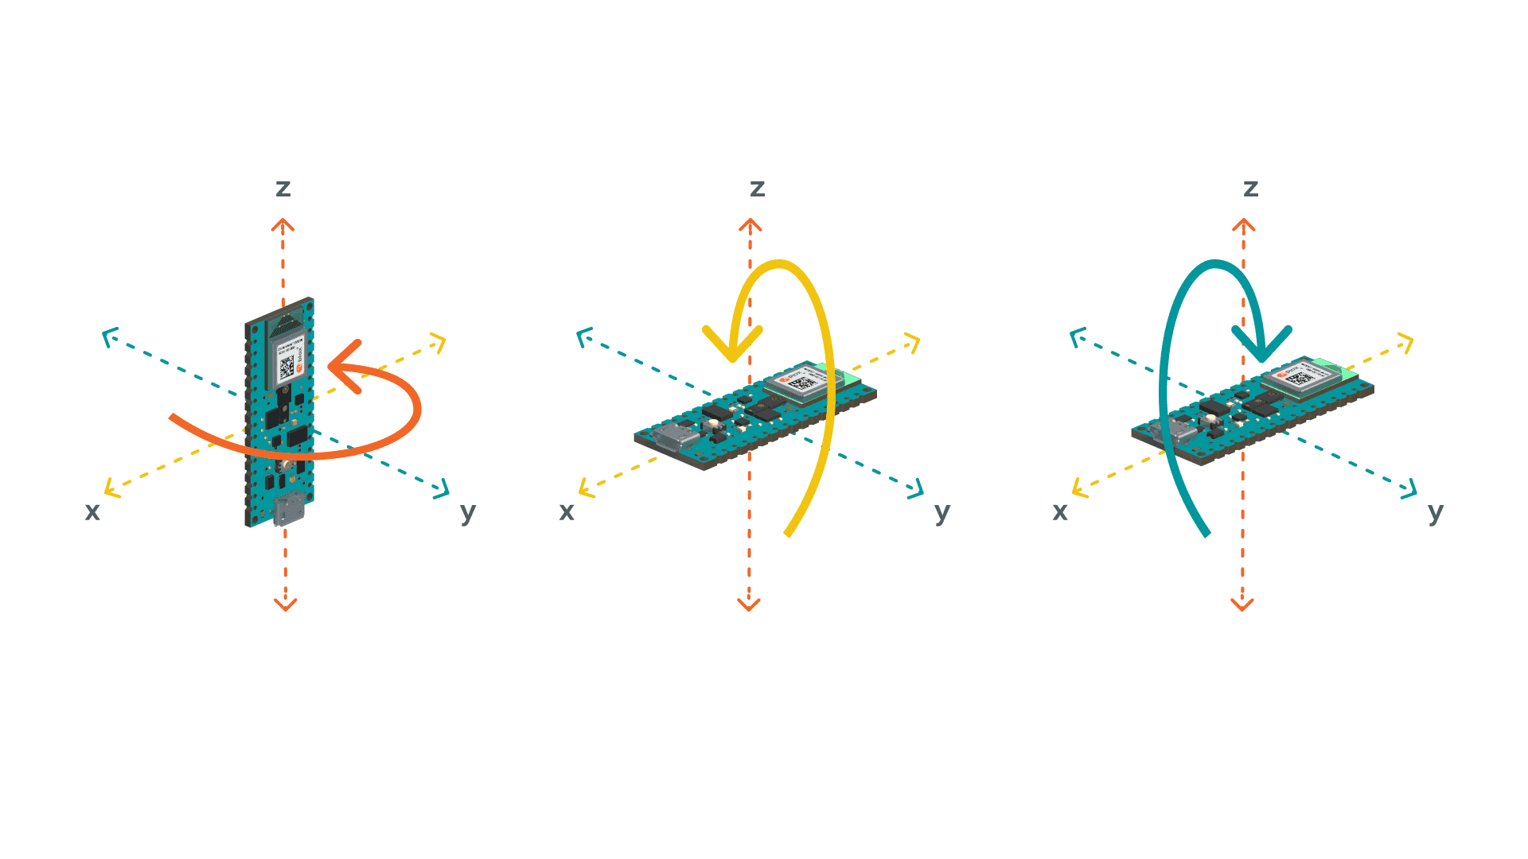

Gyroscope

Time-of-Flight Sensor

We will use the cross-platform deep learning framework TensorFlow Lite. It is open source and product ready that converts pre-trained model to a special format that can be optimized for speed storage. The Arduino Nano 33 BLE (Bluetooth Low Energy) Sense is the only microcontroller in the Arduino family that are supported by TensorFlow Lite. The model is first trained using the TensorFlow library in Python, this trained model cannot be imported the MCU unless we convert it to the Lite version that produces a smaller memory size that the MCU can handle.

As shown in Figure #, we will create a mobile application so that the patient can have a better experience using the device. It will monitor the changes of the motion sensors in real time and with this application we can train the software to detect the range when the device will send a signal to the patient or not. For the wearable and the mobile phone to communicate, we will use the Bluetooth communication protocol. In this way, we can send the raw data produced by the wearable to the mobile phone to begin the training. The trained model is saved and sends back to the wearable, then it will be able to load the model. This is a great help for the new patient that is willing to use the device.

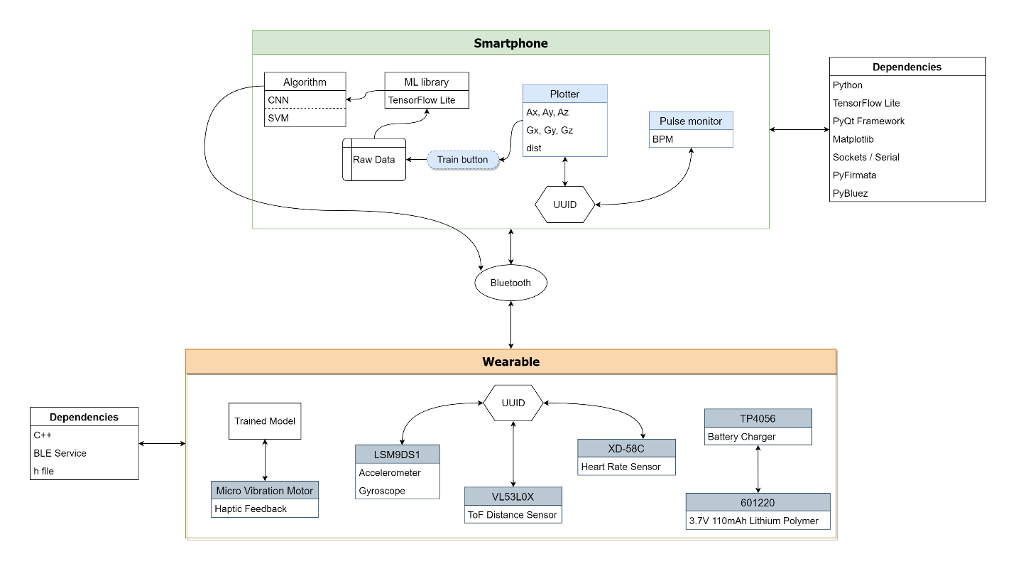

The wearable device will be able to send a warning to the patient by using the vibration motor. We can tweak the frequency for his/her preferences so that the patient will sense the vibration. For the power supply, we will use the Lithium Polymer battery for 3.7 supply voltage for the MCU. This battery is safe as it has no leakage problem because the inside of the battery does not contain a liquid electrolyte. It is also a rechargeable battery to avoid the replacement each time the battery has run out.

Materials:

TP4056 – Lithium Battery Charger Module

Arduino Nano 33 BLE Sense – Microcontroller Unit

Micro Vibration Motor

601220 Lithium Polymer Battery – 3.7V 110mAh

VL53L0X – ToF Distance Sensor includes with angular velocity for increased accuracy.

Pulse Sensor – BPM

Jumper Wires

Features might add:

HTS221 – Temperature and Humidity

APDS9960 – Gesture sensor includes with angular velocity for increased accuracy

VI. Budgetary Estimate

|  |  |  |  |  |  |
| --- | --- | --- | --- | --- | --- |
|  |  | | **Description** | **Duration** | **Amount**  **(Php)** |
| 1 | Senior Personnel  Prof. Emeline C. Guevarra (Research Adviser)  Prof. Andy A. Dizon (Technical Critique) | | Principal consultant and technical support for the proposed project. | February – June 2022 | 0 |
| 2 | Other Personnel  Prof. Poinsettia A. Vida (Subject Instructor) | | Assist researchers in their growth and development on proposed project. | February – June 2022 | 0 |
|  | Total Cost for Personnel | | | | 0 |
| 3 | Equipment | |  |  |  |
|  | a. Multi meter | |  | March – June 2022 | 350.00 |
|  | b. Soldering iron | |  | March – June 2022 | 210.00 |
| 4 | Travel | |  |  | 500.00 |
| 5 | Materials and Supplies | Quantity |  |  |  |
|  | a. TP4056 | 1 | Lithium battery charger. | March – June 2022 | 108.00 |
|  | b. Arduino Nano 33 BLE Sense | 1 | Microcontroller Unit | March – June 2022 | 3,762.00 |
|  | c. Micro Vibration Motor | 1 | Use for haptic feedback | March – June 2022 | 73.00 |
|  | d. 601220 Lithium Polymer Battery | 1 | 3.7V 110mAh | March – June 2022 | 267.00 |
|  | e. Pulse Sensor | 1 | Reads beats per minute | March – June 2022 | 187.00 |
|  | f. TP4056 | 1 | Lithium battery charger | March – June 2022 | 108.00 |
|  | g. Jumper wires | 20 | Use for connecting components | March – June 2022 | 60.00 |
|  | Total Cost for Materials and Supplies | | | | 5,625.00 |
| 6 | Consultant Fee | | - | - | - |
| 7 | Printing | | Production of final technical paper |  | 200.00 |
|  | Total Costs | | | | 200.00 |
|  | **Grand Total Project Cost** | | | | **5,825.00** |

*Includes shipping fee*

References:

[1] B. S. Tasneem Abrahams, “BFRBs: Compulsive Behaviors That Unintentionally Cause Physical Damage.” [Online]. Available: https://www.anxiety.org/what-is-body-focused-repetitive-behavior-bfrb.

[2] P. D. Christopher A. Flessner, “Body-Focused Repetitive Behaviors: Understanding BFRBs in Children,” no. 2000. pp. 2001–2002, [Online]. Available: https://www.additudemag.com/bfrb-overview-children/.

[3] P. Today, “Body-Focused Repetitive Behaviors.” [Online]. Available: https://www.psychologytoday.com/us/basics/body-focused-repetitive-behaviors#:~:text=Body-focused repetitive behaviors%2C or BFRBs%2C are a set,biting%2C or scraping one%27s hair%2C skin%2C or nails.

Accessing Accelerometer Data on Nano 33 BLE Sense. <https://docs.arduino.cc/tutorials/nano-33-ble-sense/imu_accelerometer>

Accessing Gyroscope Data on Nano 33 BLE Sense. <https://docs.arduino.cc/tutorials/nano-33-ble-sense/imu_gyroscope>