**CHAPTER I**

**Introduction**

Brief intro brief intro brief intro brief intro brief intro brief intro brief intro brief intro brief intro brief intro brief intro brief intro brief intro brief intro brief intro brief intro brief intro brief intro brief intro brief intro brief intro brief intro brief intro brief intro brief intro brief intro brief intro brief intro brief intro brief intro brief intro brief intro brief intro brief intro brief intro brief intro brief intro brief intro brief intro brief intro brief intro brief intro brief intro brief intro brief intro brief intro brief intro brief intro brief intro brief intro brief intro brief intro brief intro brief intro brief intro brief intro brief intro brief intro brief intro.

***Background of the Study***

Body-focused repetitive behavior (BFRB) is a term that refers to a group of compulsive habits that unintentionally harm one's body and alter one's appearance (Abrahams & Trotzky, 2017) but the factors that predispose individuals to these behaviors are poorly understood. The main distinction between BFRBs and other compulsive behaviors that hurt the body is that BFRBs involve direct body-to-body contact. BFRBs are one of the most misunderstood, under diagnosed, and mistreated conditions around nowadays (Houghton et al., 2018). Pulling, picking, biting, or scraping one's hair, skin, or nails are examples of these behaviors. Trichotillomania (hair pulling), dermatillomania (skin plucking, also known as excoriation disorder), and onychophagia are among the disorders (compulsive nail biting). As many as 1 in 20 people have a BFRB, affecting both children and adults (Smitha Bhandari, 2020). The lack of high-quality empirical attention is particularly troubling given that BFRBs frequently appear in childhood. Pediatric BFRBs are thought to be normal in children and to go away with maturation. (Evidence-Based Psychosocial Treatments for Pediatric Body-Focused Repetitive Behavior Disorders).

In approach to BFRB monitoring, a study shows the data collected in different locations on the head can be calculated by measuring the distance between each pair of the target locations on the head using the data from the proximity and the Inertial Measurement Unit (IMU) sensors (Jake J. Son et al., 2019). They disassembled and used N68 Fitness Tracker (ref) as their main component for their PCB along with the MCU and IMU. However besides of the appearance, the price is on the expensive side and is not affordable for the public use. The Keen created by HabitAware (ref) is a wearable-based tracking device to detect BFRB activity. It uses a gesture recognition for the initial use that makes the device recognize such habit. It then transmits a vibration signal to the patient wearing the device. Despite that, no published peer-reviewed study has shown the effectiveness of this device. There are testimonies that are presented in their website, but these are not great evidence to say that the device is well-suited for BFRB monitoring or treatment.

This proposed project aims to develop a microcontroller based wearable technology that conveys a signal to the user and is integrated with mobile application for motion sensors in real time. This project will assist in the treatment of the Body-Focused Repetitive Behavior patient. The device will be able to send a signal to the patient by using the vibration motor; it has a trained model implemented to the microcontroller by using its IMU in addition of proximity and thermal sensor to improve the accuracy. By this, the user will control the repetitive behavior. This current proposal is not a medication but will assist BFRB patients in self-control.

***Research Objectives***

The project will conduct in the proposal of microcontroller-based wearable device that will be used to help the patient control its repetitive behavior. To accomplish this, the following objectives will be met:

1. To develop a microcontroller based wearable technology that conveys a signal to the patient. The main components include Arduino Nano microcontroller board, a proximity sensor, a vibration motor, and various optional components such as batteries and a chassis.
2. To embed mobile application for motion sensors in real time. The software design will be implemented using Python programming language to build a user interface for the patient.
3. To assist in the treatment of the Body-Focused Repetitive Behavior (BFRB patient) with the proposed project. Giving alert using haptic feedback to the patient to stop the urge of repetitive behavior.

***Scope and Delimitation***

This study covers the development of microcontroller based wearable device that can detect BFRB compulsive activities such as trichotillomania, excoriation, and onychophagia. It documents how the researchers construct the wearable device. The device has two components, the main system where the microcontroller is present, it will generate data from the user; and the mobile application that collects the data from the wearable device. This study will also test how the device will accurately predict the hotspot location for the compulsive behavior of the patient. The study does not document as an alternative treatment to the patient with BFRB disorder as it requires professional treatment of psychological disorders and problems. It can be described as effective or well-suited for patients with compulsive behavior through survey after they completed the allocated schedule.

***Significance of the Study***

Patient with BFRB ( simplify )

Society **?**

Medical Professionals

Future Researchers

Definition of Terms

CHAPTER II

**Review of Related Literature**

This chapter of the study contains different literatures and studies both local and foreign to support the study. This chapter of the study contains different literatures and studies both local and foreign to support the study. This chapter of the study contains different literatures and studies both local and foreign to support the study.

**Foreign Literatures**

**Local Literatures**

**Foreign Studies**

In a related study published in npj Digital Medicine, a team lead by Child Mind Institute researchers found that utilizing heat sensors in addition to inertial measurement and proximity sensors, a wearable tracking system they designed achieves greater accuracy in position tracking. Tingle, a wrist-worn gadget, could also tell the difference between actions aimed at six distinct parts of the head. The paper, titled "Thermal Sensors Improve Wrist-worn Position Tracking," provides preliminary evidence of the device's potential use in the diagnosis and treatment of excoriation disorder, nail-biting, trichotillomania, and other body-focused repetitive behaviors (Jake J. Son, Jon C. Clucas, Curt White, Anirudh Krishnakumar, Joshua T. Vogelstein, Michael P. Milham, 2019).

**Local Studies**

**CHAPTER III**

***METHODOLOGY***

This chapter presents the data gathering methods used for the research findings. It contains the research design used by the researchers. It also contains the different equipment and materials used to design and develop the device as per objectives. It also discusses how the data will be analyzed for interpretation.

***Research Design***

The design that is used in the study is the Prototyping Research Design, which is a special type of Quantitative Design. It is a model of product built to test a concept within the improvement of planning and execution such as the designs and semantic of software programming and technological base.

***Materials***

**Arduino Nano 33 BLE Sense** is a lot more powerful processor than the ordinary Arduino Nano. It uses the nRF52840 from Nordic Semiconductors with a 32-bit ARM Cortex-M4 CPU running at 64 MHz. The size of its program memory is 1MB and 256KB of SRAM for more variables. The main feature of this board is its capability of transmitting and receiving data using the Bluetooth Low Energy communication chipset. (https://store-usa.arduino.cc/products/arduino-nano-33-ble-sense)

**VL53L0X Time-of-Flight Sensor** works optically by emitting short infrared pulses and measuring the time it takes the light to be reflected. The sensor can measure distances up to 2 meters, though that figure depends significantly on several conditions like surface reflectance, field of view, temperature etc. In general, you can expect surfaces up to 60cm to work, after that you need to make sure the surface is reflecting well enough. (https://www.st.com/resource/en/datasheet/vl53l0x.pdf)

**MAX30100 Pulse Oximeter and Heart-Rate Sensor** is a modern, integrated pulse oximeter and heart rate sensor IC, from Analog Devices. It combines two LEDs, a photodetector, optimized optics, and low-noise analog signal processing to detect pulse oximetry (SpO2) and heart rate (HR) signals. (https://datasheets.maximintegrated.com/en/ds/MAX30100.pdf)

**Micro Vibration Motor** acts as haptic feedback to any wearable devices, it provides power from a battery or microcontroller pin, and it will buzz away. The rated voltage is 2.5 to 3.8V and for many projects, we found it vibrates from 2V up to 5V, higher voltages result in more current draw but also a stronger vibration. (https://www.precisionmicrodrives.com/motors/vibration-motors)

**601220 Lithium Polymer Battery** has a 3.7V 100mAh capacity and can be easily incorporated into a variety of electrical products. The battery has one prismatic cell in a one-series, one-parallel arrangement. Over-charge, over-discharge, over-current, and short-circuit protection are all provided by integrated battery protection circuit boards (PCBs).(https://www.crazell.com/product/601220/)

**TP4056 Charger Module** is a lithium battery charger for a single cell battery, protecting the cell from over and under charging. It has two status outputs indicating charging in progress and charging complete. It also has a programmable charge current of up to 1A. It can be used to charge batteries directly from a USB port since the working input voltage range is 4V ~ 6V. (https://www.addicore.com/TP4056-Charger-and-Protection-Module-p/ad310.htm)

**SRAM 23LC1024** is a 1Mbit (125 KB) Serial SRAM chip enables limitless reads and writes to the memory array and is designed to connect directly with the Serial Peripheral Interface (SPI) port of many of today's most popular microcontroller families. With a zero write time speed, this is a wonderful alternative for data recording and is perfect for adding extra SRAM memory to the microcontroller. (https://www.microchip.com/en-us/product/23LC1024)

**LSM9DS1 Inertial Measurement Unit (IMU)** is a system-in-package featuring a 3D digital linear acceleration sensor, a 3D digital angular rate sensor, and a 3D digital magnetic sensor. It measures and reports raw or filtered angular rate and specific force/acceleration experience by the object it is attached to. Data outputs for an IMU are typically body-frame accelerations, angular rates, and magnetic field measurements. (https://www.st.com/resource/en/datasheet/lsm9ds1.pdf)

**MLX90614 Temperature Sensor** is an infrared thermometer for non-contact temperature measurements. This component has a pulse width modulation digital output setting (PWM). The 10-bit PWM is typically set up with an output precision of 0.14°C and designed to send temperature readings constantly in the range of -20 to 120°C. (https://www.melexis.com/en/product/MLX90614/Digital-Plug-Play-Infrared-Thermometer-TO-Can)

**System Overview**

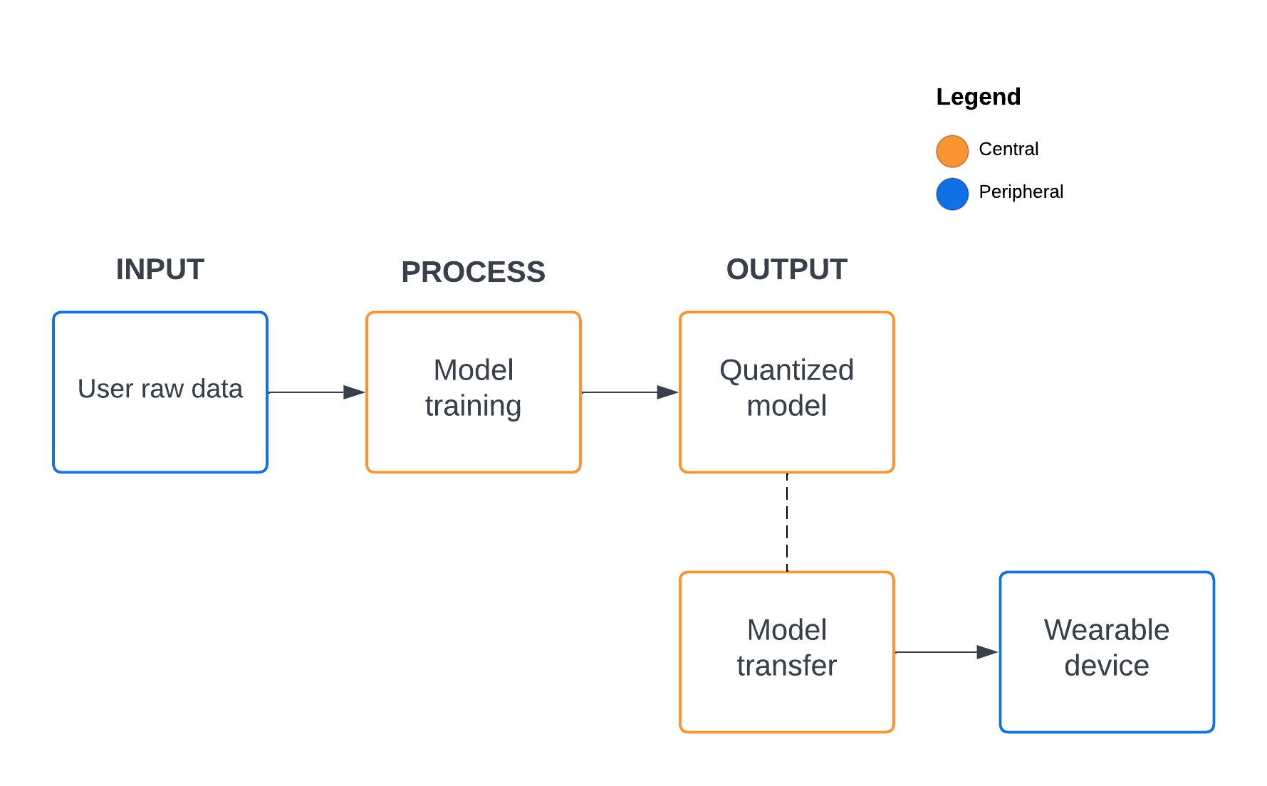

**Figure …** Wearable device and monitoring system relationship

The wearable device system diagram is shown in Figure … wherein the user will generate his/her raw data to classify two hotspots, the on-target, and the off-target. It will automatically record the position by using the IMU component as well as the temperature and distance sensor. The raw data that is generated by the device is recorded and saved directly on the web interface, this will save time and memory compared when saving from the device then sending via Bluetooth. After the recording, it will train the model using the Long short-term memory (LSTM) neural network. The data is shuffled and normalized accordingly then splits to 80% for training and 20% for evaluation. The training time is expected to be less than two (2) minutes while giving it small amount of data and using quantization to limit the model contents for transferring the file. The researchers also considered a lot of regularization to avoid overfitting since this is a big factor of this research outcome. Model is then ready for transfer using the Bluetooth characteristic of the device and the web interface. The device is given to receive the file contents of the model by using the Universal Unique Identifier (UUID) pair of connection. Finally, after the model contents are transferred, the device will initialize the model then starts calculating the prediction output of position tracking.

***BLE Characteristic***

**The Web Interface**

The researchers consider having a website that acts as a central device for pairing the wearable device (peripheral) through Bluetooth connection. The main purpose of the web interface is to act like a server, this will handle the training for deep neural networks and monitor the system for live plotting. It includes the summary (training and validation) of the trained model that will be helpful for data analysis. The data collected sent by the peripheral device are stored in an array before the model is trained then the C-header file containing the hex array will send back to the device through Bluetooth file transfer by a block of 128 bytes of data iteratively.

**Peripheral**

The Arduino Nano 33 BLE Sense is the motherboard of the wearable device. The purpose of this peripheral device is to send data to the web interface and retrieve the hex array content of the C-header file that will be used in position tracking. The web interface and the wearable device has its compatibility when sending or receiving data using the CRC32 file checksum. It will check if the two are similar after the file transfer is complete, if it is not, the model import will be cancelled. This happens because of the noise interference such as network errors and disk write errors.

***Design and Construction of the Wearable Device***

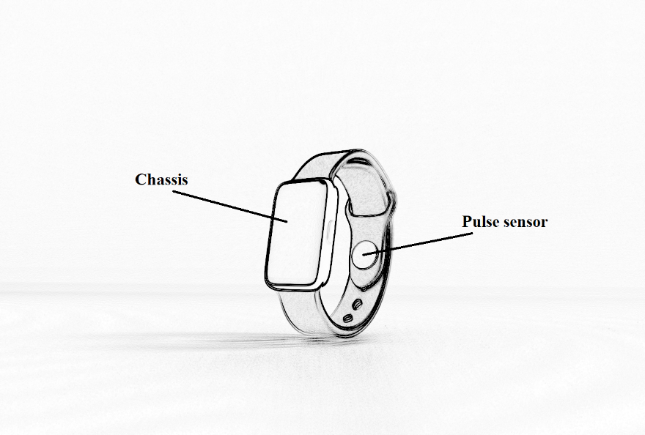

**Figure …** Expected output of the wearable device

Figure … shows the expected output of the microcontroller based wearable device. The main components are protected with a chassis to prevent it from any dirt/debris and water particles that may cause from destroying the entire circuit. The chassis are also expected to be 3D printed made with a strong filament of plastic to add durability. It can also prevent some form of electric shock commonly known as Electrostatic Discharge (ESD) to the user. The pulse sensor is located at the wrist strap that is directly pointing to the pulse of the user. The researchers plan to create a compact device like any other smartwatches that will fit to any people using it. Due to its size limitation, the design of the device and its subsystem is still subject to change and can be added more features for the monitoring system.

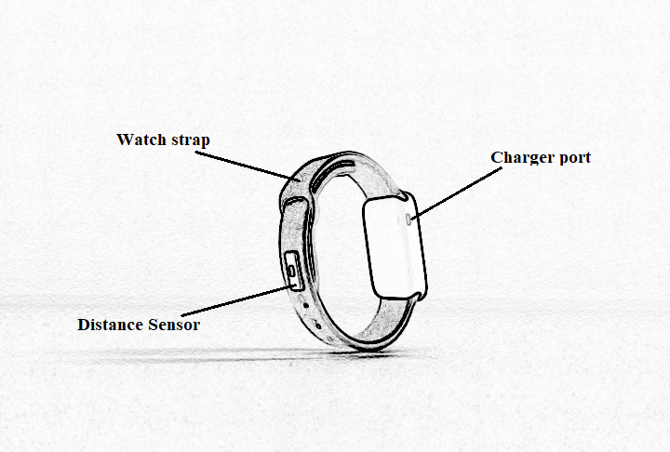

**Figure …** Expected output of the wearable device

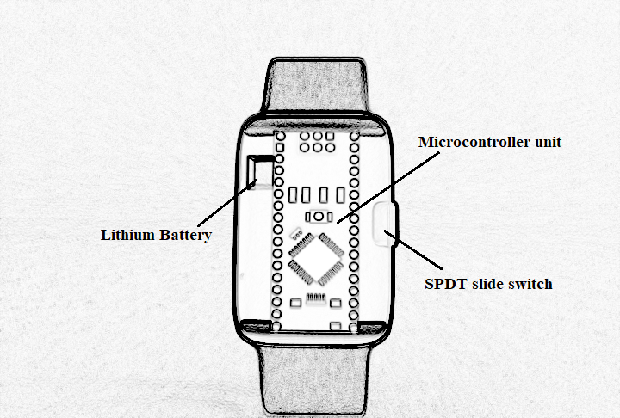

**Figure …** Chipset of the wearable device