AX20 Readme File

Platform Information
In February 2006, IRD installed an instrument to measure CO₂ in surface water on the MN Colibri. The vessel cruises from Europe to French Guyana (Kourou). 5 to 7 voyages are expected every year.

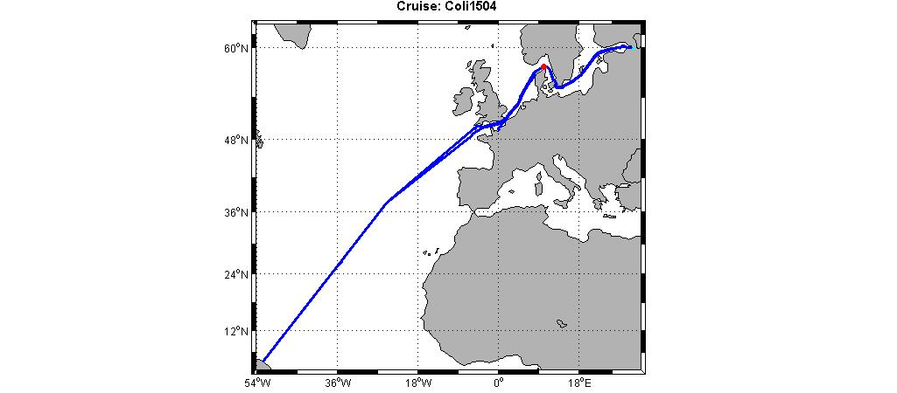

The CO₂ analyser was designed and built by Craig Neil. It is fully automated. On MN Colibri, it is located in the ship's bow thruster space. A Seabird SBE21 thermosalinograph is installed on the same sea water inlet piping. An air inlet is placed on top of the bridge. It allows atmospheric CO₂ measurements in conjunction with surface water CO₂ observations.

Cruise information
Survey type: VOS line
Vessel Name: MN Colibri
Country vessel: FR
Call sign: FNHO
Expocode: 35MJ20150312

Period: 12-24 March 2015

Geographical coverage: Atlantic Ocean
Bounds:
Westernmost longitude: 52ºW
Easternmost longitude: 0ºW
Northernmost latitude: 50ºN
Southernmost latitude: 6ºN

Class of Data: Surface ocean carbon dioxide concentrations

Investigator
Nathalie Lefèvre
IRD
LOCEAN, Université P. et M. Curie, 4 place Jussieu, T. 45-46 5ème étage, UMR 7159 Case 100, 75252 Paris Cedex 05, FRANCE
Nathalie.lefevre@locean-ipsl.upmc.fr

System operator & technical support
Denis Diverrès
IRD
Centre IRD de Bretagne, BP 70, 29280 Plouzané, FRANCE
Denis.Diverres@ird.fr

CO₂ sensors (xCO2)
The accuracies of all components, when operating optimally, are such that the calculated seawater fCO2 has an accuracy of 2 μatm or better and the calculated mole fraction of CO2 in air (xCO2) has an accuracy of 0.1 μatm.

Infrared Analyzer
LI-COR model 6262 (February 2006 - present)
ftp://ftp.licor.com/perm/env/LI-6262/Manual/LI-6262_Manual.pdf
CO2 resolution: 0.01 μmol/mol
CO2 accuracy: ± 1 ppm at 350 ppm
Pressure resolution: 0.02 hPa
Internal pressure transducer accuracy: ± 1.2 hPa
(Manufacturer specifications: ±0.1% FS, where FS = 0-1150 hPa)

The general principle of instrumental design can be found in Pierrot et al. (2009). The concentration of CO2 in the headspace gas was measured using the adsorption of infrared (IR) radiation by the CO2 molecule. The LI-COR analyzer passed IR radiation through two cells. The reference cell is constantly flushed with a reference gas CO2-free. The sample cell is flushed with the gas of interest (standard, outside atmosphere, or headspace gas from equilibration chamber).

The infrared analyzer is calibrated regularly using three standard gases (~250-~500 ppm) from Air Liquide - France, which were calibrated at DT INSU against primary NOAA standards.
The exact concentrations of the standards are:
0 ppm (nitrogen gas)
249.81 ppm
357.32 ppm
506.1 ppm
It was checked by the manufacturer in June 2014.

CO₂ in marine air method (xCO2)
Outside air was constantly being pulled (~6 liters/min) from an inlet on the top of the bridge through ~30 m of tubing (1/4" OD Dekabon) to the analytical system. The flushing rate of the LI-COR analyzer during ATM analyses is ~70-150 ml/min.
Drying: The effects of water vapor on the sample analyses were kept to a minimum by removing as much water as possible. The water was first condensed out of the sample gas stream by cooling to ~5° C using a thermoelectric device. Then water was further removed using Nafion® gas dryers before reaching the IR analyzer. The counterflow gas in the dryer is pre-dried outside air. Typical water content of the analyzed gas was less than 3 millimoles/mole with approximately 90% of the water being removed.

Sampling and equilibrator design
The seawater inlet is on the sea chest at an approximate depth of 3 meters. Seawater was pushed through a spray head into an equilibration chamber that was fabricated using a filter housing (ColeParmer, U-010509-00). The chamber had a ~0.5 L water reservoir and a ~0.8 L gaseous headspace. Water flow rate was ~2 - 3 L/min. The rate at which the headspace gas recirculated through the analyzer during EQU analyses was ~70 - 150 ml/min.
The equilibration chamber was vented to the surrounding space.
Drying: The effects of water vapor on the sample analyses were kept to a minimum by removing as much water as possible. The water was first condensed out of the sample gas stream by cooling to ~5° C using a thermoelectric device. Then water was further removed using Nafion® gas dryers before reaching the IR analyzer. The counterflow gas in the dryer is pre-dried outside air. Typical water content of the analyzed gas was less than 3 millimoles/mole with approximately 90% of the water being removed.
A typical sequence of the continuous analyses was:

STEP TYPE REPETITIONS
1 Standards (all) 1
2 ATM 6
3 EQU 90

Sea Surface Temperature (SST) and Salinity (SSS)
SeaBird model SBE-21 (February 2006 - Present)
http://www.seabird.com/pdf_documents/manuals/21_026.pdf
Temperature resolution: 0.001°C
Temperature accuracy: ± 0.01°C
Salinity resolution: 0.002 ‰

Seawater samples are taken daily at the thermosalinograph outlet. Samples are analysed at SHOM-France in an OSIL Portasal, and compared to IAPSO Sea Water Standards.
The salinity accuracy is expected to be ± 0.02 ‰

The thermosalinograph is calibrated every 18 months, either at Seabird-USA or at SHOM-France.
The seawater inlet of both CO2 analyser and TSG is located on the sea chest. The TSG is very close to the hull, the sea water flow rate is 30 l/min. We consider that the temperature inside the TSG is the SST. The warming between the TSG and the CO2 analyser is 0.2°C (T_{equ} – T_{TSG}).

Equilibrator Temperature (Tequ)
From April 2007 – Present, the water temperature is measured with a Hart 1521 thermometer. This thermometer was calibrated at SHOM - France in May 2013.

Hart model 1521 (April 2007 - present) with a 5610 thermistor probe
http://www.testequipmentdepot.com/hart/pdfs/1521_1522.pdf
Resolution: 0.001°C
Accuracy: ± 0.025°C
This thermometer was calibrated at SHOM - France in May 2013.

Atmospheric Pressure (Patm)
Druck barometer RPT350 (February 2006 - present)
http://www.ge-mcs.com/en/pressure-and-level/transducerstransmitters/rtp350.html
Accuracy: ± 0.01 %
The barometric pressure was measured in the bridge, ~20 m above the equilibrator. The Druck barometer is placed in a box, which also contains the GPS and the Iridium transmitter. It was calibrated in March 2015.

Equilibrator Pressure (Pequ)
The pressure in the equilibrator relative to the bow thruster compartment was measured with a Setra model 239 differential barometer. The LI-COR barometer measured the barometric pressure of the compartment.

Setra model 239, differential pressure (February 2006 - present)
http://www.setra.com/ProductDetails/model_239.htm
Resolution: 0.01 hPa
Accuracy: ± 0.052 hPa
(manufacturer specifications: ± 0.14% FS, where FS = ± 7.5 inches WC)

The absolute pressure of the equilibrator headspace reported in data files is the sum of the infrared analyzer pressure and the differential pressure from the pressure transducer attached to the equilibrator.

Variables info

Column header | Explanation
dd | Day
mm | Month
yy | Year UTC date
hh | Hours UTC time
mn | Minutes
ss | Seconds
day | Decimal year day
Lon | Longitude in decimal degrees (negative values in west)
Lat | Latitude in decimal degrees (negative values in southern hemisphere)
sst | Temperature from the ship's thermosalinograph (ºC)
sss | Salinity from the ship's thermosalinograph (psu)
Patm | Atmospheric pressure in millibar
Tequ | Equilibrator temperature (ºC)
xCO2 | Mole fraction of CO2 (dry) in air or equilibrated air (ppm)
H2Omm | Water content of Licor in mmol/mol
Pequ | Pressure in equilibrator (mbar)
fCO2sw | Fugacity in CO₂ in seawater (μatm)

CALCULATIONS:
Mixing ratios of dried equilibrated headspace and air, corrected from the Licor drift (xCO₂), are converted to fugacity of CO2 in surface seawater and water saturated air in order to determine the fCO2.
For ambient air and equilibrator headspace the fCO2a, or fCO2eq is calculated assuming 100% water vapor content:

fCO2eq = xCO2eq (P - pH2O) exp(B11 + 2 δ12) P/RT

where fCO2eq is the fugacity in the equilibrator, pH2O is the water vapor pressure at the sea surface temperature, P is the atmospheric pressure (in atm), T is the SST or equilibrator temperature (in K) and R is the ideal gas constant (82.057 cm³·atm·deg⁻¹·mol⁻¹). The exponential term is the fugacity correction where B11 is the second virial coefficient of pure CO2

B11 = -1636.75 + 12.0408 T - 0.032795 T² + 3.16528E-5 T³

and

δ12 = 57.7 - 0.118 T

is the correction for an air-CO2 mixture in units of cm³·mol⁻¹ (Weiss, 1974).

The calculation for the fugacity at SST involves a temperature correction term for the change of fCO2 due to changes in water temperature which when the water passes through the pump and through the rubber tubing within the ship. The water in the equilibrator is typically 0.2°C warmer than sea surface temperature.
The empirical temperature correction from equilibrator temperature to SST was:

fCO2(SST) = fCO2(eq) exp (-0.0423 (Teq - SST))

where SST is the sea surface temperature and Teq is the equilibrator temperature in ºC.

METHOD REFERENCES:
Pierrot, D., C. Neill, K. Sullivan, R. Castle, R. Wanninkhof, H. Luger, T. Johannessen, A. Olsen, R. A. Feely, and C. E. Cosca (2009). Recommendations for autonomous underway pCO2 measuring systems and data-reduction routines. Deep Sea Research II, 56: 512-522.
Weiss, R. F. (1974). Carbon dioxide in water and seawater: the solubility of a non-ideal gas. Mar. Chem. 2: 203-215.

