Spring Autowiring is a feature of the Spring Framework that automatically injects dependent objects into a bean, reducing the need for explicit configuration. It helps make applications loosely coupled, cleaner, and easier to maintain.
Automatically resolves and injects dependencies between Spring beans
Reduces boilerplate code and XML/annotation configuration

You can autowire byName or byType.
<bean id="city" class="sample.City" autowire="byName"/>
<bean id="city" class="sample.City" autowire="byType"/>

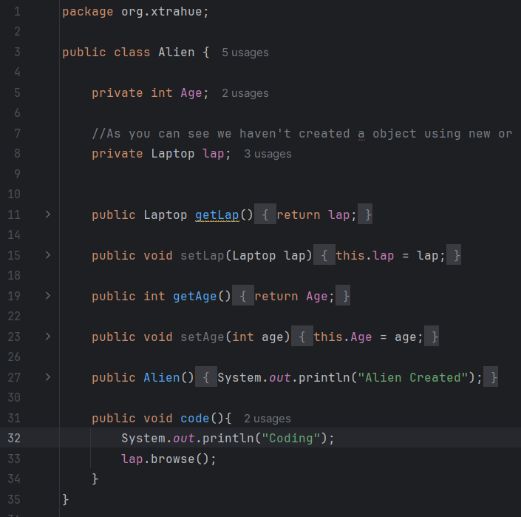
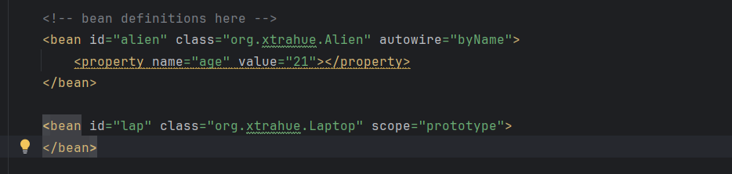
In Alien bean, we haven’t set any value of Laptop, but it autowires with the next bean of id “lap”. The only condition is bean name has to be same as the id name in bean configuration.
Use of primary when two or more bean of same type is present:
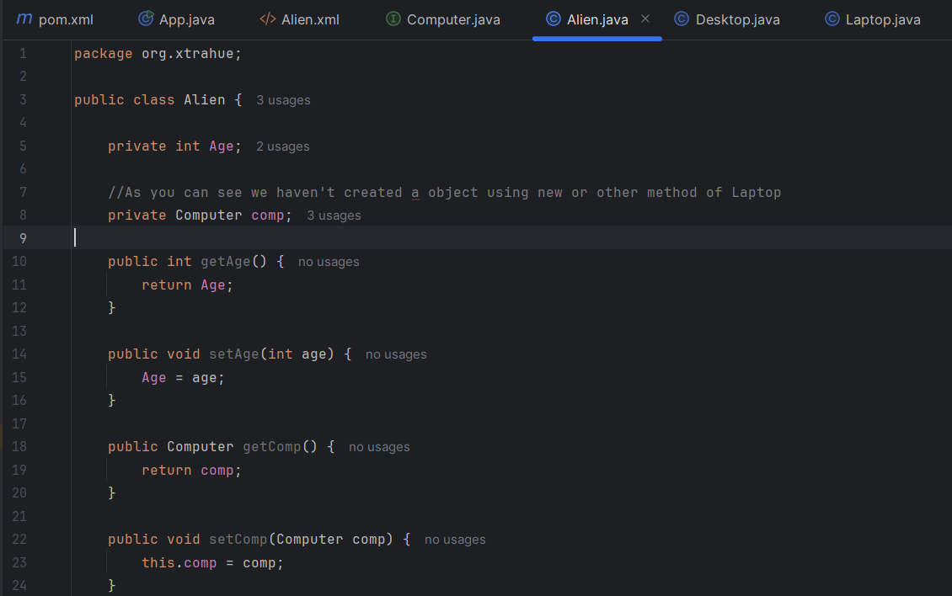
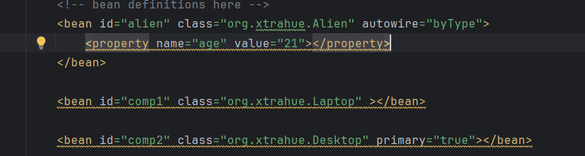

- The scope of a bean is by default Singleton, if you still want a object to get created only when it is first needed, then we can use lazy-init.
Lazy initialization is a performance optimization technique where an object’s creation, calculation, or resource-heavy process is deferred until the exact moment it is first needed.

