Config file:
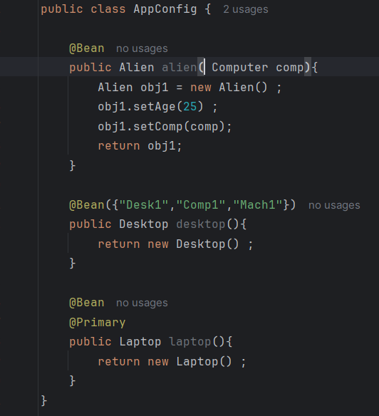
App.java:
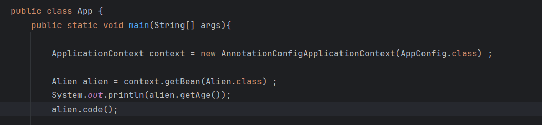

In newer version we don’t have to use the annotation of @Autowired in @Bean configuration explicitly. We are simply passing the Computer object while configuring the bean, now bean will search for if any Computer bean is present or not.

180_@Qualifier: If multiple bean of same reference is there then, we can use @Qualifer(“bean_name”) to specify the bean we are looking for. Here for desktop, we can use Desk1, Comp1, Mach1, desktop all 4 as bean name.
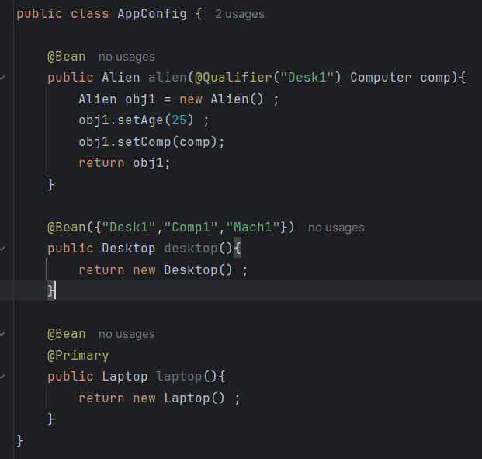
@Primary: We can simply use this annotation just below @Bean tag.
