- We will create the Servlet class by extending the HttpServlet class.
- Service class is an important class, which gets executed every time you send a request.
- If you want to send some data, you need some object where you can do that. That’s why we need to pass two parameters in the service class. One for the request, other one for the response.

- When you build a web application using Java Servlets, your code doesn't run in a vacuum. A Servlet is just a collection of Java classes; it has no built-in ability to listen to a network, read a web browser's request, or send back HTML.

To bridge the gap between your Java code and a user's web browser, you need a Web Server (like Apache Tomcat). localhost:8080 is the specific network address that connects your browser to that server.
- If we just start the server, won’t work. We have to keep the server running all the time.

Implementation:
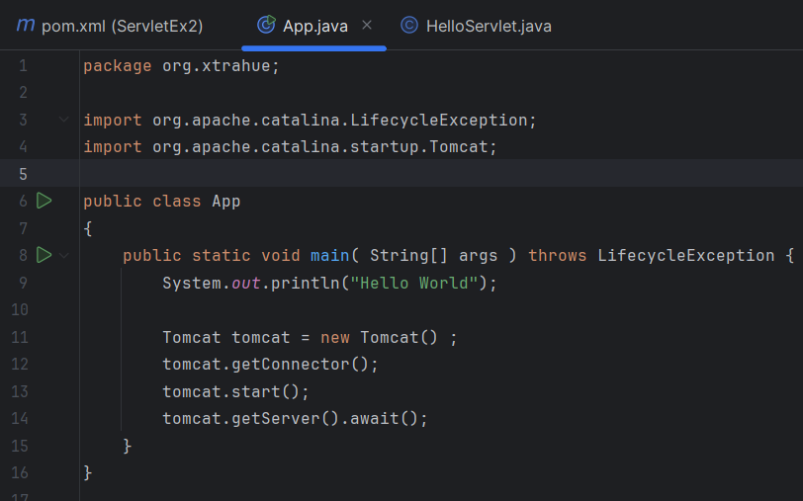
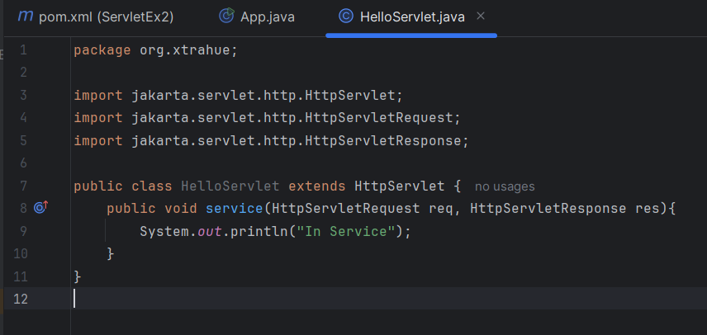

This will provide the output: 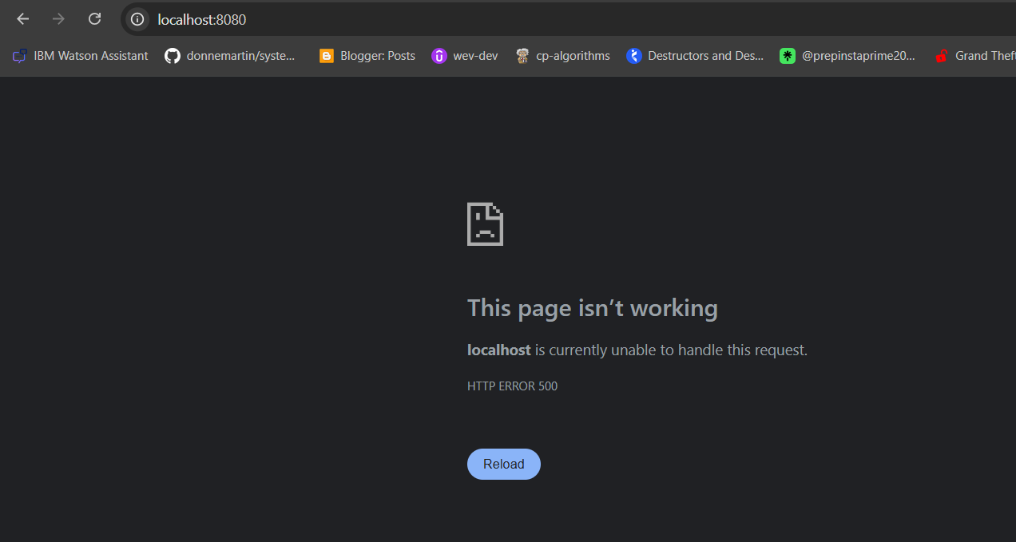

• The Browser Speaks HTTP: Your web browser sends an HTTP request targeting port 8080 on your machine.
• Tomcat Listens: Because you started Tomcat and configured it to open port 8080, Tomcat intercepts that request.
• Tomcat Translates: Web browsers don't understand Java objects, and Java doesn't naturally read raw HTTP text. Tomcat takes the raw text from the browser, wraps it into a clean Java object (HttpServletRequest), and hands it to your Servlet.
• Your Servlet Executes: Your code executes (e.g., handles a login, pulls from a database) and writes a response to HttpServletResponse.
• Tomcat Ships it Back: Tomcat converts your Java response back into a standard web packet and sends it back out through port 8080 to your browser.

