If we use external tomcat, for configuration we need to use xml. E.g: web.xml. In this you do the mapping. Or we can use the annotation way for mapping.
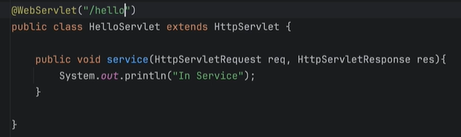

But as we are using embedded tomcat, we have to configure it by ourselves.
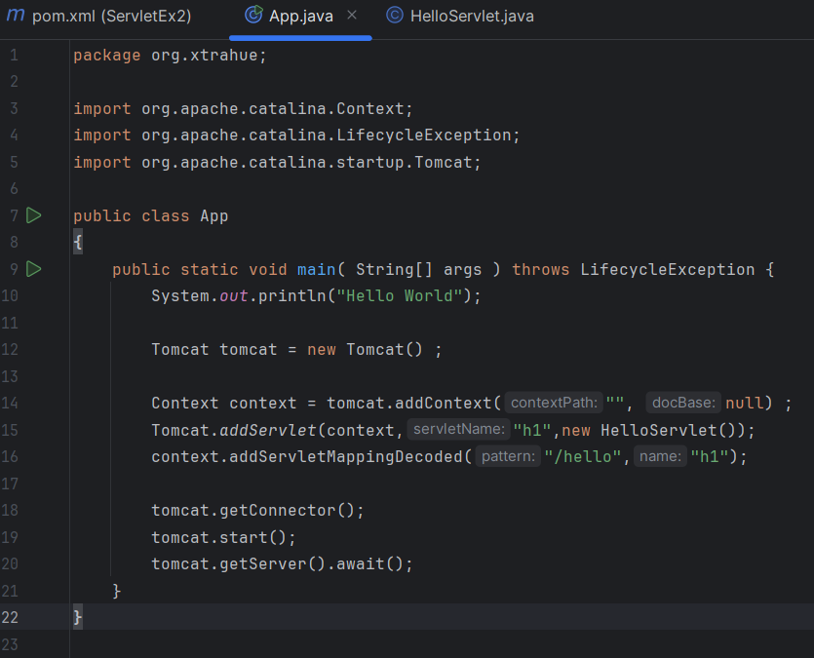
In Tomcat.addServ the second parameter is the name we are giving to the servlet, it can be anything. And in context mapping we have to provide the name of the servlet, the name should be same as the name we used in previous line.

Now, if you want to print/provide some response you can do that: 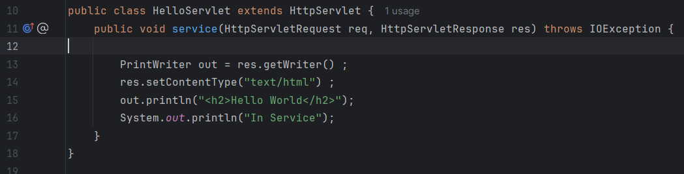
Right now, everything is jammed onto a single page, and mixing HTML inside Java is a massive anti-pattern. We need to introduce MVC here so we can cleanly separate our UI from our backend logic

