JSP -> Jakarta Server pages. Basically, it is java integrated in html. JSP is view technology.
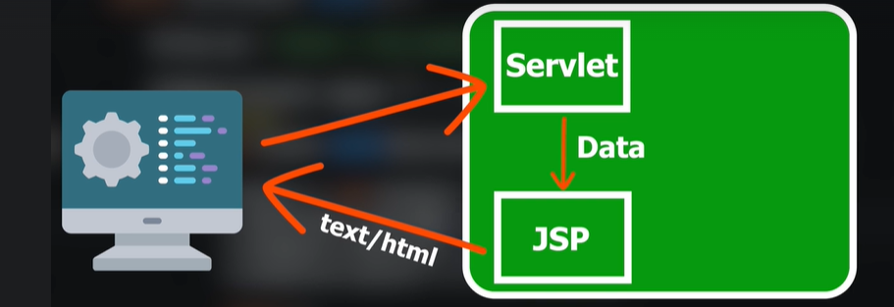
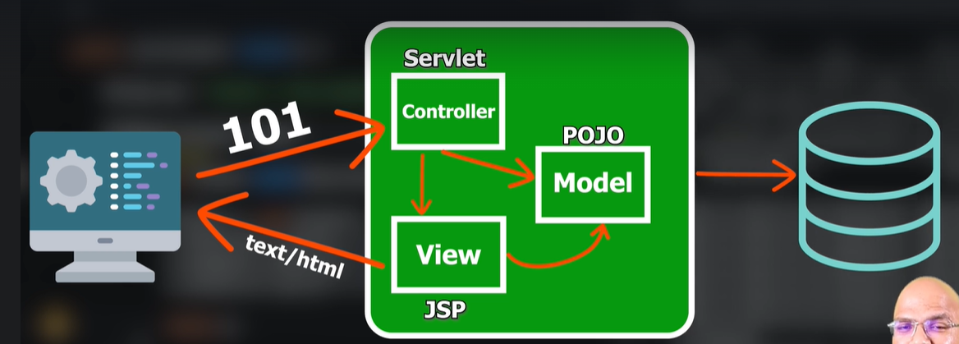
But the question comes, how tomcat will run jsp ? We know that tomcat is a server also a servlet container. This jsp page also gets converted to servlets

