## Chapter 1

## ABSTRACT

## This project involves the implementation of a Smart Door Opening System using a Raspberry Pi, where QR code-based authentication controls access. The system employs the RPi.GPIO library to manage a stepper motor and LEDs, which visually indicate the operational status of the door (opening or closing). A predefined stepper motor sequence ensures precise movement in clockwise or counterclockwise directions, executed through a Python script. The QR code is provided through a user-friendly input method (such as a keypad, touchscreen, or mobile application) and validated against a secure database of authorized codes. Upon successful verification, the motor operates for a specific number of steps to simulate door movement. LEDs toggle during the process to provide real-time feedback, such as "Access Granted" or "Access Denied." The code ensures robust GPIO initialization and cleanup for safe and reliable operation. This implementation can be further enhanced by integrating additional features such as obstacle detection using sensors, logging access attempts, or enabling multi-factor authentication. The project demonstrates the practical application of Raspberry Pi in creating secure, automated, and efficient door control systems using QR code technology.

## Chapter 2

## INTRODUCTION

## This project demonstrates the implementation of a Smart Door Opening System using a

## Raspberry Pi, incorporating QR code-based authentication for secure access control.

## The system utilizes a stepper motor for precise control of the door's opening and closing

## mechanism, managed through a predefined step sequence implemented in Python. LEDs are

## employed as visual indicators to convey the system’s operational status, such as access granted,

## access denied, or door in motion. The Raspberry Pi’s GPIO pins are configured for seamless

## control of the motor and LEDs. The QR code data is provided via a user-friendly interface

## (e.g., keypad, touchscreen, or mobile application) and verified against a secure database. This

## project highlights the versatility of Raspberry Pi in developing secure and efficient automation

## systems. It also serves as a foundation for future enhancements, such as adding sensors for

## obstacle detection, real-time logging of access attempts, or integrating remote control

## functionalities.

## Objective

## The objective of the Smart Door Opening System is to provide a secure, efficient, and automated solution using QR code authentication as the primary method.

## The system enhances security by generating QR codes containing essential details like name, USN, and year, ensuring a robust access mechanism.

## The login form requires users to input their details, such as name, USN, and year.

## This system aims to deliver a scalable and reliable solution for managing entry points, making it suitable for applications requiring entry log.

## 2.2 Problem Statement

## With the growing demand for secure and automated access control systems, there is a need for efficient solutions that combine reliability, cost-effectiveness, and ease of use. The challenge is to design a smart system capable of automating the opening and closing of a door using QR code-based authentication while providing real-time status feedback. This requires precise control of a stepper motor for door operation, seamless integration with indicators like LEDs, and robust authentication mechanisms to ensure security. The system must also prioritize safety, scalability, and flexibility for future enhancements. The project aims to address these challenges by leveraging the Raspberry Pi’s capabilities to develop a secure and programmable smart door control system.

## Chapter 3

## APPLICATIONS

## Educational Institutions :

## Provides secure access to classrooms, laboratories, and staff rooms, ensuring that only authorized personnel can enter restricted areas.

* **Home Door :**

Provides secure and automated access to homes by authenticating residents or authorized individuals through QR code scanning, eliminating the need for physical keys.

* **Classroom and Lab Access in Educational Institutions :**

Manages access to classrooms, laboratories, and other restricted areas within educational institutions, ensuring only authorized students or staff can enter.

* **Examination Hall Access :**

Facilitates secure entry to examination halls during exams, with QR codes serving as access passes for students or authorized personnel, preventing unauthorized access.

* **Event Access in Educational Institutions :**

Controls entry to events, conferences, or exhibitions in schools, colleges, or universities, using QR code-based tickets or passes for seamless and secure access.

* **Student Parking Access :**

Automates entry to student parking areas by issuing QR codes to registered vehicles, ensuring only authorized vehicles can access designated parking spaces.

## 

## Chapter 4

## COMPONENTS

## 4.1 Raspberry pi 4 Model B

## 

**Figure 4.1: Raspberry pi 4 Model B.**

The Raspberry Pi 4 Model B is a powerful single-board computer designed for a variety of applications, from education to industrial automation. It features a quad-core ARM Cortex-A72 processor, up to 8GB of RAM, dual micro-HDMI ports supporting 4K output, and USB 3.0 connectivity. Its GPIO pins enable easy interfacing with sensors, motors, and other peripherals, making it ideal for hardware projects. Built-in Wi-Fi, Bluetooth, and Ethernet provide versatile networking options. The Pi 4 is a versatile platform for learning, prototyping, and deploying IoT and embedded systems solutions.

## 

## 4.2 Stepper Motor

## 

## A stepper motor is a type of DC motor that moves in discrete steps, making it ideal for precise positioning and control. Each step corresponds to a specific angle of rotation, controlled by electrical pulses sent to the motor. Stepper motors are widely used in applications like 3D printers, CNC machines, and robotics. They come in different types, such as unipolar and bipolar, and usually include multiple wires for phase connections. The motor in the image appears to be a typical bipolar stepper motor with four wires, often used for higher torque and precision tasks.

## 4.3 Ultrasonic Sensor

## 

**Figure 4.3: Ultrasonic Sensor.**

An ultrasonic sensor is a device that measures distance by emitting ultrasonic sound waves and detecting their reflection from objects. It calculates the distance based on the time taken for the sound waves to travel to the object and back. These sensors are widely used in applications like obstacle detection, level measurement, and robotics. They are reliable, non-contact devices that work well in various environments. Ultrasonic sensors are ideal for measuring distances in the range of a few centimeters to several meters.

**4.4 Jumper Wires**

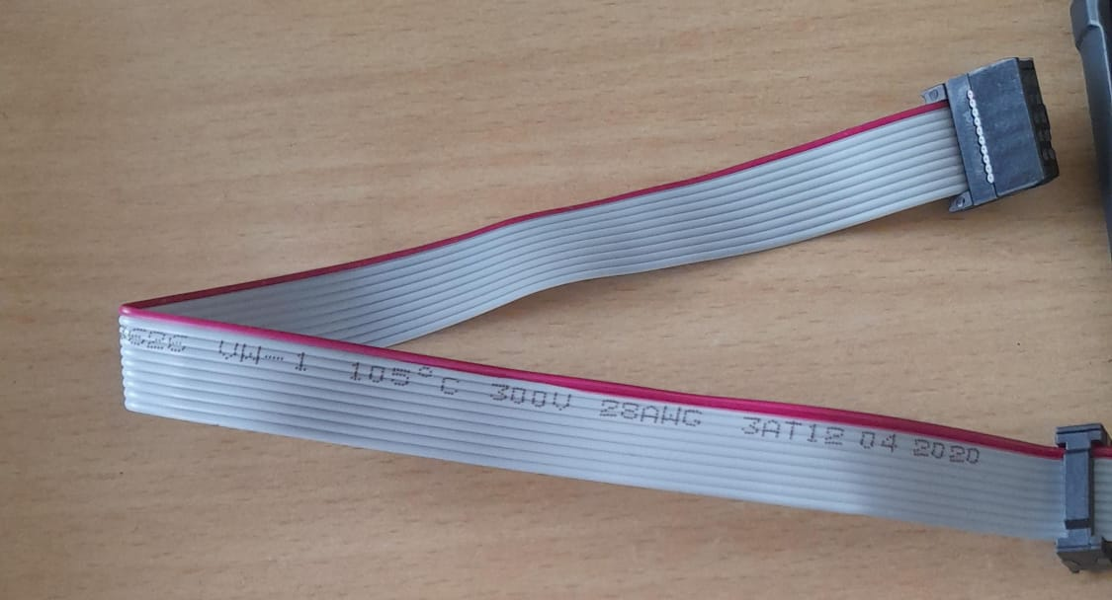

**Figure 4.4: Jumper Wires.**

**Chapter 5**

**FLOW CHART**

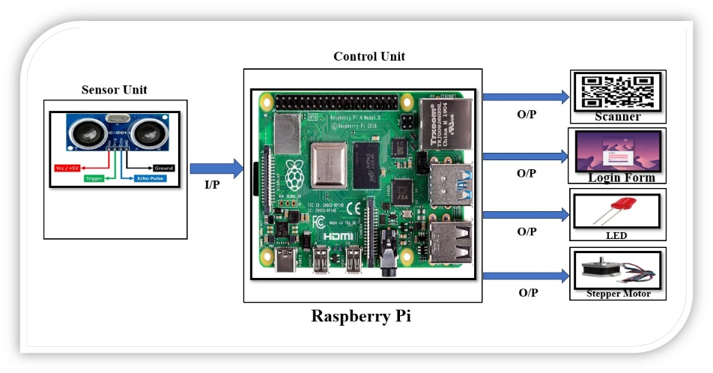

**Chapter 6**

**CONCLUSION**

The system integrates QR code authentication, a control unit, and output devices to enable secure and automated door operations. The QR code input ensures reliable and secure access control, while the Raspberry Pi handles decision-making through its GPIO interface.

The stepper motor executes precise door movements based on authentication results, and LEDs provide real-time status indicators such as access granted, access denied, or door in motion.

This configuration is effective for managing secure and automated access control, demonstrating a practical and scalable solution for various applications requiring enhanced security and convenience.

**Chapter 7**

**FUTURE WORK**

* **Enhanced Security Features:** Integrate additional security layers, such as facial recognition or multi-factor authentication (e.g., combining QR code with a PIN), to further enhance access control.
* **Cloud Integration:** Enable cloud-based management for real-time monitoring and logging of access events, providing users with remote control and alerts.
* **Mobile App Integration:** Develop a mobile app that allows users to manage and issue QR codes for remote access, track entry attempts, and control door functionality.
* **Multiple User Management**: Implement a system that supports multiple users with different access levels, such as temporary access codes for guests or restricted access for certain areas.
* **IoT Integration:** Incorporate IoT (Internet of Things) capabilities for smarter automation, such as triggering door actions based on schedules, geo-fencing, or other environmental factors.
* **Battery Backup:** Add a power backup system to ensure continuous operation of the system during power outages.
* **Energy Efficiency:** Optimize components and code to reduce power consumption and enhance the system's sustainability for long-term use.

**Chapter 8**

**APPENDIX**

1. Libraries Used:
   * RPi.GPIO: GPIO pin control for Raspberry Pi.
   * pyqrcode: QR code generation.
   * Pillow (PIL): Display QR code images.
   * time: Time delays and timestamps.
2. GPIO Configuration:
   * Stepper Motor: IN1 (GPIO 13), IN2 (GPIO 4), IN3 (GPIO 6), IN4 (GPIO 5).
   * Ultrasonic Sensor: TRIG (GPIO 19), ECHO (GPIO 26).
   * LEDs and Switches: LED3 (GPIO 3), LED4 (GPIO 5), Emergency Switch2 (GPIO 20).
3. Key Features:
   * QR Code Generation: Displays a QR code with a Google Form link when an object is detected (distance < 50 cm).
   * Stepper Motor Control: Rotates clockwise to open the door and counterclockwise to close.
   * Emergency Override: Opens the door for 5 seconds if the emergency switch is pressed.
4. Workflow:
   * Detect distance with an ultrasonic sensor.
   * Generate and display a QR code if an object is detected.
   * Open/close the door based on QR code scan and form submission.
   * Continuously monitor and respond to emergency input.
5. Safety:
   * Handles program interruption gracefully.
   * Resets GPIO pins with GPIO.cleanup() after execution.

**8.1 Pseudocode :**

