The integration of Artificial Intelligence (AI) and the Internet of Things (IoT), commonly referred to as AIoT, is transforming industries by enabling devices to not only collect data but also process, analyze, and make decisions autonomously. AIoT leverages the vast amounts of data generated by IoT devices, using advanced AI algorithms such as machine learning (ML) and deep learning (DL) to derive meaningful insights, predict trends, and optimize operations. This convergence facilitates smarter and more efficient systems across diverse sectors, including healthcare, smart cities, manufacturing, agriculture, and transportation.

In AIoT systems, IoT devices act as sensors that capture real-time data, while AI models process and interpret this data for predictive analytics, anomaly detection, and decision- making. The combination enhances automation, reduces human intervention, and improves system responsiveness. AIoT enables dynamic adaptation to changing conditions, predictive maintenance, personalized services, and more efficient resource management. However, challenges such as data privacy, security, scalability, and energy efficiency need to be addressed for successful AIoT deployment.

This abstract explores the components, applications, benefits, challenges, and future potential of AIoT, highlighting its role in revolutionizing industries and improving the quality of life through intelligent, interconnected systems.

|  |  |
| --- | --- |
| **Table of Contents** |  |
| **Contents** | **Page No.** |
| **ABSTRACT** | **i** |
| **TABLE OF CONTENTS** | **ii** |
| **LIST OF FIGURES** | **iii** |
| **LIST OF ACRONYMS** | **iv** |
| **1 About the Organization** | 1 |
| 1.1 Company Profile | 1 |
| 1.2 Vision and Mission | 1 |
| **2 Introduction** | 2 |
| 2.1 Internship Definition | 2 |
| 2.2 Internship Benifits | 2 |
| **3 Introduction to AIoT** | 3 |
| 3.1 Benefits of AIoT | 3 |
| 3.2 Applications | 3 |
| **4 Components Used** | 4-7 |
| 4.1 Raspberry pi | 4 |
| 4.2 Light Sensor | 4-5 |
| 4.3 Ultrasonic Sensor | 5-6 |
| 4.4 LED | 6 |
| 4.5 DHT11 Sensor | 6-7 |
| **5 Project Methodology** | 8-9 |
| 5.1 Objectives | 8 |
| 5.2 Problem Statement | 8-9 |
| 5.3 Flow Diagram | 9 |
| **6 Snapshots** | 10 |
| **7 Conclusion and Future Work** | 11 |
| 7.1 Conclusion | 11 |
| 7.2 Future Work | 11 |

**References**

|  |  |  |
| --- | --- | --- |
| Fig. 4.1 | Raspberry pi | 04 |
| Fig. 4.2 | Light Sensor | 05 |
| Fig. 4.3 | Ultrasonic Sensor | 05 |
| Fig. 4.4 | LED | 06 |
| Fig. 4.5 | DHT11 Sensor | 07 |
| Fig. 5.1 | Flow Diagram | 09 |

|  |  |
| --- | --- |
| AIoT | Artificial Intelligence of Things |
| IoT | Internet of Things |
| AI | Artificial Intelligence |
| ML | Machine Learning |
| LDR | Light Dependent Resistor |
| DHT | Digital Humidity and Temperature |
| GPIO | General Purpose Input/Output |

# Chapter 1

## ABOUT THE ORGANIZATION

### Company Profile

Xtrans Solutions is a company that specializes in Next-Gen Internet technologies, including IoT, AI, ML, blockchain, and privacy and security. Their mission is to help organizations improve their capabilities in these areas. The Xtrans Solutions, headquartered in the San Jose, USA, pioneers Next-Gen Internet Technologies with an unwavering commitment to Privacy and Security. Our mission is to empower organizations, elevating their capabilities in IoT, OpenAI AI/ML, and Blockchain, fostering innovation for a trusted system. Xtrans Solutions Offer SMART platform: A platform that helps organizations increase their competencies through secure devices, IoT, machine learning, AI, and robotics technologies IoT Lab and Kits: Kits for training and development that can interface with Xtrans IoT Cloud or any public IoT cloud

### Vision and Mission

Xtrans Solutions is to enable you to increase the skills and competencies of your organization, through our SMART (Secure IoT Devices, Machine Learning, Artificial Intelligence and Robotics Technologies) platform. Xtrans mission is to empower organizations, elevating their capabilities in IoT, OpenAI AI/ML, and Blockchain, fostering innovation for a trusted system Their Motto and Vision are to create awareness & training young generation to current and future jobs demand and also help to current and future jobs demand; meanwhile help the student sand employees to meet the mandatory necessities of future human resources and skill demands. They are in the 4th industrial revolution. The technological revolution is catastrophic like never before, hence continues awareness for the up-gradation environment is much essential .Xtrans solutions. is working to help and enhance the potential of students and employees. So that future human resources will be very beneficial, purposeful and profitable to the nation.

# Chapter 2

### Internship Definition

## INTRODUCTION

An internship is a professional learning experience that offers meaningful, practical work related to a student’s field of study or career interest. An internship gives a student the opportunity for career exploration and development, and to learn new skills. It offers the employer the opportunity to bring new ideas and energy into the workplace, development and potentially build a pipeline for future full-time employees. A quality internship:

1. Consists of a part-time or full-time work schedule that includes no more than 25% clerical or administrative duties.
2. Provides a clear job/project description for the work experience.
3. Orients the student to the organization, its culture and proposed work assignment(s).
4. Helps the student develop and achieve learning goals.
5. Offers regular feedback to the student intern.

Typically, an internship consists of an exchange of services for experience between the intern and the organization. Internships are used to determine whether the intern still has an interest in that field after the real-life experience.

### Internship Benefits

Internships offer a wide range of benefits to individuals seeking to gain professional experience and to organizations looking to develop talent. Some of the key benefits of internships include Skill Development: Internships provide hands-on experience in a real work environment, allowing individuals to develop and enhance specific job-related skills, such as technical, communication, problem-solving, and teamwork skills. Industry Exposure: Internships offer a first hand look at a specific industry or career field, helping individuals gain a better understanding of the industry& dynamics, culture, and expectations.

# Chapter 3

## INTRODUCTION TO AIoT

AIoT, or Artificial Intelligence of Things, is the convergence of Artificial Intelligence (AI) with the Internet of Things (IoT). It combines the data-gathering capabilities of IoT with the intelligent decisionmaking and automation abilities of AI. This integration enhances the efficiency, adaptability, and intelligence of connected systems, enabling smarter operations across industries.

### Benefits of AIoT

* + 1. **Real-Time Data Processing:** AI enhances IoT by processing large volumes of data in real time, leading to faster insights and actions.
    2. **Automation:** AIoT enables devices to operate autonomously, reducing human intervention.
    3. **Predictive Maintenance:** AI algorithms analyze IoT sensor data to predict equipment failures and optimize maintenance schedules.
    4. **Improved Efficiency:** AI-driven insights optimize operations, resource allocation, and energy use.
    5. **Enhanced User Experience:** AIoT personalizes interactions, such as in smart homes or wearable tech, to better suit user preferences.

### Applications

* + 1. **Smart Homes:** Intelligent thermostats, lights, and security systems adapt to user behavior.
    2. **Healthcare:** Wearable devices monitor patient health and alert caregivers when anomalies are detected.
    3. **Industry 4.0:** AIoT optimizes manufacturing processes, reduces downtime, and improves supply chain management.
    4. **Smart Cities:** Enables intelligent traffic management, efficient energy distribution.

# Chapter 4

## COMPONENTS USED

### Raspberry pi:

Raspberry Pi is a compact, low-cost, and powerful single-board computer that supports various programming languages and interfaces with sensors and external devices. It is equipped with GPIO (General Purpose Input/Output) pins, Wi-Fi, and Bluetooth capabilities, making it ideal for IoT and automation projects.

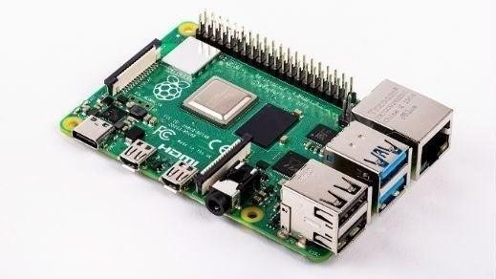

**Fig 4.1: Raspberry pi.**

#### Usage of raspberry pi in this project:

Raspberry Pi is used in the Intelligent Street Lighting System due to its versatility and computing power. It serves as the central controller, processing input from sensors (like motion detectors and light sensors) and making real-time decisions to adjust the lighting. Additionally, its built-in connectivity features allow integration with IoT platforms for remote monitoring and control.

### Light sensor:

A light sensor, also known as a photoresistor or LDR (Light Dependent Resistor), is an electronic component that detects light intensity. It changes its resistance based on the amount of light falling on it—resistance decreases as light intensity increases. These sensors are

commonly used in applications requiring automatic lighting control and brightness adjustment.

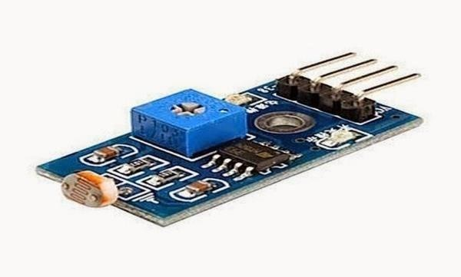

**Fig 4.2: Light sensor.**

#### Usage of light sensor in this project:

In the Intelligent Street Lighting System, the light sensor is crucial for detecting ambient light levels. It helps the system determine whether streetlights should be on or off based on natural light availability, such as during dusk or dawn. By automatically adjusting the streetlight brightness depending on the surrounding light conditions, it ensures energy efficiency by only using electricity when necessary.

### Ultrasonic sensor:

An ultrasonic sensor is a device that uses sound waves to measure the distance between the sensor and an object. It emits high-frequency sound waves and measures the time taken for the waves to bounce back after hitting an object. The sensor then calculates the distance based on the time delay.

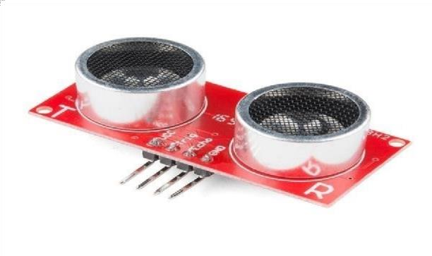

**Fig 4.3: Ultrasonic Sensor.**

#### Usage of ultrasonic sensor in this project:

In the Intelligent Street Lighting System, the ultrasonic sensor is used to detect the presence and movement of vehicles or pedestrians. When movement is detected, the sensor signals the Raspberry Pi to adjust the streetlight's brightness accordingly. This helps optimize energy usage by dimming lights when no movement is detected and brightening them when movement occurs, improving both safety and energy efficiency.

### LED:

LED (Light Emitting Diode) is a semiconductor light source that emits light when current flows through it. LEDs are known for their energy efficiency, long lifespan, and ability to produce bright light while consuming very little power compared to traditional incandescent bulbs.



**Fig 4.4: LED.**

#### Usage of LED in this project:

LEDs are used in the Intelligent Street Lighting System because of their energy efficiency, durability, and cost-effectiveness. They provide the optimal brightness needed for street lighting while consuming less energy, thus supporting the project's goal of reducing energy consumption and operational costs. Additionally, LEDs can be easily controlled and dimmed, making them suitable for dynamic adjustments based on real-time data, such as traffic flow and ambient light levels.

### DHT11 sensor:

The DHT11 is a low-cost digital sensor that measures temperature and humidity. It provides a reliable and accurate output for both parameters and communicates with microcontrollers (like Raspberry Pi)

via a digital signal. It has a relatively wide operating range, typically from 20 to 80% humidity and temperatures between 0°C and 50°C.

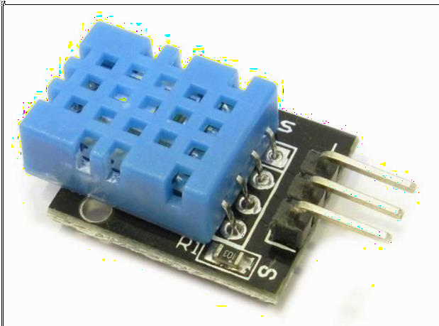

**Fig 4.5: DHT11 Sensor.**

#### Usage of DHT11 sensor in this project:

The DHT11 sensor is used in the Intelligent Street Lighting System to monitor environmental conditions, such as temperature and humidity, which may influence the lighting system’s behaviour. For instance, it can help adjust the lighting brightness in response to weather conditions, such as dimming lights during high humidity or heavy fog for safety and energy efficiency.

# Chapter 5

## PROJECT METHODOLOGY

The Intelligent Street Lighting System using Raspberry Pi will be designed to enhance energy efficiency and automation in urban lighting. By leveraging the Raspberry Pi, sensors, and IoT technologies, the system will adapt streetlight brightness based on real-time factors like traffic movement and ambient light levels. This approach will reduce energy wastage, operational costs, and environmental impact. Additionally, the system will enable remote monitoring and maintenance through cloud connectivity, aligning with the vision of smarter and more sustainable cities.

### Objectives

The primary objectives of an intelligent street lighting system are to enhance energy efficiency, improve safety, and promote sustainability. By using technologies such as LED lighting, motion sensors, and ambient light detectors, the system reduces energy consumption and adjusts illumination based on real-time conditions. This not only lowers operational costs but also minimizes environmental impact by reducing carbon emissions. Additionally, intelligent street lighting enhances public safety by ensuring optimal illumination in critical areas, such as pedestrian crossings and intersections, while deterring crime and facilitating quick emergency responses. Through remote monitoring and predictive maintenance, the system also minimizes maintenance costs and ensures consistent performance, contributing to a more sustainable and cost-effective urban infrastructure.

### Problem Statement

Traditional street lighting systems are inefficient as they consume significant energy by operating continuously at full brightness, regardless of real-time environmental conditions or pedestrian and vehicular activity. These systems lack automation, leading to unnecessary energy wastage during periods of low or no activity. Additionally, manual monitoring and maintenance of streetlights are time-consuming and often lead to delayed identification and repair of faulty lights, compromising public safety.

### Flow Diagram

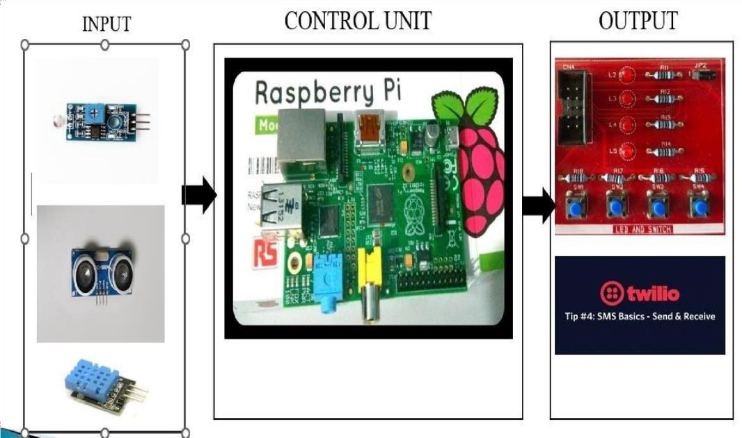

**Fig 5.1: Flow diagram.**

This flow diagram illustrates the working of a simple sensor-based system using a Raspberry Pi as the control unit. On the input side, various sensors are connected, including a flame sensor, an ultrasonic sensor, and a DHT11 temperature and humidity sensor. These sensors gather realtime data, such as detecting fire, measuring distance, and monitoring environmental conditions. This information is then sent to the control unit, the Raspberry Pi, which processes the data and determines the appropriate response.

The output side consists of two components. First, it includes hardware outputs, such as an LED and switch system, likely used for visual indication or manual response. Second, there is an integration with the Twilio platform for sending SMS alerts. This feature enables remote notifications, such as sending warnings or updates based on the sensor data. Together, this system provides an efficient solution for monitoring, processing inputs, and triggering timely outputs for user awareness and safety.

# Chapter 6

## SNAPSHOTS

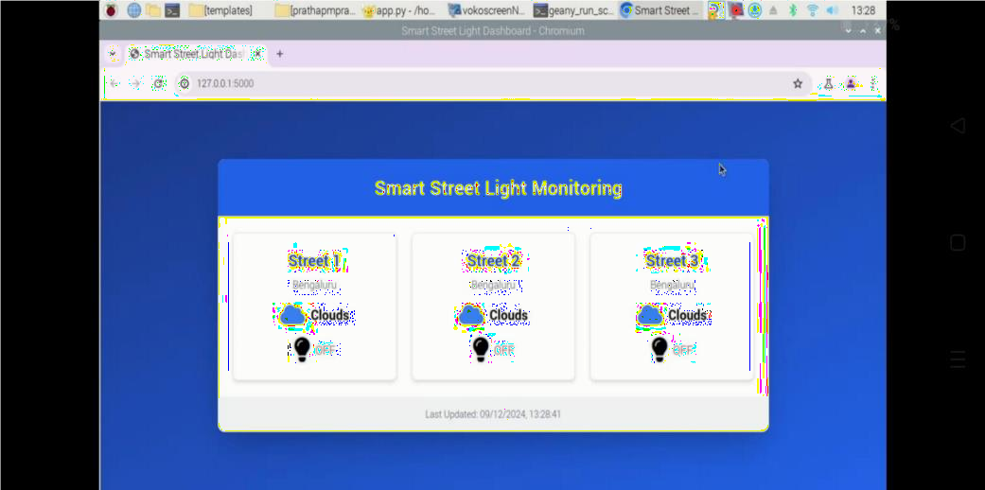

**Fig 6.1: Smart Street Light Monitoring Dashboard with Lights OFF.**

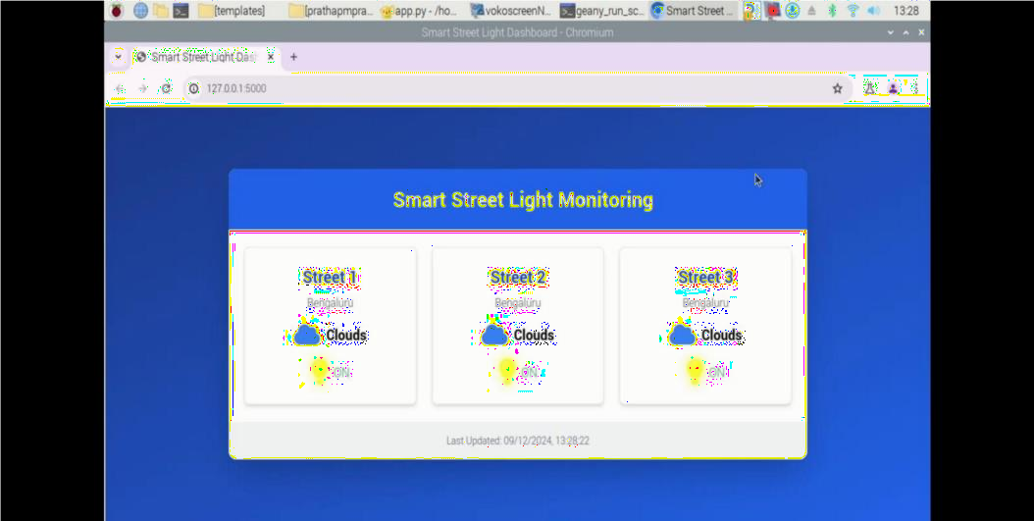

**Fig 6.2: Smart Street Light Monitoring Dashboard with Lights ON.**

# Chapter 7

## CONCLUSION AND FUTURE WORK

### Conclusion

The Intelligent Street Lighting System project implemented using Raspberry Pi successfully demonstrates the potential of IoT-based solutions in modernizing urban infrastructure. The use of Raspberry Pi as the central controller highlights its versatility, low cost, and efficiency in managing and automating street lighting systems.

In conclusion, the project demonstrates that a Raspberry Pi-based intelligent street lighting system is a feasible, sustainable, and cost-efficient solution for modern cities. It provides a strong foundation for future research and development in smart city initiatives, paving the way for greener and smarter urban environments.

### Future Work

The Intelligent Street Lighting System using Raspberry Pi has significant potential for future enhancements and expansions. Some of the future work includes:

1. **Integration of More Sensors:** Adding additional sensors, such as air quality monitors, CO2 sensors, or weather stations, to further optimize lighting control and enhance environmental awareness.
2. **Machine Learning for Predictive Lighting:** Implementing machine learning algorithms to predict traffic patterns and environmental conditions, allowing the system to adjust lighting preemptively and further reduce energy consumption.
3. **Integration with Smart Grid Systems:** Connecting the lighting system with smart grid technologies for better energy distribution, real-time data sharing, and improved grid management.
4. **Renewable Energy Optimization:** Incorporating more advanced renewable energy solutions, such as solar power with energy storage systems, to make the street lighting system completely autonomous and self-sustaining.

## REFERENCES

1. B.Abinaya, S.Gurupriya, M.Pooja,” IOT Based Smart and Adaptive Lighting in Street Lights”, 2021 Second International Conference On Computing and Communications Technologies (ICCCT’17).
2. Samir A. Elsagheer Mohamed, “Smart Street Lighting Control and Monitoring System for Electrical Power Saving by Using VANET”, Int. J. Communications, Network and System Sciences, 2020, 6, 351-360.
3. Noriaki Yoshiura, Yusaku Fujii, Naoya Ohta, “Smart street light system looking like usual street lights based on sensor networks”, 2022 13th International Symposium on Communications and Information Technologies (ISCIT).