**3rd Sem Mini Project Report on**



**Email Classification Using Random Forest Algorithm**



**Submitted in partial fulfillment of the requirement for the award of the degree of**

**BACHELOR OF TECHNOLOGY**

**IN**

**COMPUTER SCIENCE & ENGINEERING**

**Submitted by:**

**Student Name:** Sameer Singh Bhandari

**University Roll No:** 2319495



**Department of Computer Science and Engineering**

**Graphic Era Hill University**

**Dehradun, Uttarakhand**

**2024-25**



**CANDIDATE’S DECLARATION**

I hereby certify that the work which is being presented in the project report entitled **“Email Classification Using Random Forest Algorithm”** in partial fulfillment of the requirements for the award of the Degree of *Bachelor of Technology in Computer Science and Engineering* in the Department of Computer Science and Engineering of the Graphic Era Hill University, Dehradun shall be carried out by the undersigned under the supervision of **Mr. Nishant Bhandari**, Department of Computer Science and Engineering, Graphic Era Hill University, Dehradun.

**Student Name:**

Sameer Singh Bhandari

**University Roll No:**

2319495

The above-mentioned student shall be working under the supervision of the undersigned on the

**“Email Classification Using Random Forest Algorithm”**

**Supervisor**

Mr. Nishant Bhandari

**Head of the Department**

Prof. (Dr.) Dibyahash Bordoloi

**Examination**

**Name of the Examiners**

1. Mr. Nishant Bhandari

**Signature with Date**

**Table of Contents**

|  |  |  |
| --- | --- | --- |
| **No** | **Description** | **Page No** |
| 1 | Introduction and Problem Statement | **3** |
| 2 | Methodology | **5** |
| 3 | Implementation | **6** |
| 4 | Results and Discussion | **9** |
| 5 | Conclusion and Reference | **10** |
|  |  |  |

**Introduction and Problem Statement**

Introduction

Overview of Spam Email Detection:

Spam email detection has become crucial in combating the growing menace of unwanted and potentially harmful emails. Spam emails can lead to phishing, financial fraud, and wasted resources.

Need for Automated Spam Detection Systems:

Manual spam detection is impractical due to the high volume of emails. Automated systems powered by machine learning algorithms offer scalable and accurate solutions. These systems adapt to evolving spam patterns, ensuring better protection for users.

Role of Machine Learning and Random Forest:

Machine learning enables systems to learn from data and make predictions without explicit programming. The Random Forest algorithm, known for its high accuracy and robustness, is well-suited for email classification tasks due to its ability to handle noisy and imbalanced datasets effectively.

Problem Statement

Challenges in Detecting Spam Emails

Spam detection faces challenges such as:

* High email volumes.
* Evolving and diverse spam patterns.
* Differentiating between spam and legitimate (ham) emails.

Limitations of Traditional Filters

Rule-based and keyword-based spam filters often fail to adapt to new spam techniques and lack scalability.

Need for an Accurate Detection System

There is a pressing need for a scalable and automated system that accurately classifies emails while handling noise and variability in the dataset.

Literature Survey

Traditional Methods

* **Rule-based Filters:** Fixed rules to identify spam but lack adaptability.
* **Keyword-based Filters:** Detect specific keywords but prone to false positives.

Modern Approaches

* **Naive Bayes:** Probabilistic model but struggles with high-dimensional data.
* **Support Vector Machines (SVM):** Effective for binary classification but computationally intensive.
* **Random Forest:** Outperforms other methods with high accuracy and robustness.

Justification for Using Random Forest

* High accuracy due to ensemble learning.
* Handles noisy and imbalanced datasets effectively.
* Provides feature importance insights for improved decision-making.

Objectives

1. Develop a robust email classification system with high accuracy.
2. Preprocess email data for efficient feature extraction.
3. Train and evaluate a Random Forest-based classification model.
4. Deploy the model using Flask and React for real-time prediction.
5. Provide spam/ham classification with confidence percentages.

**Methodology**

Data Description

Dataset**:** Spam detection dataset (e.g., spam.csv).

Features**:**

* **Message:** Text content of the email.
* **Label:** Spam or ham classification.

**Data Preprocessing**

Cleaning**:** Removing punctuation, numbers, stopwords and converting to the small characters.

Tokenization**:** Splitting text into words.

Vectorization**:** Transforming text to numerical data using CountVectorizer.

Example of Text Transformation**:**

|  |  |  |
| --- | --- | --- |
| **Original Text** | **Cleaned Text** | **Vectorized Format** |
| "Buy now! Limited ..." | "buy limited …" | [1, 0, ...] |

**Model Selection and Training**

Algorithm**:** Random Forest.

* **Parameters:** Number of estimators, depth, and splits.

Training**:**

* Train-test split (80/20) with stratification.
* Metrics: Accuracy, precision, recall, F1-score.

**System Workflow**

Architecture**:**

* User input ➔ Preprocessing ➔ Vectorization ➔ Prediction ➔ Output (Spam/ Ham).

**Implementation**

**Tools And Technologies**

Python Libraries:

* NLTK: Text Preprocessing.
* Scikit-learn: Model Training.
* Joblib: Model Serialization.

Frameworks:

* Flask: Backend Development.
* React: Frontend Interface.

Code Snippets:

* **Load Data:**



* **Data Preprocessing:**

* **Feature Extraction**

* **Encoding labels:**

* **Model Training:**

* **Flask Endpoint:**

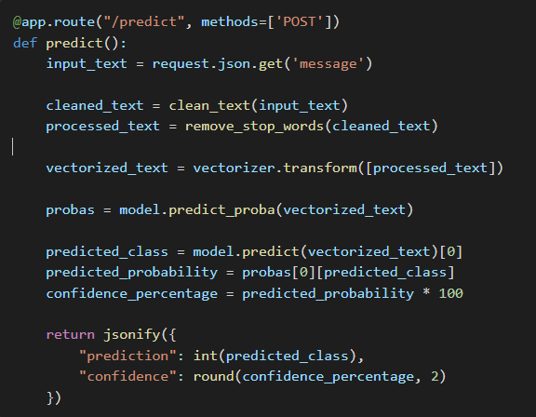

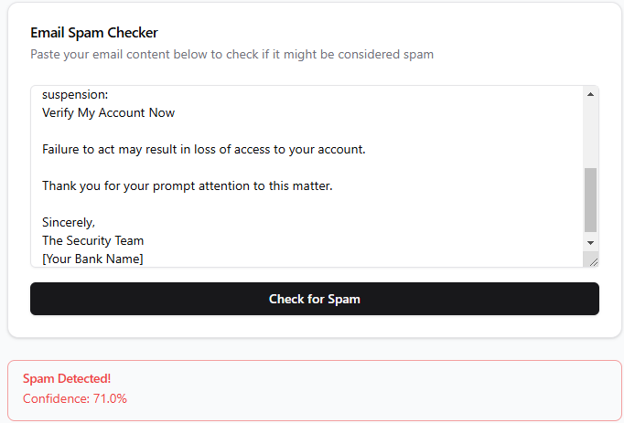**Ham Example:**

**Spam Example:**

**Results and Discussion**

**Model Performance**

Metrics:

* + Accuracy: 96%
  + Precision: 98%
  + Recall: 89%
  + F1-Score: 93%

Visualization:

* + Confusion Matrix: Displays True positives, false positives, etc.
  + Accuracy Graph: Trends over training epochs.

**Strengths**

* High accuracy and robust to noise.
* Effective for real-time predictions.

**Limitations**

* Handling highly imbalanced data remains challenging.
* Limited multilingual support.

**Learnings**

1. Gained technical knowledge in text preprocessing and machine learning.
2. Improved skills in backend/frontend integration.
3. Enhanced teamwork and project management capabilities.

**Conclusion and References**

**Conclusion**

This project successfully developed an email classification system with 96% accuracy, leveraging the Random Forest algorithm. The real-time prediction tool was deployed using Flask and React. Future improvements include deep learning models and multilingual spam detection capabilities.

**References**

1. Scikit-learn documentation: <https://scikit-learn.org>
2. Flask documentation: <https://flask.palletsprojects.com>
3. React documentation: <https://reactjs.org>
4. Dataset source: <https://huggingface.co/datasets/thehamkercat/telegram-spam-ham/tree/main>