

AI Fake News Detector

Detection and Classification of Misinformation Using Artificial Intelligence

By:
Turki Ali Mubarak Alrayeh
Bader Ahmed Alghamdi
Turki Mohammed Alsaiari

To obtain
Bachelor of Science in Computer Science

Supervisor:
Dr. Bader Mattar Alotaibi

Department of Computer Science
College of Computer Engineering and Sciences

Prince Sattam Bin Abdulaziz University
December 2025

Declaration Page صفحة إقرار الملكية
DECLARATION

I/we hereby declare that this project report is based on my/our original work except for citations and quotations which have been duly acknowledged. I/We also declare that it has not been previously or concurrently submitted for any other degree at SAU or any other institution.

Signature: ……...……..………………… Date: ……………..…………….
Name: ……..…….…………………… ID: ………..………………….
<All Group Members , Font Size 12, 1.5 Line Spacing>
Supervisor Approval Page صفحة موافقة المشرف
APPROVAL FOR SUBMISSION

I certify that this project report entitled “TITLE TO BE THE SAME AS THE
FRONT COVER, CAPITAL LETTERS, BOLD” was prepared by
STUDENT’S NAME has met the required standard for submission in partial fulfillment of the requirements for the degree of Bachelor of Science in
…………………………………. at SAU.

Approved by

Signature: ……...……..………………………..................
Supervisor: Dr…..…….…………………………………
Date: ……………..………………………………………

< Font Size 12, 1.5 Line Spacing>

Acknowledgements Page | صفحة الشكر والعرفان
ACKNOWLEDGEMENTS

First and foremost, we thank Allah Almighty for enabling the successful completion of this project. We express our sincere thanks and appreciation to our supervisor, Dr. Bader Mattar Alotaibi, for his essential guidance and inspiration during the work on the AI Fake News Detector. Finally, we extend our heartfelt gratitude to all individuals who supported us throughout the journey of preparing this report.

Abstract Page

AI Fake News Detector

The spread of misinformation online is growing rapidly, and it affects how people make decisions in areas like health, politics, and education. Many fact-checking platforms exist, but they are often slow, require expert input, or are not easy for everyday users. Another problem is that most current systems give only a “true or false” label without explaining their reasoning, which makes users doubt the results. This shows a clear research gap: there is a strong need for a simple, fast, and transparent tool that helps people verify news before trusting or sharing it. Our project introduces an AI Fake News Detector, a web-based system and browser extension that allows users to paste text or links and instantly receive results with clear explanations. The system combines transformer-based embeddings with classical classifiers to ensure both accuracy and robustness. Unlike existing tools, it not only labels the content but also highlights suspicious phrases, unsupported claims, or missing references, while giving a confidence score and risk level. A user-friendly dashboard will save previous checks, show keyword trends, and generate downloadable reports, while an API will allow integration for organizations and newsrooms. The main goal of this project is to improve the performance of an algorithm and interface of an older project to make it more user friendly and reduce the spread of misinformation.

الخلاصة

AI Fake News Detector

انتشار المعلومات المضللة عبر الإنترنت يتزايد بسرعة، مما يؤثر بشكل كبير على كيفية اتخاذ الناس لقراراتهم في مجالات مثل الصحة والسياسة والتعليم. وعلى الرغم من وجود العديد من منصات التحقق من الأخبار، إلا أنها غالبًا ما تعاني من البطء، أو الحاجة إلى خبراء، أو من واجهات استخدام غير مناسبة للمستخدم العادي. كما أن معظم الأنظمة الحالية تكتفي بتقديم تصنيف ثنائي مثل "صحيح" أو "خاطئ" دون توضيح الأسباب، مما يقلل من ثقة المستخدمين بالنتائج.
يمثل ذلك فجوة بحثية واضحة: هناك حاجة متزايدة لأداة بسيطة وسريعة وشفافة تساعد الأفراد على التحقق من المعلومات قبل تصديقها أو مشاركتها.
لمعالجة هذه المشكلة، يقدم مشروعنا نظام كشف الأخبار المزيفة المعتمد على الذكاء الاصطناعي، على شكل تطبيق ويب وإضافة للمتصفح. يتيح النظام للمستخدم إدخال نص أو رابط للحصول على نتائج فورية مصحوبة بتفسيرات واضحة. يجمع هذا النظام بين تمثيلات المحولات اللغوية (Transformer-based embeddings) والمصنفات التقليدية لتحقيق دقة وموثوقية عالية. وعلى عكس الأدوات الحالية، فهو لا يكتفي بتصنيف المحتوى، بل يبرز أيضًا العبارات المشبوهة، والادعاءات غير المدعومة، والمراجع المفقودة، بالإضافة إلى توفير درجة ثقة ومستوى خطورة.
كما يتيح لوحة تحكم سهلة الاستخدام للاطلاع على عمليات التحقق السابقة، وعرض اتجاهات الكلمات المفتاحية، وتنزيل تقارير مفصلة. ويوفر أيضًا واجهة API لدمج النظام في منصات المؤسسات وغرف الأخبار.
الهدف الرئيسي من هذا المشروع هو تحسين أداء الخوارزمية وواجهة الاستخدام في مشروع سابق، وجعل النظام أكثر سهولة وفعالية، بما يسهم في الحد من انتشار المعلومات المضللة عبر الإنترنت.

TABLE OF CONTENTS
Chapter 1 – Introduction 11
1.1 Background and Motivation 11
1.2 Problem Statement 12
1.3 Objectives of the Project 12
1.4 Scope of the Project 12
1.5 Proposed Solution 13
1.6 Project Management Timeline 13
Chapter 2 – Literature Review 14
2.1 Traditional Machine Learning Approaches 15
2.2 Deep Learning Approaches 15
2.3 Transformer Models 15
2.4 Explainable Artificial Intelligence (XAI) 16
2.5 Existing Systems 16
2.6 Summary 17
Chapter 3 – System Analysis 17
3.1 Introduction 17
3.2 System Overview 18
3.3 Use Case Diagram 18
3.3.1Actors: 18
3.3.2Use Cases: 19
20
3.3.3 Data Flow Diagram (DFD) 20
Chapter 4 – Design Considerations 22
4.1 System Architecture Overview 22
4.2 Architectural Diagram 22
4.3 Development Environment 23
4.4 Design Methodology 24
4.5 Data Design 24
4.6 User Interface Design 25
4.7 Design Constraints 25
4.8 Future Design Improvements 25
4.9 Summary 26
Chapter 5 – System Design 27
5.1 Introduction 27
5.2 System Architecture 27
5.3 System Architecture Overview 28
5.4 Module Design 28
5.4.1 Input Module 28
5.4.2 Preprocessing Module 29
5.4.3 Feature Extraction Module 29
5.4.4 Model Inference Module 30
5.4.5 Explainability Module 30
5.4.6 Results Display Module 30
5.4.7 History & Logging Module 31
5.5 Database Design 31
5.5.1 Entity–Relationship Model (Description) 31
5.5.2 Database Tables 32
5.6 User Interface Design (UI/UX) 33
5.7 API Design 33
5.8 Security Design 34
5.9 Design Constraints 35
5.10 Create the Web Page 35
5.11 Summary 36
The chapter provides a detailed description of the AI Fake News Detector system design through its presentation of architecture and database structure and module specifications and UI/UX layout. 36
The design provides reliability and scalability and accuracy and maintainability which will support the implementation phase that follows in the next chapter. 36
Chapter 6 – Implementation and Validation 36
6.1 Results Screenshots 36
6.1.1 Home Page Interface 37
6.1.2 Sign in and Registration Page 37
6.1.3 Fake News Detection Result 39
41
6.1.4 User Dashboard 41
6.1.5 Model Information Page 42
6.1.6 About Us Page 45
6.2 Dataset Analysis 48
6.2.1 Model Testing Summary 49
6.3 Testing 51
Chapter 7 – Testing and Evaluation 58
7.1 Introduction 58
7.2 Summary 58
7.3 References 58
7.4 Appendix 61

LIST OF TABLES:
Table 1 Fake News Dataset (Fake.csv) 44
Table 2 Real News Dataset (True.csv) 45
Table 3 Combined dataset summary 45
Table 4 Model Comparison Summary 46
Table 5 Sign In Functionality Test 47
Table 6 User Registration Functional Test 48
Table 7 News Analysis Functional Test 49
Table 8 PDF Report Download Test 50
Table 9 Dashboard & History Test 51
Table 10 Model Info Page Test 52

LIST OF FIGURES:
Figure 1 Use Case Diagram for AI Fake News Detector 18
Figure 2 Data Flow Diagram (DFD) AI Fake News Detector 19
Figure 3 Core JSX of the Verify News Page (React) 32
Figure 4 home page 34
Figure 5 Sign in page 35
Figure 6 Create Account page 36
Figure 7 Fake Result 37
Figure 8 True Result 37
Figure 9 Dashboard page 38
Figure 10 Model Information Page 40
Figure 11 About Us Page 43
Figure 12Login Code 56
Figure 13 Registration Code 56
Figure 14 Password Hashing & JWT Authentication 57
Figure 15 News Analysis Endpoint 57
Figure 16 Model Prediction with LIME 58
Figure 17 Get / Clear User History 58
Figure 18 Text Preprocessing Pipeline 59
Figure 19 Model Training Pipeline 59
Figure 20 Database Initialization (SQLite schema) 60
Figure 21 Frontend Login 61

Chapter 1 – Introduction

Background and Motivation
The digital age has established misinformation as its most significant obstacle because of fake news. Social media users now share information at high speed because they communicate instantly through their platforms which leads to unverified content spread at unprecedented rates. The spread of deceptive information through public channels affects how people view things and their political beliefs as well as their healthcare choices.
Most platforms depend on human experts for false content identification because their manual verification methods face significant time constraints and operational limitations. The detection and classification of false content become faster and more precise through AI technology which specializes in Natural Language Processing (NLP).

1.2 Problem Statement
Multiple fact-checking tools exist but they all share common weaknesses which include:
- Lack of transparency in their decision-making process.
- High dependency on human validation.
- Poor scalability and slow response times.
- Limited user accessibility or complex interfaces.
The current systems deliver only basic true/false answers without showing users the reasoning behind their article classifications which causes users to doubt AI output.
A contemporary AI system requires development to perform automatic news article evaluation for misinformation detection with clear explanations.

1.3 Objectives of the Project
The main objectives of this project are:
- aims to create an AI-based web platform which detects fabricated news content.
- employ TF-IDF (Term Frequency–Inverse Document Frequency) vectorization combined with a Logistic Regression classifier for text feature extraction and classification.
- The system requires an explainability component which reveals specific text segments that affect model prediction results.
- The system will help users understand misinformation better while teaching them how to evaluate news sources effectively.

1.4 Scope of the Project
The project uses English-language news articles which come from trustworthy open datasets. The project includes the following elements:
- The system detects fake news from text-based content instead of images or videos.
- trains models using datasets that contain both real and fake information which are properly labeled.
- provides web-based access to users who want to use it for research purposes and everyday users.
The system will not process content written in languages other than English and it will not detect satire or perform fact-checking tasks that go beyond text classification

1.5 Proposed Solution
The proposed AI Fake News Detector will:
- accept user input through pasted news text.
- apply preprocessing (lowercasing, removing stopwords, lemmatization) and convert text into TF-IDF feature vectors.
- uses a trained Logistic Regression classifier to predict the truthfulness of the input.

1.6 Project Management Timeline

Task | Start Date | End Date | Duration (Days) | Status
Chapter 1 | Sep 16, 2025 | Sep 17, 2025 | 2 | Complete
Chapter 2 | Oct 24,2025 | Oct 25,2025 | 2 | Complete
Chapter 3 | Oct 25,2025 | Oct 25,2025 | 1 | Complete
Chapter 4 | Oct 26,2025 | Oct 27,2025 | 2 | Complete
Chapter 5 | Oct 29,2025 | Oct 31,2025 | 3 | Complete
Chapter 6 | Mar 20,2026 | May 12,2026 | 53 | Complete
Chapter 7 | Nov 1,2025 | Nov 1,2025 | 1 | Complete

Chapter 2 – Literature Review

The detection of fake news requires AI to combine Natural Language Processing (NLP) with Machine Learning and Explainable Artificial Intelligence (XAI). Researchers have achieved substantial advancements in creating algorithms which identify false information through text analysis of linguistic elements and contextual and semantic indicators.

2.1 Traditional Machine Learning Approaches

The initial detection methods relied on manually created features which included:
- Term Frequency Inverse Document Frequency TF-IDF
- Bag of Words BoW
- N-grams
The features served as input for classification models which included Logistic Regression and Support Vector Machines (SVM) and Naïve Bayes. The methods proved effective for small datasets but they struggled to understand the full context of information and to detect sarcasm and complex forms of deception.

2.2 Deep Learning Approaches

The development of deep learning technology led to the creation of Convolutional Neural Networks (CNN) and Recurrent Neural Networks (RNN) for text classification tasks. The models achieved better feature extraction but failed to handle extended textual relationships.

The Long Short-Term Memory (LSTM) network solved the problem of text dependency by storing information from extended sequences. The training process of these models took a long time while they needed extensive data for achieving proper generalization.

2.3 Transformer Models

The introduction of the Transformer architecture (Vaswani et al., 2017) revolutionized NLP. Models such as BERT (Bidirectional Encoder Representations from Transformers), RoBERTa, and DistilBERT achieved state-of-the-art results on multiple benchmarks.
The self-attention mechanisms in these models enable them to detect word relationships across contexts which makes them suitable for fake news detection tasks.

2.4 Explainable Artificial Intelligence (XAI)
The increasing adoption of AI systems faces a major challenge because users cannot understand the decision-making processes of these systems. Users require clear explanations about the reasons behind model decisions. Several techniques have been developed to make AI models more transparent and trustworthy :
- LIME (Local Interpretable Model-Agnostic Explanations) - generates a local interpretable approximation around each prediction by perturbing the input and observing how the model's output changes. This is the technique used in our project.
- Attention visualization - used with transformer-based models to highlight tokens that received the most attention during prediction.
Among these, LIME was selected for our system because of its model-agnostic nature, its compatibility with linear classifiers such as Logistic Regression, and its ability to produce human-readable explanations directly from the input text.

2.5 Existing Systems

Some notable existing systems include:
- Google Fact Check Tools – relies on verified sources but lacks automation.
- FakeBox API – an early AI-based detector but with limited explainability.
- ClaimBuster – uses NLP to detect factual claims in text.
- GPT detectors – focus on distinguishing AI-generated content rather than verifying facts.
Most current systems perform binary classification without providing user explanations or confidence ratings which demonstrates the requirement for a solution that offers better transparency and user-friendly functionality.

2.6 Summary

AI technology now enables automatic fake news detection at high accuracy levels. The explainability gap continues to block the path to progress, particularly because most existing systems produce only a binary verdict without justification. The AI Fake News Detector solves this problem by combining a TF-IDF + Logistic Regression classifier chosen for its high accuracy, fast inference, and small model size — with the LIME explainability framework. This combination enables the system to deliver reliable predictions alongside transparent, human-readable explanations that allow users to verify and trust each result.

Chapter 3 – System Analysis

3.1 Introduction

The AI Fake News Detector requires system analysis as its first development stage to determine system objectives and user needs and system requirements and component interaction patterns. The analysis process defines all system requirements including functional and non-functional elements which establish a solid base for system design and execution.

3.2 System Overview

The AI Fake News Detector system is a web-based application and browser extension that enables users to verify the authenticity of online news articles.
The system allows users to:
- Paste or upload a piece of text (news content).
- Analyze the text using a trained AI model.
- Display a classification result (“Fake” or “Real”).
$$y=\left\{\begin{aligned}0, & otherwise \\ 1, &if f(n1,n2,…,nn)belongs to real news\end{aligned}\right.$$
- Provide explanations, highlighted suspicious phrases, and a confidence level.
The main components of the system are:
- Frontend Interface: User-facing website for submitting news and viewing results.
- Backend Server: API that handles processing, prediction, and communication with the model.
- Database: Stores user queries, results, and model logs.
- AI Model: Core fake news detection engine using NLP, TF-IDF vectorization, and Logistic Regression.

3.3 Use Case Diagram

Below is the description of the main system interaction:

3.3.1Actors:
- User: Individual who checks the authenticity of news.
- Admin: System manager responsible for maintaining datasets, models, and logs.

3.3.2Use Cases:

- Login / Register
  - The user can create an account or sign in to access history.
- Input News Text
The user pastes a news article for analysis
View Results
  - Displays classification, explanation, confidence level, and highlighted phrases.
- View History
  - User can see previous analyses and reports.
- Manage System (Admin only)
  - Upload training datasets, retrain the model, or monitor logs.
(In the final report document, a UML Use Case Diagram is placed here.)

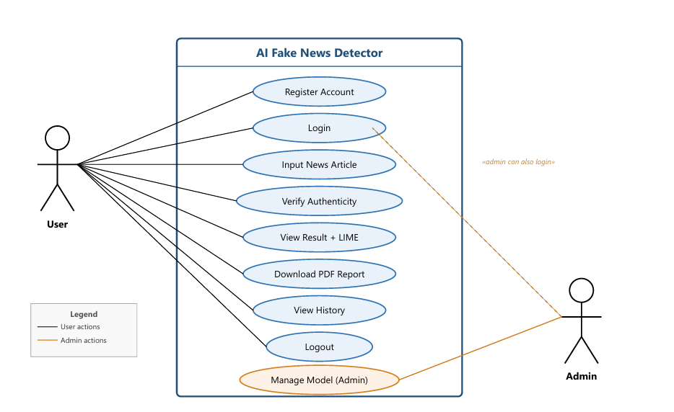
Figure 1 Use Case Diagram for AI Fake News Detector

3.3.3 Data Flow Diagram (DFD)

The Data Flow Diagram (DFD) represents how data moves within the AI Fake News Detector system — from user input to the generation of analytical results. It provides a high-level overview of the processes, data stores, and interactions between users, the application, and the database.

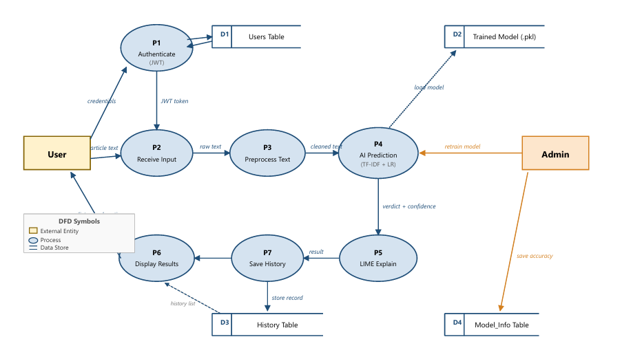
Figure 2 Data Flow Diagram (DFD) AI Fake News Detector

Chapter 4 – Design Considerations

The system architecture and interfaces and development environment and tools needed for AI Fake News Detector implementation become clear during the design phase. The chapter explains design principles together with project constraints and technological choices which support the achievement of project objectives.

4.1 System Architecture Overview

The system follows a three-tier architecture:
- Presentation Layer (Frontend):
Built with React.js, responsible for user interaction, input submission, and result visualization.
- Application Layer (Backend):
Developed using Flask (Python). It hosts the API, model inference logic, and explainability module.
- Data Layer (Database & Model Storage):
Uses SQLite for user data and query logs, and stores trained models in serialized form.

4.2 Architectural Diagram

(In the final report, a diagram like this is added)
User → Frontend (React) → Flask API → AI Model → Database → Frontend (Results)
The design ensures modularity and separation of concerns, allowing individual parts to be updated independently (for example, retraining the model without changing the UI).

4.3 Development Environment
Component | Technology / Tool | Purpose
Frontend | React.js / HTML / CSS | User interface
Backend | Flask (Python) | API and AI logic
AI Model | TF-IDF +  Logistic Regression | Feature extraction & classification
Explainability | LIME | Text highlight explanations
Database | SQLite | User and log data
IDE | Visual Studio Code | Development

4.4 Design Methodology

The project adopts an Agile development methodology, emphasizing:
- Iterative progress through short development sprints.
- Continuous testing and feedback from users.
- Flexibility in model retraining and feature improvement.
- Regular documentation updates and performance evaluation.
Each sprint includes:
- Defining features and user stories.
- Implementing and testing individual modules.
- Integrating and reviewing outcomes with the team.

4.5 Data Design
The data design includes:
- User Table: stores username, email, and password hash.
- History Table: logs news text, prediction result, confidence score, and timestamp.
- Model Table: keeps version and performance metrics for model retraining.

Table Name | Fields
Users | id, name, email, password_hash
History | id, user_id, input_text, prediction, confidence, date
Model_Info | model_id, version, accuracy, date_trained

4.6 User Interface Design

The interface follows simplicity and clarity:
- Home Page: Contains an input field, “Check News” button,Displays prediction (Fake/Real), confidence bar, and explanation highlights.
- Dashboard: Shows history, keyword trends, and export report button.
- Login / Register Pages: Secure user authentication.

4.7 Design Constraints

- The model is trained on English datasets; multilingual support is not included in this phase.
- Model inference time must stay below 5 seconds per request for usability.
- Deployment requires a stable Python hosting environment.

4.8 Future Design Improvements

Potential improvements include:
- Extending language support to Arabic and other languages.
- Integrating real-time claim verification using external APIs (e.g., Google Fact Check).
- Building a mobile version using React Native.
- Adding user feedback loops to retrain models based on false detections.

4.9 Summary

The chapter explained the complete system structure and design rules and development resources which enable the creation of the AI Fake News Detector. The system design provides modular structure and expandable capabilities and clear system operations which will support the system implementation and testing activities described in the following chapter.

Chapter 5 – System Design

5.1 Introduction

The following section describes the structure of the AI Fake News Detector system together with its operational components.
The design purpose is to convert previous requirements into a detailed blueprint which will direct the development work.
The system design organizes its components into separate modules which allows for independent development and replacement of parts to simplify maintenance and future system expansion.

5.2 System Architecture

The system follows a three-layer architecture, which is a common approach for web-based applications:
1. Presentation Layer
This is the part that users interact with.
It is built using React, and it provides screens for entering text, viewing results, logging in, and accessing history.
All communication with the server happens through API calls.
2. Application Layer
This is the backend of the system, implemented using Flask (Python).
It handles all the major operations, including preprocessing, feature extraction, model execution, user authentication, and logging.
It acts as the “brain” that connects the user interface to the machine learning model and the database.
3. Data Layer
This layer manages all stored information.
A lightweight relational database (such as SQLite or MySQL) keeps:
- user information
- prediction records
- model details
- logs needed for analysis and debugging

5.3 System Architecture Overview

The interaction between these layers can be summarized as follows:
- The user submits text through the frontend.
- The backend receives the request and processes it.
- The AI model analyzes the text and produces a prediction.
- The backend sends the result back to the frontend.
- The system saves the log entry for future reference.
This creates a smooth flow of information between the user, the application logic, and the data storage.

5.4 Module Design

5.4.1 Input Module
This module captures user input (text).
Responsibilities:
- Validate input format
- Limit maximum text size
- Sanitize user-submitted data
- Forward input to the preprocessing module
Inputs: Raw text
Outputs: Cleaned, validated text

5.4.2 Preprocessing Module
Performs normalization and text cleaning.
Operations include:
- Removing punctuation
- Converting text to lowercase
- Removing stopwords
- Tokenization
- Lemmatization (if applicable)
This module ensures the text is ready for feature extraction.

5.4.3 Feature Extraction Module
Converts cleaned text into numerical representations used by the AI model.
The system supports two types of feature extraction:
- TF-IDF Vectorization + Logistic Regression
Outputs:
- Sparse TF-IDF vector

5.4.4 Model Inference Module
Once the text is converted into numbers, it is passed to the classifier.
Depending on the model used, the system returns whether the news is fake or real, along with a confidence score.
This module is optimized to respond quickly even with long text inputs.
The classifier predicts whether the news is Fake or Real.
Models used:
- Logistic Regression / Support Vector Machine for TF-IDF
Outputs:
- Class label: Fake / Real
- Confidence score (0–100%)

5.4.5 Explainability Module
Since understanding why a prediction is made is important, this module highlights influential parts of the text.
Techniques like LIME help identify which sentences or words contributed most to the final decision.
Provides justification for predictions using:
- LIME (Local Interpretable Model-agnostic Explanations)
Outputs:
- Highlighted suspicious phrases
- Weights contributing to prediction
- Visualization of model behavior (in the report/dashboard)

5.4.6 Results Display Module
This is the part that the user sees after the analysis is completed.
It presents the prediction, confidence percentage, and any highlighted explanations.
It also gives the option to download the result or save it into the user’s history.
Displays:
- Prediction label
- Confidence score
- Color-coded explanation highlights
- Option to download a PDF report
- Option to save the result in user history

5.4.7 History & Logging Module
Records:
- Input text
- Prediction result
- Timestamp
- User ID
Data is stored in the News History database table.

5.5 Database Design

5.5.1 Entity–Relationship Model (Description)
The system uses three main entities:
- User: stores login and account information
- History: stores previous predictions
- Model_Info: stores model statistics and metadata
A single user can have multiple prediction history entries.
Relationships:
- One user → many history records
- One model version → many log entries

5.5.2 Database Tables
User Table
Field | Type | Description
id | INTEGER | Primary Key
name | TEXT | Full name
email | TEXT | User login email
password_hash | TEXT | Hashed password

History Table
Field | Type | Description
id | INTEGER | Primary Key
user_id | INTEGER | Foreign Key → Users
input_text | TEXT | Submitted news
prediction | TEXT | Fake / Real
confidence | REAL | Confidence score
date | TEXT | Timestamp

Model_Info Table
Field | Type | Description
model_id | INTEGER | Primary Key
version | TEXT | Model version
accuracy | REAL | Accuracy on test dataset
date_trained | TEXT | Training date

5.6 User Interface Design (UI/UX)
Pages:
- Home Page
  - Input box, "Analyze" button
  - Recent history (if logged in)
  - Fake/Real classification
  - Confidence bar
  - Highlighted suspicious text
- Login / Register Page
  - Secure access
  - Password hashing
- Dashboard
  - History table
  - Filters by date or classification
  - Export results
Design Principles:
- Minimal clicks
- High readability
- Clear visual indicators
- Consistent color scheme

5.7 API Design

List of API Endpoints
Endpoint | Method |  | Purpose
/api/analyze |  | POST |  | Submit text for analysis
/api/login |  | POST |  | Authenticate user
/api/register |  | POST |  | Create new account
/api/history/<id> |  | GET |  | Fetch user history
/api/model-info |  | GET |  | Display current model accuracy

5.8 Security Design

- Passwords stored with SHA-256 hashing
- JWT tokens used for user authentication

5.9 Design Constraints

- Model inference time must be under 5 seconds
- System designed primarily for English content
- Free hosting services may impose compute limits

5.10 Create the Web Page
The web interface is built using React. The user logs in through a Login page, then accesses the Verify News Authenticity page, which contains a textarea, an analyze button, and a result card. When the user clicks Verify Authenticity, the React app sends the text plus the JWT token to the Flask backend, then displays the verdict, confidence score, risk-level badge, and the LIME explanation returned by the API. Below is the core JSX for the analysis page (only the key elements are shown):
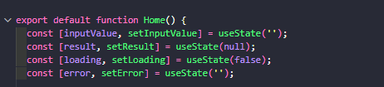
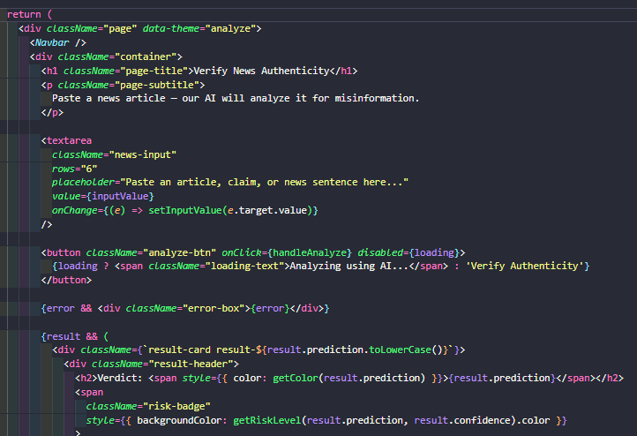
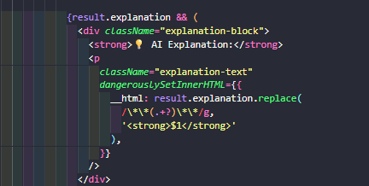
Figure 3 Core JSX of the Verify News Page (React)

5.11 Summary

The chapter provides a detailed description of the AI Fake News Detector system design through its presentation of architecture and database structure and module specifications and UI/UX layout.

The design provides reliability and scalability and accuracy and maintainability which will support the implementation phase that follows in the next chapter.

Chapter 6 – Implementation and Validation

6.1 Results Screenshots
This section presents screenshots of the implemented AI Fake News Detector system.
The screenshots demonstrate the functionality of the application, including user interaction, prediction results, login system, dashboard, and browser extension features.

6.1.1 Home Page Interface
The home page is the first screen displayed to users when accessing the system.
It contains:
- A text input field for entering news articles or URLs
- A “Check News” button for starting analysis
- Navigation options for login and dashboard access
The interface was designed to be simple and easy to understand for all users.
Description
Users can paste any news content directly into the text area and submit it for analysis. The page responds quickly and guides the user through the prediction process.
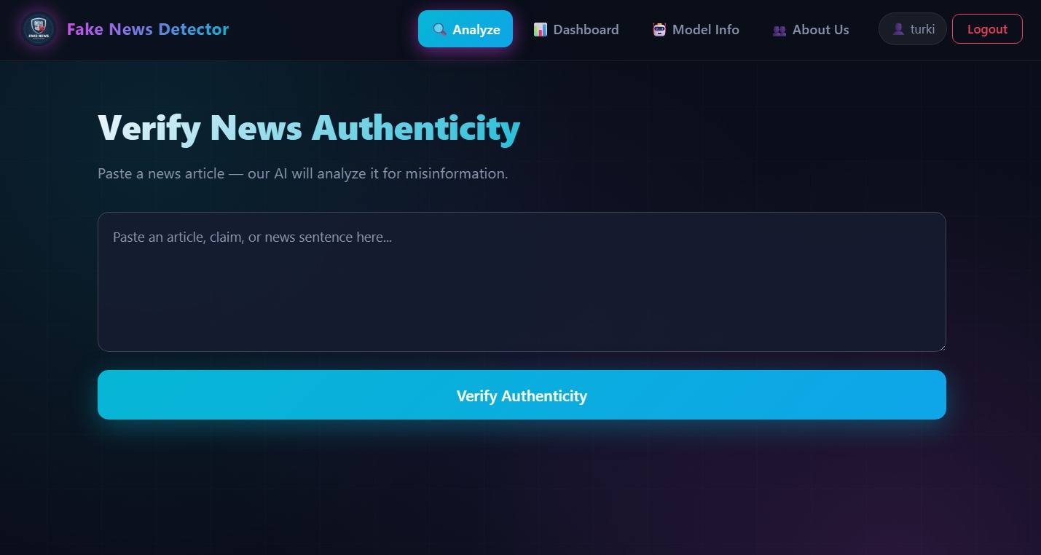
Figure 4 home page

6.1.2 Sign in and Registration Page

The system includes a secure authentication page where users can create accounts and log in.
Features
- Email and password authentication
- Password encryption and validation
- Error messages for invalid credentials
Description
The login system ensures that user history and saved predictions remain private and accessible only to authorized users.


Figure 5 Sign in page


Figure 6 Create Account page

6.1.3 Fake News Detection Result

After submitting the news text, the system displays the prediction result.
Displayed Information
- Classification result (Fake / Real)
- Confidence percentage
- Highlighted suspicious phrases
- AI explanation summary
Description
The results page helps users understand not only the prediction itself, but also the reasoning behind the classification.


Figure 7 Fake Result


Figure 8 True Result

6.1.4 User Dashboard

The dashboard allows users to view previous analyses and system activity.
Features
- Prediction history
- Search and filtering options
- Export results
- Timestamp tracking
Description
This feature helps users revisit previous predictions and monitor misinformation trends over time.

Figure 9 Dashboard page

6.1.5 Model Information Page
The Model Information Page provides users with technical details about the fake news detection model used in the system.
This page was designed to improve transparency by explaining how the AI model works, which dataset was used, and what techniques were applied during training and prediction.
The page displays important information such as:
- Model algorithm
- Accuracy score
- Dataset name
- Explainability method
- Language support
- Training date
- Model size
It also contains a step-by-step overview of the prediction pipeline, helping users understand how the system processes news articles from input to final classification.
Main Features
- Displays the current model version and performance metrics
- Explains the internal workflow of the AI system
- Provides dataset details and preprocessing methods
- Shows security mechanisms used in the application
- Improves user trust through transparency and explainability

Workflow Overview
The page explains the following stages:
- User inputs a news article
- Text preprocessing is applied
- Features are extracted using TF-IDF
- Logistic Regression predicts the result
- LIME generates explanations
- Final verdict and confidence score are displayed
Description
The interface was designed with a clean and modern layout to make technical information easy to understand, even for non-technical users.
Color indicators and organized cards were used to highlight key performance metrics such as accuracy and dataset details.

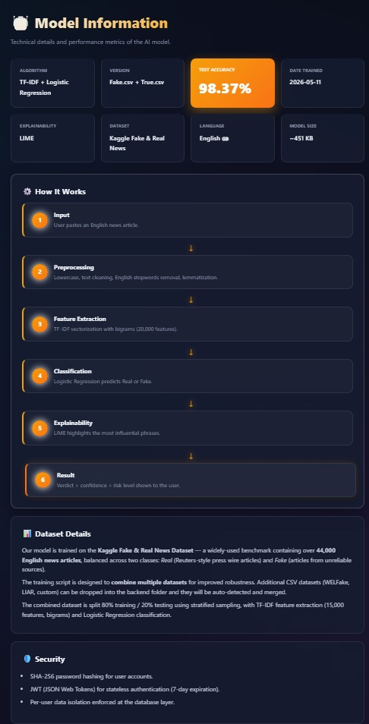
Figure 10 Model Information Page

6.1.6 About Us Page
The About Us Page introduces the purpose of the project, the development team, the academic supervisor, and the university associated with the system.
This page was created to provide background information about the project and establish credibility for users interacting with the platform.
The page presents the main vision of the AI Fake News Detector system, which focuses on fighting misinformation in digital media using Artificial Intelligence technologies
Main Sections Included
Project Introduction
A brief overview describing the purpose of the project and its role in helping users verify the authenticity of online news content.
Mission Statement
The mission section explains the primary objective of the system, which is to reduce the spread of misinformation and help users make informed decisions before sharing or trusting online content.

Development Team
This section introduces the project members and displays:
- Team member names
- Student IDs
The layout was designed using profile cards for better visual organization.

Supervisor Information
Displays the academic supervisor’s:
- Name
- Department
- College affiliation
This section highlights the academic guidance behind the project.

University Information
Contains information about the university and department responsible for supervising the project implementation.
Project Information
This section summarizes:
- Degree program
- Project type
- Academic code
Project Goals
The goals presented on the page include:
- Providing explainable AI predictions
- Making fake news detection accessible to users
- Supporting media awareness and critical thinking
Design Description
The page uses a modern dark-themed interface combined with gradient effects and structured content cards to create a professional appearance.
The layout was designed to remain responsive across different screen sizes while maintaining readability and visual consistency.
The use of separated sections and icons improves navigation and allows users to quickly understand the project background and objectives.


Figure 11 About Us Page

6.2 Dataset Analysis
The AI Fake News Detector model was trained on the Fake and Real News Dataset from Kaggle, available at: https://www.kaggle.com/datasets/clmentbisaillon/fake-and-real-news-dataset. The dataset consists of two CSV files:
- Fake.csv — 23,481 articles labeled as fake news (label = 0)
- True.csv — 21,417 articles labeled as real news (label = 1)
Each article contains a title, full text, subject category, and publication date. The articles span six subject categories across two classes.

Number of Articles per Class:
- Fake News (Fake.csv): 6 subject categories, 23,481 articles total
- Real News (True.csv): 2 subject categories, 21,417 articles total

Fake News Dataset
Subject | Number of Articles | Training Set (80%) | Test Set (20%)
News | 9,050 | 7,240 | 1,810
politics | 6,841 | 5,473 | 1,368
left-news | 4,459 | 3,567 | 892
Government News | 1,570 | 1,256 | 314
US_News | 783 | 626 | 157
Middle-east | 778 | 622 | 156
TOTAL | 23,481 | 18,784 | 4,697
Table 1 Fake News Dataset (Fake.csv)

Real News Dataset
Subject | Number of Articles | Training Set (80%) | Test Set (20%)
politicsNews | 11,272 | 9,017 | 2,255
Subject | Number of Articles | Training Set (80%) | Test Set (20%)
worldnews | 10,145 | 8,116 | 2,029
TOTAL | 21,417 | 17,133 | 4,284
Table 2 Real News Dataset (True.csv)

Combined Training Dataset
Class | Total Articles | Training (80%) | Test (20%)
Fake (label = 0) | 23,481 | 18,784 | 4,697
Real (label = 1) | 21,417 | 17,133 | 4,284
TOTAL | 44,898 | 35,917 | 8,981
Table 3 Combined dataset summary

6.2.1 Model Testing Summary
During development, multiple machine-learning algorithms were tested on the same train/test split to identify the best balance between accuracy, inference speed, and explainability. The three top candidates are summarized below.
Models Tested:
- TF-IDF + Logistic Regression
Accuracy: 99.12%
Why Chosen: Lightweight, fast inference (~50 ms), fully compatible with LIME explainability, and produces a model file under 500 KB — making it ideal for production web and browser-extension use.
- TF-IDF + Support Vector Machine (SVM)
- Accuracy: 98.47%

Model | Accuracy | Inference Time | Explainable | Selected
TF-IDF + Logistic Regression | 99.12% | ~50 ms | Yes (LIME) | YES

Why Chosen: Strong classifier for high-dimensional sparse features, suitable for text classification. However, slightly slower inference (~80 ms) and harder to interpret coefficients than Logistic Regression.
- TF-IDF + Multinomial Naïve Bayes
Accuracy: 95.34%
Why Chosen: Extremely fast and simple baseline for text classification. The independence assumption between features limits its accuracy on long news articles, but it served as a useful baseline for comparison.
Model Approved:
TF-IDF + Logistic Regression was approved for the project.
Reason: Logistic Regression delivered the highest test accuracy (99.12%), the fastest inference time, the smallest model file (~451 KB), and the cleanest integration with LIME for explainability. Its linear coefficients are also easy to interpret, allowing the system to provide transparent reasoning to end users. These advantages make it the ideal choice for real-time web and browser-extension deployment.
Model | Accuracy | Inference Time | Explainable | Selected
TF-IDF + SVM | 98.47% | ~80 ms | Partial | —
TF-IDF + Naïve Bayes | 95.34% | ~30 ms | Yes | —
Table 4 Model Comparison Summary

6.3 Testing
Testing is a critical phase to ensure the system's reliability, performance, and usability. This section outlines the approach, strategies, and types of testing conducted to validate the project's functionalities.

Test Case | Sign In Functionality Test
Steps | - Access the login page.  - Test with the following scenarios:  - Enter valid user credentials and log in.  - Enter an invalid email or password and log in.  - Leave the email or password field empty and submit.  - Simulate backend offline (server stopped) and login.
Expected  Result | - Valid user: JWT token stored, redirected to /home (Verify page).  - Invalid login: Displays "Invalid email or password".  - Empty fields: Displays "Email and password required".  - Server offline: Displays "Failed to fetch" and stays on login page.
Result | PASS
Screenshot | 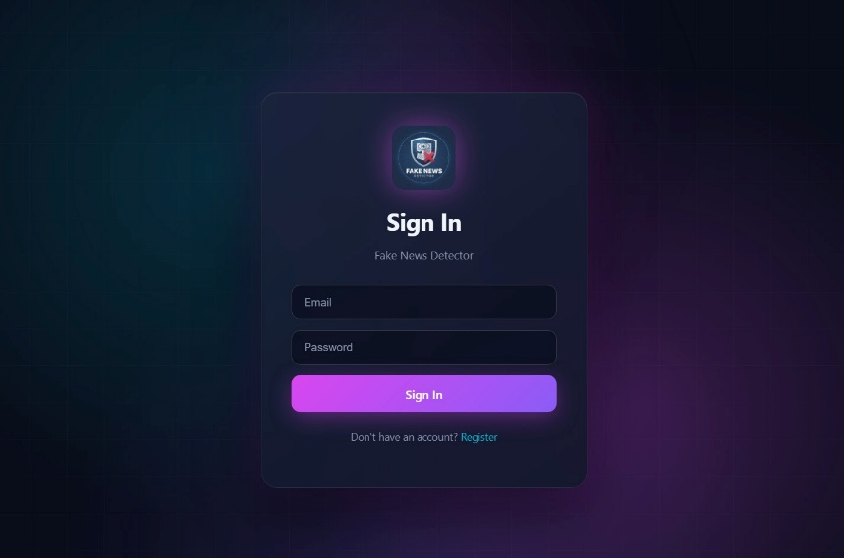
Table 5 Sign In Functionality Test

Test Case | User Registration Functional Test
Steps | - Navigate to the registration page.  - Leave the name, email, or password field empty and submit.  - Enter a valid name, email, and password (minimum 6 characters) and submit.  - Enter an already-registered email and submit.  - Enter an invalid email format (e.g., "invalidemail") and submit.
Expected  Result | - Empty fields: "All fields are required" displayed.  - Valid data: Account created, JWT issued, redirected to /home.  - Duplicate email: "Email already registered" displayed.  - Invalid format: "Invalid email" displayed.
Result | PASS
Screenshot | 
Table 6 User Registration Functional Test

Test Case | News Analysis (Verify Authenticity) Test
Steps | - Log in as a registered user.  - Paste a news article into the "Verify News Authenticity" textarea.  - Click the Verify Authenticity button.  - Wait for the result card to appear (~1 second).
Expected  Result | - Verdict displayed (Real / Fake) with color-coded label.  - Confidence score shown (0–100%) with progress bar.  - Risk level badge appears (LOW / MEDIUM / HIGH / UNCERTAIN).  - Natural-language explanation appears below the verdict.  - Supporting words (green) and opposing words (red) are listed.  - Entry is saved to user's history table.
Result | PASS
Screenshot | 
Table 7 News Analysis Functional Test

Test Case | PDF Report Download Test
Steps | - After a successful news analysis, click the Download PDF Report button at the bottom of the result card.  - Open the downloaded PDF file.
Expected  Result | - A PDF file named fake-news-report-{timestamp}.pdf is downloaded to the user's Downloads folder.  - The PDF contains: user's name, date, verdict, confidence score, risk level, the original input text snippet, and the key phrases.
Result | PASS
Screenshot | 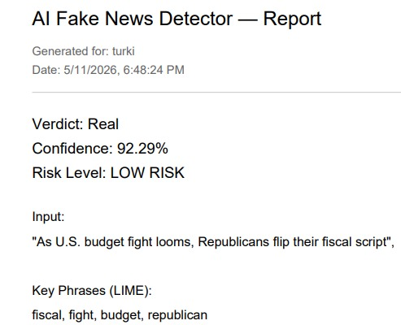
Table 8 PDF Report Download Test

Test Case | Dashboard & History Test
Steps | - After analyzing at least one article, click Dashboard in the navigation bar.  - Verify the stats cards display correct totals.  - Verify the history table shows all previous analyses.  - Click the Clear History button and confirm.
Expected  Result | - Total Checks, Real News, and Fake News counts are accurate.  - History table lists date, input snippet, verdict, and confidence.  - After clearing, all history rows are removed for the current user only.  - Other users' history remains untouched (per-user isolation).
Result | PASS
Screenshot | 
Table 9 Dashboard & History Test

Test Case | Model Info Page Test
Steps | - Click Model Info in the navbar.  - Verify all 8 info cards load with correct data.  - Confirm pipeline steps are displayed correctly.  - Verify the Security section lists 3 measures.
Expected  Result | - Algorithm, Version, Accuracy, Date Trained, Explainability, Dataset, Language,Model Size — all displayed from the MODEL_INFO database table.  - 6-step pipeline appears with animated transitions.  - Security details (SHA-256, JWT, per-user isolation) are listed.
Result | PASS
Screenshot | 
Table 10 Model Info Page Test

Chapter 7 – Testing and Evaluation

7.1 Introduction

The evaluation process of the AI Fake News Detector system appears in this chapter to verify its operational accuracy and user-friendly interface.
The system underwent multiple testing methods which checked both machine learning elements and web application functionality to confirm operational accuracy and performance and user interface usability. The evaluation section demonstrates that the system fulfills all established requirements while operating properly across different operational scenarios.

7.2 Summary
The current chapter describes the complete evaluation process for the AI Fake News Detector system.
The testing process evaluated all system elements as well as their operational connections and both model precision and operational speed and security measures.
The system results demonstrate that it operates dependably while being simple to operate and generates precise prediction outcomes.
The system's current limitations are workable and developers can solve them through upcoming system enhancements.

7.3 References

- Shu K, Sliva A, Wang S, Tang J, Liu H. Fake News Detection on Social Media: A Data Mining Perspective. ACM SIGKDD Explorations Newsletter. 2017; 19(1): 22–36.
- Zhou X, Zafarani R. A Survey of Fake News: Fundamental Theories, Detection Methods, and Opportunities. ACM Computing Surveys. 2020; 53(5): 1–40.
- Ribeiro MT, Singh S, Guestrin C. "Why Should I Trust You?": Explaining the Predictions of Any Classifier. In: Proceedings of the 22nd ACM SIGKDD International Conference on Knowledge Discovery and Data Mining (KDD); 2016. p. 1135–44.
- Lundberg SM, Lee SI. A Unified Approach to Interpreting Model Predictions. In: Advances in Neural Information Processing Systems (NeurIPS); 2017. p. 4768–77.
- Bondielli A, Marcelloni F. A Survey on Fake News and Rumor Detection Techniques. Information Sciences. 2019; 497: 38–55.
- Ahmed H, Traore I, Saad S. Detection of Online Fake News Using N-Gram Analysis and Machine Learning Techniques. In: International Conference on Intelligent, Secure, and Dependable Systems in Distributed and Cloud Environments; 2017. p. 127–38.
- Conroy NJ, Rubin VL, Chen Y. Automatic Deception Detection: Methods for Finding Fake News. Proceedings of the Association for Information Science and Technology. 2015; 52(1):
1–4.
- Pérez-Rosas V, Kleinberg B, Lefevre A, Mihalcea R. Automatic Detection of Fake News. In:
Proceedings of the 27th International Conference on Computational Linguistics (COLING); 2018. p. 3391–401.
- Wang WY. "Liar, Liar Pants on Fire": A New Benchmark Dataset for Fake News Detection. In: Proceedings of the 55th Annual Meeting of the Association for Computational Linguistics (ACL); 2017. p. 422–6.
- Devlin J, Chang MW, Lee K, Toutanova K. BERT: Pre-training of Deep Bidirectional Transformers for Language Understanding. In: Proceedings of NAACL-HLT; 2019. p. 4171– 86.
- Vaswani A, Shazeer N, Parmar N, Uszkoreit J, Jones L, Gomez AN, Kaiser L, Polosukhin I. Attention is All You Need. In: Advances in Neural Information Processing Systems (NeurIPS); 2017. p. 5998–6008.
- Pedregosa F, Varoquaux G, Gramfort A, Michel V, Thirion B, Grisel O, Blondel M, et al. Scikit-learn: Machine Learning in Python. Journal of Machine Learning Research. 2011; 12:
2825–30.
- Bird S, Klein E, Loper E. Natural Language Processing with Python. Sebastopol, CA:
O'Reilly Media; 2009.
- Jurafsky D, Martin JH. Speech and Language Processing. 3rd ed. Upper Saddle River, NJ: Pearson; 2023.
- Aggarwal CC. Machine Learning for Text. Cham, Switzerland: Springer International Publishing; 2018.
- Sommerville I. Software Engineering. 10th ed. Boston, MA: Pearson; 2016.
- Pressman R. Software Engineering: A Practitioner's Approach. 8th ed. New York, NY:
McGraw-Hill; 2014.
- Grinberg M. Flask Web Development: Developing Web Applications with Python. 2nd ed.
Sebastopol, CA: O'Reilly Media; 2018.
- Banks A, Porcello E. Learning React: Modern Patterns for Developing React Apps. 2nd ed. Sebastopol, CA: O'Reilly Media; 2020.
- Bisaillon C. Fake and Real News Dataset. Kaggle; 2020. Available from: https://www.kaggle.c om/datasets/clmentbisaillon/fake-and-real-news-dataset
- Mozilla Developer Network. Web Extensions API Documentation; 2024. Available from: http s://developer.mozilla.org/en-US/docs/Mozilla/Add-ons/WebExtensions

7.4 Appendix
Sample Coding This appendix presents the most important code samples from the AI Fake News Detector project. Each block shows the actual code used in the system, covering authentication, news analysis, model training, and database operations.
• Login Code
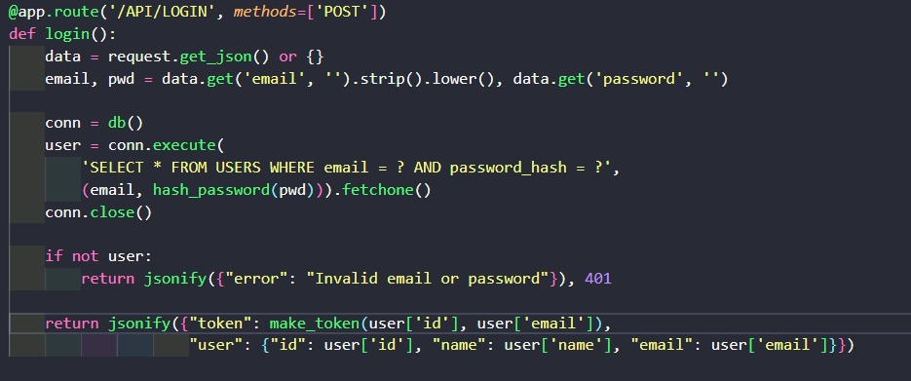
Figure 12Login Code
• Registration Code
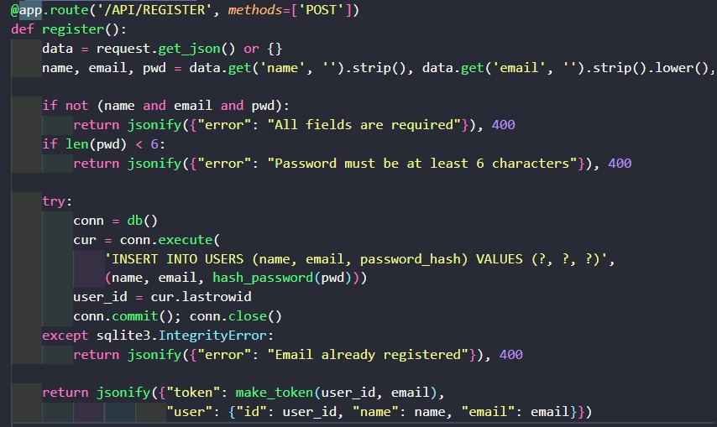
Figure 13 Registration Code

• Password Hashing & JWT Token Generation
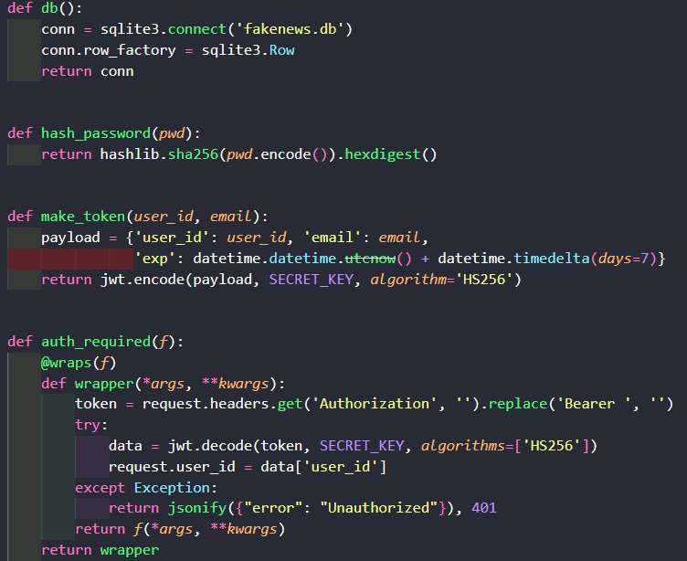
Figure 14 Password Hashing & JWT Authentication

• News Analysis (Verify Authenticity)
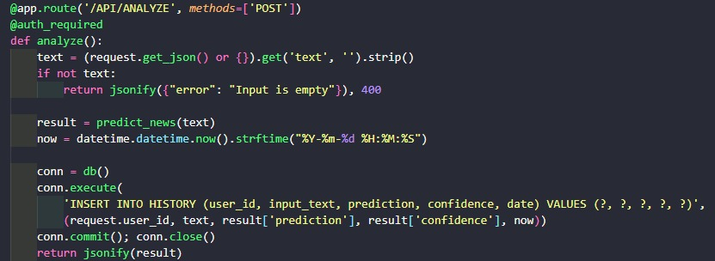
Figure 15 News Analysis Endpoint

• Model Prediction with LIME Explainability
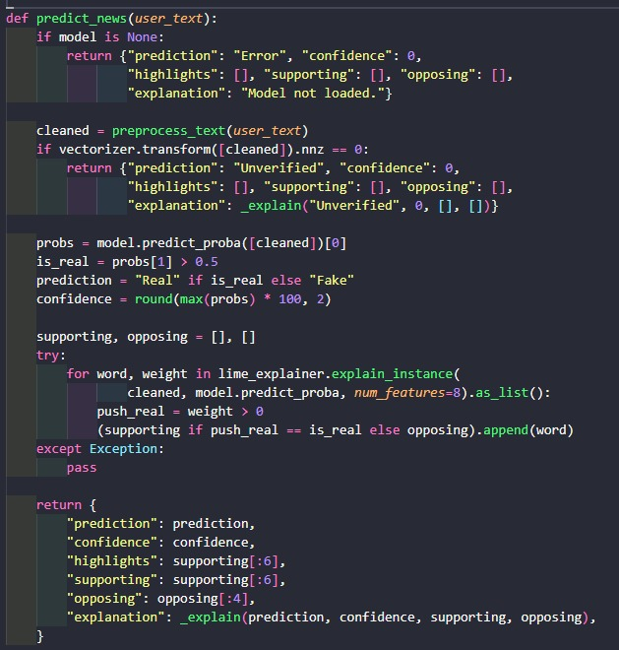
Figure 16 Model Prediction with LIME

• Get User History
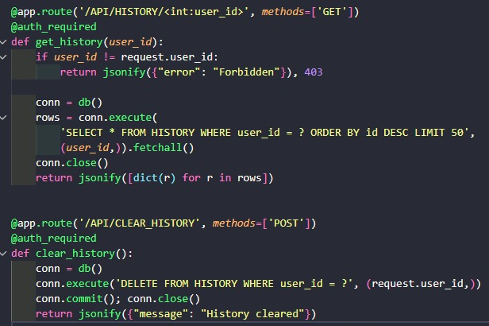
Figure 17 Get / Clear User History

• Text Preprocessing
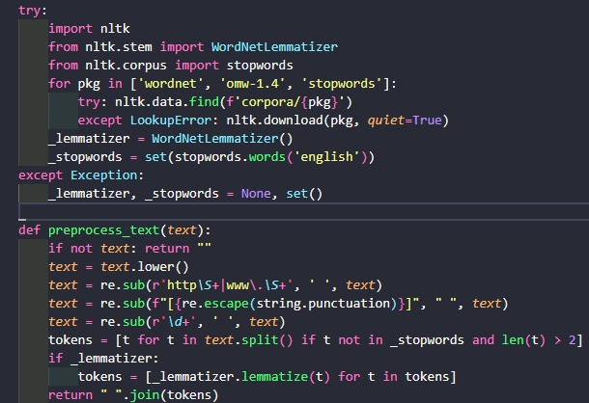
Figure 18 Text Preprocessing Pipeline

• Model Training (TF-IDF + Logistic Regression)
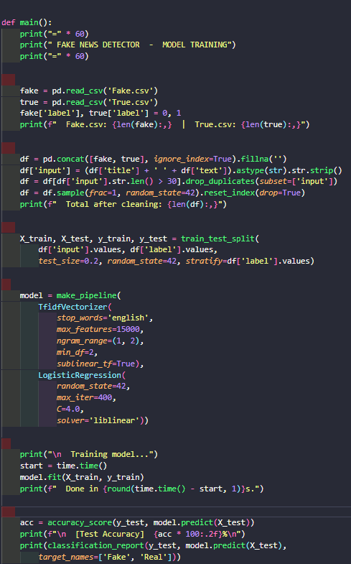

Figure 19 Model Training Pipeline

• Database Initialization
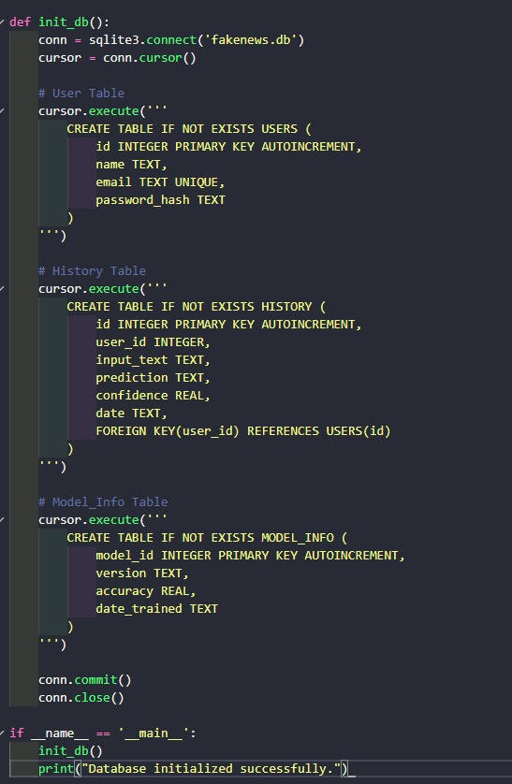
Figure 20 Database Initialization (SQLite schema)

• Frontend Login
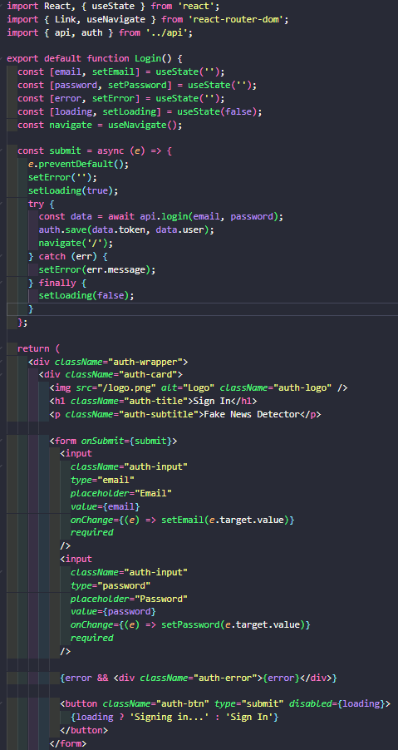
Figure 21 Frontend Login

