Introduction
The objective of Design Project 2 is to design, and implement an arithmetic logic unit (ALU) with a 4-bit register that can execute a number of arithmetic, logic, and shift micro-operations. The ALU includes the logic to perform the operations: CLRW, NOP, MOVLW, SUBLW, ASLW, and ADDLW. These six operations are clear, no operation, load, subtract input, arithmetic shift left, and add input. Additionally, either NEGL (negate input) or DECW (decrement) must be implemented. The circuit must be implemented using only one 74283 (4-bit binary full adder), one 74175 (Quad D flip-flop with clear), two 74153 (Dual 4-to-1 multiplexer), and four gate IC’s; either 7400 (Quad 2-input NAND gate) or 7404 (Hex Inverter).
It is also a requirement to generate a sequence of micro-operations that will compute a result for the following high-level function: f(x, y, z) = (x + y)×2 + z. The sequence must use each of the six required micro-operations at least once. The first micro operation in the sequence must be CLRW. The function must be implemented with the values x = -6, y = 5, and z = 5. The result of the calculation should be 3.

Implementation
The processor is implemented with an adder and four multiplexers. The two most significant bits of the opcode are wired to the four multiplexers and determine which input to route to the adder. The adder takes the inputs from the multiplexers and inputs from the flip-flops which are ANDed (through a NAND NOT) with the least significant bit of the opcode. This is done because the outputs of the adder go to the D flip-flops, but addition is not always necessary. Setting the bit to zero makes the adder pass the value from the multiplexers through to the D flip-flops. The least significant input of the multiplexers is the inverse of L. The second input is W itself, which allows for an arithmetic shift left (multiplication times two). The third input is L, which can be used either for assigning L to W or adding L and W. The most significant input is inverted W which is used for clearing W.
To implement the function f(x, y, z) = (x + y)×2 + z with the values x = -6, y = 5, and z = 5 using all six required micro operations I chose to implement the operations in the order CLRW, NOP, MOVLW, SUBLW, ASLW, then ADDLW. The information inputted and the resulting register contents are presented in the table below.
Mnemonic | Opcode |  |  | Input (L) |  |  |  | Register Contents (W)
CLRW | 1 | 1 | 1 | X | X | X | X | 0 | 0 | 0 | 0
NOP | 0 | 1 | 0 | X | X | X | X | 0 | 0 | 0 | 0
MOVLW | 0 | 0 | 1 | 0 | 1 | 0 | 1 | 0 | 1 | 0 | 1
SUBLW | 1 | 0 | 0 | 0 | 1 | 1 | 0 | 1 | 1 | 1 | 1
ASLW | 1 | 1 | 0 | X | X | X | X | 0 | 1 | 1 | 0
ADDLW | 1 | 0 | 1 | 0 | 1 | 0 | 1 | 0 | 0 | 1 | 1

For the extra operation I chose to implement NEGL. I did this by passing the inverse of L through the adder while also adding triggering the carry in input.
Mnemonic | Opcode |  |  | Input (L) |  |  |  | Register Contents (W)
NEGL | 0 | 0 | 0 | 1 | 0 | 0 | 0 | 1 | 0 | 0 | 0
LogicWorks Simulation Results
Output Timing File:
$T | $D | $O CLK | $O L3 | $O L2 | $O L1 | $O L0 | $O S0 | $O S1 | $O S2 | $O W0 | $O W1 | $O W2 | $O W3
0 | 200NS | 0 | 0 | 0 | 0 | 0 | 1 | 1 | 1 | 1 | 1 | 1 | 1
200NS | 50NS | 1 | 0 | 0 | 0 | 0 | 1 | 1 | 1 | 1 | 1 | 1 | 1
250NS | 150NS | 1 | 0 | 0 | 0 | 0 | 1 | 1 | 1 | 0 | 0 | 0 | 0
400NS | 200NS | 0 | 0 | 0 | 0 | 0 | 1 | 1 | 1 | 0 | 0 | 0 | 0
600NS | 200NS | 0 | 0 | 0 | 0 | 0 | 0 | 1 | 0 | 0 | 0 | 0 | 0
800NS | 200NS | 1 | 0 | 0 | 0 | 0 | 0 | 1 | 0 | 0 | 0 | 0 | 0
1US | 200NS | 0 | 0 | 0 | 0 | 0 | 0 | 1 | 0 | 0 | 0 | 0 | 0
1200NS | 200NS | 0 | 0 | 1 | 0 | 1 | 1 | 0 | 0 | 0 | 0 | 0 | 0
1400NS | 50NS | 1 | 0 | 1 | 0 | 1 | 1 | 0 | 0 | 0 | 0 | 0 | 0
1450NS | 150NS | 1 | 0 | 1 | 0 | 1 | 1 | 0 | 0 | 1 | 1 | 0 | 1
1600NS | 200NS | 0 | 0 | 1 | 0 | 1 | 1 | 0 | 0 | 1 | 1 | 0 | 1
1800NS | 200NS | 0 | 0 | 1 | 1 | 0 | 0 | 0 | 1 | 1 | 1 | 0 | 1
2US | 50NS | 1 | 0 | 1 | 1 | 0 | 0 | 0 | 1 | 1 | 1 | 0 | 1
2050NS | 150NS | 1 | 0 | 1 | 1 | 0 | 0 | 0 | 1 | 0 | 1 | 1 | 0
2200NS | 200NS | 0 | 0 | 1 | 1 | 0 | 0 | 0 | 1 | 0 | 1 | 1 | 0
2400NS | 200NS | 0 | 0 | 0 | 0 | 0 | 0 | 1 | 1 | 0 | 1 | 1 | 0
2600NS | 50NS | 1 | 0 | 0 | 0 | 0 | 0 | 1 | 1 | 0 | 1 | 1 | 0
2650NS | 150NS | 1 | 0 | 0 | 0 | 0 | 0 | 1 | 1 | 0 | 1 | 0 | 1
2800NS | 200NS | 0 | 0 | 0 | 0 | 0 | 0 | 1 | 1 | 0 | 1 | 0 | 1
3US | 200NS | 0 | 0 | 1 | 0 | 1 | 1 | 0 | 1 | 0 | 1 | 0 | 1
3200NS | 50NS | 1 | 0 | 1 | 0 | 1 | 1 | 0 | 1 | 0 | 1 | 0 | 1
3250NS | 150NS | 1 | 0 | 1 | 0 | 1 | 1 | 0 | 1 | 1 | 1 | 1 | 1
3400NS | 0 | 0 | 0 | 1 | 0 | 1 | 1 | 0 | 1 | 1 | 1 | 1 | 1

Timing Window:
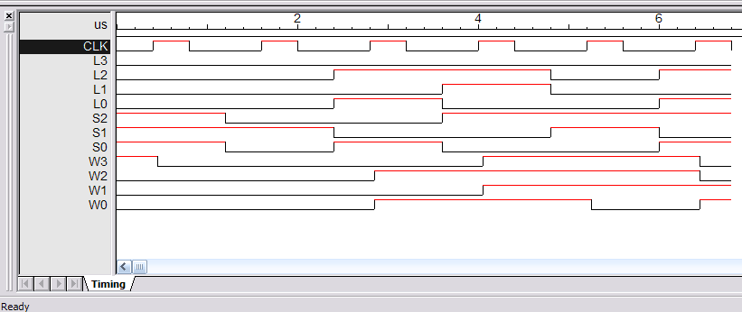
Circuit Layout:
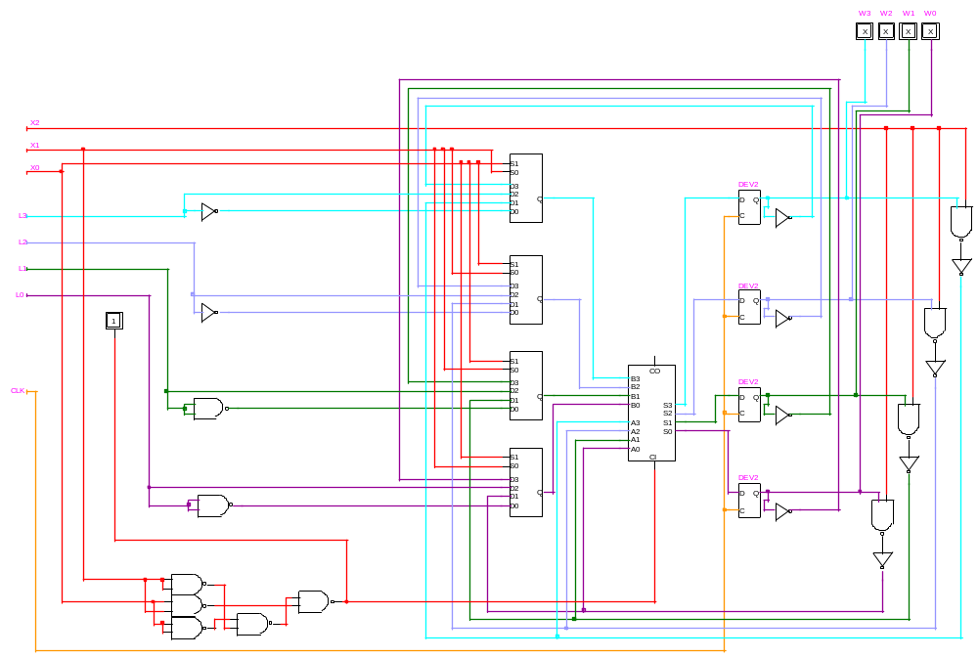

Chip Layout:
