
ES8311
Low Power Mono Audio CODEC

FEATURES
System
- High performance and low power multi-bit delta-sigma audio ADC and DAC
- I²S/PCM master or slave serial data port
- 256/384Fs, USB 12/24 MHz and other non standard audio system clocks
- I²C interface ADC
- 24-bit, 8 to 96 kHz sampling frequency
- 100 dB signal to noise ratio, -93 dB THD+N
- One pair of analog input with differential input option
- Low noise pre-amplifier
- Noise reduction filters
- Auto level control (ALC) and noise gate
- Support analog and digital microphone
DAC
- 24-bit, 8 to 96 kHz sampling frequency
- 110 dB signal to noise ratio, -80 dB THD+N
- One pair of analog output with headphone driver and differential output option
- Dynamic range compression
- Pop and click noise suppression Low Power
- 1.8V to 3.3V operation
- 14 mW playback and record
- Low standby current

APPLICATIONS
  - Automotive
  - Phone
  - Toy
  - 2-way radio
  - Dash cam
  - IP Camera
  - DVR, NVR
  - Surveillance

ORDERING INFORMATION
ES8311 -40°C ~ +105°C QFN-20

1

BLOCK DIAGRAM
DSDIN
ASDOUT
SCLK LRCK
CDATA
CCLK CE
MCLK

MIC1P MIC1N
I²C
PGA
Mono
ADC
Mono
DAC
HP Driver
Power Supply
Analog Reference

ADC ALC DAC DRC
Noise Filter
I²S/PCM
Clock Mgr
DVDD
PVDD DGND AVDD AGND
ADCVREF
DACVREF VMID
OUTP OUTN

PIN OUT AND DESCRIPTION
VMID
MIC1N MIC1P/DMIC_SDA
CDATA
CE

CCLK MCLK PVDD DVDD DGND
1
2
3
4
5
ES8311
15
14
13
12
11
16
17
18
19
20
10
9
8
7
6
AGND
DSDIN LRCK ASDOUT
SCLK/DMIC_SCL
ADCVREF DACVREF OUTN OUTP AVDD

Pin Name | Pin number | Input or Output | Pin Description
CCLK, CDATA, CE | 1, 19, 20 | I, I/O, I | I²C clock, data, address
MCLK | 2 | I | Master clock
SCLK/DMIC_SCL | 6 | I/O | Serial data bit clock/DMIC bit clock
LRCK | 8 | I/O | Serial data left and right channel frame clock
ASDOUT | 7 | O | ADC serial data output
DSDIN | 9 | I | DAC serial data input
MIC1P/DMIC_SDA  MIC1N | 18  17 | I | Mic input
OUTP, OUTN | 12, 13 | O | Differential analog output
PVDD | 3 | Analog | Power supply for the digital input and output
DVDD, DGND | 4, 5 | Analog | Digital power supply
AVDD, AGND | 11, 10 | Analog | Analog power supply
VMID | 16 | Analog | Filtering capacitor connection
ADCVREF, DACVREF | 15, 14 | Analog | Filtering capacitor connection

DACVREF ADCVREF
VMID
AGND PGND
AVDD

TYPICAL APPLICATION CIRCUIT
DVDD PVDD
DGND
MCLK SCLK/DMIC_SCL LRCK
ASDOUT DSDIN
CCLK CDATA CE
MIC1P/DMIC_SDA
MIC1N
18
17
1uF
1uF
MIC1P
MIC1N
ES8311
OUTN
13
OUTP 12
1uF
1uF
OUTN
OUTP
For the best performance,decoupling and filtering capacitors should be located as close to the device package as possible
* Additional paralle capacitors(typically 0.1 μF) can be used, larger value capacitors(typically 10 μF) would also help
AGND2
6
8
MCU/DSP ⁷
9
1
19
20
4
3
5
0.1uF 0.1uF
* *
* 1uF
AGND

VD VP
* * *
1uF 1uF 1uF
AGND AGND
VA
AGND
AGND
In the layout, chip is treated as a analog device
0R
GND(SYS)
14
15
16
10
21
11

- CLOCK MODES AND SAMPLING FREQUENCIES
The device supports standard audio clocks (64F, 128Fs, 256Fs, 384Fs, 512Fs, etc), USB clocks (12/24 MHz), and some common non standard audio clocks (16 MHz, 25 MHz, 26 MHz, etc).
According to the serial audio data sampling frequency (Fs), the device can work in two speed modes: single speed mode or double speed mode. In single speed mode, Fs normally ranges from 8 kHz to 48 kHz, and in double speed mode, Fs normally range from 64 kHz to 96 kHz.
The device can work either in master clock mode or slave clock mode. In slave mode, LRCK and SCLK are supplied externally, and LRCK and SCLK must be synchronously derived from the system clock with specific rates. In master mode, LRCK and SCLK are derived internally from device master clock.

MICRO-CONTROLLER CONFIGURATION INTERFACE
The device supports standard I²C micro-controller configuration interface. External microcontroller can completely configure the device through writing to internal configuration registers.
I²C interface is a bi-directional serial bus that uses a serial data line (CDATA) and a serial clock line (CCLK) for data transfer. The timing diagram for data transfer of this interface is given in Figure 1a and Figure 1b. Data are transmitted synchronously to CCLK clock on the CDATA line on a byte-by-byte basis. Each bit in a byte is sampled during CCLK high with MSB bit being transmitted firstly. Each transferred byte is followed by an acknowledge bit from receiver to pull the CDATA low. The transfer rate of this interface can be up to 400 kbps.
A master controller initiates the transmission by sending a “start” signal, which is defined as a high-to-low transition at CDATA while CCLK is high. The first byte transferred is the slave address. It is a seven-bit chip address followed by a RW bit. The chip address must be 0011 00x, where x equals CE. The RW bit indicates the slave data transfer direction. Once an acknowledge bit is received, the data transfer starts to proceed on a byte-by-byte basis in the direction specified by the RW bit. The master can terminate the communication by generating a “stop” signal, which is defined as a low-to-high transition at CDATA while CCLK is high.
In I²C interface mode, the registers can be written and read. The formats of “write” and “read” instructions are shown in Table 1 and Table 2. Please note that, to read data from a register, you must set R/W bit to 0 to access the register address and then set R/W to 1 to read data from the register.
Table 1 Write Data to Register in I²C Interface Mode

 | Chip Address | R/W |  | Register Address |  | Data to be written
start | 0011 00 CE | 0 | ACK | RAM | ACK | DATA | ACK | Stop

Chip Addr
Write ACK
Reg Addr
ACK
Write Data
ACK

CDATA
bit 1 to 7
bit 1 to 8
bit 1 to 8

CCLK

START STOP

Figure 1a I²C Write Timing
Table 2 Read Data from Register in I²C Interface Mode

 | Chip Address | R/W |  | Register Address
Start | 0011 00 CE | 0 | ACK | RAM | ACK
 | Chip Address | R/W |  | Data to be read
Start | 0011 00 CE | 1 | ACK | Data | NACK | Stop

Chip Addr
Write ACK
Reg Addr
ACK
Chip Addr
Read ACK
Read Data
NO ACK

CDATA
bit 1 to 7
bit 1 to 8
bit 1 to 7
bit 1 to 8

CCLK

START
START
STOP

Figure 1b I²C Read Timing

DIGITAL AUDIO INTERFACE
The device provides many formats of serial audio data interface to the input of the DAC or output from the ADC through LRCK, SCLK and DSDIN or ASDOUT pins. These formats are I²S, left justified, right justified and DSP/PCM. DAC input DSDIN is sampled by the device on the rising edge of SCLK. ADC data is out at ASDOUT on the falling edge of SCLK. The relationship of SDATA (DSIN/ASDOUT), SCLK and LRCK with these formats are shown through Figure 2a to Figure 2d.
1 SCLK 1 SCLK

LRCK
L Channel
R Channel

SCLK

SDATA
MSB LSB MSB LSB

Figure 2a I²S Serial Audio Data Format

LRCK
L Channel
R Channel

SCLK

SDATA
MSB LSB MSB LSB

Figure 2b Left Justified Serial Audio Data Format
1 SCLK

LRCK
L Channel
R Channel

SCLK

SDATA
MSB LSB MSB LSB
Figure 2c DSP/PCM Mode A Serial Audio Data Format

LRCK
L Channel
R Channel

SCLK

SDATA
MSB LSB MSB LSB

Figure 2d DSP/PCM Mode B Serial Audio Data Format

ELECTRICAL CHARACTERISTICS

ABSOLUTE MAXIMUM RATINGS
Continuous operation at or beyond these conditions may permanently damage the device.

PARAMETER | MIN | MAX
Analog Supply Voltage Level | -0.3V | +3.6V
Digital Supply Voltage Level | -0.3V | +3.6V
Analog Input Voltage Range | AGND-0.3V | AVDD+0.3V
Digital Input Voltage Range | DGND-0.3V | PVDD+0.3V
Operating Temperature Range | -40°C | +105°C
Storage Temperature | -65°C | +150°C

RECOMMENDED OPERATING CONDITIONS

PARAMETER | MIN | TYP | MAX | UNIT
DVDD | 1.6 | 3.3 | 3.6 | V
PVDD | 1.6 | 3.3 | 3.6 | V
AVDD | 1.7 | 3.3 | 3.6 | V
ADC ANALOG AND FILTER CHARACTERISTICS AND SPECIFICATIONS
Test conditions are as the following unless otherwise specify: AVDD=3.3V, DVDD=3.3V, AGND=0V, DGND=0V, Ambient temperature=25°C, Fs=48 KHz, MCLK/LRCK=256.

PARAMETER | MIN | TYP | MAX | UNIT
ADC Performance
Signal to Noise ratio (A-weigh) | 95 | 100 | 102 | dB
THD+N | -95 | -93 | -85 | dB
Gain Error |  |  | ±5 | %
Filter Frequency Response – Single Speed
Passband | 0 |  | 0.4535 | Fs
Stopband | 0.5465 |  |  | Fs
Passband Ripple |  |  | ±0.05 | dB
Stopband Attenuation | 70 |  |  | dB
Filter Frequency Response – Double Speed
Passband | 0 |  | 0.4167 | Fs
Stopband | 0.5833 |  |  | Fs
Passband Ripple |  |  | ±0.005 | dB
Stopband Attenuation | 70 |  |  | dB
Analog Input
Full Scale Input Level |  | AVDD/3.3 |  | Vrms
Input Impedance |  | 6 |  | KΩ

DAC ANALOG AND FILTER CHARACTERISTICS AND SPECIFICATIONS
Test conditions are as the following unless otherwise specify: AVDD=3.3V, DVDD=3.3V, AGND=0V, DGND=0V, Ambient temperature=25°C, Fs=48 KHz, MCLK/LRCK=256.

PARAMETER | MIN | TYP | MAX | UNIT
DAC Performance
Signal to Noise ratio (A-weigh) | 100 | 110 | 115 | dB
THD+N | -85 | -80 | -75 | dB
Gain Error |  |  | ±5 | %
Filter Frequency Response – Single Speed
Passband | 0 |  | 0.4535 | Fs
Stopband | 0.5465 |  |  | Fs
Passband Ripple |  |  | ±0.05 | dB
Stopband Attenuation | 53 |  |  | dB
Filter Frequency Response – Double Speed
Passband | 0 |  | 0.4167 | Fs
Stopband | 0.5833 |  |  | Fs
Passband Ripple |  |  | ±0.005 | dB
Stopband Attenuation | 56 |  |  | dB
Analog Output
Full Scale Output Level |  | AVDD/3.3 |  | Vrms

DC CHARACTERISTICS

PARAMETER | MIN | TYP | MAX | UNIT
Normal Operation Mode
DVDD=1.8V, PVDD=1.8V, AVDD=3.3V |  | 8 |  | mA
Power Down Mode
DVDD=1.8V, PVDD=1.8V, AVDD=3.3V |  | 0 |  | uA
Digital Voltage Level
Input High-level Voltage | 0.7*PVDD |  |  | V
Input Low-level Voltage |  |  | 0.5 | V
Output High-level Voltage |  | PVDD |  | V
Output Low-level Voltage |  | 0 |  | V
SERIAL AUDIO PORT SWITCHING SPECIFICATIONS

PARAMETER | Symbol | MIN | MAX | UNIT
MCLK frequency |  |  | 51.2 | MHz
MCLK duty cycle |  | 40 | 60 | %
LRCK frequency |  |  | 200 | KHz
LRCK duty cycle |  | 40 | 60 | %
SCLK frequency |  |  | 26 | MHz
SCLK pulse width low | TSCLKL | 15 |  | ns
SCLK Pulse width high | TSCLKH | 15 |  | ns
SCLK falling to LRCK edge | TSLR | –10 | 10 | ns
SCLK falling to SDOUT valid | TSDO | 11 |  | ns

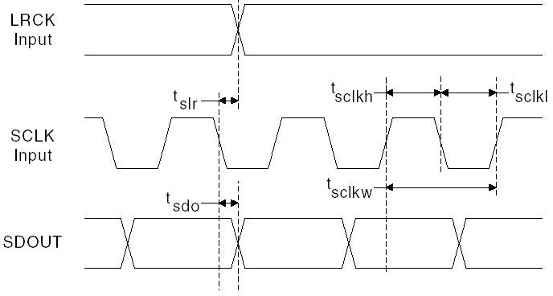

Figure 3 Serial Audio Port Timing

I²C SWITCHING SPECIFICATIONS
PARAMETER | Symbol | MIN | MAX | UNIT
CCLK Clock Frequency | FCCLK |  | 400 | KHz
Bus Free Time Between Transmissions | TTWID | 1.3 |  | us
Start Condition Hold Time | TTWSTH | 0.6 |  | us
Clock Low time | TTWCL | 1.3 |  | us
Clock High Time | TTWCH | 0.4 |  | us
Setup Time for Repeated Start Condition | TTWSTS | 0.6 |  | us
CDATA Hold Time from CCLK Falling | TTWDH |  | 900 | ns
CDATA Setup time to CCLK Rising | TTWDS | 100 |  | ns
Rise Time of CCLK | TTWR |  | 300 | ns
Fall Time CCLK | TTWF |  | 300 | ns

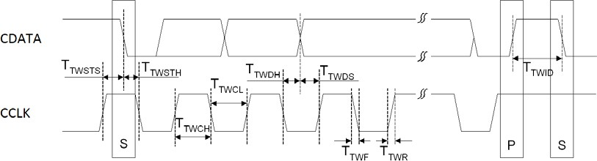

Figure 4 I²C Timing

PACKAGE

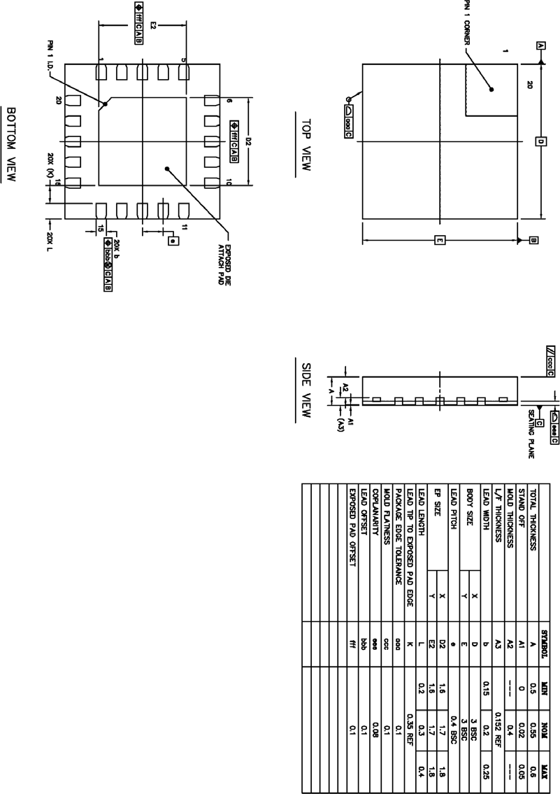

- CORPORATE INFORMATION

Everest Semiconductor Co., Ltd.
No. 1355 Jinjihu Drive, Suzhou Industrial Park, Jiangsu, P.R. China, Zip Code 215021
苏州工业园区金鸡湖大道 1355 号国际科技园, 邮编 215021 Email: info@everest-semi.com


