BridgePoint Model Export
The contents of a single xtUML model can be exported to a file using the BridgePoint Model Export wizard. The model can be exported with or without graphics.
The export wizard is shown below.

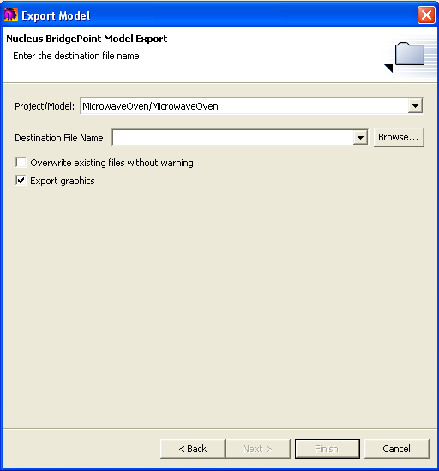
Project/Model are the project name and model name. The pull-down dialog lets you select from all of the project/model pairs in the current workspace.
Destination File Name selects the destination file. Click the Browse… button to navigate to the desired location.
The Overwrite existing files without warning checkbox can be used to avoid a pop-up warning dialog.
The Export graphics checkbox controls whether or not graphics are written to the model file along with the model data. Deselecting this checkbox is most often used to create a model file for input to a model compiler.

