Model Explorer View
The Model Explorer View shows a hierarchical view of a UML model. It also serves as a navigation tool to the various editors associated with model elements. All editors are accessed via the Model Explorer.

Organization
Model data is organized hierarchically, shown from top to bottom in the Model Explorer View. Error: Reference source not found shows this with the enclosing model element in the left column, one or more contained elements in the middle, and the icon for each contained element on the right. Model elements are shown in the Model Explorer as the icon followed by the name.
The data type package, for example, can contain three other model elements: other data type packages, data types, and enumerations.
Enclosing Model Element | Contained Model Element(s) | Icon (Contained Element)
N/A | System Package
System Package | Domain Package
Domain Package | Data Type Package
Domain Package | Function Package
Domain Package | External Entity Package
Domain Package | Subsystem Package
Data Type Package | Data Type Package | Same as above
Data Type Package | Core Data Type
Data Type Package | User Data Type
Data Type Package | Enumeration
Enumeration | Enumerator
Function Package | Function Package | Same as above
Function Package | Function
Function | Parameter
External Entity Package | External Entity Package | Same as above
External Entity Package | External Entity
External Entity | Bridge Operation  Event
Bridge Operation | Parameter
Event | Event parameter
Subsystem Package | Subsystem Package | Same as above
Subsystem Package | Class
Class | Attribute
Class | Operation
Class | Instance State Machine Package
Class | Class State Machine Package
Operation | Parameter
[Instance|Class] State Machine Package | State
[Instance|Class] State Machine Package | Event
[Instance|Class] State Machine Package | Event Data Item Package
Event Data Item Package | Event Data Item

Packages
Packages provide the primary means of organizing the data in the system. BridgePoint supports several types of stereotyped packages, each with its own contents.
Each package may contain model elements that belong to the package, or other packages of the same type. For example, a data type package can contain data types and other data type packages, a use case package can contain use cases and the relationships between them, and other use case packages.
The following table describes each of the organizational packages along with a short description.
Package | Description
System | Topmost package. Contains zero or more domain packages.
Domain | Contains zero or more of the following packages: data type, function, external entity, and subsystem. A domain package may only contain other packages, not individual model elements.
Data Type | Organizes data types for the xtUML model. A data type package contains individual data types and enumerations, or other data type packages. When a new xtUML model is created, a package called “Datatypes” is created which contains the primitive, or core data types such as: boolean, date, integer, and so on.
Function | Organizes functions in the domain. A function package contains function packages. Functions themselves do not have a graphical notation.
External Entity | Organizes external entities in the domain. An external entity package contains external entities (and their bridge operations and events), or other external entity packages.
Subsystem | Organizes classes in a subsystem. Subsystem packages contain classes, or other subsystem packages.
Event Data Item | Organizes the event data items for a state machine. There is one event data item package per state machine.
BridgePoint packages allow the user to organize the model elements that comprise the system. BridgePoint enforces model element groupings similar to those of UML 2.0. Examples of groupings and the model elements contained within them are:
- Data type package: contains primitive, user-defined, and enumeration data types.
- Subsystem package: contains classes, associations, and other subsystem packages.

Editor Access
Double-clicking on a model element in the Model Explorer brings up the default editor associated with that element. Other editors for a model element can be accessed by highlighting the element, choosing Open With, and selecting the desired editor from the list.
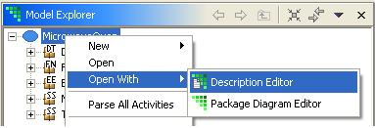

Diagram
The following table shows those model elements whose default editor is a Diagram Editor.

Model Element | Diagram Editor
Domain Package | Domain Package
Data Type Package | Data Type
Function Package | Function Package
External Entity Package | External Entity
Subsystem Package | Class
Instance State Machine | State Machine
Class State Machine | State Machine

Activity and Description
Double-clicking on a model element that does not have an associated Diagram Editor brings up either an Activity Editor, if the model element can have activities described by action language, or a Description Editor if it does not.
The following model elements have an Activity Editor as their default editor:
- Function
- Bridge operation
- Derived attribute
- Operation (class-based or instance-based)
- State action
All other model elements, e.g., classes, attributes, and parameters, have a default Description Editor.
A portion of the Model Explorer View for the MicrowaveOven sample model is shown in Error: Reference source not found .
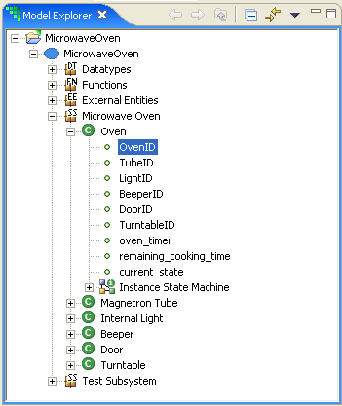
From top to bottom the Model Explorer shows the MicrowaveOven domain, a data type package called Datatypes, a function packaged called Functions, an external entity package called External Entities, the Microwave Oven subsystem package, the Oven class, the Oven class’ attributes, and so on.
Double-clicking on the Microwave Oven subsystem package brings up the Class Diagram Editor for that subsystem whereas double-clicking on the Oven class brings up a Description Editor. Double-clicking on a function brings up an Activity Editor.
Each of the editors can also be accessed by highlighting the model element, right-clicking, and selecting Open With to choose the desired editor.

Model Explorer Tools
Model Explorer has several tool buttons that assist the user in navigation and managing his view of the model data.
Collapse All collapses the model explorer to the highest model element in the hierarchy.

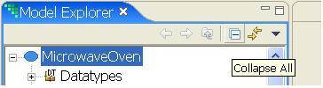
Link with Editor synchronizes an open diagram with the currently selected model element in the Model Explorer.

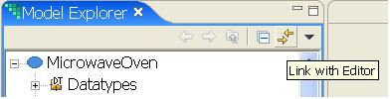
The Filter button allows selective filtering of model elements from the Model Explorer.

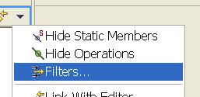

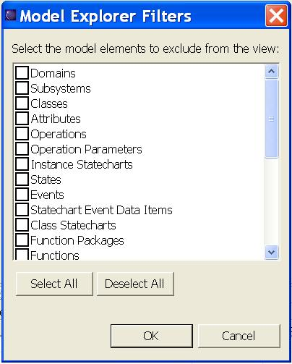

Creating and Deleting Model Elements
Certain model elements can be created and deleted from the Model Explorer tree. Some model elements, such as relationships between classes or transitions between states, can only be created on a Diagram Editor.
A new model element is created by highlighting the enclosing model element, right-clicking, and selecting New -> <Model Element Name>.
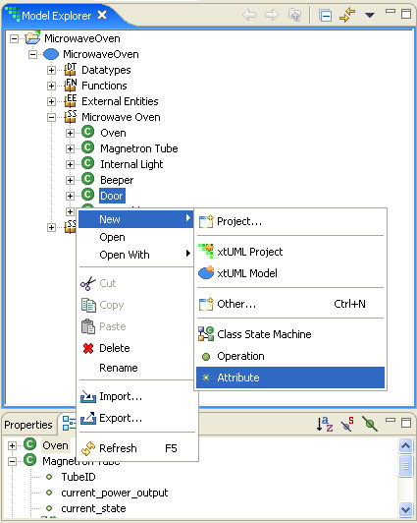
A new model element is created in the tree with the name “Unnamed <Model Element Name>”.
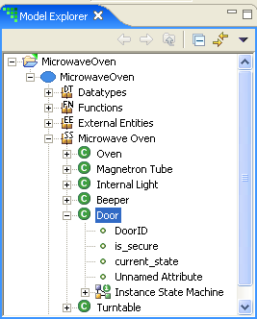
A model element is deleted by highlighting the model element, right-clicking, and selecting Delete.
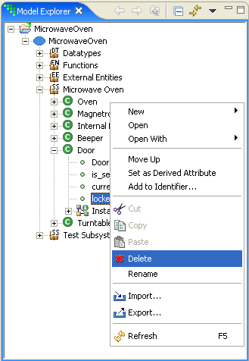

Renaming Model Elements
Model elements have in-place renaming in the Model Explorer. To rename an element, highlight the element, right-click, and select Rename. The element is made available for renaming in the Model Explorer.

