xtUML Model
An xtUML model is created to model an application in xtUML. xtUML models are contained within xtUML projects.
The xtUML Model wizard creates a new xtUML model in the current xtUML project. The new xtUML Model wizard is accessed by selecting New > xtUML Model from either the File menu, or the Model Explorer View context menu.
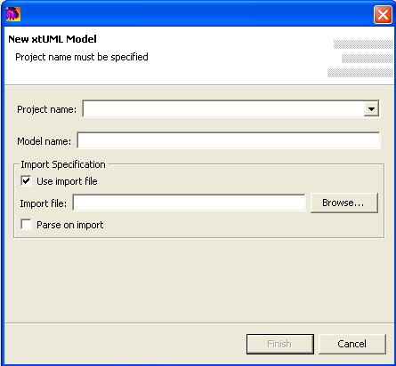
Project name is the name of the project in which the xtUML model is to be created. The pull-down is used to select a project from those in the workspace. If a project is selected in the Model Explorer, the pull-down menu will be highlighted on the selected project.
Model name is the name of the model and should adhere to the file naming conventions of the underlying operating system.
Import Specification allows for the specification of a model file used in the creation of the model. If used, the xtUML model will be created using the contents of the specified model file. To use an import file, check the Use import file checkbox and select a valid file using the Browse… button. The file can be either a BridgePoint model file, or a BridgePoint 6.1 SQL file (for backward-compatibility purposes only).
Parse on import directs the import to parse all activities (Object Action Language) during import. Any parse errors are reported in the Problems View.

