Model Debugger Overview
This section introduces you to the Model Debugger.

Windows
There are two main windows from which you perform most of your work: The Execution Control Window and the System Browser Window. A third window, the Target Output Window captures the standard output of the connected target.

Execution Control Window
The Execution Control Window controls the execution of the target, allows viewing of event occurrences, and displays trace output and logging information. Refer to the “Execution Control Window” topic for complete details.
The Execution Control Window is shown in the following figure:
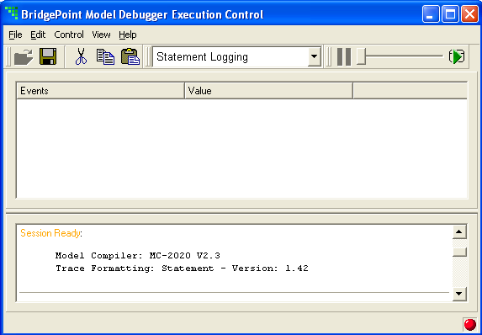

System Browser Window
The System Browser Window shows a hierarchical view of the data in each of the domains under execution. You can move up and down the tree for each domain, examining all of the data for each model element and instance in the system. See the "System Browser Window" topic for more information on navigating the data in your system.
The System Browser Window is shown below:
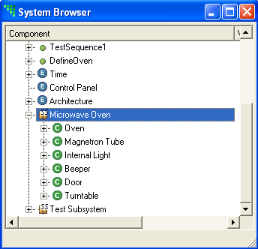
The Target Output Window logs data coming directly from the target’s standard output:
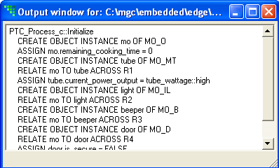
Refer To "Error: Reference source not found" for more information on this window.

Look and Feel
The BridgePoint Model Debugger is built on a GUI library that has a standard look and feel of the platform on which it runs.

Title Bar
Each of the windows has a standard title bar that looks similar to the following figure:
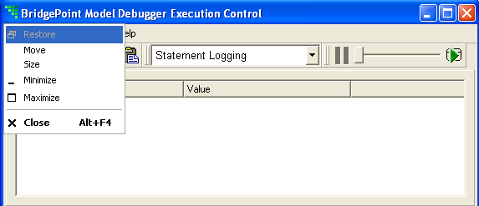
Clicking on the BridgePoint icon in the upper-left hand corner of any title bar yields a set of options that control the window:
Restore - Restores the window when minimized on the task bar.
Move – Allows movement of the window using the mouse after selecting and pressing any key.
Size – Allows adjustment of the window size using the mouse after selecting and pressing any key.
Minimize – Removes the window from the desktop and places it on the task bar. Use Restore to reanimate the window.
Maximize – Increases the size of the window such that it takes up the entire desktop. Double-clicking on a window’s title bar maximizes the window. Double-clicking on a maximized window returns it to its normal size.
Close (Alt+F4) - Initiates an exit from the tool.
Minimize, Maximize, and Close can be accessed from the upper-right corner of the title bar as in the figure (from left to right):
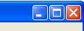
The size of a window can also be changed by hovering over any corner or edge and depressing the left mouse button when the cursor changes.

Scroll Bars
Any window or sub-window that has text that exceeds the bounds of the window automatically places scroll bars in order to gain access to the information. Both horizontal and vertical scroll bars are provided.
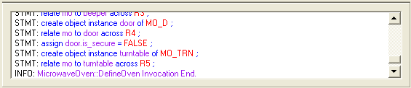

Toolbars
Removable and dockable toolbars are provided to group common operations. Each toolbar can be placed horizontally or vertically on it’s docking window or detached completely to the desktop. All toolbar manipulations are accomplished through the two vertical bars located on the left side of the toolbar:
or by right-clicking on the toolbar to gain access to the toolbar menu:
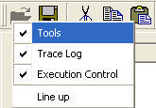

Moving a Toolbar
To move a toolbar, select and hold down the two vertical bars with the left mouse button moving the mouse to position the tool bar. As you move the toolbar a shadow outline appears to indicate the positioning. Drop the toolbar to the desired location.

Detaching a Toolbar from the Docking Window
In order to detach the toolbar from the docking window, move the toolbar to a position that is outside of the docking window and release. Alternatively, double-click on the two vertical bars.

Hiding a Toolbar
Single left-click on the two vertical bars in order to hide the toolbar. The toolbar isn’t really gone, it has only been replaced by a set of horizontal bars docked on the window. To restore the toolbar, single left-click the set of two horizontal bars.
Alternatively, right-click on any toolbar and de-select the toolbar by name. A toolbar is hidden when the check-box is un-checked. To un-hide the toolbar check the check-box.

Lining up Toolbars
Lining up the toolbars straightens any toolbars that are docked to the docking window. Detached toolbars remain unaffected. To line up the toolbars, right-click on any toolbar and select Line up.

Menu Bar
Whereas the toolbars provide access to a limited number of commonly used facilities, the menu bar provides access to all of the capabilities for a given window. Menu bar names reflect their purpose. For example the File menu provides access to file-based operations such as Open and Close. The Edit menu surfaces editing operations such as Cut, Copy, and Paste.
The following figure shows the Edit menu:
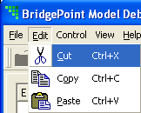
Frequently used operations have short-cut keys assigned. As show above, the short-cut for Cut is the Ctrl key plus the X key.
Menus provide an alternate way to navigate a window that does not involve the mouse. By selecting the ALT key and the underlined letter of the menu name, the menu list is opened. For example, selecting ALT-F opens the file menu. Each option under the menu can then be selected using the up and down arrow keys. The next and previous menus can be accessed using the left and right arrow keys.

