Using Model Debugger to Debug the Sample Models

Overview
This section provides a brief introduction to the Model Debugger. It is meant to be a step-by-step guide enabling you to familiarize yourself with the tool, its look and feel, and how to get around. By the end of this section you should be able to open, execute, and control executables created by your model compiler.
Throughout this section <workspace_dir> is used to refer to the default BridgePoint workspace directory that contains the sample models, e.g., C:\Documents and Settings\<user_id>\workspace. This directory is the default chosen workspace when BridgePoint is brought up. If you selected a different workspace, you can change to this one by selecting File > Switch Workspace… and selecting <workspace_dir>.

Sample Model
The Microwave Oven executable used is based on the Microwave Oven sample model included in the BridgePoint workspace. The executable was generated using one of Mentor’s off the shelf model compilers, MC-3020.
During this demonstration, you may find it useful to have the MicrowaveOven model open so that the correspondences between the model and Model Debugger output can be seen and understood. If you do not see the MicrowaveOven project, click the link below:
Click here to create the sample project.

Using the Model Debugger

Start Model Debugger
Use the EDGE Projects Perspective (Window > Open Perspective > EDGE Projects) to navigate to the pre-translated sample Microwave Oven executable. It is located in the following folder: MicrowaveOven/Model_Debug/Output.
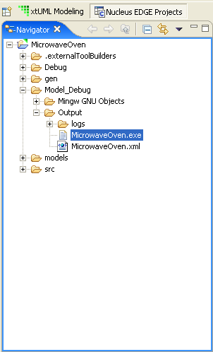
NOTE: Model Debugger enabled executables are brought up in the Model Debugger by double-clicking on the executable in the EDGE Projects Perspective, or by highlighting the executable and selecting Open With > Model Debugger.
For complete information on configuring the model compiler to produce a Model Debugger enabled executable, please see the model compiler documentation.
Double-click on MicrowaveOven.exe.
After the selection has been made, the Model Debugger and the executable communicate in order to prepare for the debugging session. This communication includes handshaking and data exchange which includes XML symbol data for each of the models in the project. A message is written to the Execution Trace Window upon completion.

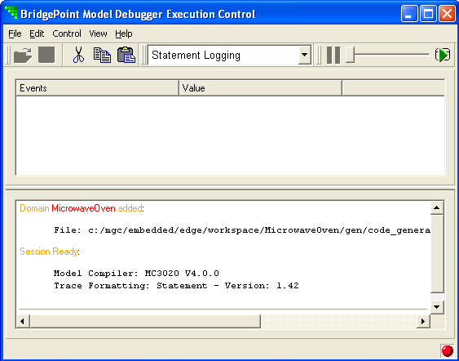

The first message indicates that the model was added successfully and shows the actual path for the MicrowaveOven model XML file. Normally the location of the file is in the directory in which it was created. If the Model Debugger cannot find the XML file in the location specified by the executable it looks in the directory in which the executable resides.
The second messasge, the Session Ready message, shows the name and version of the Model Compiler used to create the executable and the name and version of the trace formatting stylesheet currently selected.

Open the System Browser Window
Open the System Browser Window in order to see the model data for the MicrowaveOven system under debug.
Select View > Windows > System Browser
The System Browser Window is brought up with one entry for the one model in the system, MicrowaveOven.

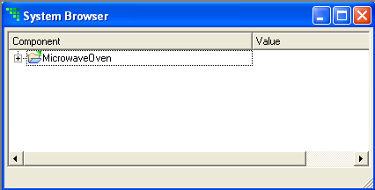

Navigate the Model
Open the model folder labeled MicrowaveOven. All of the model elements under the model are shown.
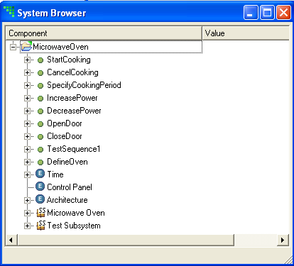
Hierarchically, the first entries are marked with a green symbol. They are the functions defined in the model. In the case of the MicrowaveOven model there are quite a few. Next are the External Entities followed by the Subsystems.

Navigate the External Entities
Under the functions are the External Entities (EEs). For the MicrowaveOven there are three folders for each of the External Entities in the model, Time, Control Panel, and Architecture.
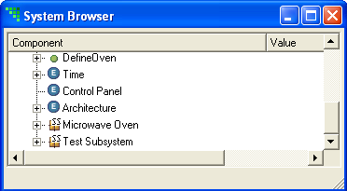
Open each of the EEs. Bridge operations are listed for those EEs that have them defined (the Control Panel EE has no such entries).
Open the Time External Entity and the timer_start bridge operation. Two parameters, microseconds and event_inst are listed.
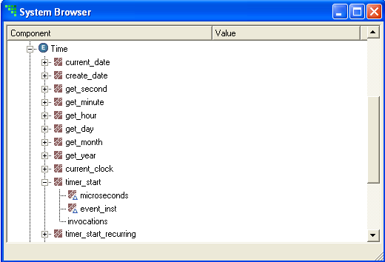
Right click the timer_start bridge. A context menu opens with the entry Break on Bridge Invocation.
Select this entry. A red dot appears against the tree entry to indicate that you have set a breakpoint.
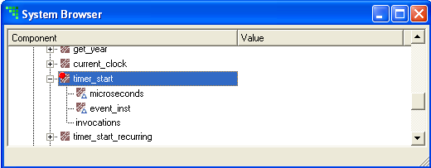
From this point forward, Model Debugger will stop every time this bridge operation is invoked (until you disable or clear it).

Navigate a Subsystem
Below the EE folders are the subsystem folders for this model; Microwave Oven, and Test Subsystem. Open Microwave Oven to expand the tree:
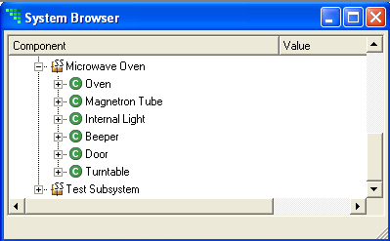
The classes of the subsystem are listed.

Navigate a Class
Open the Oven class to see the attributes listed with hollow green symbols to distinguish them clearly from operations that also appear in this part of the tree. Note: the Oven class doesn't have any operations.
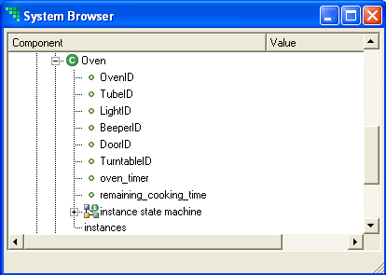
Click the instance state machine item to see the events and states for the Oven class instance state machine. States are shown as green vertical bars, events as green stars.
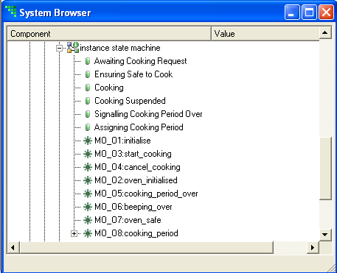s
Open the cooking_period event to see the data carried by the event. cooking_period has one data item, period.
Right click on a state. Notice that you can have Model Debugger break on entry to a state. Right click on an event. You can break on event generation, when an event is dequeued and when an event is ignored. You can set more than one of these break conditions simultaneously if you need to.

Execute an Initialization Function
In order to execute the model we must first define some instances of the classes in the model. To do this we will execute the DefineOven function.
Find the function in the System Browser. Right-click and select Invoke Function.
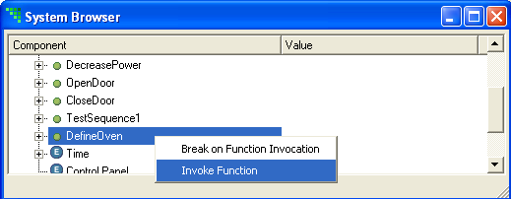
Notice the changes in the Execution Control Window:
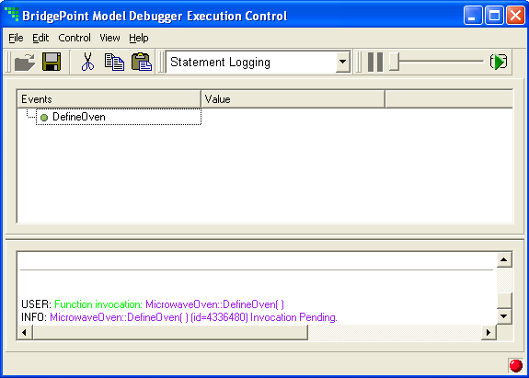

Press the Run button (or press F5) to execute the pending function.
The Execution Trace Window shows the activities (Object Action Language statements) being executed.
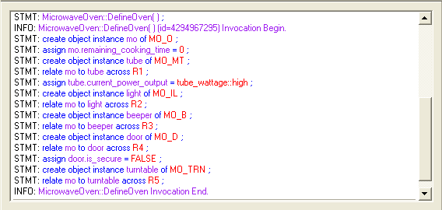

Browse Instance Data
From the System Browser Window, open the Magnetron Tube class followed by the instances item. There is one instance in the list with an id value of something like 9245232. Note that if you had done this before you executed the initialization function (by pressing Run/F5) there would have been no instances to see.
Open up the Magnetron Tube instance to see the values of its attributes. The current state of this instance is shown to the right of the object state item as Output Power Stable and OFF.
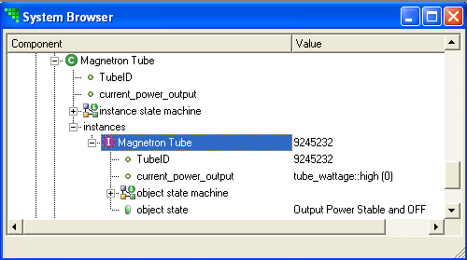

Browse an Instance State Machine
Open object state machine. This entry opens to show the states and events of the Magnetron Tube instance. This may seem like repetition of information, but it isn't. Setting a breakpoint on a state or event here has instance scope, whereas setting the same breakpoint two levels up in the instance state machine has class scope. In other words, a breakpoint set here only halts execution when it happens to this specific instance. If set two levels above, the same event or state entry causes a halt for any instance.
In the figure below we have set two breakpoints for instance 9245232 of the Magnetron Tube class , one on state Output Power Stable and OFF, the other on state Raising Output Power.
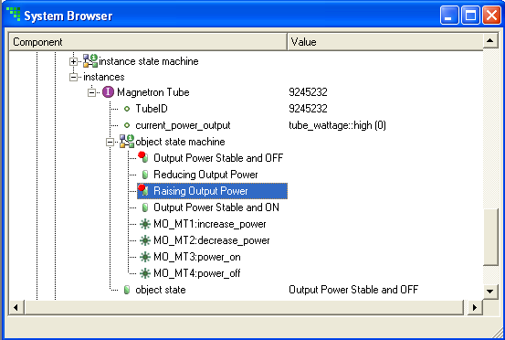

Navigate from the Execution Control Window to the System Browser Window
Move to the Execution Control Window and point your mouse cursor at the statement that creates instance mo of the Oven class.
STMT: create object instance mo of MO_O;
When you move the cursor over mo, it changes to a hand symbol. This symbol indicates a live link into the System Browser Window.
Click on the text mo. The System Browser Window comes to the foreground with the instance (e.g., Oven: 9254296) highlighted in the tree. The link feature allows you to easily inspect the state of instances that are being processed right from the Execution Trace Window.

Continue Execution
Move back to the main Model Debugger window. Move the rate control slider into the middle of it’s range and click the green Run button. The MicrowaveOven executable continues it’s execution.
Notice that the Target Status LED in the lower right hand corner of the Execution Control Window is green. This means that the executable is currently running on it’s own, waiting for more input from the outside world.
In a few seconds we are going to invoke a function then stop execution soon afterwards. We want to stop the execution at the end of state Performing Test Sequence 1 of the Test Sequences class. There are two ways to do this: 1) by hitting the Pause button to stop execution at the right moment, or 2) by setting a breakpoint. The surest method is to set the breakpoint.
Once you have set the breakpoint, scroll up to the top of the System Browser Window, right click on the function named TestSequence1, and select Invoke Function.
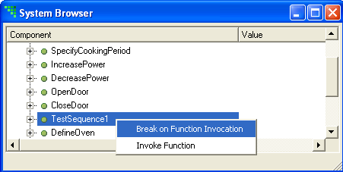
The execution should continue until seven events are waiting in the event queue. Your Event Window should look similar to the following window:
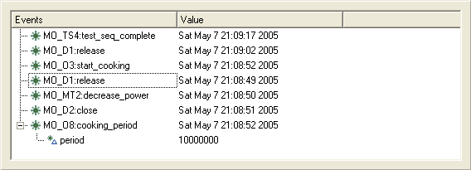

More Linking
In the Event Window, double-click the start_cooking event. The System Browser Window opens with the event instance highlighted. Notice that the event is shown under the state machine of the instance to which it was sent. You can see the current state of this instance in the Value column which is currently Awaiting Cooking Request.
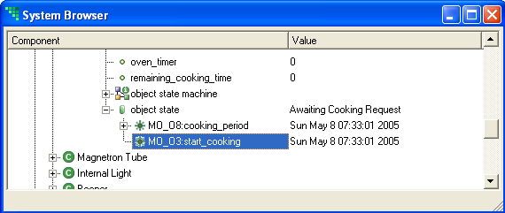
Go back to the Execution Control Window. Double-click the cooking_period event in the Event Window for the Oven class. The event opens to show the value of its data item period (10000000 uSec). Note that the event is also highlighted in the System Browser Window.
Right click on the event item start_cooking and choose Break on Event Dequeue. A red dot is added to the event icon to indicate that a breakpoint is set on it.
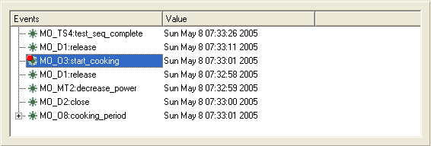
Notice that the breakpoint status is also reflected in (and can be changed from) the System Browser Window entry for the event.
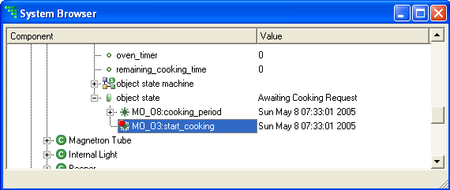
Click on the green Run button on the Execution Control toolbar.
The Model Debugger executes several state actions until event start_cooking is dequeued. You can scroll back over the execution history in the lower pane. Notice that the last state is preceded by a message reporting that the breakpoint was hit.
An event, oven_safe, is now in the Event Window:
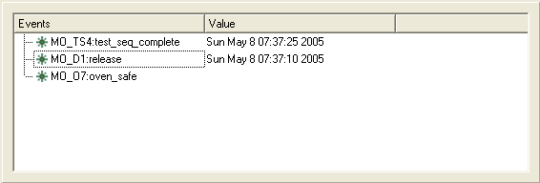
This event has no timestamp in the value column. This is because the event is not delayed and is dispatched immediately (or perhaps not – the behavior depends on the dispatching policy of the model compiler that generated the executable). Delayed events always show the time they will be delivered in the value column. If you pause the execution, the delivery time is delayed appropriately.

Logging
Open the dropdown list showing Statement Logging. Choose State Logging.
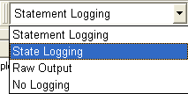
Move the slider in the toolbar all the way to the right.
Click the green Run button again. The Model Debugger now executes state actions continuously until the event queue is empty or until you click the red Pause button.
Notice that the State Logging script now causes only state change information to be output in the Execution Trace Window. You can create your own scripts to control exactly how much detail is written to the log pane and change between them, even while execution is in progress.
Regardless of how much or how little information is shown in the Execution Trace Window, everything is written to disk during execution. The log files are named after the executable with a timestamp appended. The logs are put in a subdirectory logs, in the same directory as the executable. Note if you want to see the logs you will have to perform a File > Refresh on the MicrowaveOven project folder from the Resource Perspective.
The same stylesheets used to process the log file during execution can be run (using a standard xsl processor) after execution as post-processing on the log files to obtain more detailed information on the execution as necessary.
The execution of the microwave oven finishes after the last delayed event has been delivered. The test sequence completes and the target shuts down. Notice the last trace entry in the Execution Trace Window.

Where to go from here?
You should now be familiar with the Model Debugger and its various features. Here is a short list of additional exercises:
- Experiment with different breakpoints to see what they do.
- Modify the XSLT scripts and see how the output is changed in the Execution Trace Window.
- Debug your own application generated from a Model Debugger enabled model compiler.

