Taking a Look at the Sample Models
In this part of the tour, we take a look at the sample models. This part of the tour requires the MicrowaveOven sample project to exist in the workspace. If you do not see the MicrowaveOven project click the link below.
Click here to create the sample project.

Reviewing the Sample UML Model
Before we look at the sample model, make sure you are in the xtUML Modeling perspective. This is usually the default when the tool is brought up and can be seen from the tab just above the Model Explorer View shown in the following image. If you are not in this perspective, select Window > Open Perspective > xtUML Modeling.
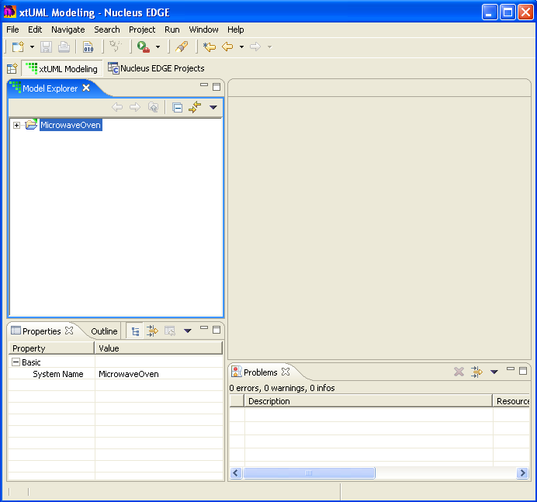

Reviewing the Sample UML Model
For this tour, BridgePoint creates a workspace containing an xtUML project and model for the MicrowaveOven. When you change to the xtUML Modeling Perspective it will show the MicrowaveOven project folder similar to the image above.
Now let’s take a closer look at the models and the tool.

Model Explorer
Model Explorer is the view you use to explore and navigate the model. From this view you can drill down into the model to see all of the constituent model elements. It also provides the place from which you launch the diagram, activity, and description editors.
The Model Explorer view organizes a UML model hierarchically starting with the project, followed by one or more models. Each model contains packages that organize the model elements that make up the model.
Expand the Model Explorer view so that the contents of the MicrowaveOven project and model are shown. It should look similar to the image shown below.
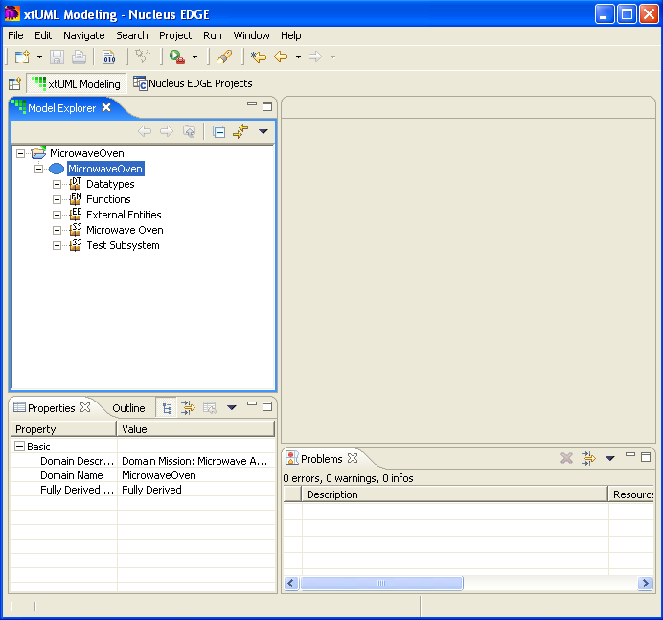

Packages
If you drill down into the hierarchy, you will notice that there are many different types of packages, as denoted by two small letters that sit on top of the package symbol. Each of these packages contains unique elements used to build the microwave oven application:
Domain Package – This is the top-most package for the entire model. It is used to organize the other packages in the microwave oven model.
Data Type Package – This package is used to describe data types for the microwave oven model. There are built-in data types (called primitive data types), user-defined data types, and enumerations. Each user-defined data type is based on a primitive data type.
Function Package – Function packages organize the functions in the model. Functions describe processing in terms of activities written in OAL (Object Action Language) and are used in this model for driving the microwave oven test sequences.
External Entity Package – An External Entity (EE) package describes those things outside of the current model that need to be referenced by this model. They can represent other models, or pieces of hand-written code with which our model needs to interact. The EE’s used in the microwave oven model control shutdown of the application and provide timers.
Subsystem Package – Subsystem packages organize the classes and associations for a subsystem. There can be many subsystems in a model. Subsystems are provided to break up a model into manageable pieces. The microwave oven model contains two subsystems: Microwave Oven and Test Subsystem.
State Machine Package – State machine packages organize the states, events, transitions, and activities for a class that has behavior. There are two kinds: instance-based state machines, which describe the behavior of each instance of a class, and class-based state machines, which describe the behavior of the class as a whole. Most of the classes in the microwave oven model have behavior described by state machines.

Taking a Look at the Diagrams
Each package has an associated diagram which can be accessed through the Model Explorer by double-clicking on the package or right-clicking on the package and selecting Open.

Domain Package Diagram
Open the Domain Package Diagram by double-clicking on the MicrowaveOven model.
Packages are shown on diagrams as tabbed folders. There are packages for the data types, external entities, and functions. There are also two packages for the two subsystems that make up the microwave oven model.
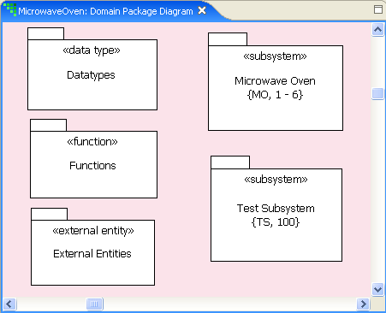
All diagrams have a diagram toolbar which is located above the diagram. The left-most tools are common to all diagrams and are related to performing zoom operations on the diagram.
From left to right, the tools are:
Magnifying Glass - Plus Sign – Zooms in on the diagram. The short-cut key is Ctrl-Shift Up Arrow.
Magnifying Glass - Minus Sign – Zooms out on the diagram. The short-cut key is Ctrl-Shift Down Arrow.
Magnifying Glass - Page – Zooms all elements on the diagram.
Magnifying Glass - Elements – Zooms the currently selected elements only.
The button with the arrow is the selection tool. Use this tool to select an element on the diagram.
Tools to the right of the selection tool put the diagram in “draw mode” and are used to draw model elements specific to the diagram. The four tools on the DPD toolbar are used to create new subsystem, external entity, function, and data type packages respectively.
Double-clicking on a package inside a diagram brings up the diagram editor for the package.
Open the Datatypes package by double-clicking on it.

Data Type Package Diagram
The Data Type Package Diagram for the microwave oven looks similar to this:
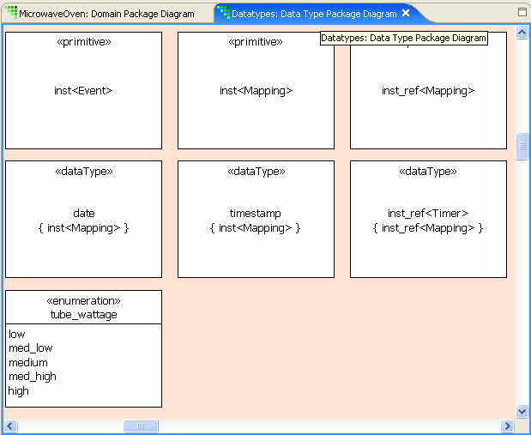
Notice that the tools to the right of the selection tool have changed for this diagram’s context. The tools are used to draw user data types, enumeration data types, and data type packages.
The Data Type Package Diagram above shows only a portion of the data types for the microwave oven. Notice that there are a few primitive types, as denoted by the <<primitive>> label, three user-defined data types as denoted by the label <<dataType>>, and one enumeration type that defines tube wattages. Once defined on this diagram, data types can be used to type class attributes and parameters of UML elements.
Note that primitive data types are provided on the diagram for you and do not need to be defined.

External Entity Package Diagram
Open the External Entity Package Diagram. You can do this by either going back to the Model Explorer or the Domain Package Diagram.
The External Entity Package Diagram shows those things, or entities, that are outside (external) to what we are modeling. EE’s can represent other models, or code that our model needs to interact with.
The microwave oven model has three EE’s: Control Panel, Architecture, and Time. The Control Panel represents the control panel of the microwave. The Architecture EE represents the model compiler and contains one bridge operation named shutdown which is used to shutdown the microwave application (more on this later).
The Time EE provides time and date bridge operations so that our microwave oven model can have access to dates, time, and timer (i.e., delayed) events.
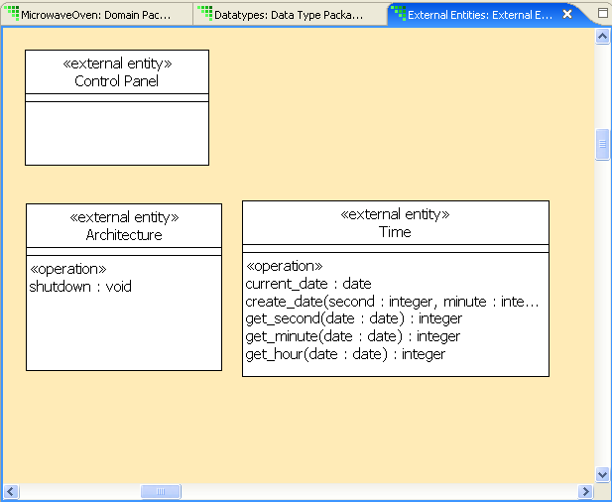

Function Package Diagram
Function Package Diagrams provide a way to organize functions. Function packages have a representation on the diagram, but functions don’t – there is no UML notation for them. They can only be seen in the Model Explorer.
The microwave oven model uses several functions to provide initialization and simulate the operation of the microwave.

Class Diagram
Subsystems provide a convenient way to break up a model into manageable chunks. The microwave oven model contains two subsystems, one that models the microwave oven, and one that tests it.
Double-clicking on a subsystem opens the Class Diagram. Open the Class Diagram for the Microwave Oven subsystem.
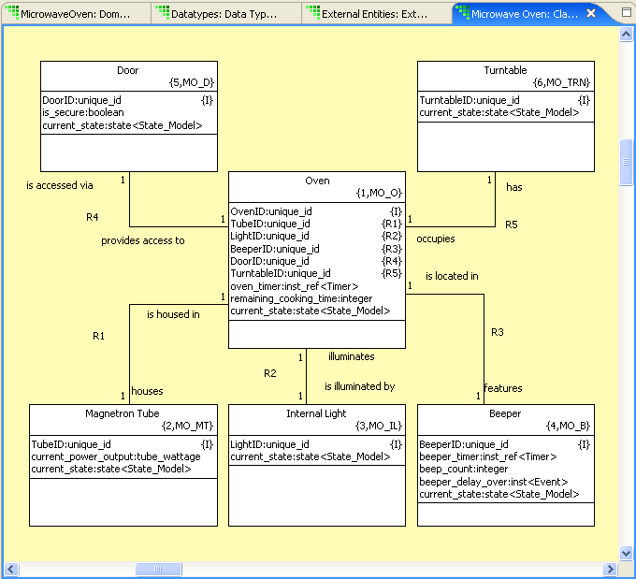
When the microwave oven was modeled, the following six classes were identified:
- Oven
- Door
- Turntable
- Beeper
- Internal light
- Magnetron tube
The Class Diagram represents the classes as boxes. The class attributes are the variables listed in the boxes, and the associations (relationships) between individual classes are the lines between the boxes. Associations have multiplicity and are named with text phrases.
The Oven class (at the center of the screen) has an association with several of the other classes. For example, there is an association, labeled R4, between the Oven and the Door. The R4 association is drawn as a solid, undirected line with a 1 at both end points, which denotes a one-to-one association. In our example, all of the associations are one-to-one.
The phrases “is accessed via” and “provides access to” describe the association between the two classes.

State Machine Diagram
A State Machine Diagram is used to represent the behavior of a class. Let’s take a look at the State Machine Diagram for the Door class. To open the State Machine Diagram for the Door, navigate inside the Door class in the Model Explorer and double-click on Instance State Machine.
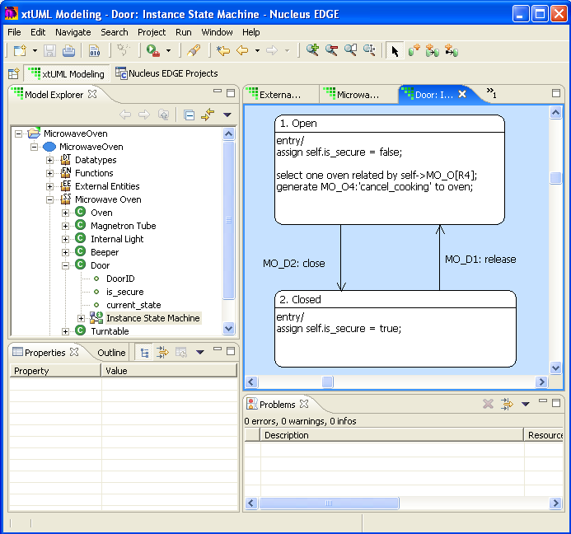
A state is represented by a rectangle with rounded corners. Each state has a name and number. The directed arrows represent state transitions and are labeled with the event that causes the transition. Activities are shown inside the rectangle and represent the processing that occurs on entry to a state.
The Door state machine has two states, Open and Closed. When the release event is received and the door is closed, it transitions to the Open state. Likewise when a close event is received in the Open state the door transitions to the Closed state.

Activities
The processing for each state in the State Machine Diagram is specified with activities written in OAL (Object Action Language). As an example, let’s look at the activities for the Open state of the Door state machine.
Accessing the activity for a state can be done in one of two ways: by double-clicking on the state in either the Model Explorer or the State Machine Diagram.
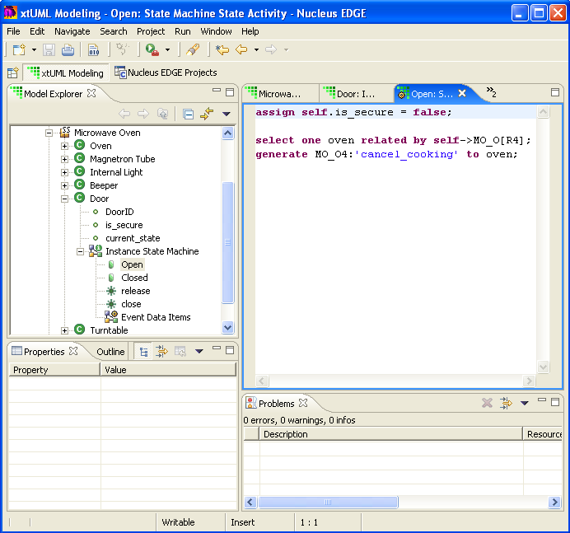

The behavior being modeled for the Door is this: when the door is opened, the oven is not secure and must be told to stop cooking. The activities written for the Open state reflect this by setting the attribute variable is_secure to false and sending the event MO_O4:’cancel_cooking’ to an Oven instance.
The Activity Editor is a context-sensitive editor that provides syntax and semantic highlighting, showing you errors as they are typed. Errors are reported in the Problems View.

Testing our Microwave Oven
So far, we have seen the modeling elements for the microwave oven application. In order to test the application model, we need to see how it operates in typical situations. For that purpose we’ve created a few functions and a subsystem dedicated to testing the microwave.
Functions are one of the places where we can model activities. This makes them a convenient place to create instances of the classes in the microwave oven model; oven, door, tube, and the associations between them. We can also generate events to kick off the various scenarios.
The “Test Subsystem” subsystem models a set of test scenarios used to exercise the microwave oven models. One of the nice things about using a subsystem to model the scenarios is that our tests are modeled at the same level of abstraction as the microwave oven model.

Initialization
Take a look at the function DefineOven. You can access the activities for this function by double-clicking on it in the Model Explorer. This brings up the Activity Editor for the function.
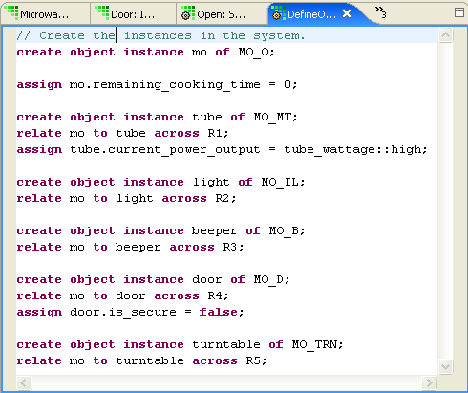

The DefineOven function contains activities that create the instances of the classes, set attribute values, and establish the associations between them. Note that the Activity Editor highlights keywords in red and comments in light green.
Now take a look at the TestSequence1 function. This function is used to generate an event that kicks off the simulation.
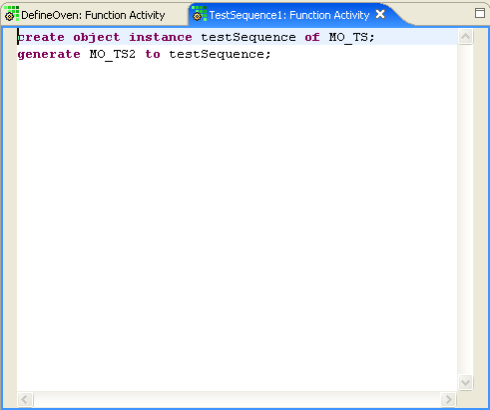
When we create the instance of the class MO_TS, we get a handle back (testSequence) which can then be used to generate the MO_TS2 event to the instance of Test Sequences.

Test Subsystem
Open up the state machine for the Test Sequences class so we can see what happens in our model when the MO_TS2 event is received. Remember that the class you are looking for is in the Test Subsystem subsystem.
The State Machine Diagram for the Test Sequences class is shown below:
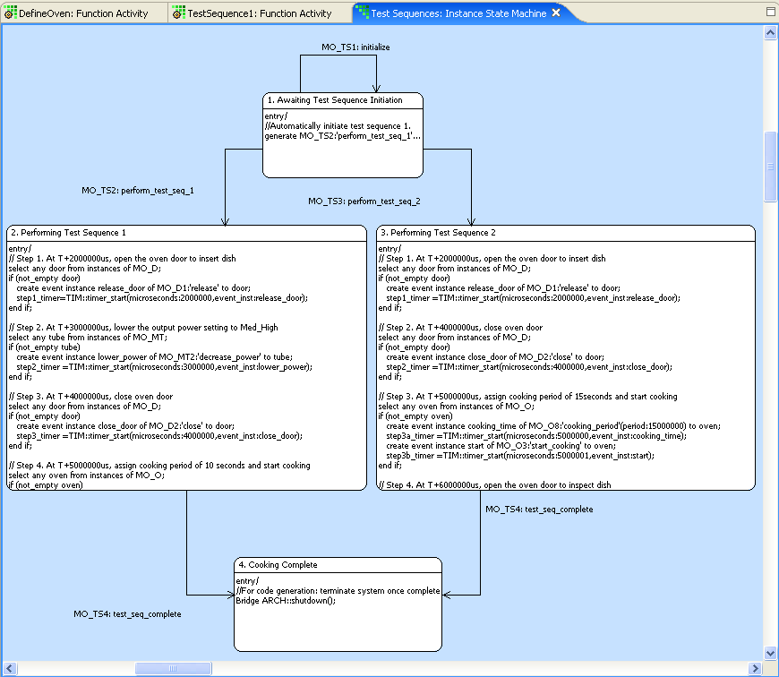
There are four states in the diagram. State 1 (Awaiting Test Sequence Initiation) sends an event to the next state to start a specific test sequence. States 2 and 3 (Performing Test Sequence 1 and 2, respectively) are specific test scenarios for operating the oven. State 4 (Cooking Complete) takes steps necessary to terminate the application (note the bridge call to the ARCH external entity).
You can see a portion of the activities for state 2 in the diagram above. Essentially, it specifies the following processing:
- Open the door.
- Lower the power setting to medium high.
- Close the door.
- Select a cooking time of 10 seconds.
- After 20 seconds, open the door.
By default, all state machines start out in the lowest numbered state. This means that the event sent by the TestSequence1 causes this state machine to transition from state 1 to state 2. Upon entering state 2, the activities are executed and the models begin to execute.

A Few Other Views and Editors
There are a few other views and editors that you need to be aware of when using the tool.

Outline View
The Outline View is active when a diagram editor has focus. It shows an outline of the model elements on the diagram. Here is what the Outline View looks like for the Door state machine.
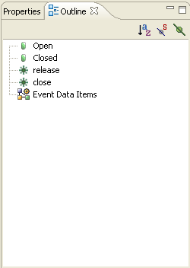
Bring up the Outline View and see how it changes when different diagram editors are selected.

Properties View
You can use the Properties View to change the attributes of the currently selected model element. There are basic and advanced properties. The following is what the Properties View looks like for the Oven class:
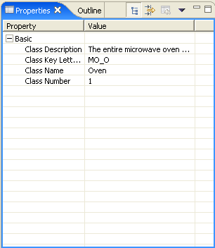

Problems View
Problems with activities (parsing errors) are reported on the Problems View. A brief description of the problem is noted along with the location. Double-clicking on a problem in the Problem View brings up the editor for the activity associated with the problem.
The “unexpected char” problem appears in the Problems View when an underscore is pre-pended to the assign keyword.
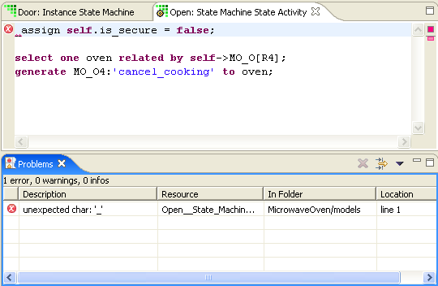

Description Editor
Virtually every model element can have a description. Descriptions are entered using the Description Editor. To access the description editor for a model element, select it (in the Model Explorer or Diagram Editor), right-click, and select Open With > Description Editor. The following shows the Description Editor for the Oven Class.
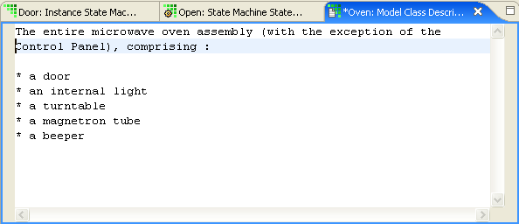

That covers the sample model portion of this tour. To translate the sample models with a Model Compiler, please proceed to the next section.

