The Translation Process in Detail
This section describes the fundamental translation process in greater detail.

Detailed Process Flow
The following flow diagram describes a breakdown of the translation process in terms of the two BridgePoint translation tools used to accomplish translation: pt_gen_import, and pt_gen_file. Normally, you don’t need to worry about invoking these programs directly because they are used by the model compiler to generate code. If however, you write your own translation rules in order to generate code outside of the model compiler, these details will be helpful.

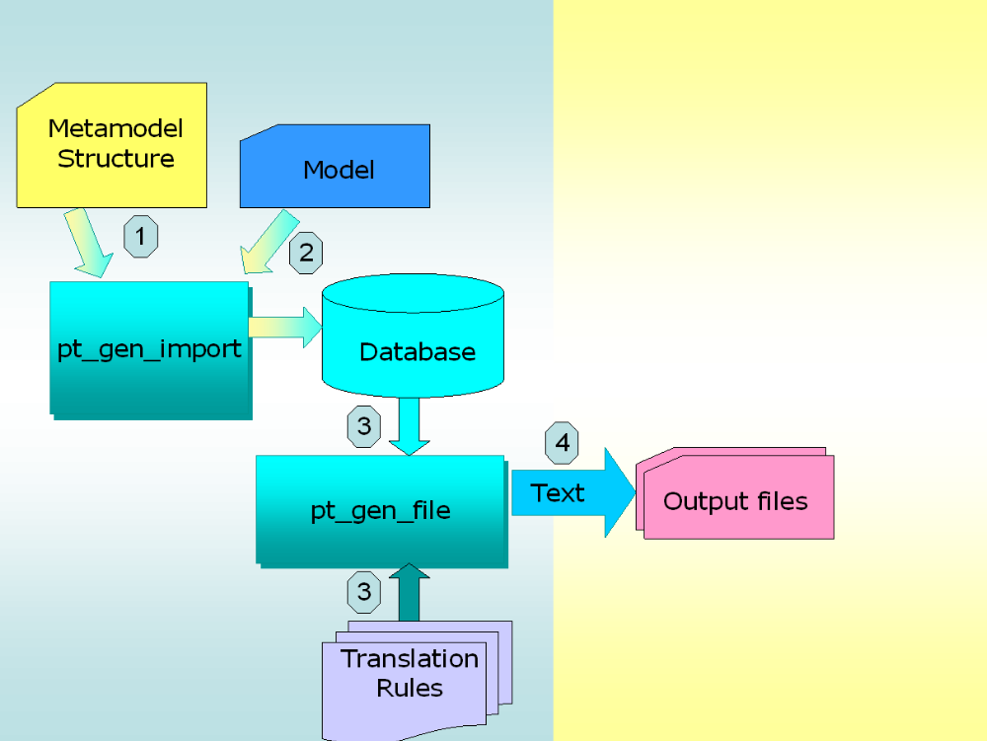

Steps in the Process
The following are the steps depicted in the figure above:
- The pt_gen_import program is used to create the translation database. To create a translation database, first import a file containing the metamodel structure. By convention, translation databases have a name that ends in .tdb as to distinguish them from other files in the system. From the command-line, creating a translation database looks like this:
pt_gen_import database.tdb metamodel.xtuml
A metamodel file contains statements that define the structure of the database. The database structure must be defined in the translation database before model data can be imported. The metamodel file that Model Builder uses can be found in the BridgePoint installation directory.
- Next, pt_gen_import is used to populate the empty database created in the previous step. The input is a set of statements that describe instances of model data that adhere to the structure of the translation database (as defined in the previous step). From the command-line, importing model data into the translation database looks like this:
pt_gen_import database.tdb model_data.xtuml
- Once the translation database has been populated with model data, pt_gen_file can be used to apply translation rules to the translation database. There are two inputs to pt_gen_file: the translation database and the rules file containing the translation rules:
pt_gen_file database.tdb translation_rules.rule
A translation rule file is a specification of the rules from which one or more text files are created. The rule specification language (RSL) controls how the model data is transformed into text. RSL is a mix of literal text, control statements, and substitution variables. Directives within the rules, or options from the command-line can be used to emit the text in one or more files.
The translation programs, pt_gen_import, and pt_gen_file, provide a general-purpose translation solution. This means that any metamodel can be used to define the structure of the translation database, and any model can be used to populate it, as long as 1) the model adheres to the structure of the metamodel, and 2) the files conform to the standard expected by the BridgePoint translation programs.

Translation Programs

Creating and Importing into the Database
The signature of the pt_gen_import command is:
pt_gen_import [-d <num>] <database_name>.tdb <model_file>.xtuml
-d <num> where <num> specifies the domain code used for the import, 0-15 inclusive. If this option is omitted, a unique number is allocated by the tool.
<database_name> is the name of the translation database and should carry the .tdb file extension. The translation database may or may not already exist. If it doesn’t exist, then <model_file>.xtuml must contain statements that define the structure of the database. The .gen extension can be used for backward compatability.
<model_file> is the name of the file containing either a metamodel definition or model data. The .sql extension can be used for backward compatability.
Under Windows, the name of the command is pt_gen_import.[cmd|bat].

The pt_gen_file program
The signature of the pt_gen_file command is:
pt_gen_file [-# <num>] [-l] [ -q ] [-f <file>] <database_name>.tdb <rule_file_name>.rule
-# <num> where <num> is a specified number of output files for the rule file. For example, if a rule file specifies the creation of one file per class, potentially many files are generated from one rule file. This option allows control in order to create a limited number of files during the rule file development phase.
-l directs pt_gen_file to output all text that would normally go to stdout or stderr to a file named database_name.gen_log. The log file is written in the current working directory.
-q forces pt_gen_file to quit after the first error. Without this option, an incorrectly specified .rule (translation rule file) iteratively reports many errors.
-f <file> tells pt_gen_file which files to create from within the rule file. If one or more .emit statements are used for several files, only the file specified on the command-line via the -f option is created.
<database_name> is the name of the translation database and should carry the .tdb file extension. The translation database must exist and have been created by the pt_gen_import program. The .gen extension can be used for backward compatability.
<rule_file_name> is the name of the rule file containing RSL. A rule file contains literal text, control statements, and string substitutions used to navigate the translation database and produce files containing ASCII text. The .arc extension can be used for backward compatability.
Under Windows, the name of the command is pt_gen_file.[cmd|bat].

Using Scripts and Makefiles
The pt_gen_import and pt_gen_file programs can be invoked directly from within shell scripts and makefiles. Doing so allows you to fully automate the process of implementation through translation. Here are some tips:
The exit status of pt_gen_import and pt_gen_file corresponds to the number of errors which have occurred during the execution of the program. Make runs smoothly as long as the exit status of each command is 0. If the exit status of a command is not 0, then make stops execution of the commands for that rule.
In pt_gen_file, the control statement .exit <exit_status> causes the program to exit with the exit status <exit_status>. This exit status can then be used within shell scripts and makefiles to take appropriate action.

