Execution Control Window

Target Status
Target status is presented via a small LED icon in the lower right-hand corner of the Execution Control Window.
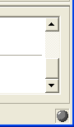
This icon shows the status of the target and can carry one of three states:
State | Color | Meaning
Disconnected | Grey | The target is not connected to the Model Debugger.
Ready | Red | The target is waiting for Model Debugger to tell it what to do.
Running | Green | The target is running and does not currently have the attention of the Model Debugger.

The target status LED is a very good way to see what is exactly going on in the target.

Disconnected
In the disconnected state, as far as the Model Debugger is concerned, it is not currently connected to any target. This state is shown when the Model Debugger is first brought up, or the target is killed either intentionally from the Model Debugger, or at some point during its execution. In this state, there is obviously no way to control the target from the Model Debugger user interface.

Ready
The ready state means that the target is waiting for the Model Debugger to tell it what to do next. Target executables communicate with the Model Debugger by continually asking it if it is ok to execute the next action, or set of actions. When the target stops and asks the Model Debugger, the status light is set to red, meaning it is ready to accept the next command.

Running
When the target is running, it is not in direct contact with the Model Debugger, i.e., it is not ready to receive additional commands. A target can be out of contact with the Model Debugger for any number of reasons; it could be executing actions in a state or function body, or it could be blocking on a semaphore waiting for an event to show up on an event queue, a timer to expire, or for the user to manually invoke a function from the System Browser Window.

Target Control
Model Debugger provides several ways to control the behavior of the target, and view its current status as it executes the translated xtUML application.
The target is controlled via the execution control bar shown below.
From left to right are the Pause button (used to stop execution), the execution rate control slider (used to control the rate at which the target executes), and the Run button (used to start execution).
Think of the execution control toolbar as the means by which you can use the Model Debugger to control the execution of the target. When you use this toolbar, your actions direct the target’s behavior by telling MD how to interact with the target the next time MD has the target’s attention (i.e., the next time the target is ready).
Other control mechanisms include state and statement stepping, and target reset, each of which is described in further detail below.

Starting Execution
There are three ways in which a target may be started; by using the Run button on the Execution Control toolbar, from the Control menu, and by pressing the F5 hotkey. When an executable is first opened, pressing the Run button causes execution to begin. In the case of a paused target, pressing Run resumes execution.
Execution starts, or restarts from the point at which it was stopped.

Using the Execution Control toolbar
Click on the green Run/Continue button to the right of the slider control. Note that when execution starts, this button is disabled and the red Pause button is enabled.

Starting from the Control Menu
Select Control > Run/Continue from the main menu.
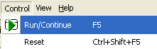

Using F5
Push F5 to continue execution on the target.

Stopping Execution
Stopping execution is achieved by pressing the Pause button on the Execution Control toolbar, from the Control menu, or by using the Alt-Shift-F5 hotkey.
On request, execution stops at the next state or statement and waits for further commands. Events not yet processed are shown in the Event Window. The System Browser Window shows the currently existing instances and their values.

Using the Execution Control toolbar
Click on the red Pause button to the left of the slider control. Note that this button is disabled until execution starts.

Pausing using the Control Menu
Select Control > Pause from the main menu.
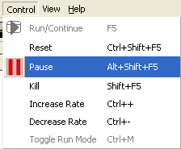

Using the Hotkey Alt-Shift-F5
Push Alt-Shift-F5 to stop the target.

Target Reset
Sometimes it is desirable or necessary to reset the target, for instance, when you wish to restart execution, or when the target hangs due to an error in the model. Target resets come in two flavors: soft (reset) and hard (kill).

Resetting the Target Process
This option is used when you want to start over with a debugging session. It causes the target executable to re-initialize. It is invoked in two ways, using the Control menu and by a hotkey.

Resetting from the Control Menu
To reset the target, select Control > Reset.
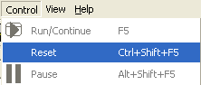

Resetting using Ctrl-Shift-F5
Press Ctrl-Shift-F5 to reset the target.

Killing the Target Process
Killing the target makes it stop and unload itself from memory. It does not empty the debugging data collected by Model Debugger (if you wish to close the target and discard the debugging data, use File > Close).
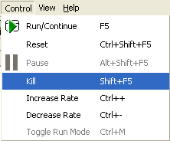
To kill the target process, use Control > Kill or Shift-F5.

Execution Rate
Execution rate is the speed at which the target is allowed to execute. When the execution rate is at it’s minimum, pressing the Run button causes execution to proceed for one unit (state or statement) as specified by the run mode. When the execution rate is off the minimum, execution proceeds at a graduated rate, continuously executing states or statements until the Pause button is pressed, or until the target finishes all it’s work.
Execution rate is controlled by using the Control menu, by using the toolbar slider control or by hotkey.

Controlling Execution rate from the Control Menu
To increase execution speed, use Control > Increase. To slow execution use Control > Decrease.
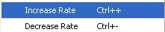

Using the Rate Slider
The slider is used to control execution rate. Move it all the way to the right to execute at maximum speed, move it all the way to the left to execute only one unit (single step).
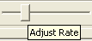

Using the Hotkeys Ctrl+/-
To change the execution rate directly from the keyboard, use Ctrl+ to increase the rate and Ctrl- to decrease it (note that on laptops, Ctrl+ must be accessed through Ctrl-Shift-=).

Run Mode
Model Debugger allows two levels of stepping granularity, action stepping and statement stepping. In action stepping, a single push of the Run button executes one action. In statement stepping mode, execution can be stopped by a Pause command on a statement boundary. This can be useful if something is going wrong in a piece of Object Action Language and you need to step through the individual statements of the action to find out why.
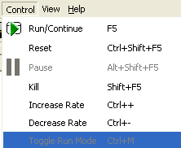
The run mode is changed in two ways, using the Control menu Control > Toggle Run Mode, or by the hotkey Ctrl-M.

Event Window
The upper pane of the Execution Control Window shows both state machine events and any serialized action invocations that are pending in the executing target. Looking at the contents of this pane shows you exactly what is pending in the target at any given time.

Events
An event is shown with keyletters and meaning. If an event carries data items, the event bears a + sign. Clicking on the + sign or double clicking the event opens it to show the event data items and their values.
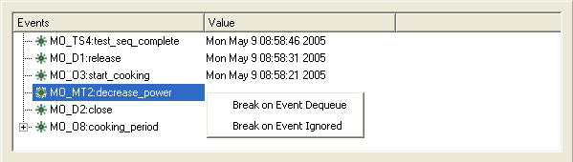
Double clicking on an event in the Event Window opens the System Browser Window at the event in its state machine queue. Using this facility, you can quickly see the context for any event seen in the Event Window.
Right clicking on an event in the Event Window opens a context menu that allows setting and clearing of breakpoints for event generation, event dequeue and event ignored. (Event Can't Happen is an error condition. Many architectures shut down when a Can't Happen Event is encountered. Model Debugger allows architectures to carry out their normal Event Can’t Happen handling. Setting breakpoints on them would interfere with that behavior).
Events are shown in the order they were generated. This is not necessarily the order in which they are processed, because different architectures have different dispatching policies. The order in which they are removed from the queue is guaranteed to match what the target architecture does, so events may be removed and processed that are not at the queue head.

Delayed Events
If an event is delayed, the expiry time is shown in the Value column. In all other respects, delayed events are treated like regular events, you can set breakpoints and navigate to their target instances as described above.
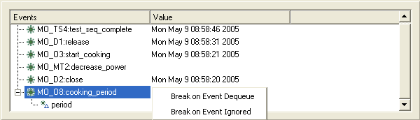

Serialized Action Invocations
In addition to state machine events, the Event Window shows any pending action invocations. This includes functions that have been invoked manually from the System Browser window of the Model Debugger.
A function invocation is shown with its name. If the function has parameters, the function invocation bears a + sign. Clicking on the + sign opens it to show the parameters and their values.
Double clicking on a function invocation in the Event Window opens the System Browser Window at the function invocation. Using this facility, you can quickly see the context for any function invocation seen in the Execution Control Window.
Right clicking on a function invocation does nothing. Setting a breakpoint on a user created function invocation is not supported.
Function invocations are shown in the order they were created. The order in which they are removed from the queue is guaranteed to match what the target architecture does. Most architectures process function invocations in the creation order. The target architecture may interleave processing of function invocations with processing of state actions.
The image below shows two functions, StartCooking and SpecifyCookingPeriod. The latter has a single parameter, cookingPeriod whose value is 6.
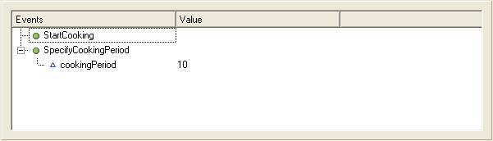

Trace and Logging

Output
The lower pane of the Execution Control Window shows the execution trace and is called the Execution Trace Window. The terse messages that indicate the precise activity on the target are converted by Model Debugger into human readable text and written to this window.
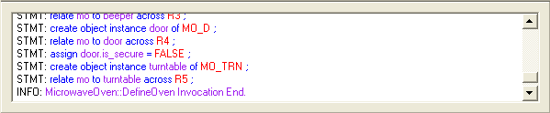

Stylesheets
The conversion to human readable form is done by a built in XSLT (XML Stylesheet Language for Transformations) processor. Model Debugger comes with a few example stylesheets. One of the exciting things about Model Debugger is that you can write your own style sheets to process the data any way you like.
You could for example write a stylesheet to show high and low watermark information on instance populations and/or event queues during execution. If you have difficulty distinguishing some colors, you can change them by editing the stylesheet, or you can increase the font size used for output by the tool.

Linking to the System Browser Window
Instance handles in the Execution Trace Window have hotlinks to the corresponding instance in the System Browser Window; if you move your mouse over a hotlink, it turns into a pointing hand to indicate the existence of the hotlink. These links function like hyperlinks in a Web browser, click once to instantly open the System Browser Window at the appropriate place.

Custom Protocol Messages
We have provided a general purpose log protocol message that can be used to put messages into the Execution Trace Window from the running target. This is largely unnecessary with code generated by a model compiler, because it is already fully instrumented. However, it is possible to log additional execution data from handwritten, realized code using the log message.

Target Output
When an executable is run from the command line, many architectures emit logging information to the console. The Target Output Window allows you to see this output as if the target was running from the command line. Of course if the architecture has been colored so that it does not produce trace output to the command line, no output is seen in this window. For many purposes, using the Model Debugger makes this trace output obsolete, so you may want to turn it off once you have gained experience using Model Debugger. Conversely, you may find it useful to confirm what the target is doing using an alternate method.
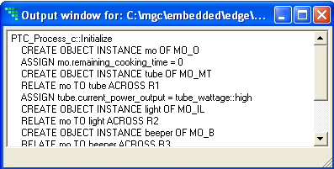
The Target Output Window is scrollable, so you can review the information it contains even if it is no longer present in the window. On an extended run, this information can become bulky. For this reason, Model Debugger discards this information if the window is not open. We recommend closing this window on long runs unless you know you need to see the output.

Opening and Closing the Target Output Window
The Target Output Window is opened using the View menu, View > Window > Target Output. It can be closed in the same way or by using the system menus or buttons on the window.
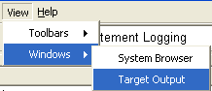

Due to data integrity issues that may arise from concurrently executing actions, most model compilers serialize the execution of all state and non-state (e.g., function, operation) actions. When the user manually invokes a function from the Model Debugger user interface, for example, a request to invoke the function is “queued” so that the function’s actions are executed only when it is safe.

