Diagram Text
The text font used on UML diagrams can be changed by selecting Window > Preferences > Workbench > Colors and Fonts.
To change the font, select UML Diagram Text from the scroll list and select the Change… button.
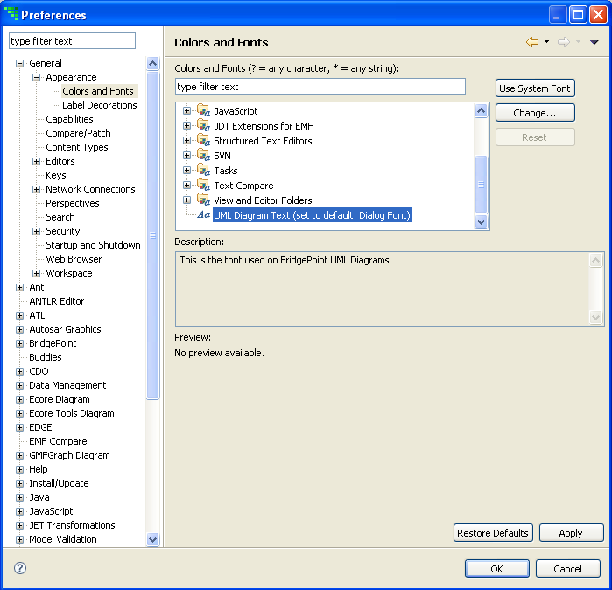
The dialog that pops up allows you to change the font, size, and weight.

