The Basics

Startup

Starting the Model Debugger
To start Model Debugger from within BridgePoint, perform the following steps:
- Bring up the Resource Perspective by selecting Window > Open Perspective ... > Resource.
- Navigate to the folder that contains the executable.
- Double-click on the executable name.
To start Model Debugger outside of BridgePoint, i.e., from a DOS command line, execute the command file directly:
- Change directory to the location of the command-file: <install_dir>/bin.
- Execute the command: pt_debugger.cmd.

Command-line Options
Model Debugger can be invoked in either GUI mode or in batch mode.

GUI Mode
The signature of the command in GUI mode is:
<command> [<target_file>] [-scripting_on]
where:
<command> is the name of the command, pt_debugger.cmd.
<target_file> is the absolute path to the target executable. If any of the directory names contain spaces this argument must be enclosed in double quotes. If <target_file> is not specified, the file can be opened from within the GUI using File > Open.
-scripting_on is a flag which directs Model Debugger to allow script recording and playback from the GUI. Script recording is used to create script files for running Model Debugger in batch mode (see below). Without this option the script recording GUI entries are absent from the menus.
Be sure to use the file naming conventions that are appropriate to the shell from which you bring up Model Debugger. This includes most notably back-slash or forward-slash usage in directory path names.

Examples
To invoke Model Debugger from the command-line:
cd <install_dir>/bin
./pt_debugger
To invoke Model Debugger specifying the sample MicrowaveOven target executable on the command-line:
cd <install_dir>/bin
./pt_debugger “<workspace_dir>/MicrowaveOven/source/MicrowaveOven.exe”
To bring up Model Debugger with script recording/playback capabilities:
cd <install_dir>/bin
./pt_debugger -scripting_on

Batch Mode
The command-line options for batch mode are:
<command> -script <script_file> <target_file>
where:
<command> is the name of the command, pt_debugger.cmd.
-script directs Model Debugger to run in batch mode.
<script_file> is the absolute path to the script file. If any of the directory names contain spaces this argument must be enclosed in double quotes.
<target_file> is the absolute path to the target executable. If any of the directory names contain spaces this argument must be enclosed in double quotes.
All three arguments, -script, <script_file>, and <target_file> must be present to run in batch mode.
Be sure to use the file naming conventions that are appropriate to the shell from which you bring up Model Debugger. This includes most notably back-slash or forward-slash usage in directory path names.

Examples
To run Model Debugger in batch mode specifying the script file and target executable:
cd <install_dir>/bin
./pt_debugger -script “<install_dir>/samples/md/test.xml” “<workspace_dir>/MicrowaveOven/source/MicrowaveOven.exe”
The sample test script file test.xml is located in <install_dir>/samples/md.

Opening and Closing a Target Executable
Opening and closing a target executable is performed via the File menu.

Opening
To open a target executable select File > Open, use the shortcut Ctrl-O, or click on the folder icon on the file toolbar. A file chooser dialog is brought up:
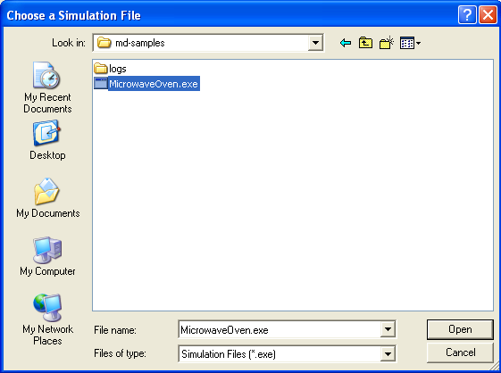
Navigate the to executable you wish to open and click Open.
Note that an XML file (one that contains data about the model) must reside in the location where it was created by the model compiler, or be located in the directory in which the executable resides. If Model Debugger cannot find the XML file it issues an error message and exits.

Closing
To close a target executable and disconnect, select File > Close or use the Ctrl-W shortcut.

XML State Save
The state of the running system may be saved at any time during your debug session. State save data is written in XML format that can be used for manipulation outside of the Model Debugger.
To save for the first time, select File > Save As and specify the name of the file you wish to save. For subsequent saves using the same file name select File > Save, or use the Ctrl-S shortcut.

Log Files
Regardless of how much (or how little) you choose to show in the Execution Trace Window, everything sent by the target is written to disk as it is received. The files are placed below the target executable directory, beneath a subdirectory called logs. Each time a debugging session is opened, a new file is created. Each file is named after the name of the target executable with a timestamp appended to disambiguate one debugging session from another. For example, MicrowaveOven_020817_120650.log is a log file made from a debugging session of the target MicrowaveOven.exe, carried out on August 17 2002 at 6 minutes and 50 seconds after 12pm.
The content of the log file consists of the raw XML messages that were originally sent by the target as opposed to the more readable form shown in the Execution Trace Window. This has the advantage that you can review the complete execution record with different stylesheets after processing is complete. This means you never miss anything because the logging stylesheet you selected produced too little output.
Because the log file format matches what the target originally sent, it follows that you can reprocess the output using the same stylesheets originally used to format the output in the Model Debugger. However, because the original stylesheet had access to the model symbol tables, you will need a simple utility that combines the model and log data before you can reprocess the log successfully. Stylesheets that can be used with the Model Debugger must at present produce only textual output. However, when post processing the output, no such restriction exists. Execution logs could be used to produce derived diagrams such as Sequence Charts, for example.

Domain XML Files

Model Debugger Usage
An XML file is created by the model compiler for each domain used to build the target executable. The XML file is used by the Model Debugger as a sort of symbol table to a) set up the structure of the System Browser Window and to b) be referenced as protocol messages arrive in order to change the state of the system visible to the user.
The location of the XML file, as created during translation, is specific to the model compiler. Normally the location of the XML file is not required by the user since it is passed in one of the protocol messages from the target to the Model Debugger during startup. The location of the XML file is written to the Execution Trace Window.
If Model Debugger cannot find the XML file for a domain it checks in the directory that contains the target executable. If it cannot find the XML file in this directory, it checks the directory in which the Model Debugger executable resides. If this fails, an error message is shown.
If you need to move your target executable files, make sure that you move the model XML files to the same location.

Contents
The contents of a domain XML file are roughly equivalent to that of a configuration version file used for translation. It contains all of the model information without the graphical data.

Stylesheets

Overview
The Execution Trace Window is formatted by the currently selected trace format. The content and number of trace formats available is not limited as you can change the default stylesheets that ship with Model Debugger or create your own.
Each stylesheet is defined in:
<install_dir>/stylesheets/md
and carries the name <sheet_name>.xsl.
Model Debugger is made aware of the available trace formats through the file:
<install_dir>/stylesheets/md/sheets.xml.
This file specifies each of the desired trace formats by identifying the stylesheet that produces the format. A few stylesheets are required to be in the sheets.xml file and should not be removed. See comments in the file for details.
A set of helper utilities is provided in:
<install_dir>/stylesheets/md/script_utils.xsl.

Default Formats
The following are the default stylesheets available:
statement.xsl – Complete formatted tracing including all Object Action Language statements.
state.xsl – A subset of the trace formatting which excludes statement detail.
no_logging.xsl – Minimal tracing limited to breakpoint output and severe error messages.

Resources

XML
Although we do not go into the details of XML or how to write your own stylesheets, we can provide you with some resources. There are some excellent XML/XSL tutorials on the web. Check out http://www.w3.org/Style/XSL/
This site provides links to all kinds of resources.

Scripting Interface

Overview
This release of Model Debugger contains a limited scripting interface. The interface is not currently complete and is not officially supported. For this release the scripting tools are meant as a toolkit that allows you to record, modify, and playback scripts in order to automate your use of the Model Debugger. Note the word “modify” - you must manually add some commands such as waits. See the “Manual Script Operations” topic.
The script record feature is enabled via the -scripting_on command-line option as described in the “Command-line Options" topic. When included, Model Debugger adds the following menu entries under File:
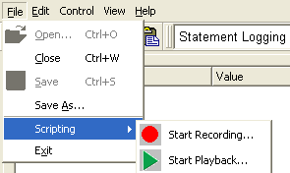
The scripting options change depending on the state of the recording or playback.
Select File > Scripting > Start Recording... in order to record a script that represents your actions in the GUI. When selected, this option prompts you for the location of the script file to be created:
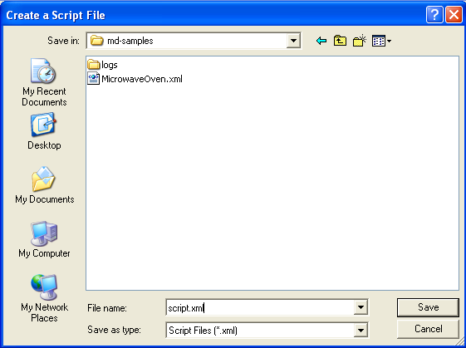
Enter the name of the script file and press the Save button.
From this point on, Model Debugger records your GUI operations to the script file you specified. When finished recording, select File > Scripting > Stop Recording:
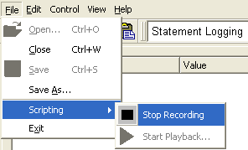
In order to playback a recorded script, select File > Scripting > Start Playback... and select the script from the dialog box.
To stop play back, select File > Scripting > Stop Playback.
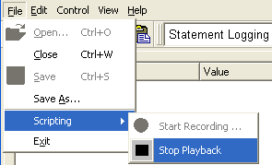

Manual Script Operations
The following GUI activities are not captured when in script recording mode:
- breakpoint
- log
- saveLogText
- shutdown
- wait
For syntax and examples for those operations recorded automatically by the tool, please refer to a recorded script.
Each of the manual operations are described below.

Breakpoint
The breakpoint command is executed when a breakpoint condition is reached. It contains a list of commands to execute. These commands are executed each time a breakpoint is reached. If there are multiple breakpoint commands, each command is only in effect for the script commands that follow it (until the next breakpoint command is reached).

XML Example
<breakpoint>
<wait delay="2" />
<button name="startRun()" />
</breakpoint>

Log message
Places an entry in the log. Formatting is supplied by the current trace formatting script.

XML Example
<log severity="INFO" message="Starting test...." />

Save Execution Trace Window to file
Saves the current contents of the Execution Trace Window to the filename.

XML Example
<saveLogText filename="C:/test1.html" />

Shutdown
The shutdown command is executed when the 'Session Done' message is received from the target. It contains a list of commands to execute. If there are multiple shutdown commands, each command is only in effect for the script commands that follow it (until the next shutdown command is reached).

XML Example
<shutdown>
<!-- need to wait for the last 'state exit' message -->
<wait delay="2" />
<menu item="fileExit()" />
</shutdown>

Wait
Waits the period of time specified in seconds.

XML Example
<wait delay="5" />

