Properties View
The Properties View shows the properties of the currently selected item. This view provides a convenient non-modal way to browse and/or update a model element. When a class is selected in a Class Diagram, for example, the Properties View shows all of its properties such as class name, key letter, number, and description. The figure shows the Properties View for the Oven class.
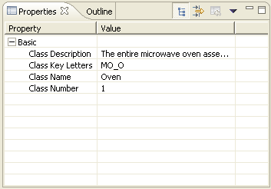
By default, the Properties View shows the basic properties for a model element. Basic properties are the attributes of the class in the xtUML meta-model. Advanced properties are accessed via the Show Advanced Properties button.
