Overview
Translation is the process by which xtUML application models are turned into code - C, C++, Java, or any other language for which you have written translation rules. Off the shelf model compilers, such as MC-3020, make use of BridgePoint’s translation features to produce complete applications in optimized ANSI C.
There are two types of translation available to you. The first is translation via a model compiler. The second is by using the fundamental translation features provided with the BridgePoint UML Suite.

Definitions

Model
A model is a group of model elements organized in some fashion according to a defined structure (a metamodel). For the purposes of the BridgePoint UML Suite, a model is an xtUML model created in Model Builder.

Metamodel
A metamodel describes the structure of a model. For an xtUML model, the structure is defined by the xtUML metamodel. Metamodels themselves are modeled using xtUML.

Database
The database, or translation database, is used to store the model data during translation. When translating with a model compiler, the database is called an xtUML database. It’s structure is defined by the xtUML metamodel, and it’s data is defined by what was entered in Model Builder.
The words database, translation database, and xtUML database, are sometimes used interchangeably.

Translation Rules
Translation rules are the means by which model data stored in the database are accessed, formatted, and output to files. Translation rules are written in RSL (Rule Specification Language).

Translating with a Model Compiler
This is the most common way to translate. To translate your application models into code using a model compiler, all you have to do is:
- bring up BridgePoint Model Builder
- create an xtUML model
- configure the model compiler using markings
- press the build button
The result of the build is a host executable or target image, ready for execution and debug.
An example of the translation process, using the MC-3020 C model compiler to produce an executable, is shown in the figure below:
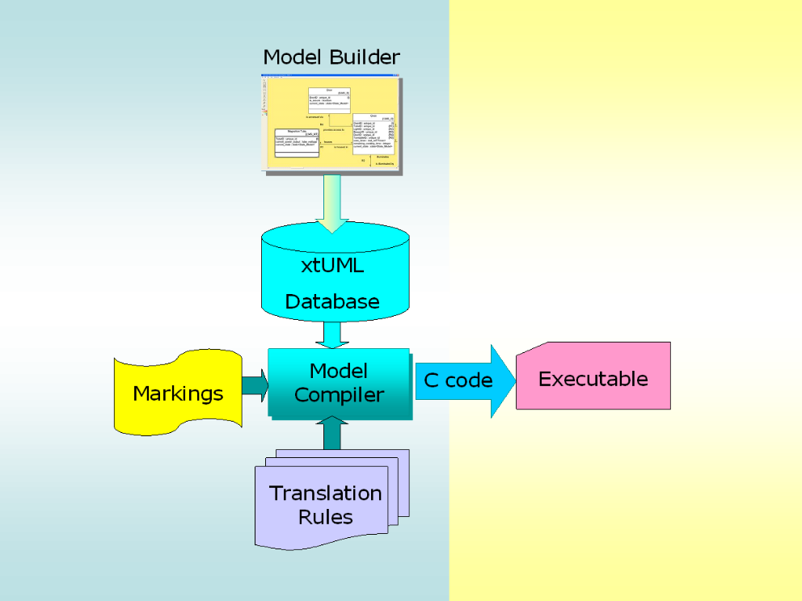

The xtUML application model is created in Model Builder. Markings are supplied to the model compiler and the build button is pressed to initiate the build. The xtUML application and any marking data are stored in an xtUML database as input to the model compiler. The model compiler, driven by the markings and the translation rules, gathers data from the xtUML database, transforms it into the specified implementation, and produces an executable.
The model compiler user interface consists of an editor used to specify the marking data, and a few toolbar buttons used to build the executable. Typical markings include specifying optimizations and choosing whether or not to produce an executable for the Model Debugger.
Please consult your Model Compiler’s User’s Guide and the Getting Started section of the online documentation for complete details.

Translation Outside of a Model Compiler
The model compilers encapsulate BridgePoint’s translation features in order to make the translation process as streamlined and easy to use as possible. The fundamental translation process used by the model compilers, however, is very simple. The process consists of the following:
- creating a database with the structure of the desired metamodel (we supply the xtUML metamodel, but you can define any metamodel you like)
- importing an xtUML model created with BridgePoint Model Builder into the database
- applying a set of translation rules written in RSL (BridgePoint’s Rule Specification Language) against the database
That is all you need, at the most fundamental level, to produce C, C++, HTML, Java, text (literally anything), from an xtUML model. Here is what the process looks like graphically:
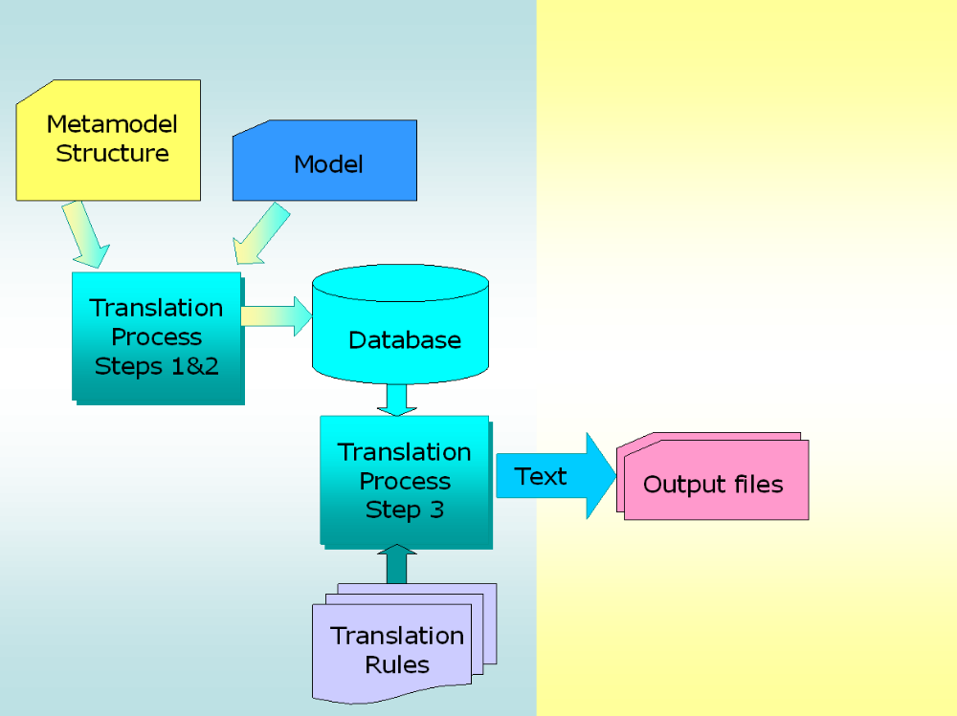

The first step in the translation process is to define the structure of the database. This is accomplished by importing into the database, a file that defines the structure of any to-be-imported model data.
When a model compiler performs the first step, it defines the structure as the xtUML metamodel that ships with the BridgePoint tools.
The second step is to import into the database a file containing model data - data that adheres to the structure defined in the previous step. This can be data output from Model Builder, created by hand, or created by translation rules.
When performing the second step, a model compiler imports the model data produced by BridgePoint Model Builder. Data saved from Model Builder is guaranteed to match the xtUML metamodel that ships with the BridgePoint tools.
In the third step, one or more translation rule files are applied to the database, which at this point, contains the structure and data from the model. Each of the translation rule files are written in RSL (Rule Specification Language). RSL statements can be used to gather data from the database, transform it, and emit it to one or more output files.
When performing the third step, a model compiler applies all of the translation rule files that encompass the system architecture. The result is a set of files that are compiled and linked into an executable, or target image.
The tools that comprise BridgePoint’s fundamental translation features provide a generic translation solution whereby text can be created using any arbitrary model, the structure of which is defined by any arbitrary metamodel.

