Problems View
BridgePoint adds problems to the Problems View under certain conditions such as when it detects an inconsistency in the model, or an error in an activity.
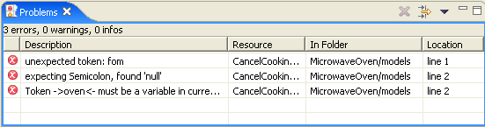
The Problems View in the figure above shows tasks related to an incorrect line of action language in the CancelCooking function. The error shows that the OAL parser does not understand the token “fom” since it appears to be missing the “r” in the keyword “from”.

