BridgePoint 6.1 SQL Export
This wizard is provided for backward compatibility with model compilers that only understand the BridgePoint 6.1 SQL format. You won’t need to use this dialog unless you are using a pre-V7.0 version of BridgePoint.

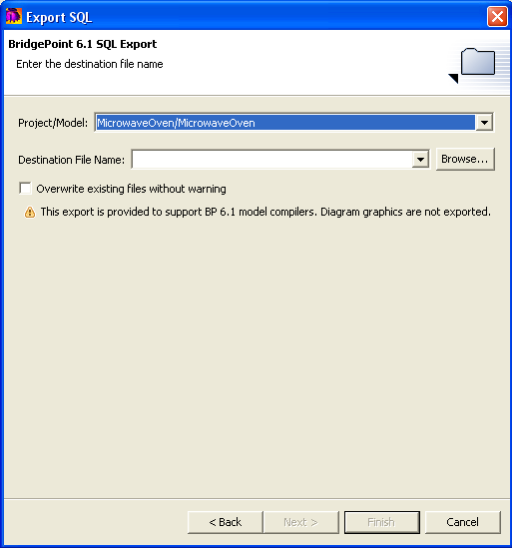
Project/Model are the project name and model name. The pull-down dialog lets you select from all of the project/model pairs in the current workspace.
Destination File Name selects the destination file. Click the Browse… button to navigate to the desired location.
The Overwrite existing files without warning checkbox can be used to avoid a pop-up warning dialog.

