Translating the Sample Model to Code
Once again, this part of the tour requires the MicrowaveOven sample project to exist in the workspace. If you do not see the MicrowaveOven project click the link below.
Click here to create the sample project.
NOTE: In order to proceed with this section you must have a license for the BridgePoint MC-3020 component. This license is not included in some evaluations. To see if you have this license select Help > License Information … If you do not have a license, or if your license has expired, please contact your local Mentor Graphics representative to obtain one. Skip to Reviewing the Generated Code.

Translating the Model
Having looked over the model using the Model Explorer and the various editors, we are now ready to produce code directly from the sample model. To do this, we’ll use MC-3020. MC-3020 is a model compiler that produces optimized C code.
When the sample MicrowaveOven project was created, the following downstream tools were selected:
- MC-3020 as the translation component
- Minimalist GNU Win32 tools as the compiler/linker
Since everything was set up when the sample project was created, all you need to do in order to translate the models into code is:
- Switch to the EDGE Projects Perspective by selecting Window > Open Perspective > EDGE Projects.
- Select the MicrowaveOven project
- Right-click and select Build Project.
The following figure illustrates the last few steps:
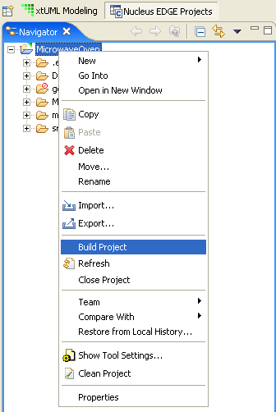
First the models are translated. During the first part of the translation, the models are analyzed for the purpose of gathering statistical information and storing away information for the second pass of translation. This latter data is used to optimize out unused attributes, unused relationships, and other data to create efficient code. During the next part of translation, the models for each of the domains are generated into their implementation. Next, the system-level code is generated. This code performs the initialization of the model compiler structures, and orchestrates the initialization sequence of the user and architecture components.
Finally the generated code, along with any user supplied files is compiled and linked into a single system image.
As the build progresses, information is output to the build console:
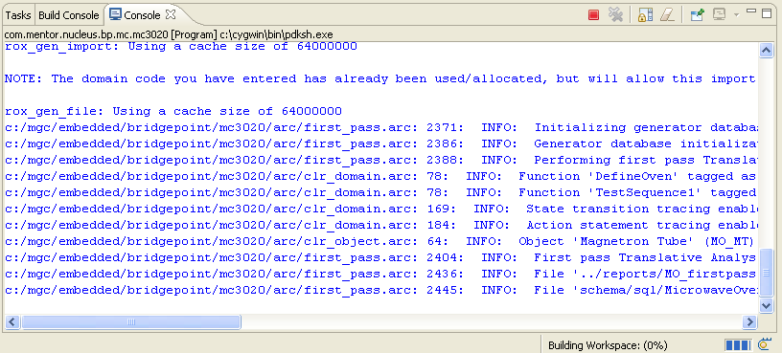

Reviewing the Generated Code
When the translation has finished, you will see Code generation complete in the console window. Using the Resource Navigator, explore the MicrowaveOven project folder.
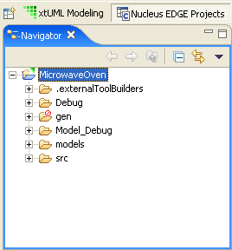
The following sub-folders are present:
.externalToolBuilders – contains the launch specification that allows MC-3020 to detect changes to the project and regenerate the code for you.
Debug – contains the object files including the executable created by the compiler/linker after the models are translated into code.
gen – contains files used for marking the model to direct the code generation process.
Model_Debug – contains the pre-translated Model Debugger-enabled executable created for the Model Debugger part of this quick tour (next section).
models – contains the files that store your xtUML models.
src – contains the generated code.
Examine the contents of src folder found in the root of the MicrowaveOven project. This folder contains all of the generated code for the microwave oven. Locate and open the MicrowaveOven_MO_MT_class.h file (double-click on the file to open the source editor).
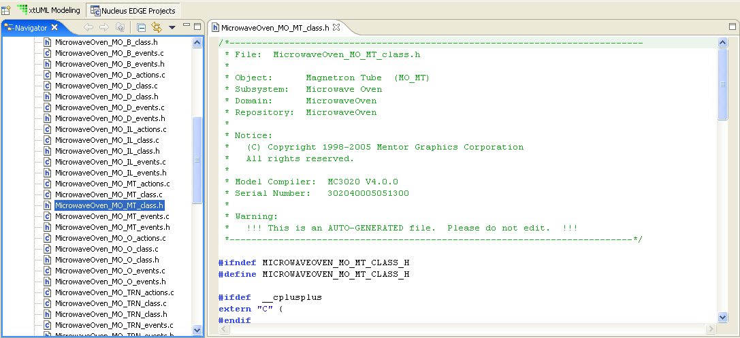
Note first of all that the generated banner contains lots of useful information about the name of the class, its subsystem and domain, the name and version of the model compiler etc. Notice also that the banner contains a warning not to edit the generated code. This is because changes made in here will be overwritten when the model is regenerated. To effect changes in here, one modifies the rules that generated the code, i.e., the model compiler, not the generated code.
Now scroll down to the structure declaration. At this point, it will be useful to open the Microwave Oven class diagram and locate and center the Magnetron tube class. Note that the name of the Class is generated as a comment above the structure declaration. Note also that the key letters of the class (MO_MT) are used to create the name of the generated source file itself. Now examine the data members of the structure. See how each data member relates directly to an attribute defined in the class.
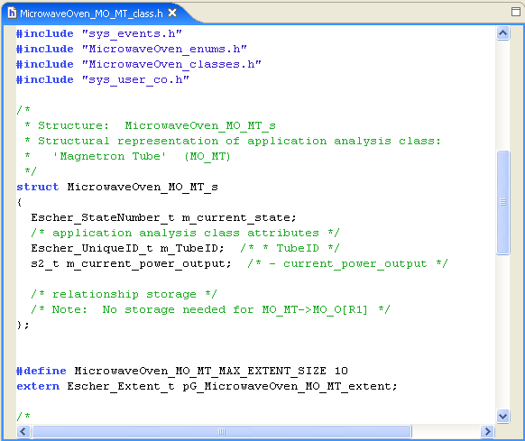
Moving down through the file from the structure declaration, you will see a definition of the Magnetron Tube extent size. This is set to the default value of 10. That is, the generated code can accommodate up to ten instances of the Magnetron Tube class. In fact we only need space for one of these, but the generated program will run just fine taking more space than it needs. Later, we will see how we can customize such things as the maximum number of each instance set required.
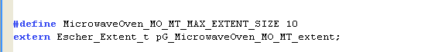
Further yet through the file we find various definitions of the states, events, and activities defined for the Magnetron tube. Compare these with the items found on the Magnetron Tube state machine diagram.
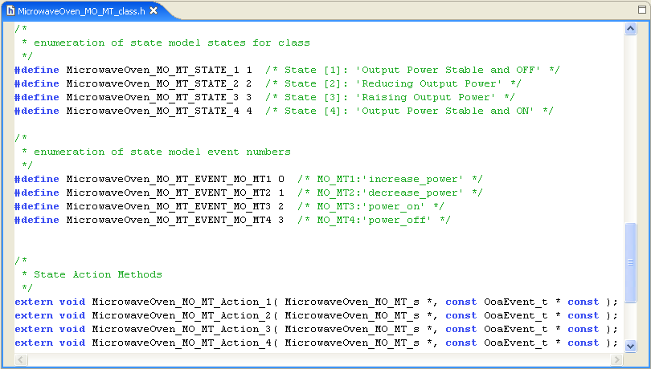
Examine other generated files to get a further insight into the quality of the generated code. MC-3020 is capable of performing optimizations too. Locate and open the MicrowaveOven_MO_O_class.h file. This is the file that declares the structure for the Oven class itself. Notice that this file contains member declarations that are commented out by the model compiler. This is because MC-3020 determined that the attributes from which these members were generated were not accessed anywhere form the action language. It was therefore able to optimize them out of the generated code, though it left the commented out versions there for reference.
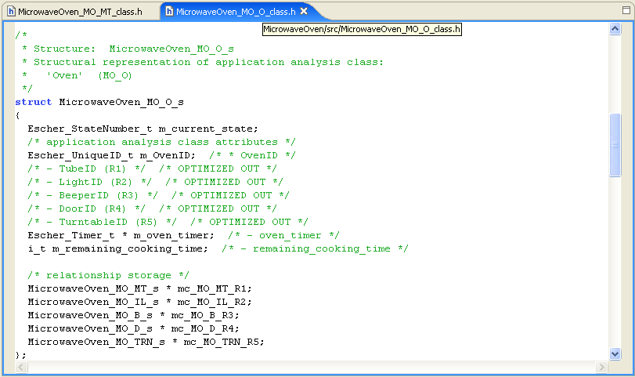
Using the Resource Navigator, examine the contents of the gen folder in the root of the project.
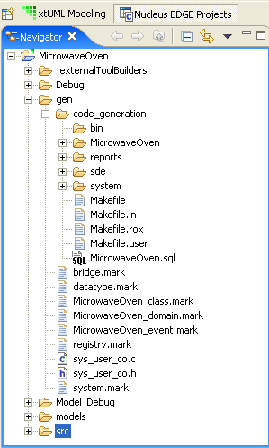
It contains marking files, discussed below, which are used to customize the code generation process. The gen folder also contains another folder, code_generation that contains information created by the code generation process. This folder contains the make files used to build the executable. It also contains a folder called reports. The reports folder contains all kinds of useful statistics about the models that were used to generate the executable and information about the code generation process itself. In particular, code generation warnings are written to files in this folder. The rest of the code_generation folder contains the generated code. For full details of the files produced during code generation, please see the MC-3020 user guide.

Customizing the Generated Code
NOTE: In order to proceed with this section you must have a license for the BridgePoint MC-3020 component. This license is not included in some evaluations. To see if you have this license select Help > License Information … If you do not have a license, or if your license has expired, please contact your local Mentor Graphics representative to obtain one. Skip to Running the Generated Code.
Turn now to the .mark files in the root of the gen folder. Locate and open the file named MicrowaveOven_class.mark. Notice the example translation rule function invocation, .invoke TagObjectExtentSize(“MY_OBJ”, 20) located inside the comment. Copy and paste this so that it is outside of the rule comment, and modify the key-letter argument so that it reads MO_MT. Finally, set the extent size to ‘1’ and retranslate by selecting Build Project from the Resource Navigator context menu. The line should look like this:
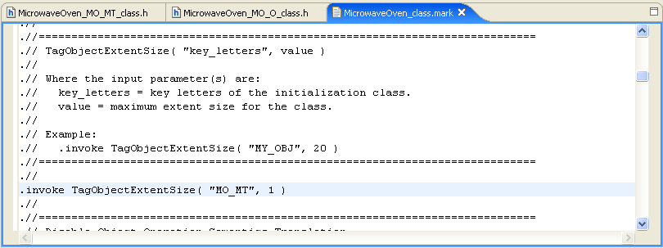
When regeneration is complete, you will see that the generated code now carries an extent size as specified. There are many other customizations you can make to the generated code, describing all of them is outside the scope of this quick start guide. Please see the MC-3020 user guide for more details.

Running the Generated Code
The executable is placed in MicrowaveOven/Debug/Output/MicrowaveOven.exe. NOTE: You must open the executable with the system editor. The default editor (the one brought up by double-clicking) is the Model Debugger. Since this executable is not instrumented for the Model Debugger (the one in the next section will be), you need to use the system editor.
Navigate to the executable, right-click on it, and select Open With > System Editor. For an executable file, the system editor is a command shell.
The shell starts and the generated code begins running in the shell. Tracing output from the execution is emitted to the console window. This output is shown in terms of the original UML model elements.
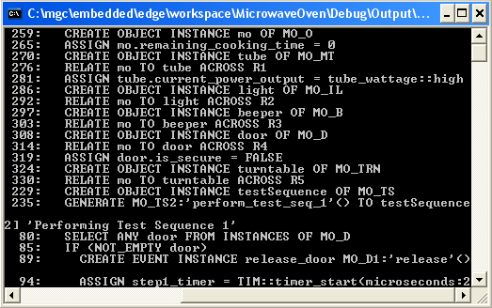
That covers the translation portion of this tour. To execute the sample models with the Model Debugger, please proceed to the next section.

