Activity Editor
The Activity Editor is used to edit the action language (called activities in UML 2.0) for those model elements that can define them: functions, bridge operations, instance-based and class-based operations, derived attributes, and state actions. The Activity Editor is a syntactically-aware editor that assists the user in writing the applications actions.
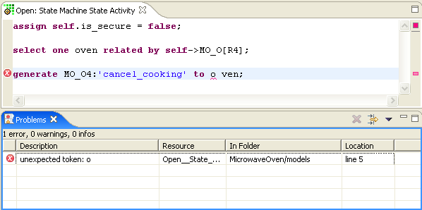
When an activity is written, it is checked for both syntax errors (missing semi-colons and malformed keywords) and semantic errors (references to unknown classes or events in the model). As can be seen in the figure above, the two errors result in several indicators inside the editor and entries in the Problems View.
The small red circle with an X in the left-hand vertical ruler points to the line that contains the error. This annotation in the editor corresponds to the error as it is listed in the Problems View. The Problems View shows a description of the error along with its location. Double-clicking on the error in the Problems View positions the cursor on the activity in the editor. If the activity is not currently being edited, the Activity Editor is brought up.
The right-hand vertical ruler shows an overview of the annotations for the text currently being displayed in the editor. The red ones indicate the position of errors in the activities. Clicking on the annotation positions the cursor to the activity containing the error.
Each of the errors is also underlined with a red squiggly line to indicate the exact position of the error on the line.

