Diagram Editor
Diagram editors provide a graphical view in which to display and edit model data. Each diagram has the same look and feel and behaves in the same way. Below is the Domain Package Diagram for the Microwave Oven sample model.
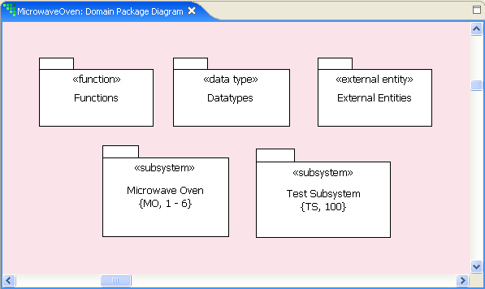
All diagram editors have a toolbar on which there are tools. Tools are available for the most common operations – other operations are available from context menus. Some of the tools are common to all diagrams, some common to several, and some specific to the diagram itself.
The following figure shows the toolbar for the Domain Package Diagram.
The left-most tools are common to all diagrams and provide zoom in, zoom out, zoom all, and zoom selected functionality. The arrow is the selection tool, and is used to select model elements on the diagram. The right-most tools put the diagram in “input mode” allowing model elements to be drawn on the diagram.
Hovering over a tool shows the tool tip associated with the tool. The tool tip corresponds to the button name. The following is a list of the operations available on all canvases:
- Symbol display, drawing, selection, movement, and resize
- Selection highlighting
- Zooming, scrolling and panning
- Context menu activation
- Scaling
- Waypoint manipulation
- Diagram printing
Diagram editors provide a way to navigate the model (using zooming, panning, and scrolling) to gain access to the different model elements for inspection and edit. Pressing the space bar on a diagram changes the cursor to a hand symbol in order to grab and move the canvas to the desired location. Specific toolbars and operations for each of the diagrams are discussed in further detail under Diagram Toolbars.

