Model Explorer
The Model Explorer View has several buttons that let you control the behavior of the Model Explorer, how the model elements are shown, and how it interacts with the editors in the xtUML perspective. The icons from left to right are:
- Collapse All
- Link with Editor
- Pull-down Menu
- Minimize
- Maximize
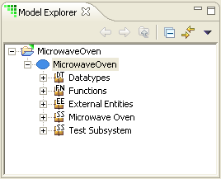

Collapse All
Collapse All folds all of the entries in the Model Explorer hierarchy.

Link with Editor
Link with Editor synchronizes the Model Explorer with the currently selected model element on an open editor.

Pull-down Menu
The pull-down menu provides filtering for the Model Explorer View.
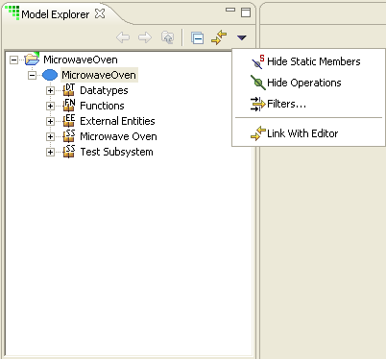

Hide Operations
This option hides class-based operations.

Filters
This option filters the Model Explorer for the selected model elements. When a model element is filtered, it, and any model elements it contains, are removed from the Model Explorer View.

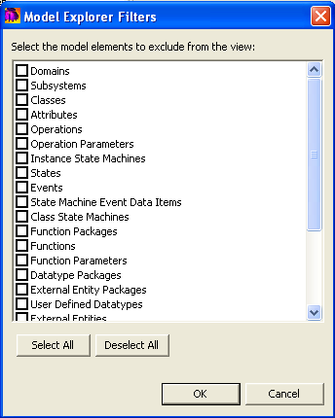

Minimize
This option minimizes the Model Explorer View.

Maximize
This option maximizes the Model Explorer View.

